**THEORY:** MATLAB is a programming language developed by Math Works. It started out as a matrix programming language where linear algebra programming was simple. MATLAB (matrix laboratory) is a fourth-generation high-level programming language and interactive environment for numerical computation, visualization and programming.

MATLAB is developed by Math Works.

It allows matrix manipulations; plotting of functions and data; implementation of algorithms; creation of user interfaces; interfacing with programs written in other languages, including C, C++, Java, and FORTRAN; analyze data; develop algorithms; and create models and applications.

It has numerous built-in commands and math functions that help you in mathematical calculations, generating plots, and performing numerical methods.

In MATLAB environment, every variable is an array or matrix. Variables can be defined in MATLAB in the following ways:

x = 3 % defining x and initializing it with a value

x = sqrt(16) % defining x and initializing it with an expression

The clear command deletes all (or the specified) variable(s) from the memory.

clear x % it will delete x, won't display anything

clear % it will delete all variables in the workspace

% peacefully and unobtrusively

A vector is a one-dimensional array of numbers. MATLAB allows creating two types of vectors:

* Row vectors
* Column vectors

**Row vectors** are created by enclosing the set of elements in square brackets, using space or comma to delimit the elements.

For example,

r = [7 8 9 10 11]

**Column vectors** are created by enclosing the set of elements in square brackets, using semicolon(;) to delimit the elements.

c = [7; 8; 9; 10; 11]

## Creating Matrices

A matrix is a two-dimensional array of numbers.

In MATLAB, a matrix is created by entering each row as a sequence of space or comma separated elements, and end of a row is demarcated by a semicolon. For example a 3-by-3 matrix is created as:

m = [1 2 3; 4 5 6; 7 8 9]

## MATLAB ENVIRONMENT:

* + Command Window
  + Command History
  + Workspace
  + Current Directory
  + Figure Window

## Command Window:

Whenever MATLAB is invoked, the main window called command window is activated. The command window displays the command prompt’>>’ and a cursor where commands are entered and are executed instantaneously.

## Command History Window:

Command history window consists of a list of all the commands that are entered at the command window. These commands remain in the list until they are deleted. Any command may be executed by selecting and double clicking it with the mouse.

## Workspace:

A workspace is a collection of all the variables that have been generated so far in the current MATLAB session and shows their data type and size. All the commands executed from Command Window and all the script files executed from the Command Window share common workspace, so they can share all the variables.

## Current Directory:

The Current Directory window contains all the files and folders present in the Current Directory. To run any file, it must either be in the Current Directory or on the search path.

## Edit Window:

An Edit Window is used to create a new program file, or to modify existing files. In this window, programs can be written, edited and saved. The programs written using the MATLAB editor are automatically assigned an extension (.m) by the editor and are known as M- files.

## Figure Window:

A Figure Window is a separate window with default white background and is used to display MATLAB graphics. The results of all the graphic commands executed are displayed in the figure window.

MATLAB allows two different types of arithmetic operations −

* Matrix arithmetic operations
* Array arithmetic operations

Matrix arithmetic operations are same as defined in linear algebra. Array operations are executed element by element, both on one dimensional and multi-dimensional array.

The matrix operators and arrays operators are differentiated by the period (.) symbol. However, as the addition and subtraction operation is same for matrices and arrays, the operator is same for both cases.

The following table gives brief description of the operators −

|  |  |
| --- | --- |
| **Operator** | **Description** |
| **+** | Addition or unary plus. A+B adds the values stored in variables A and B. A and B must have the same size, unless one is a scalar. A scalar can be added to a matrix of any size. |
| **-** | Subtraction or unary minus. A-B subtracts the value of B from A. A and B must have the same size, unless one is a scalar. A scalar can be subtracted from a matrix of any size. |
| **\*** | Matrix multiplication. C = A*B is the linear algebraic product of the matrices A and B. More precisely,  Matrix Multiplication  For non-scalar A and B, the number of columns of A must be equal to the number of rows of B. A scalar can multiply a matrix of any size. |
| **.\*** | Array multiplication. A.*B is the element-by-element product of the arrays A and |

|  |  |
| --- | --- |
|  | B. A and B must have the same size, unless one of them is a scalar. |
| **/** | Slash or matrix right division. B/A is roughly the same as B*inv(A). More precisely, B/A = (A'\B')'. |
| **./** | Array right division. A./B is the matrix with elements A(i,j)/B(i,j). A and B must have the same size, unless one of them is a scalar. |
| **\** | Backslash or matrix left division. If A is a square matrix, A\B is roughly the same as inv (A)*B, except it is computed in a different way. If A is an n-by-n matrix and B is a column vector with n components, or a matrix with several such columns, then X = A\B is the solution to the equation *AX = B*. A warning message is displayed if A is badly scaled or nearly singular. |
| **.\** | Array left division. A.\B is the matrix with elements B(i,j)/A(i,j). A and B must have the same size, unless one of them is a scalar. |
| **^** | Matrix power. X^p is X to the power p, if p is a scalar. If p is an integer, the power is computed by repeated squaring. If the integer is negative, X is inverted first. For other values of p, the calculation involves eigenvalues and eigenvectors, such that if [V,D] = eig(X), then X^p = V*D.^p/V. |
| **.^** | Array power. A. ^B is the matrix with elements A (i,j) to the B(i,j) power. A and B must have the same size, unless one of them is a scalar. |
| **'** | Matrix transpose. A' is the linear algebraic transpose of A. For complex matrices, this is the complex conjugate transpose. |
| **.'** | Array transpose. A' is the array transpose of A. For complex matrices, this does not involve conjugation. |

## Functions for Arithmetic Operations:-

Apart from the above-mentioned arithmetic operators, MATLAB provides the following commands/functions used for similar purpose −

|  |  |
| --- | --- |
| **Function** | **Description** |
| uplus(a) | Unary plus; increments by the amount a |
| plus (a,b) | Plus; returns a + b |
| uminus(a) | Unary minus; decrements by the amount a |
| minus(a, b) | Minus; returns a - b |
| times(a, b) | Array multiply; returns a.*b |
| mtimes(a, b) | Matrix multiplication; returns a* b |

|  |  |
| --- | --- |
| rdivide(a, b) | Right array division; returns a ./ b |
| ldivide(a, b) | Left array division; returns a.\ b |
| mrdivide(A, B) | Solve systems of linear equations *xA = B* for *x* |
| mldivide(A, B) | Solve systems of linear equations *Ax = B* for *x* |
| power(a, b) | Array power; returns a.^b |
| mpower(a, b) | Matrix power; returns a ^ b |

## PROGRAM:-

a = 10;

b = 20;

c = a + b d = a – b

e = a * b

f = a / b

g = a \ b

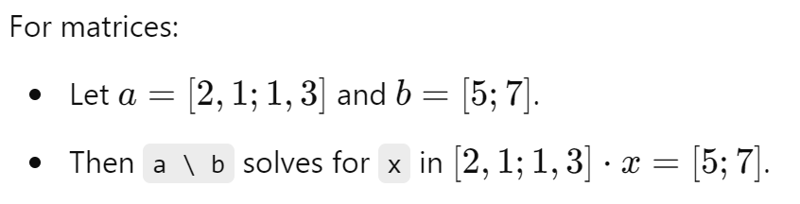

x = 7;

y = 3;

z = x ^ y

## The M Files

MATLAB allows writing two kinds of program files −

* + **Scripts** − script files are program files with **.m extension**. In these files, you write series of commands, which you want to execute together. Scripts do not accept inputs and do not return any outputs. They operate on data in the workspace.
  + **Functions** − functions files are also program files with **.m extension**. Functions can accept inputs and return outputs. Internal variables are local to the function.

You can use the MATLAB editor or any other text editor to create your **.m** files.

1. **Hello World**

disp('Hello, World!');

1. **Simple Addition**

a = 5;

b = 10;

c = a + b;

disp(c);

1. **For Loop**

for i = 1:10

disp(i);

end

1. **While Loop**

i = 1;

while i <= 10

disp(i);

i = i + 1;

end

1. **If-Else Statement**

a = 5;

if a > 0

disp('Positive number');

else

disp('Negative number');

end

1. **Function Definition**

function y = square(x)

y = x^2;

end

function main()

result = square(5); % Call the function with x = 5

disp(result); % Display the result

end

function y = square(x)

y = x^2;

end

1. **Plotting a Sine Wave**

x = linspace(0, 2*pi, 100);

y = sin(x);

plot(x, y);

title('Sine Wave');

xlabel('x');

ylabel('sin(x)');

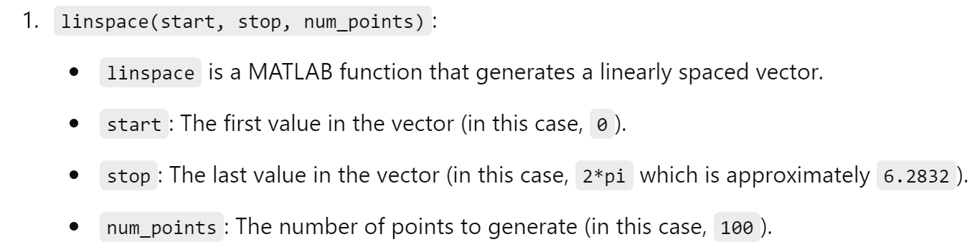

1. **Matrix Addition**

A = [1 2; 3 4];

B = [5 6; 7 8];

C = A + B;

disp(C);

1. **Matrix Multiplication**

A = [1 2; 3 4];

B = [5 6; 7 8];

C = A * B;

disp(C);

1. **Element-wise Multiplication**

A = [1 2; 3 4];

B = [5 6; 7 8];

C = A .* B;

disp(C);

1. **Transpose of a Matrix**

A = [1 2; 3 4];

B = A';

disp(B);

1. **Inverse of a Matrix**

A = [1 2; 3 4];

B = inv(A);

disp(B);

1. **Solving Linear Equations**

A = [1 2; 3 4];

B = [5; 6];

X = A\B;

disp(X);

1. **Finding Eigenvalues**

A = [1 2; 3 4];

eigvals = eig(A);

disp(eigvals);

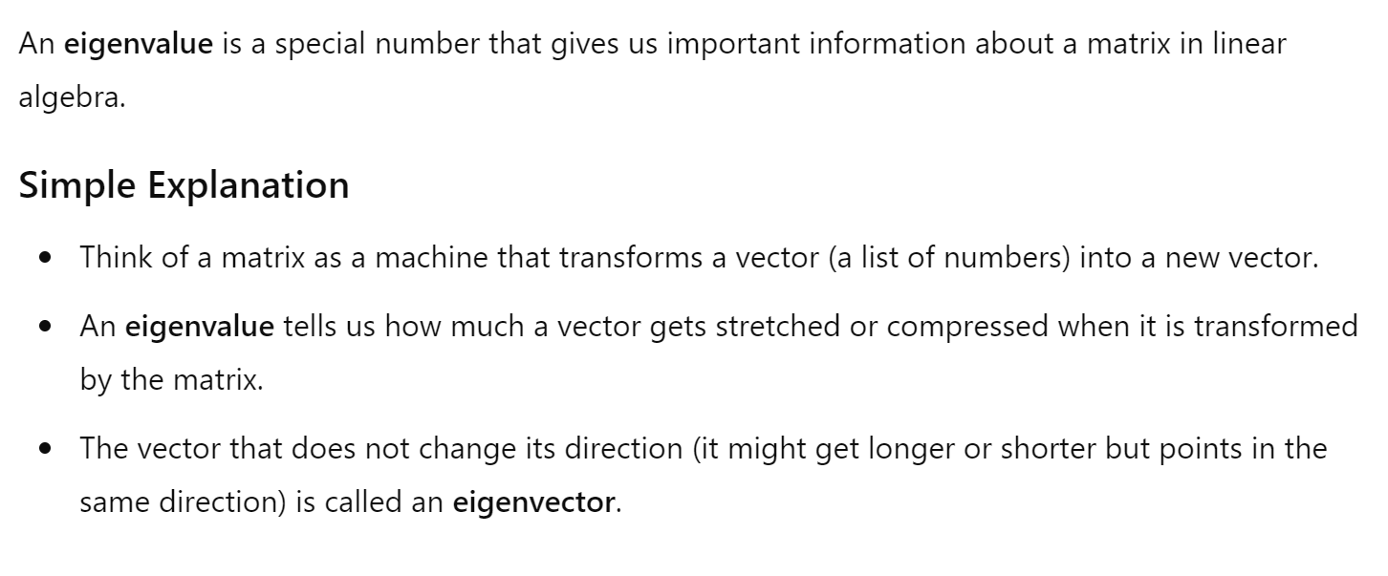



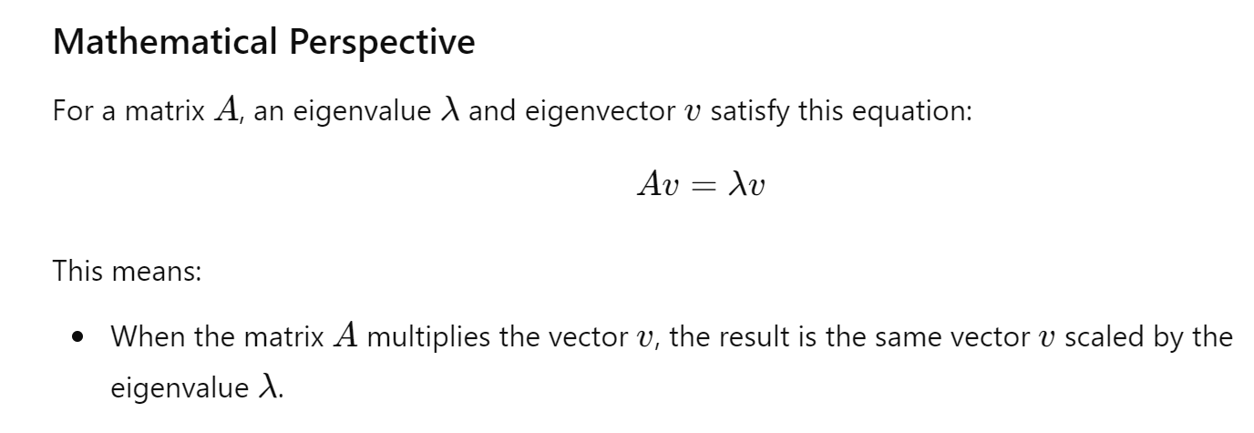

1. **Creating a 3D Plot**

[X, Y] = meshgrid(-2:0.1:2, -2:0.1:2);

Z = X.^2 + Y.^2;

surf(X, Y, Z);

title('3D Plot');

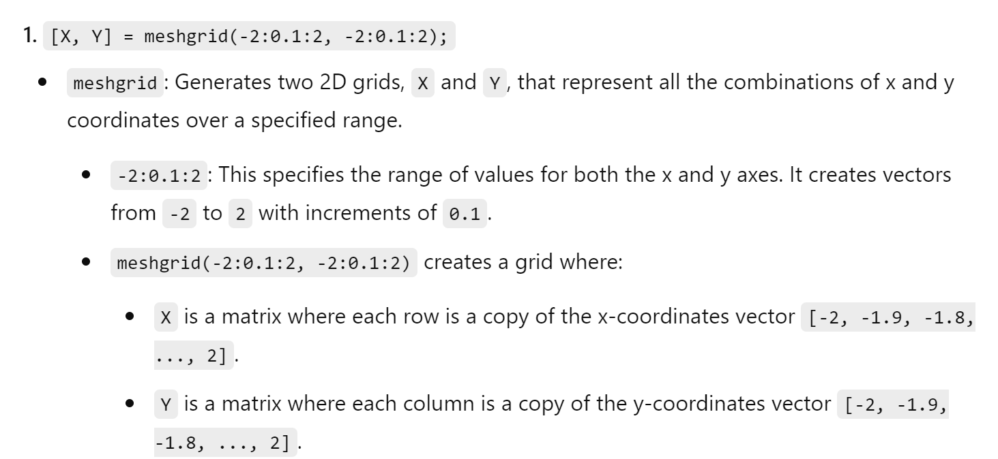

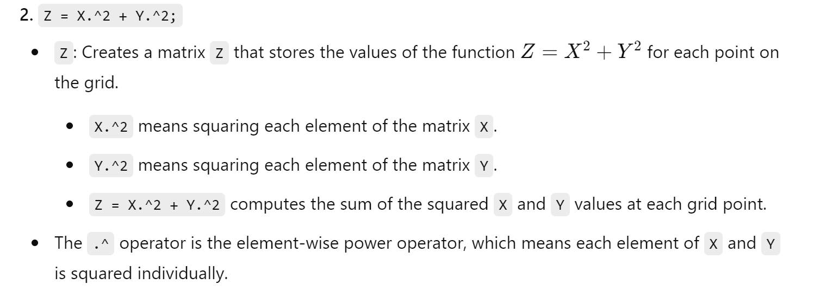

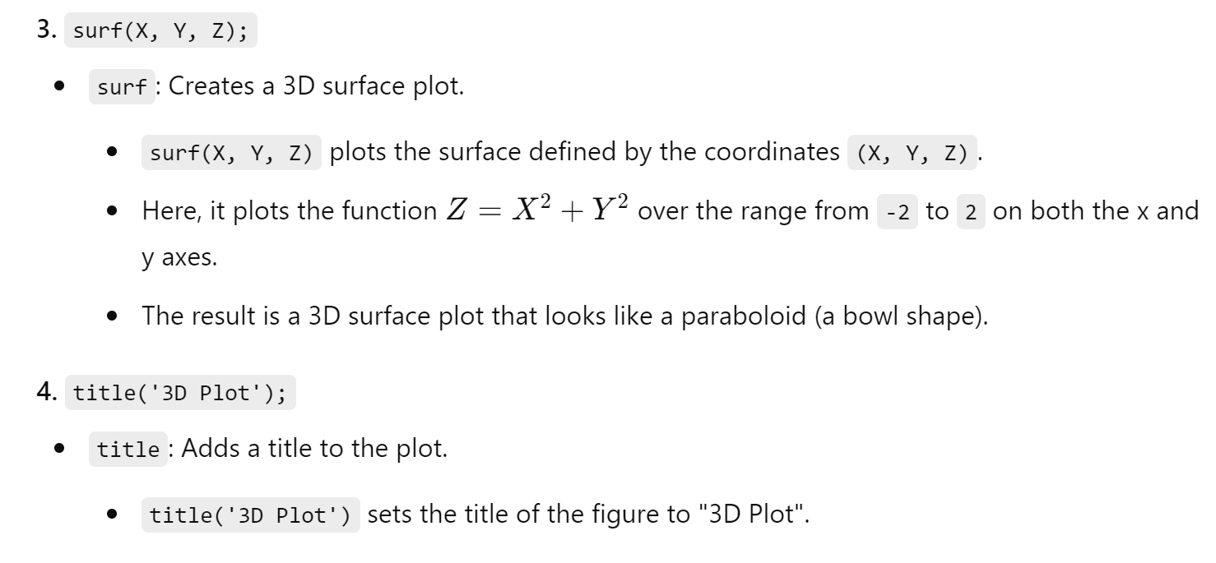

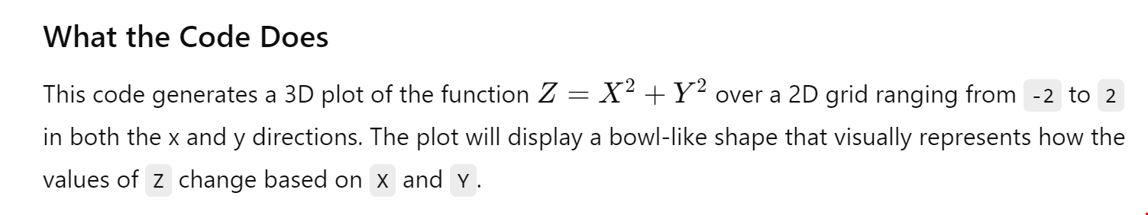

1. **Saving a Variable to File**

a = 10;

save('myVariable.mat', 'a');

1. **Loading a Variable from File**

load('myVariable.mat');

disp(a);

1. **Reading Data from a File**

data = load('data.txt');

disp(data);

1. **Writing Data to a File**

data = [1 2 3; 4 5 6; 7 8 9];

save('output.txt', 'data', '-ascii');

1. **Calculating the Mean**

data = [1, 2, 3, 4, 5];

mean_val = mean(data);

disp(mean_val);

1. **Calculating the Standard Deviation**

data = [1, 2, 3, 4, 5];

std_val = std(data);

disp(std_val);

1. **Finding the Maximum Value**

data = [1, 2, 3, 4, 5];

max_val = max(data);

disp(max_val);

1. **Finding the Minimum Value**

data = [1, 2, 3, 4, 5];

min_val = min(data);

disp(min_val);

1. **Sorting an Array**

data = [5, 3, 1, 4, 2];

sorted_data = sort(data);

disp(sorted_data);

1. **Creating a Histogram**

data = randn(1000, 1);

histogram(data);

title('Histogram');

1. **Generating Random Numbers**

random_numbers = rand(1, 10);

disp(random_numbers);

1. **Solving a System of Equations**

syms x y;

eq1 = 2*x + 3*y == 6;

eq2 = 4*x - y == 5;

sol = solve([eq1, eq2], [x, y]);

disp(sol.x);

disp(sol.y);

1. **Symbolic Differentiation**

syms x;

f = x^2 + 3*x + 2;

f_prime = diff(f);

disp(f_prime);

1. **Symbolic Integration**

syms x;

f = x^2 + 3*x + 2;

f_int = int(f);

disp(f_int);

1. **Creating a Subplot**

x = linspace(0, 2*pi, 100);

y1 = sin(x);

y2 = cos(x);

subplot(2,1,1);

plot(x, y1);

title('Sine Wave');

subplot(2,1,2);

plot(x, y2);

title('Cosine Wave');

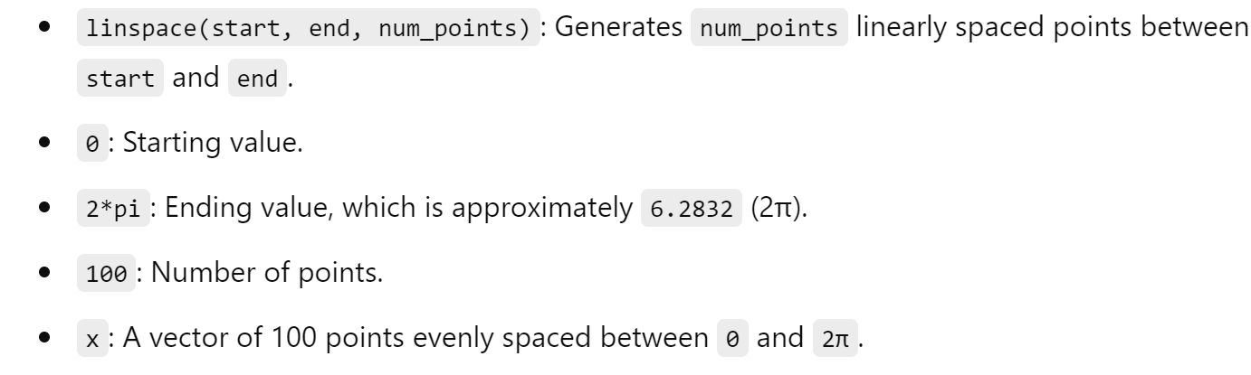

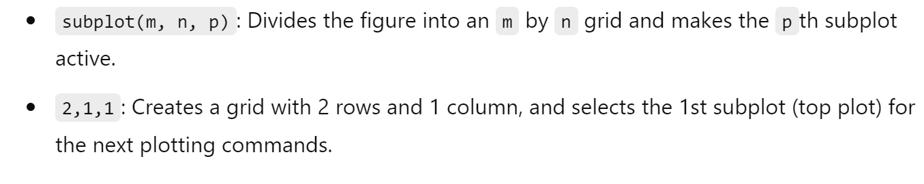

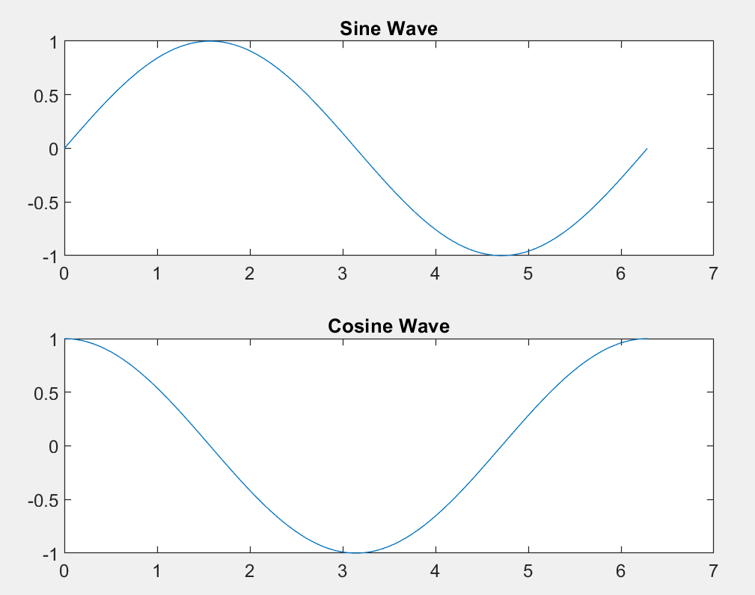

**Sample Experiments**

Basic Mathematics and Operations

Experiment 1.1: Matrix Operations

Theory: Matrix operations are fundamental in MATLAB. They include addition, subtraction, multiplication, and division.

Code:

A = [1 2; 3 4];

B = [5 6; 7 8];

% Matrix Addition

C = A + B;

% Matrix Subtraction

D = A - B;

% Matrix Multiplication

E = A * B;

% Element-wise Multiplication

F = A .* B;

% Matrix Division

G = A / B;

% Display Results

disp('Matrix Addition:'), disp(C)

disp('Matrix Subtraction:'), disp(D)

disp('Matrix Multiplication:'), disp(E)

disp('Element-wise Multiplication:'), disp(F)

disp('Matrix Division:'), disp(G)

Experiment 1.2: Solving Linear Equations

Theory: Solving a system of linear equations can be achieved using matrix inversion or MATLAB's backslash operator.

Code:

A = [2 1; 3 4];

b = [5; 6];

% Solve using inverse

x1 = inv(A) * b;

% Solve using backslash operator

x2 = A \ b;

% Display Results

disp('Solution using inverse:'), disp(x1)

disp('Solution using backslash operator:'), disp(x2)

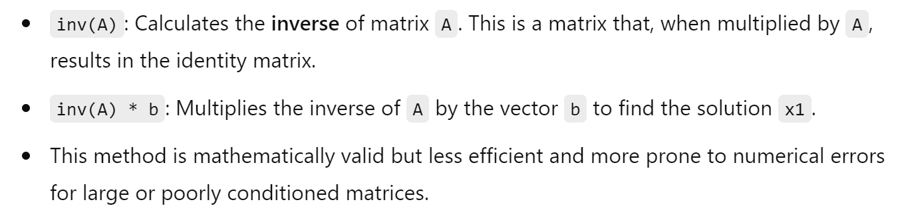

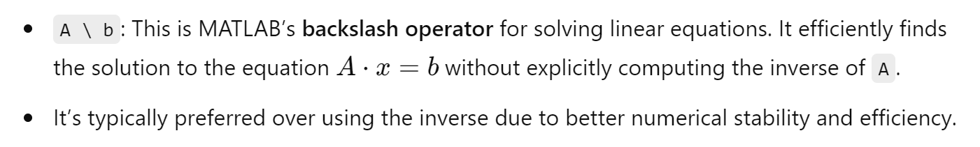

2. Data Analysis and Visualization

Experiment 2.1: Plotting Data

Theory: Visualizing data using different types of plots helps in understanding the data better.

Code:

x = 0:0.1:10;

y = sin(x);

figure;

plot(x, y);

title('Sine Wave');

xlabel('x');

ylabel('sin(x)');

grid on;

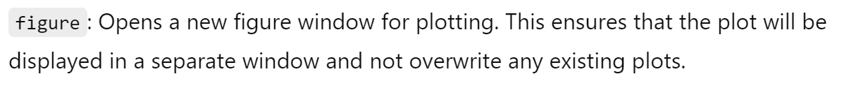



Experiment 2.2: Histogram

Theory: Histograms represent the distribution of data.

Code:

data = randn(1000, 1);

figure;

histogram(data);

title('Histogram of Random Data');

xlabel('Data Values');

ylabel('Frequency');

grid on;

5. Optimization

Experiment 6.1: Minimizing a Function

Theory: Optimization involves finding the minimum or maximum of a function.

Code:

fun = @(x) (x-2)^2 + 3;

x0 = 0; % Initial guess

x = fminsearch(fun, x0);

disp('The minimum value is at:'), disp(x)

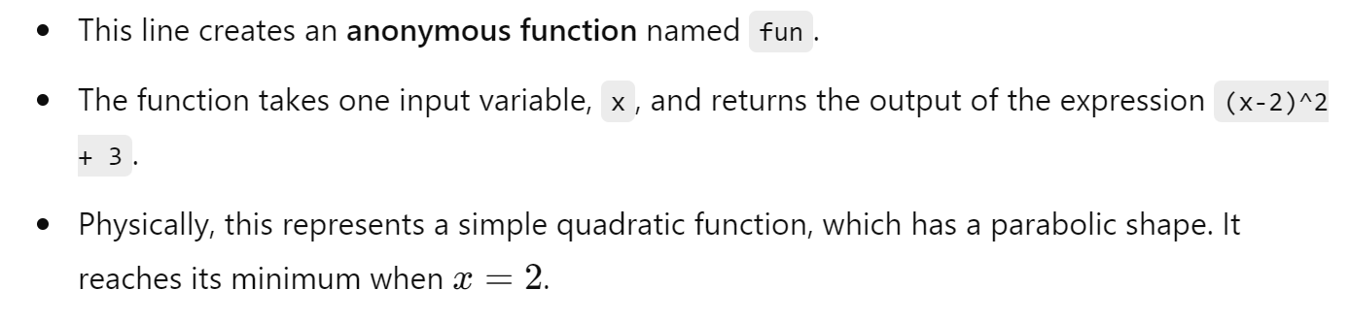







Here actually we calculated a Minima of a Function

6. Numerical Methods

Experiment 6.1: Solving ODEs

Theory: Solving ordinary differential equations (ODEs) is essential in many scientific fields. Code:

% Define the ODE

ode = @(t, y) -2*y;

% Initial condition

y0 = 1;

% Time span

tspan = [0 5];

% Solve ODE

[t, y] = ode45(ode, tspan, y0);

% Plot results

figure;

plot(t, y);

title('Solution of ODE');

xlabel('Time');

ylabel('y(t)');

grid on;



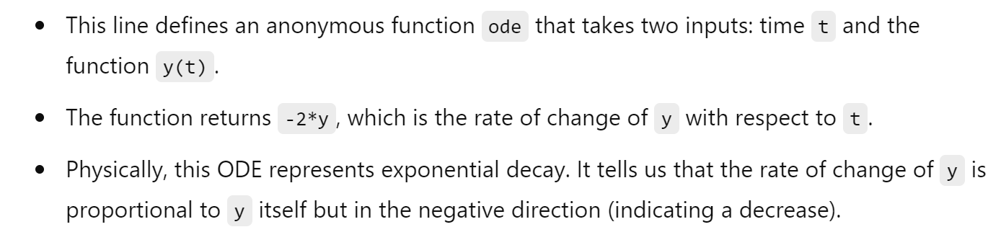





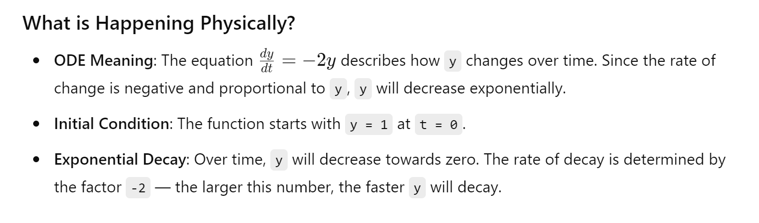

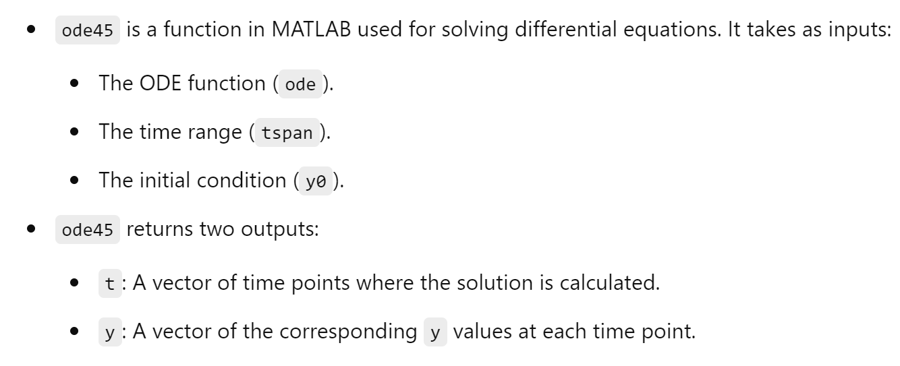

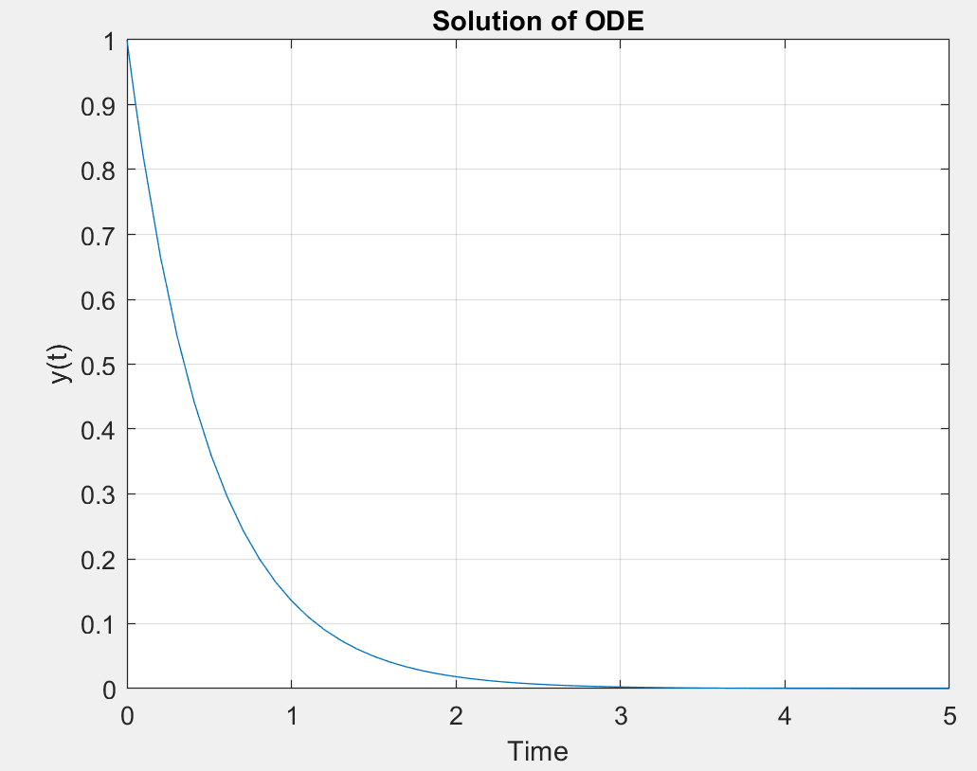

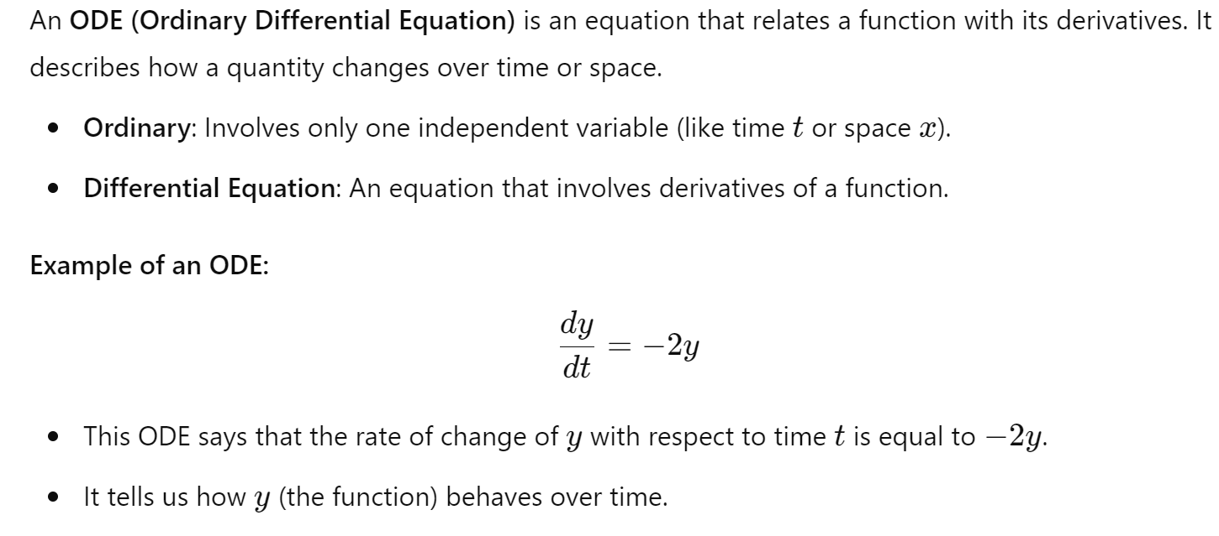





10. File I/O and Data Import/Export

Experiment 10.1: Reading and Writing CSV Files

Theory: Importing and exporting data is crucial for data analysis and sharing.

Code:

% Generate sample data

data = rand(10, 3);

% Write data to CSV

csvwrite('data.csv', data);

% Read data from CSV

data_read = csvread('data.csv');

disp('Data read from CSV:'), disp(data_read)

.

## 2-D plot

Define x as a vector of linearly spaced values between 0 and . Use an increment of π/10 between the values. Define y as sine values of x.

## Program:

clc clear all

x=(0:pi/10:2*pi) y=sin(x) plot(x,y) title('2D Plot') xlabel('Time')

ylabel('Amplitude')

## 3-D plot

A three-dimensional plot may refer to

* 1. A graph or plot embedded into a three-dimensional space
  2. The plot of a function of two variables, embedded into a three-dimensional space

## Program:

clc clear all

t=(-4:0.01:4)

x=t.^2 y=4*t plot3(x,y,t) grid on

xlabel('x-axis')

ylabel('y-axis')

zlabel('z-axis') title('3D Plot')

1

0.8

0.6

0.4

0.2

Amplitude

0

-0.2

-0.4

-0.6

-0.8

-1

2D Plot

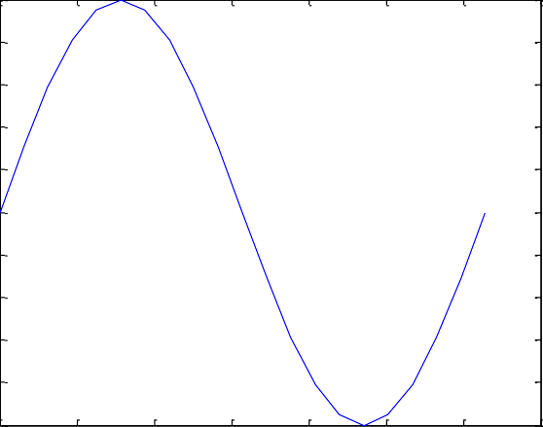

0 1 2 3 4 5 6 7

Time

Figure-4

3D Plot

4

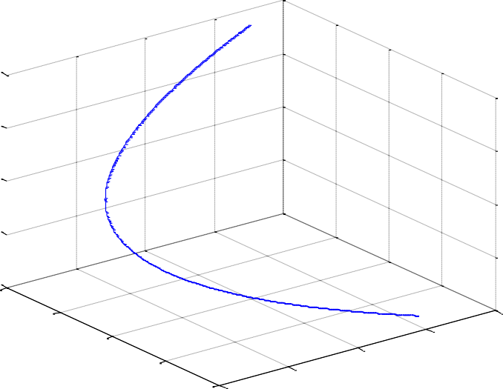

2

0

z-axis

-2

-4

20

10

0

y-axis

-10

-20 0

20

15

10

5

1. ax

#### Ohm's Law Verification

Ohm’s law states that the voltage or potential difference between two points is directly proportional to the current or electricity passing through the resistance, and directly proportional to the resistance of the circuit. The formula for Ohm’s law is V=IR. This relationship between current, voltage, and relationship was discovered by German scientist Georg Simon Ohm. Let us learn more about Ohms Law, Resistance, and its applications.

**Ohm’s Law Definition**

Most basic components of electricity are voltage, current, and resistance. Ohm’s law shows a simple relation between these three quantities. **Ohm’s law** states that the current through a conductor between two points is directly proportional to the voltage across the two points.

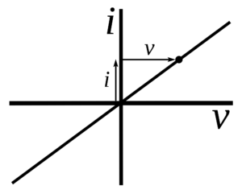

**Ohm’s Law Formula**

Voltage= Current× Resistance  
**V= I×R**V= voltage, I= current and  R= resistance

The SI unit of resistance is **ohms** and is denoted by **Ω**

This law is one of the most basic laws of electricity. It helps to calculate the [power](https://www.toppr.com/guides/physics/work-energy-and-power/power/), efficiency, current, voltage, and resistance of an element of an electrical circuit.

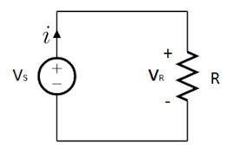

**Objective:** Verify Ohm's Law using MATLAB.

**Steps:**

1. Define the resistance and current.
2. Calculate the voltage using Ohm's Law.
3. Display the result.

**Code:**

% Step 1: Define the resistance and current

R = 10; % resistance in ohms

I = 2; % current in amperes

% Step 2: Calculate the voltage

V = R * I;

% Step 3: Display the result

disp(['Voltage (V) = ', num2str(V), ' V']);

#### 2. Series RC Circuit Response

**Objective:** Analyze the step response of a series RC circuit.

**Steps:**

1. Open Simulink and create a new model.
2. Add a resistor, capacitor, and step input to the model.
3. Connect the components in series.
4. Run the simulation and observe the voltage across the capacitor.

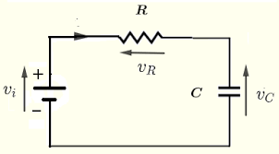

**Simulink Setup:**

1. Drag and drop a Resistor, Capacitor, and Step block from the library.
2. Connect them in series.
3. Add a Scope block to visualize the voltage across the capacitor.
4. Configure the parameters (e.g., R = 1 ohm, C = 1 F).

**Steps:**

1. Set up the Simulink model as described.
2. Run the simulation.
3. Observe the voltage across the capacitor on the Scope.

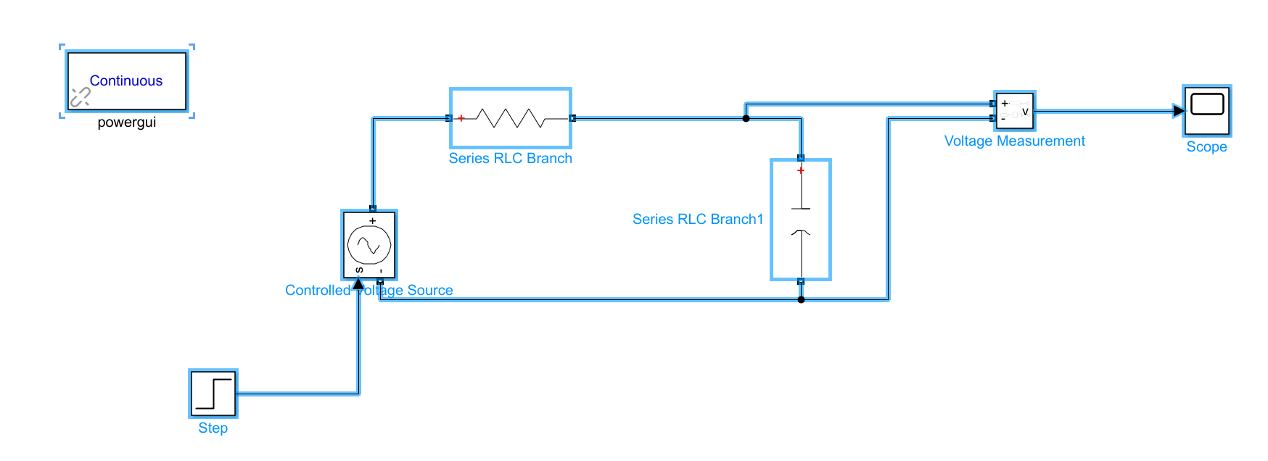

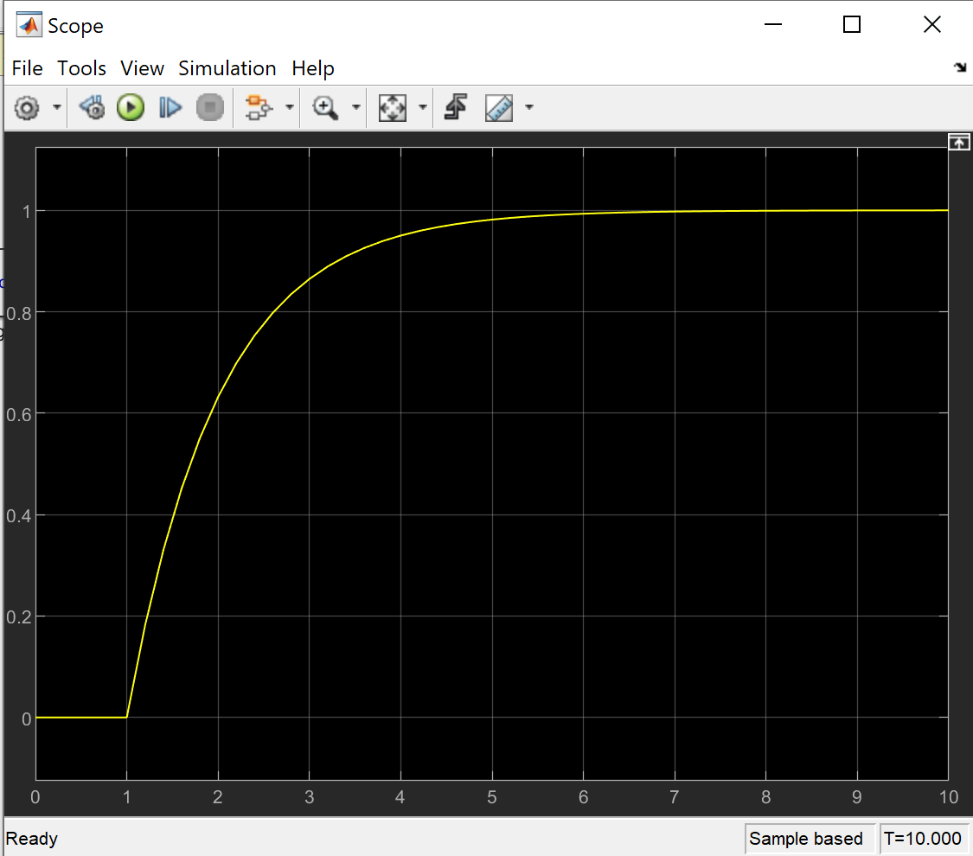

#### 3. Parallel RLC Circuit

**Objective:** Study the resonance frequency of a parallel RLC circuit.

**Steps:**

1. Define the values of R, L, and C.
2. Calculate the resonance frequency.
3. Plot the impedance vs. frequency.

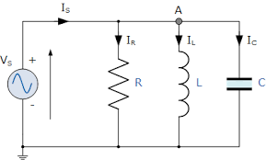

**Code:**

% Step 1: Define the values of R, L, and C

R = 10; % resistance in ohms

L = 1e-3; % inductance in henries

C = 1e-6; % capacitance in farads

% Step 2: Calculate the resonance frequency

f_res = 1 / (2 * pi * sqrt(L * C));

disp(['Resonance Frequency (Hz) = ', num2str(f_res)]);

% Step 3: Plot the impedance vs. frequency

f = linspace(0, 2*f_res, 1000);

Z = abs(R + 1./(1i*2*pi*f*C) + 1i*2*pi*f*L);

plot(f, Z);

xlabel('Frequency (Hz)');

ylabel('Impedance (Ohms)');

title('Impedance vs Frequency');

grid on;

This code above is for series RLC circuit so the below formula is used which is wrong

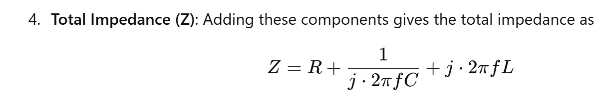

For parallel RLC Circuit:

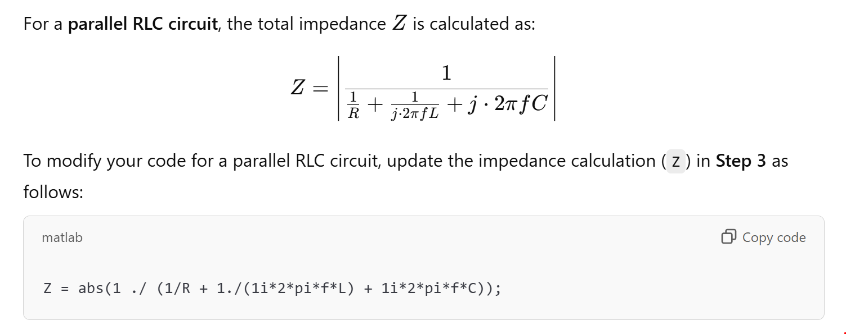

So the code will be:

% Step 1: Define the values of R, L, and C

R = 10; % resistance in ohms

L = 1e-3; % inductance in henries

C = 1e-6; % capacitance in farads

% Step 2: Calculate the resonance frequency

f_res = 1 / (2 * pi * sqrt(L * C));

disp(['Resonance Frequency (Hz) = ', num2str(f_res)]);

% Step 3: Plot the impedance vs. frequency for a parallel RLC circuit

f = linspace(0, 2*f_res, 1000);

Z = abs(1 ./ (1/R + 1./(1i*2*pi*f*L) + 1i*2*pi*f*C));

plot(f, Z);

xlabel('Frequency (Hz)');

ylabel('Impedance (Ohms)');

title('Impedance vs Frequency (Parallel RLC Circuit)');

grid on;

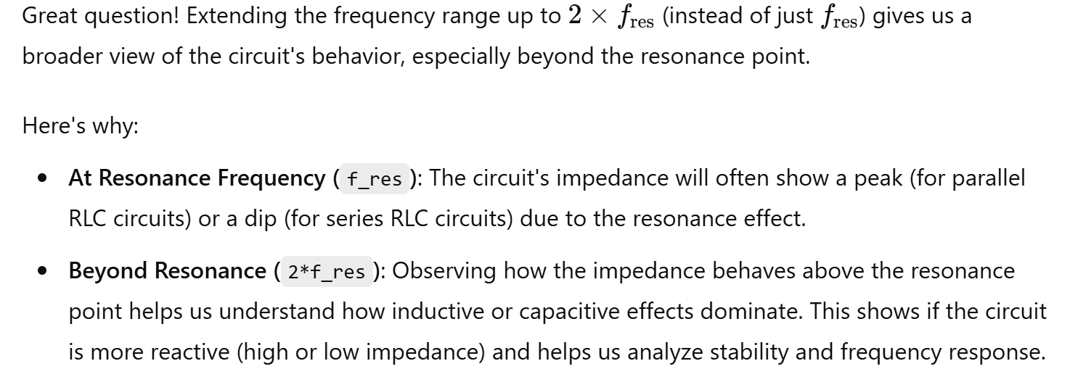

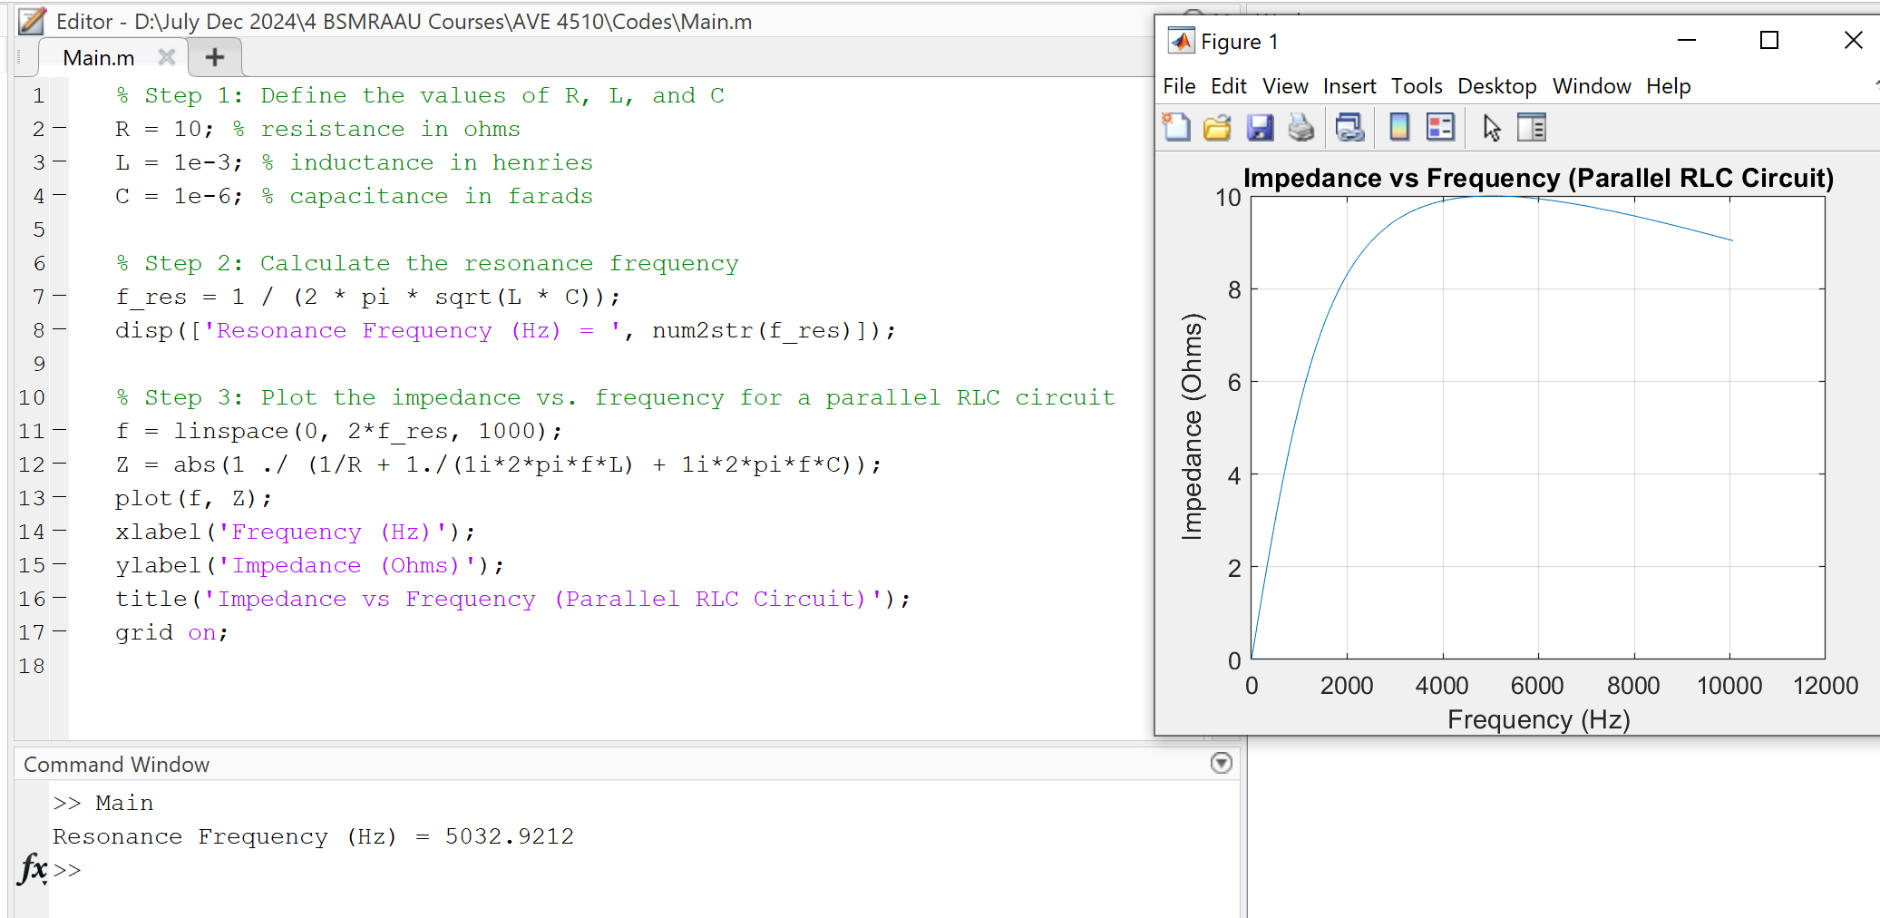

#### 4. Diode Characteristics

**Objective:** Plot the I-V characteristics of a diode.

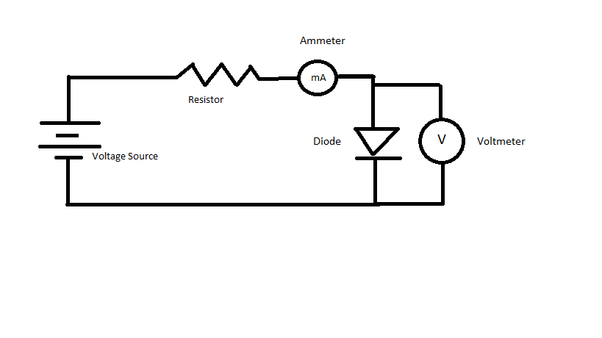

**Steps:**

1. Define the diode equation.
2. Plot the current vs. voltage.

**Code:**

% Step 1: Define the diode equation

Is = 1e-12; % saturation current in amperes

Vt = 0.025; % thermal voltage in volts

% Step 2: Plot the current vs. voltage

V = linspace(-0.7, 0.7, 1000);

I = Is * (exp(V/Vt) - 1);

plot(V, I);

xlabel('Voltage (V)');

ylabel('Current (I)');

title('I-V Characteristics of a Diode');

grid on;

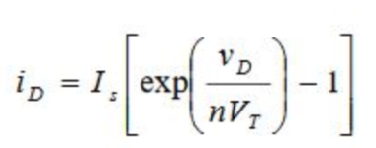

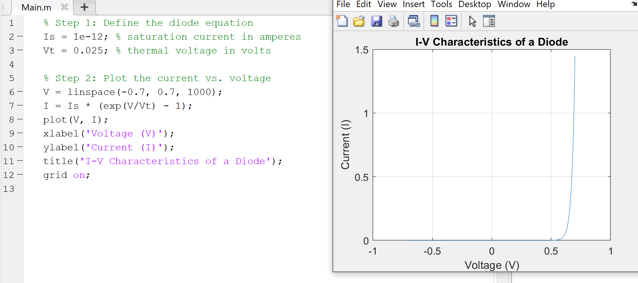

#### 5. Transistor as a Switch

**Objective:** Demonstrate the operation of a transistor in switch mode.

**Steps:**

1. Open Simulink and create a new model.
2. Add an NPN transistor, resistor, and DC voltage source.
3. Connect the components to form a switch circuit.
4. Run the simulation and observe the output.

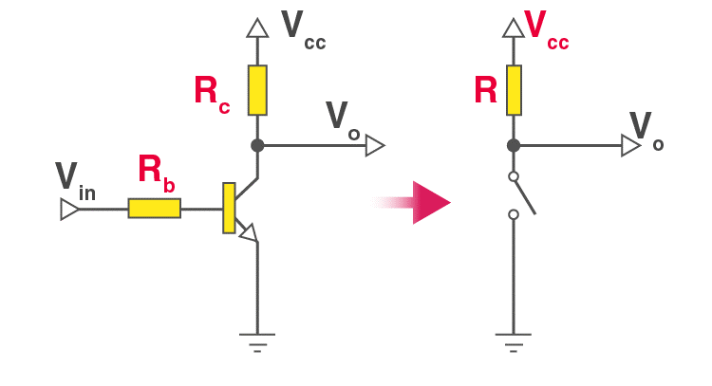

**Simulink Setup:**

1. Drag and drop an NPN Transistor, Resistor, DC Voltage Source, and Scope block.
2. Connect the transistor base to a pulse generator, the collector to the voltage source via a resistor, and the emitter to ground.
3. Connect the Scope to the collector-emitter voltage.
4. Configure the pulse generator to provide a switching signal.

**Steps:**

1. Set up the Simulink model as described.
2. Run the simulation.
3. Observe the collector-emitter voltage on the Scope.

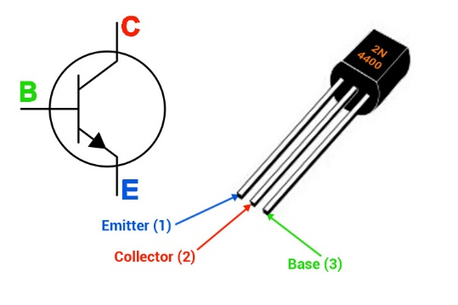

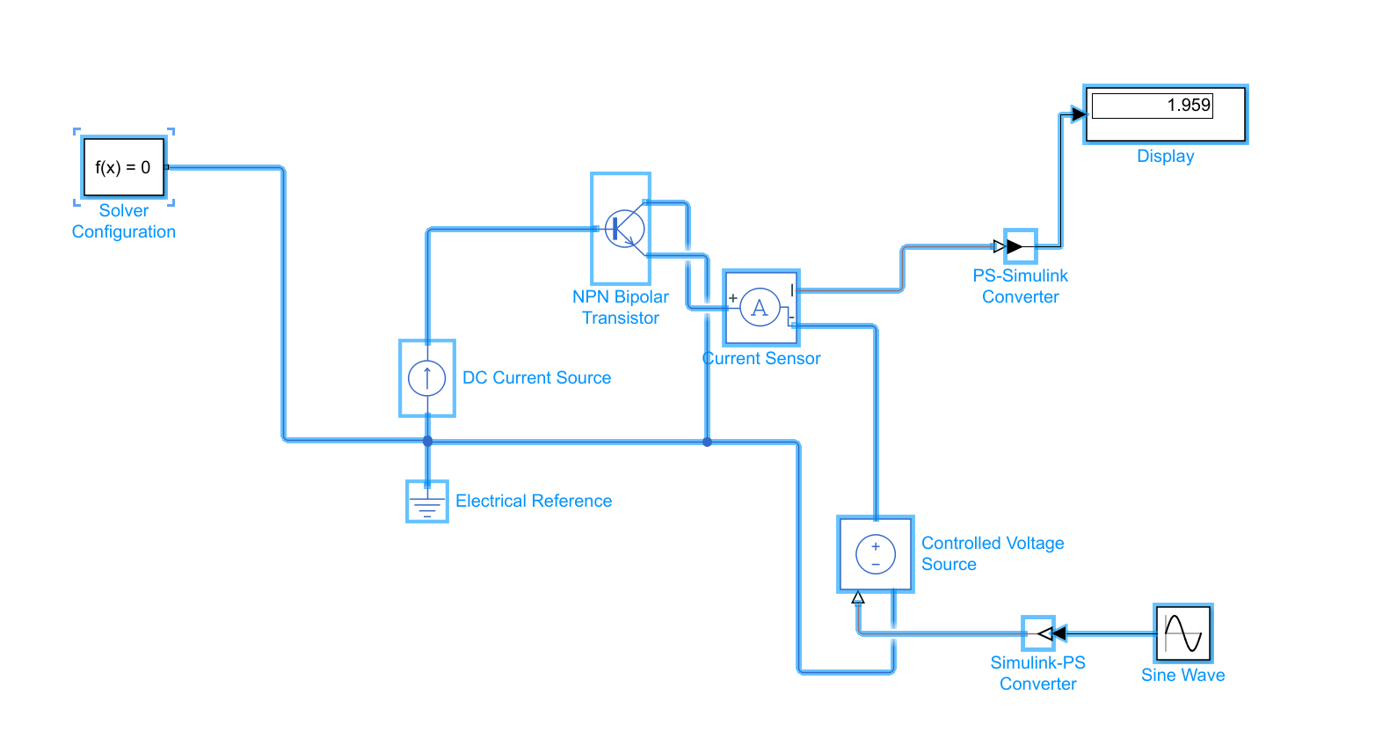

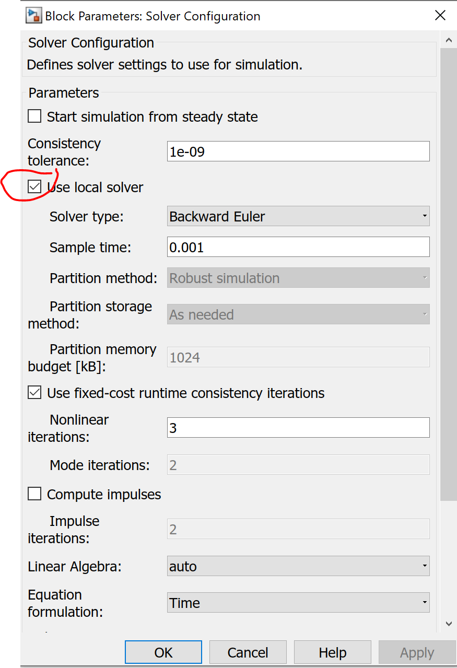

Must click Use local solver

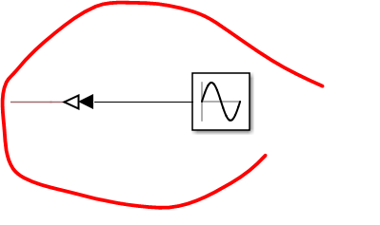

These portions are flipped with Ctrl + I

In the above we interfaced a NPN transistor. Now lets try the question given:

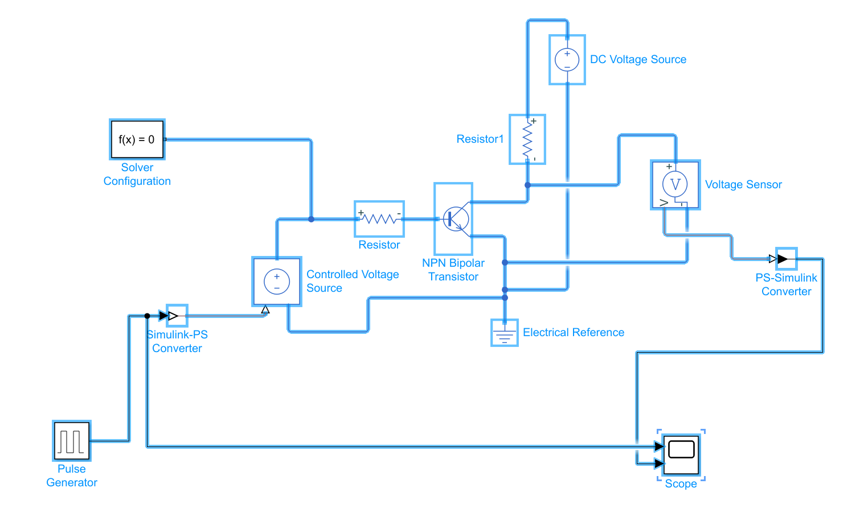

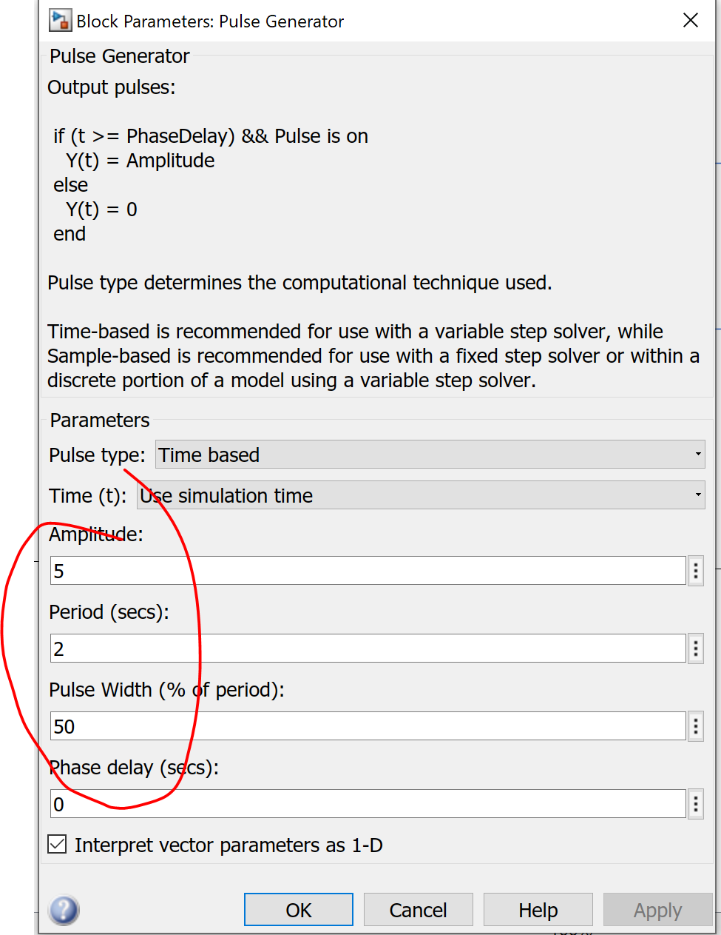

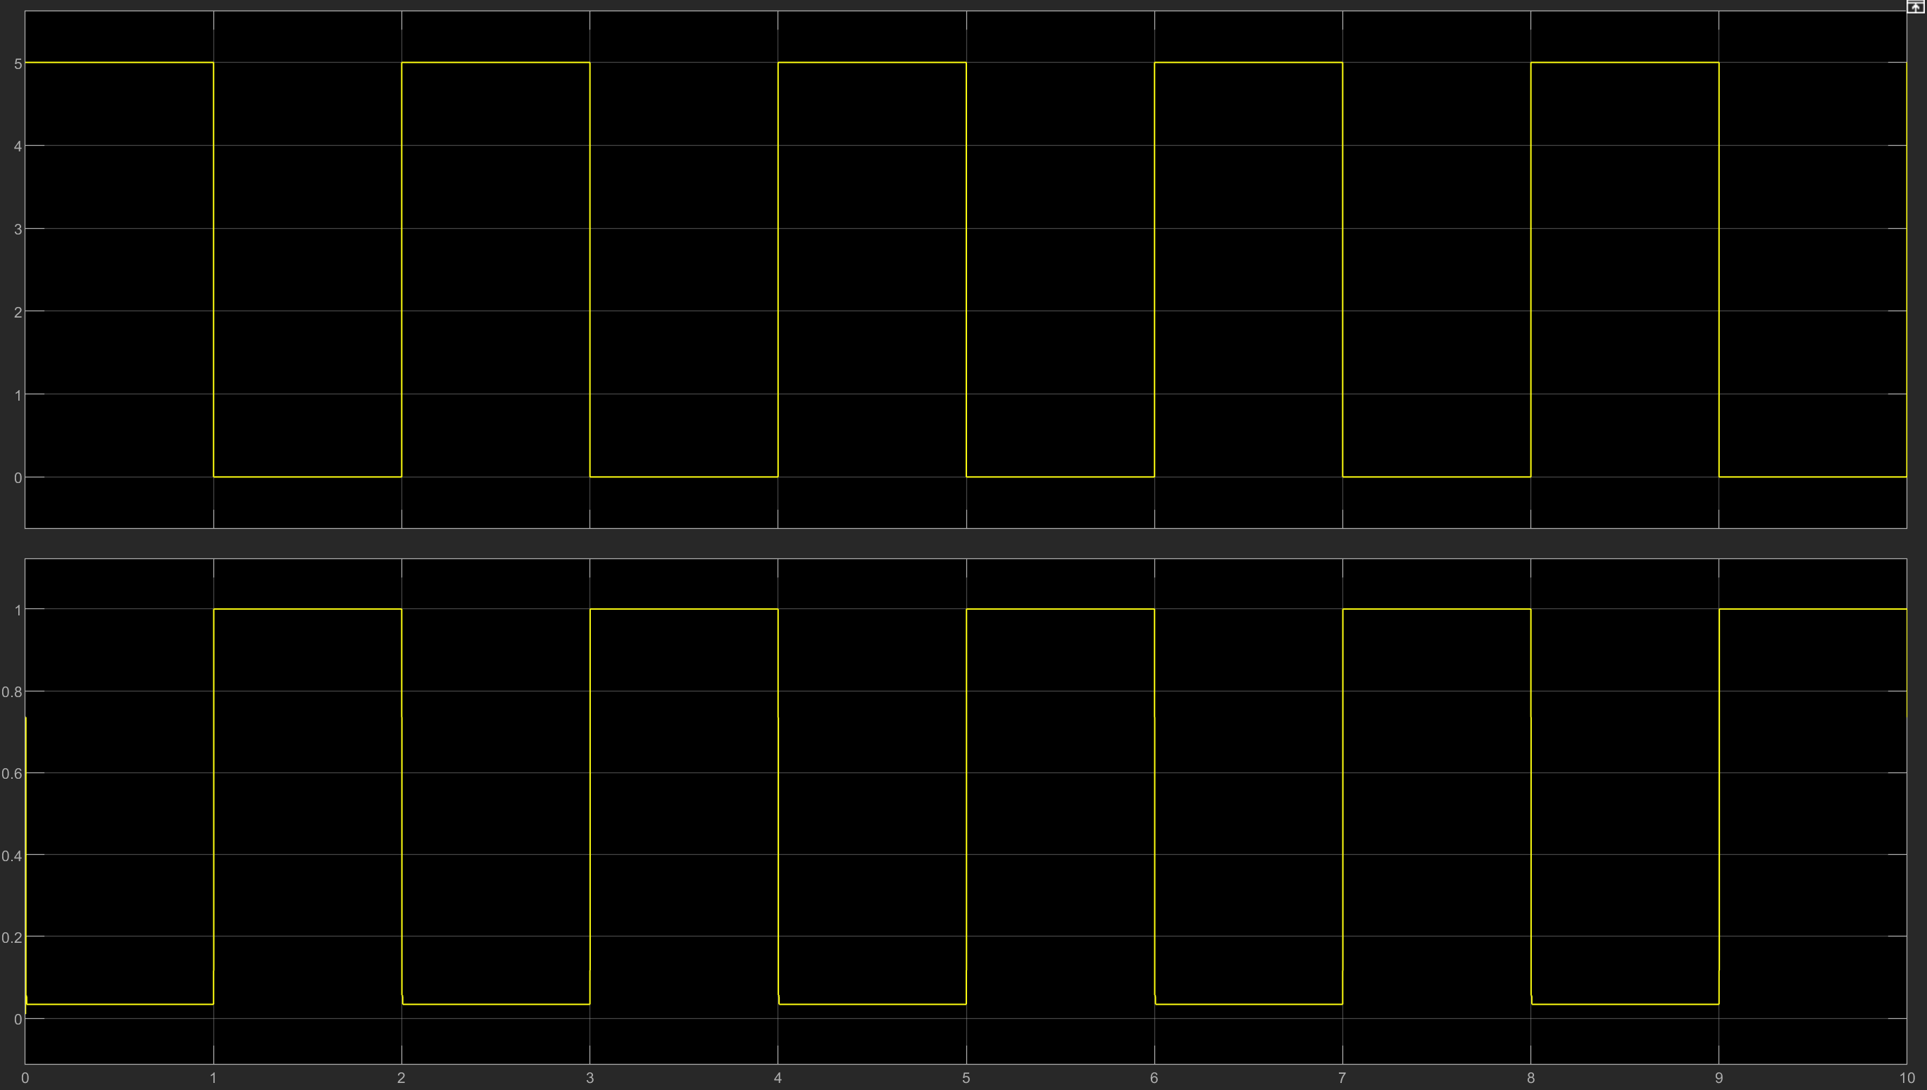

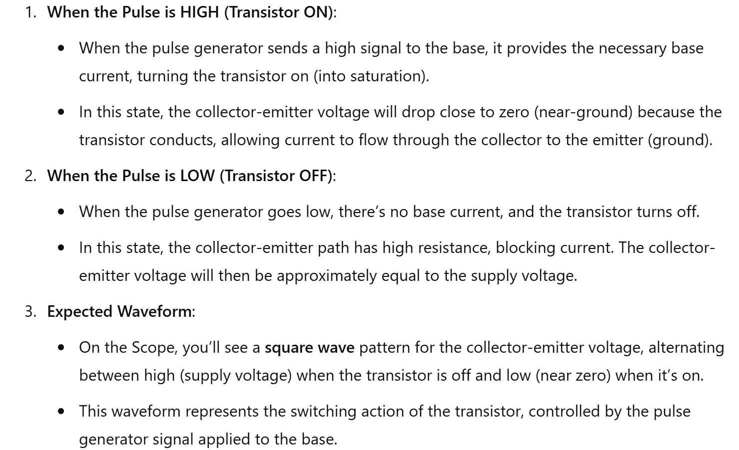

#### 6. Operational Amplifier (Op-Amp) as an Inverting Amplifier

**Objective:** Verify the inverting amplification using Op-Amp.

**Steps:**

1. Open Simulink and create a new model.
2. Add an Op-Amp, resistors, and DC voltage source.
3. Connect the components to form an inverting amplifier circuit.
4. Run the simulation and observe the output.

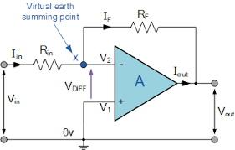

**Simulink Setup:**

1. Drag and drop an Op-Amp block, Resistors, and DC Voltage Source.
2. Connect the inverting input of the Op-Amp to the input signal via a resistor.
3. Connect the feedback resistor between the output and inverting input.
4. Ground the non-inverting input.
5. Connect a voltage source to the input and a Scope to the output.

**Steps:**

1. Set up the Simulink model as described.
2. Run the simulation.
3. Observe the output voltage on the Scope.

#### 7. Full-Wave Rectifier

**Objective:** Simulate a full-wave rectifier and analyze the output waveform.

**Steps:**

1. Open Simulink and create a new model.
2. Add diodes, resistors, and a sine wave generator.
3. Connect the components to form a full-wave rectifier circuit.
4. Run the simulation and observe the output.

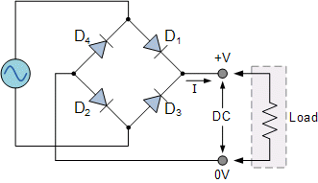

**Simulink Setup:**

1. Drag and drop Diodes, Resistors, Sine Wave Generator, and Scope block.
2. Connect the diodes in a bridge configuration.
3. Connect the load resistor to the bridge output.
4. Connect the Sine Wave Generator to the bridge input.
5. Connect a Scope to the output.

**Steps:**

1. Set up the Simulink model as described.
2. Run the simulation.
3. Observe the rectified output on the Scope.

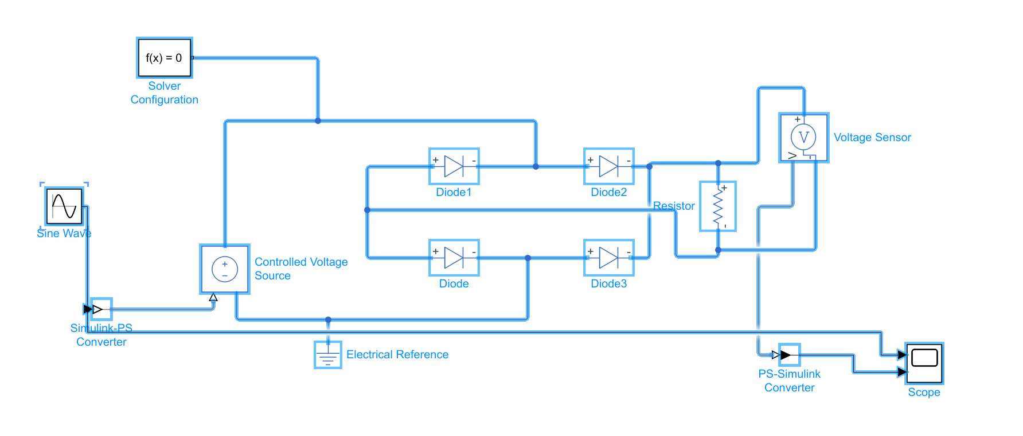

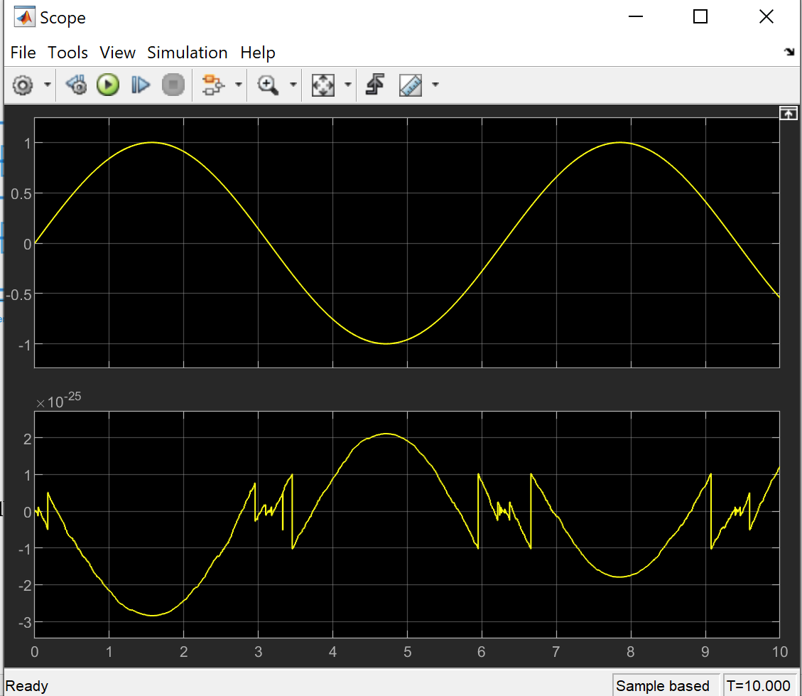

#### 8. RC Low-Pass Filter

**Objective:** Design and analyze the frequency response of an RC low-pass filter.

**Steps:**

1. Define the values of R and C.
2. Calculate the transfer function.
3. Plot the frequency response.

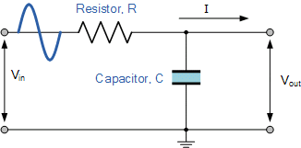

**Code:**

% Step 1: Define the values of R and C

R = 1e3; % resistance in ohms

C = 1e-6; % capacitance in farads

% Step 2: Calculate the transfer function

H = tf([1], [R*C 1]);

% Step 3: Plot the frequency response

bode(H);

title('Frequency Response of RC Low-Pass Filter');

grid on;

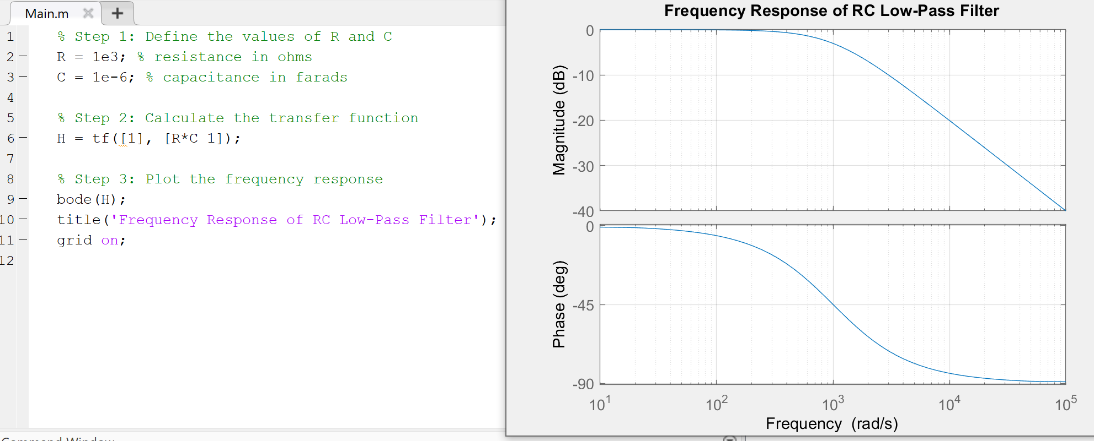

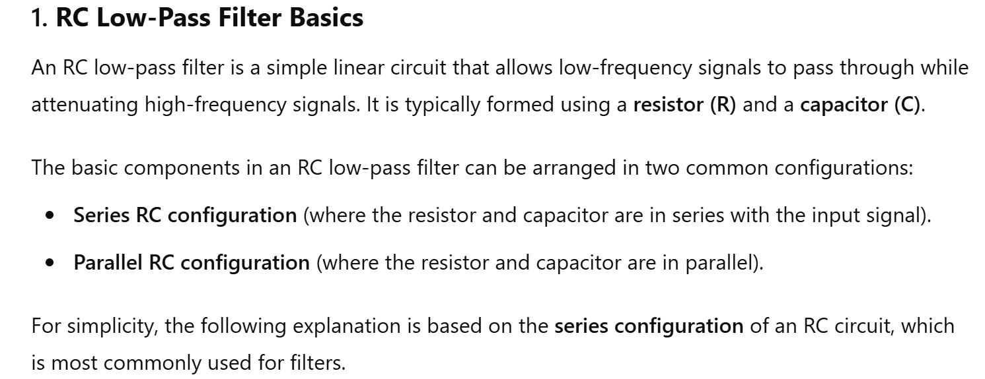

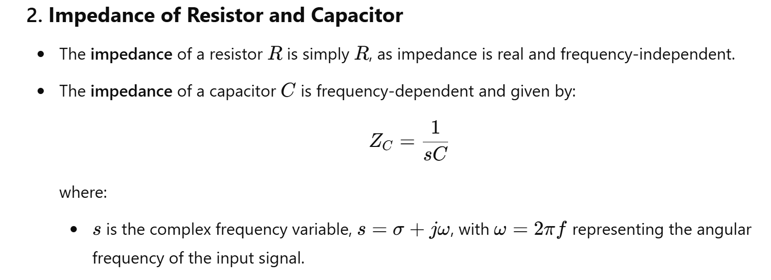

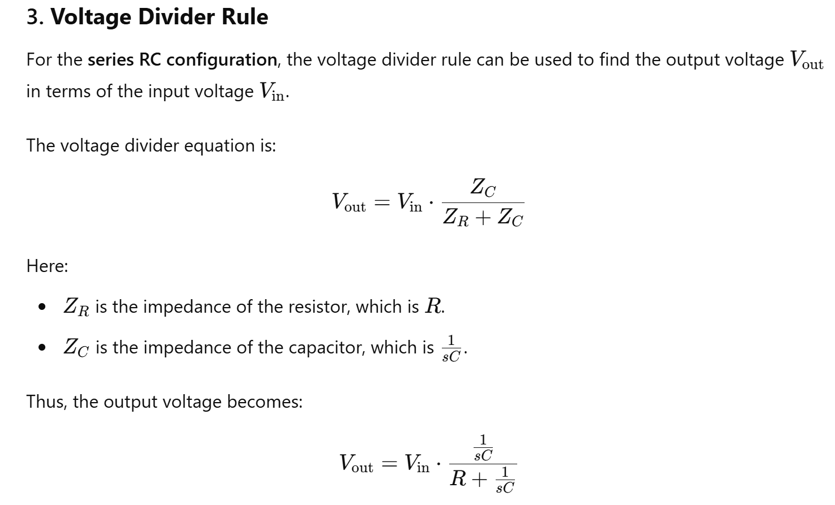

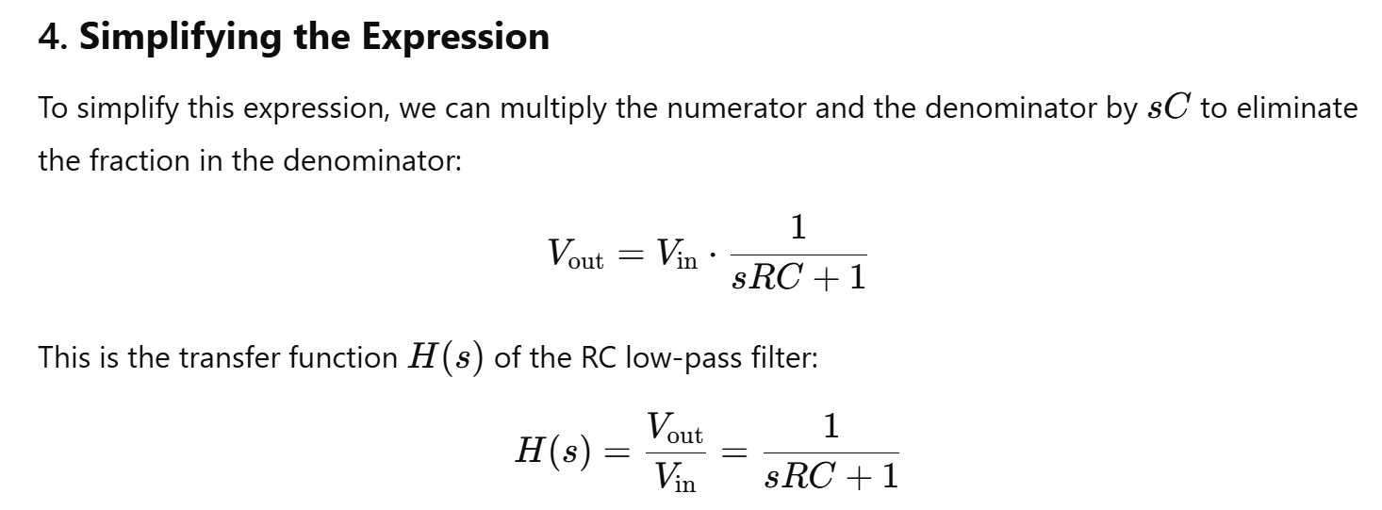

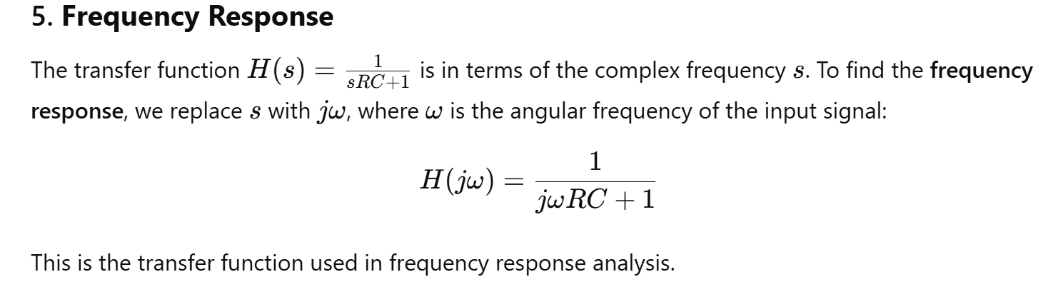

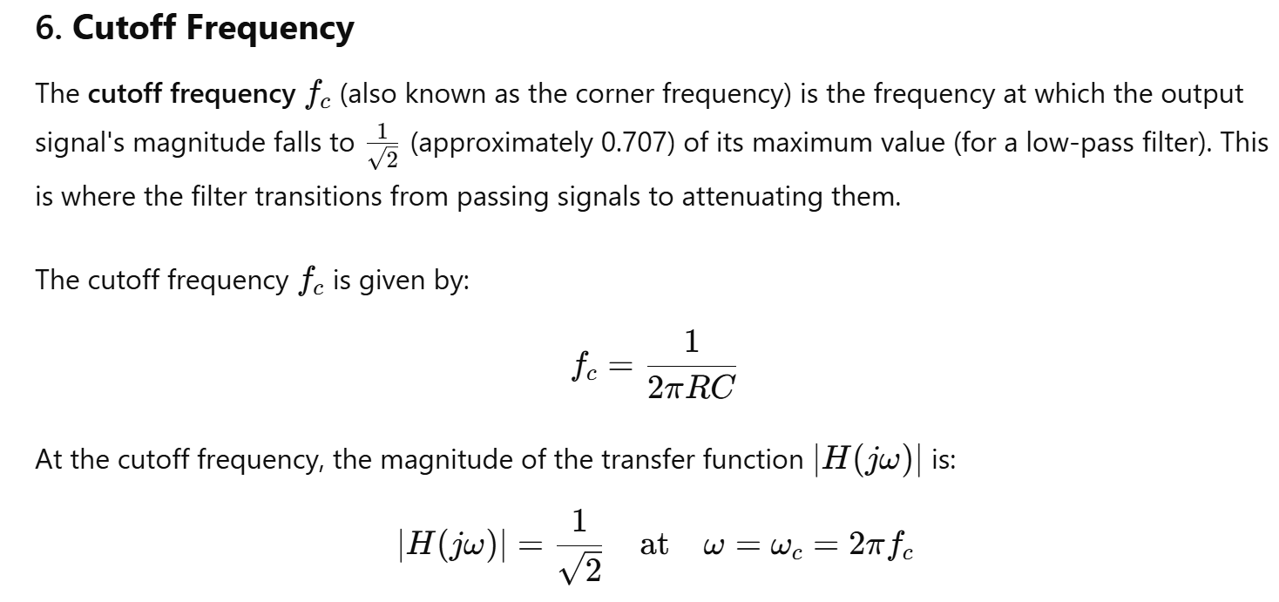

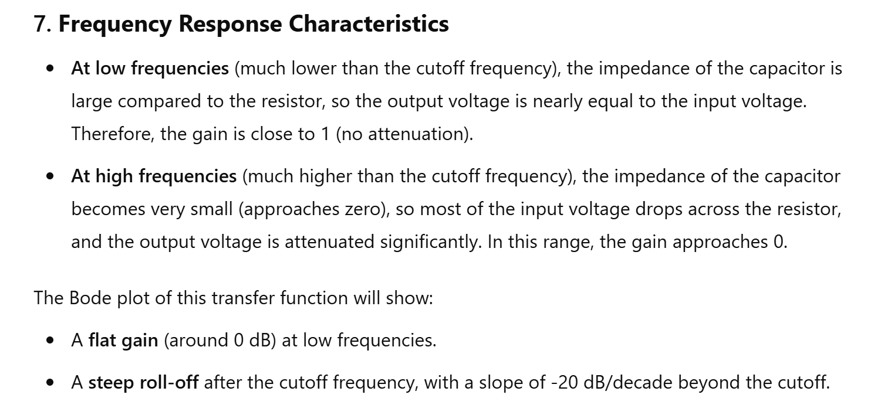

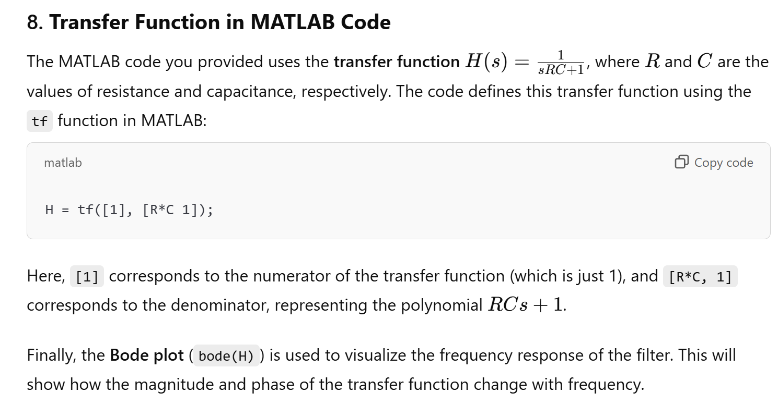

#### 9. RL High-Pass Filter

**Objective:** Design and analyze the frequency response of an RL high-pass filter.

**Steps:**

1. Define the values of R and L.
2. Calculate the transfer function.
3. Plot the frequency response.

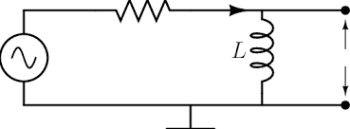

**Code:**

% Step 1: Define the values of R and L

R = 1e3; % resistance in ohms

L = 1e-3; % inductance in henries

% Step 2: Calculate the transfer function

H = tf([L 0], [L R]);

% Step 3: Plot the frequency response

bode(H);

title('Frequency Response of RL High-Pass Filter');

grid on;

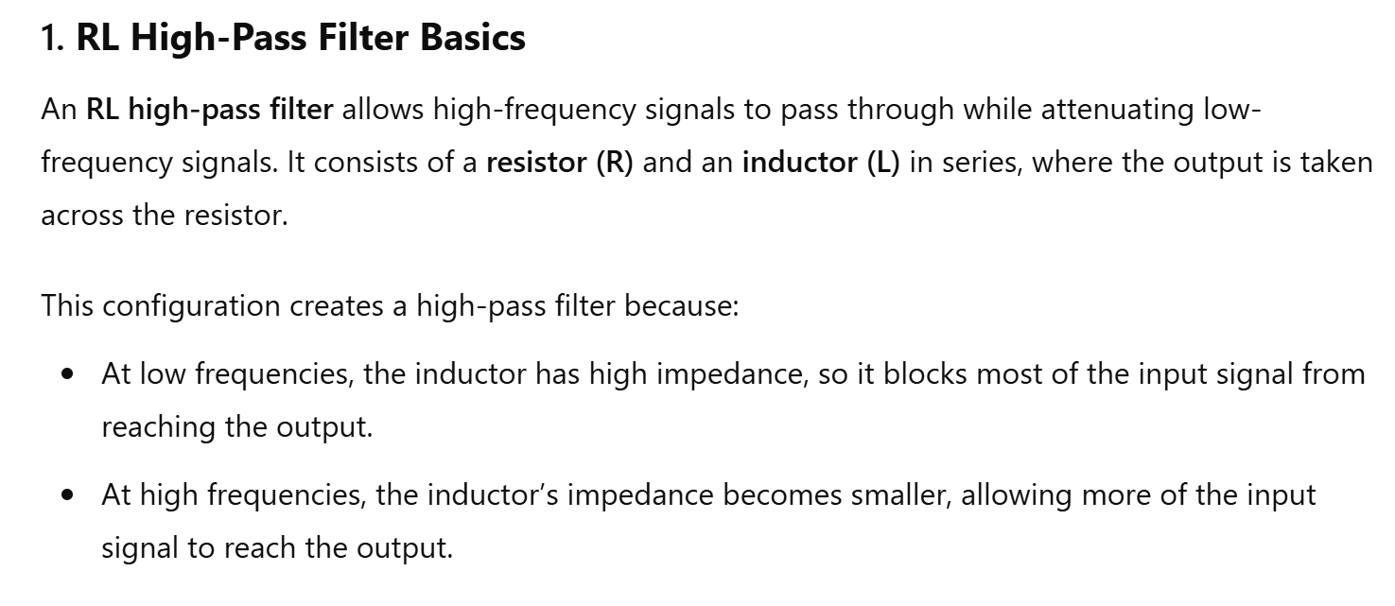

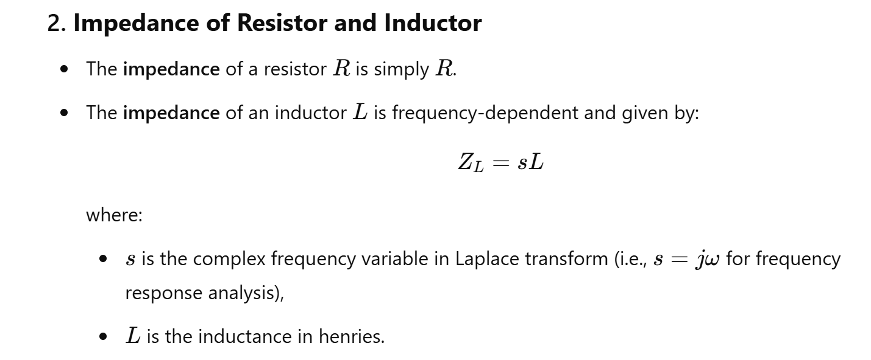

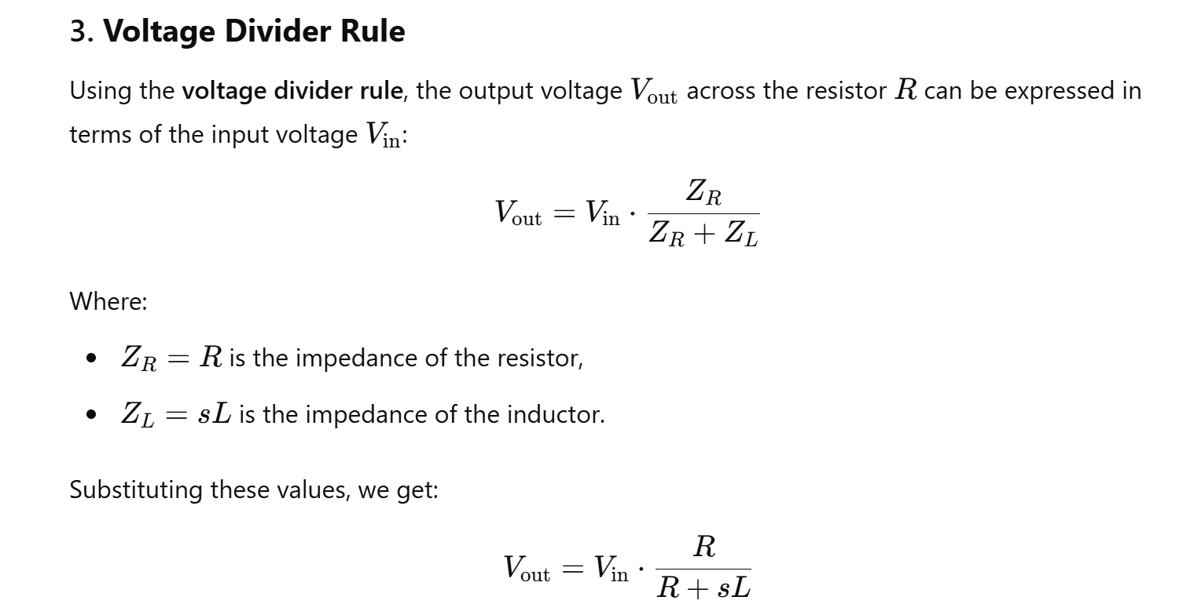

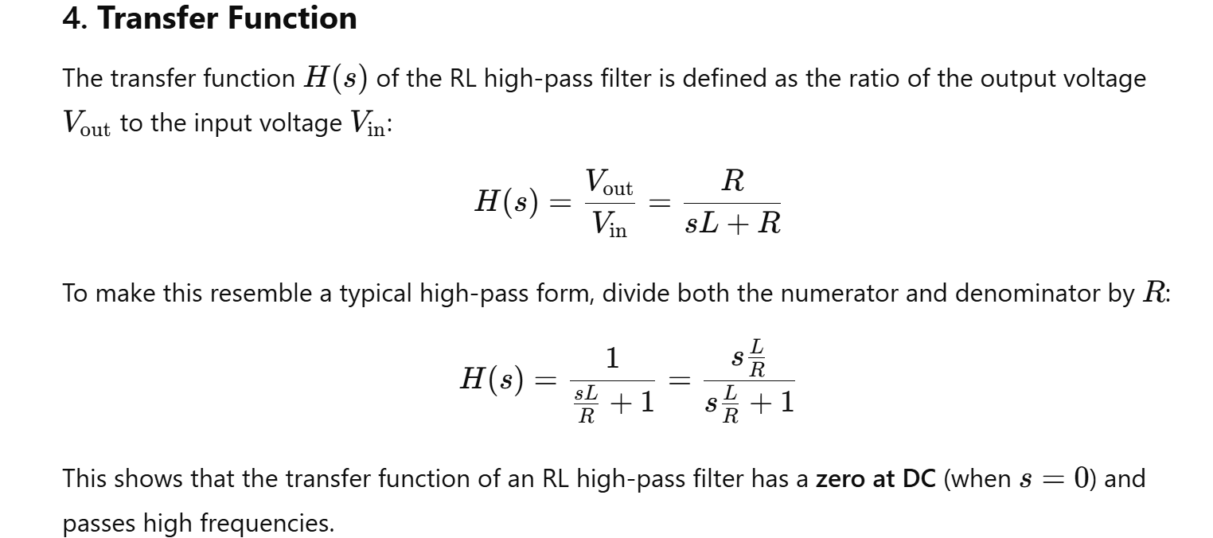

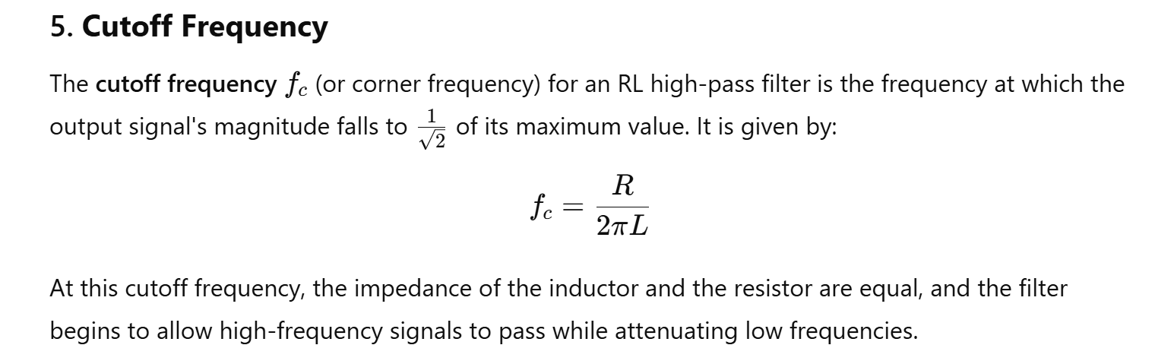

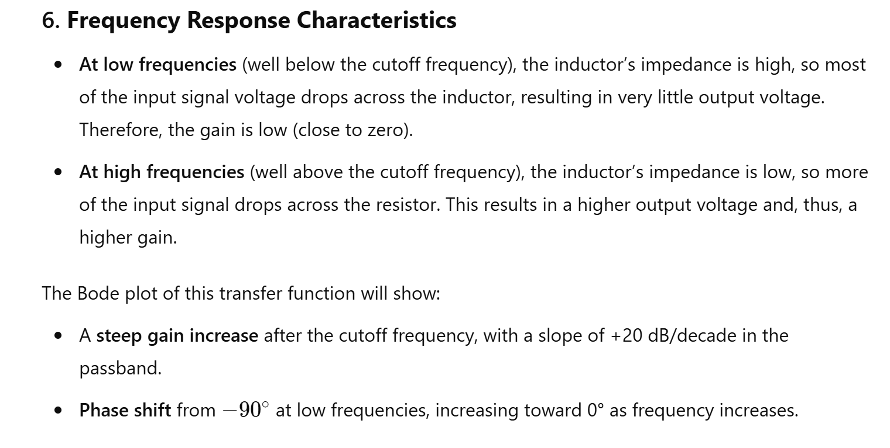

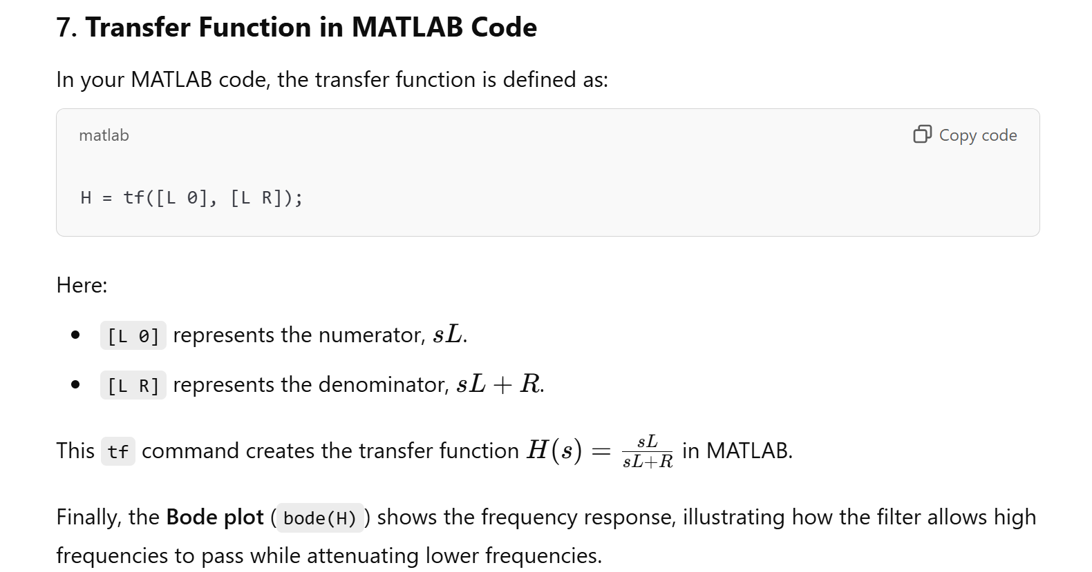

#### 10. BJT Amplifier

**Objective:** Simulate the frequency response of a BJT amplifier.

**Steps:**

1. Open Simulink and create a new model.
2. Add a BJT transistor, resistors, capacitors, and a sine wave generator.
3. Connect the components to form a common-emitter amplifier circuit.
4. Run the simulation and observe the output.

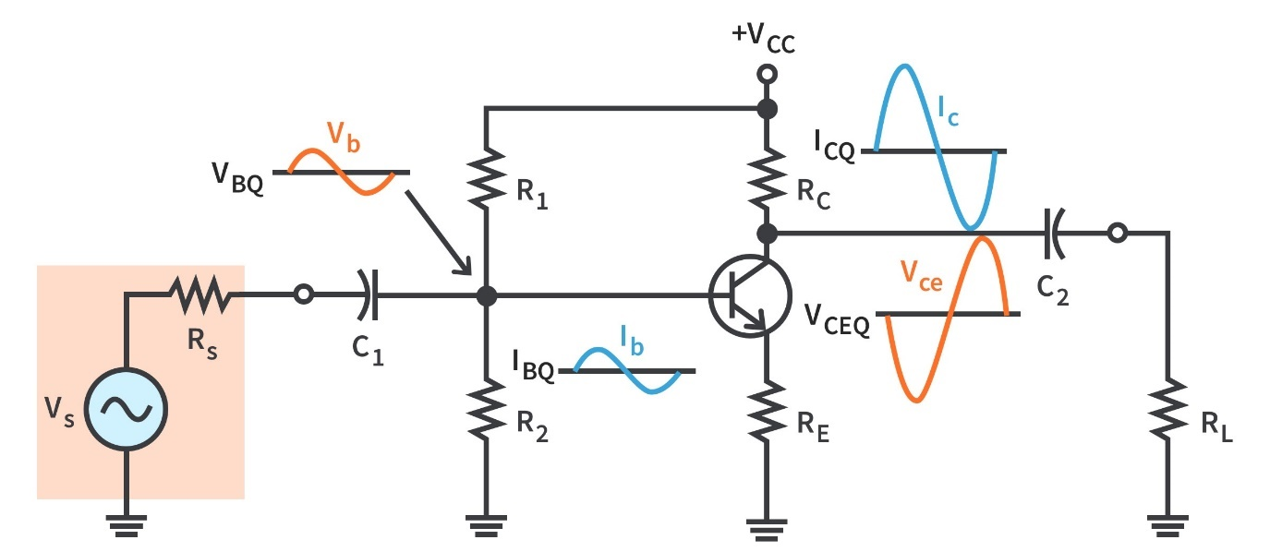

**Simulink Setup:**

1. Drag and drop a BJT Transistor, Resistors, Capacitors, Sine Wave Generator, and Scope block.
2. Connect the BJT in a common-emitter configuration.
3. Add a bypass capacitor and load resistor to the collector.
4. Connect the Sine Wave Generator to the base through a coupling capacitor.
5. Connect a Scope to the output.

**Steps:**

1. Set up the Simulink model as described.
2. Run the simulation.
3. Observe the amplifier output on the Scope.

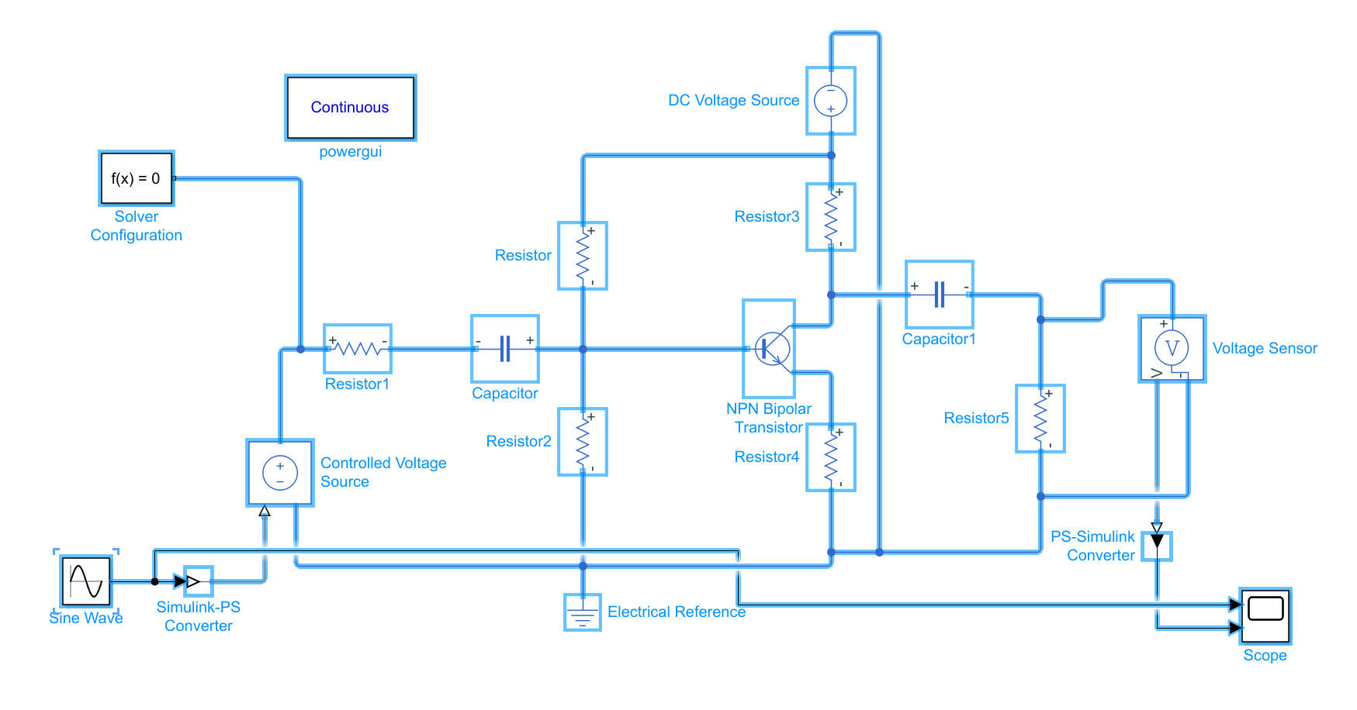

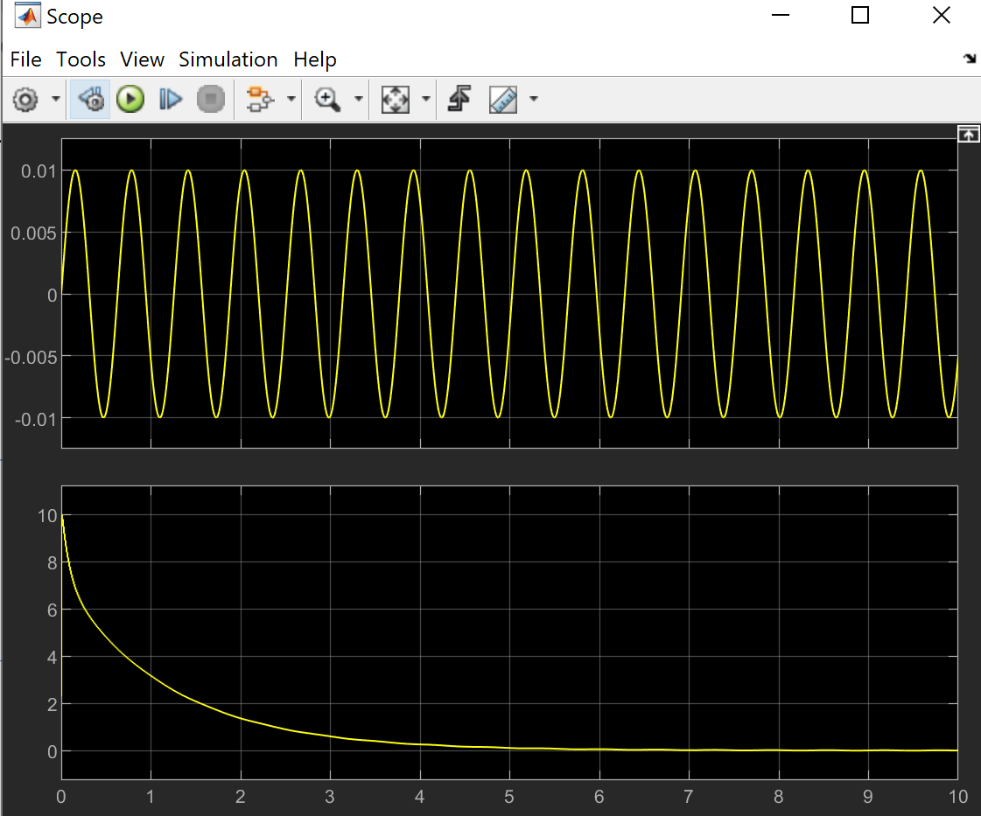

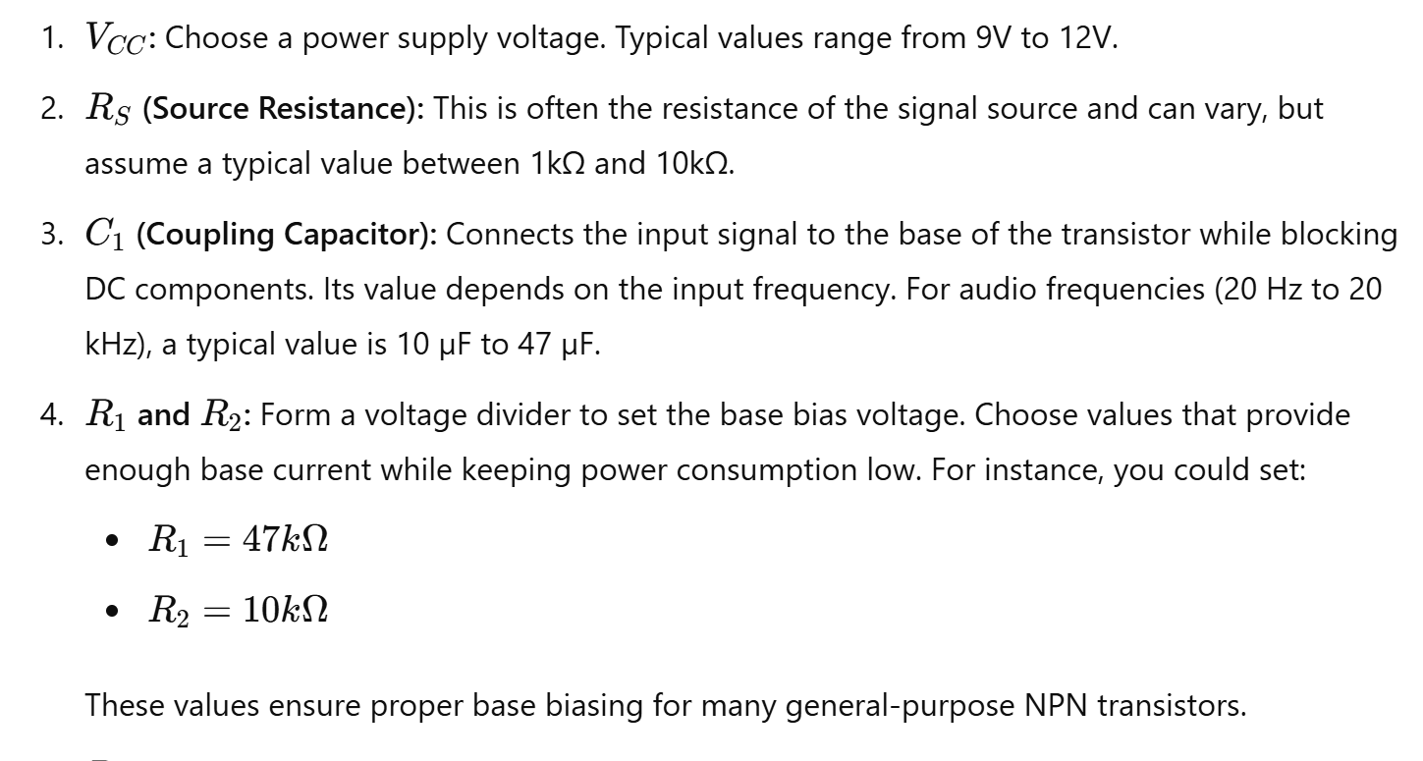

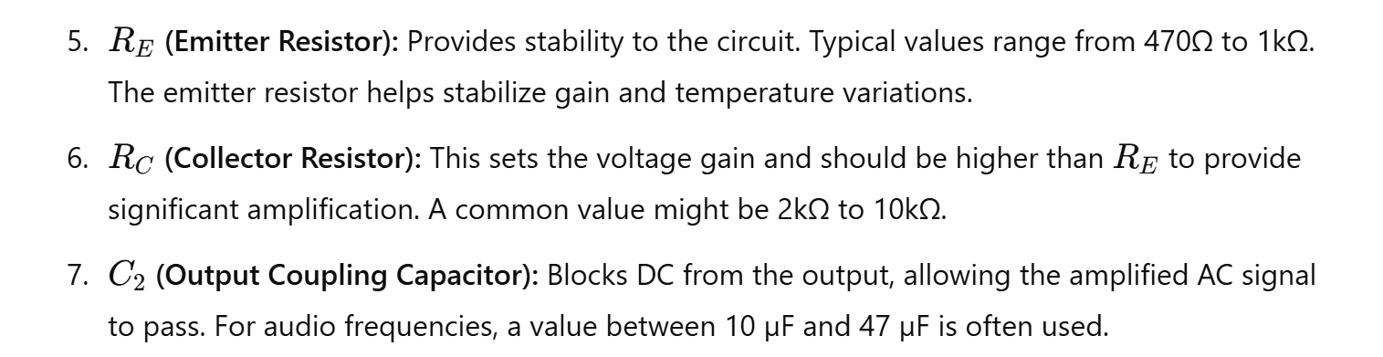

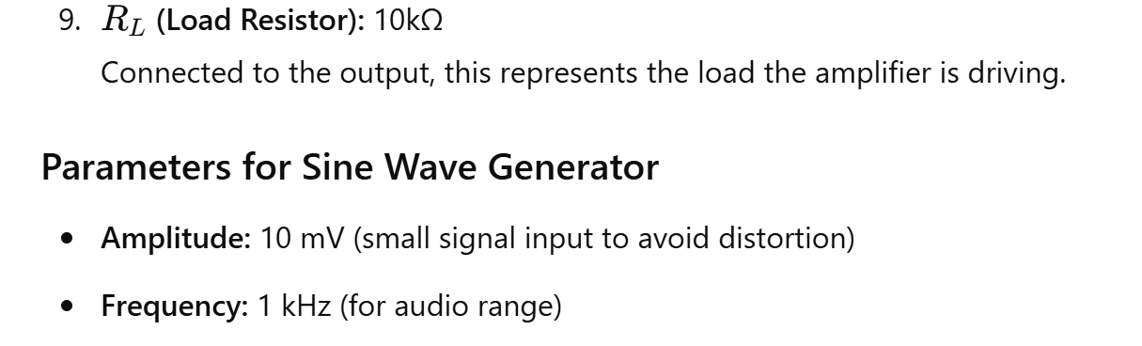

1. Ohm's Law

Theory: Ohm's Law states that the current through a conductor between two points is directly proportional to the voltage across the two points.



MATLAB Code:

% Ohm's Law: V = I * R

R = 10; % resistance in ohms

I = 2; % current in amperes

V = I * R; % voltage in volts

disp(['Voltage: ', num2str(V), ' V']);

2. Kirchhoff's Voltage Law (KVL)

Theory: The sum of all electrical voltages around a loop is zero.

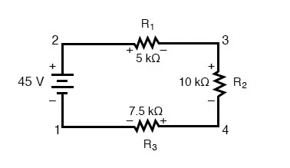

MATLAB Code:

% Kirchhoff's Voltage Law example

V1 = 5; % Voltage source 1 in volts

V2 = 10; % Voltage source 2 in volts

V3 = -3; % Voltage drop in volts

total_voltage = V1 + V2 + V3; % Should be zero in a closed loop

disp(['Total Voltage: ', num2str(total_voltage), ' V']);

3. Series RLC Circuit Response

Theory: Analyze the response of a series RLC circuit to a step input.

MATLAB Code:

% RLC Circuit Response

R = 5; % Resistance in ohms

L = 1e-3; % Inductance in henrys

C = 100e-6; % Capacitance in farads

sys = tf([1], [L*C R*C 1]);

step(sys);

title('Series RLC Circuit Step Response');

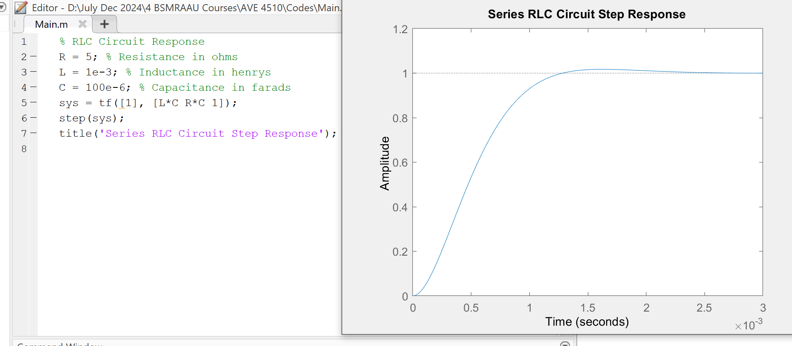

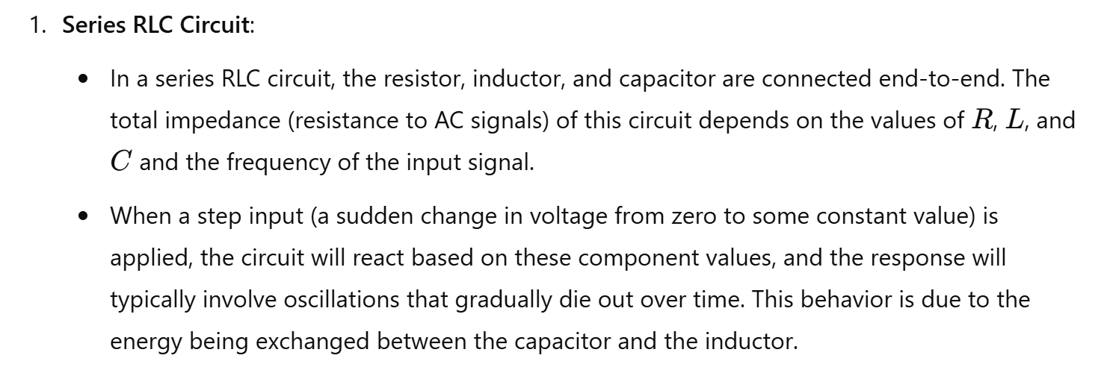

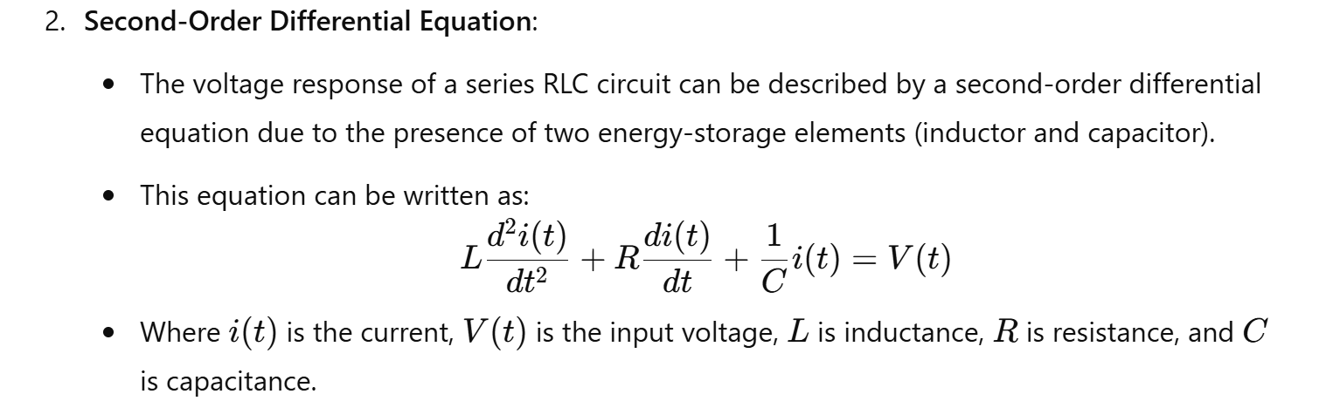

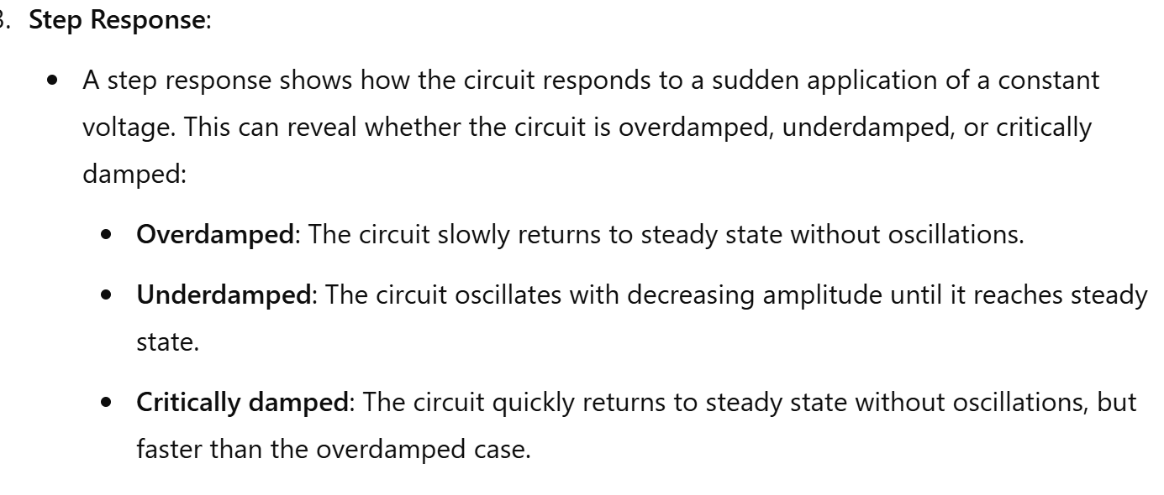

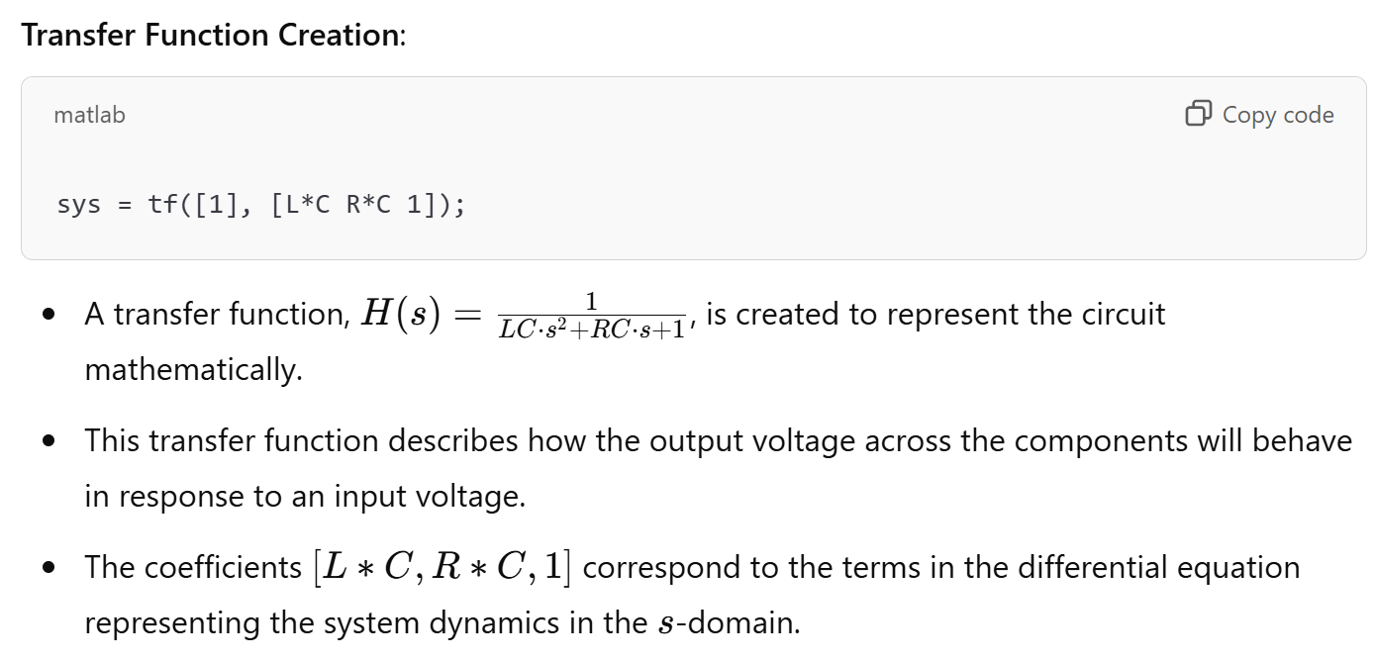

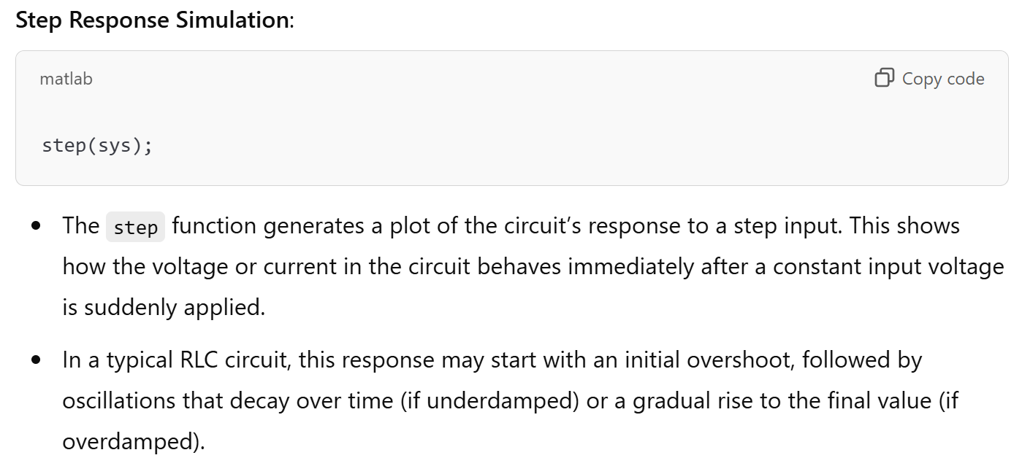



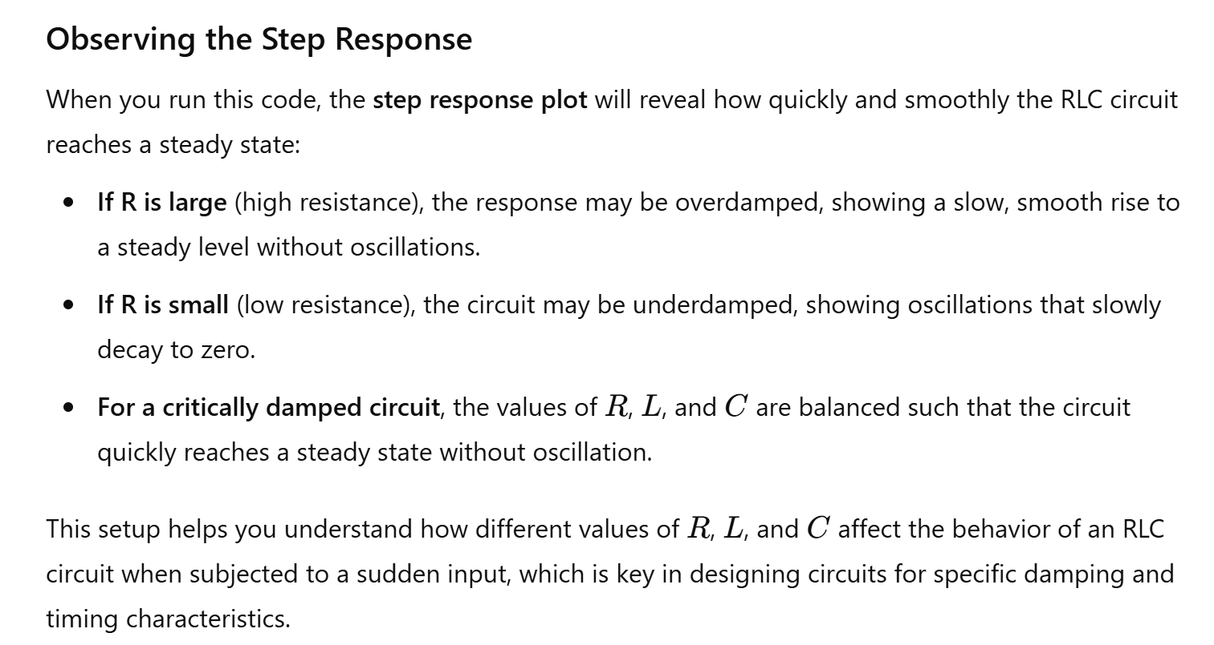

4. Fourier Transform

**Fourier Transform** is a mathematical model which helps to transform the signals between two different domains, such as transforming signal from frequency domain to time domain or vice versa. Fourier transform has many applications in Engineering and Physics, such as signal processing, RADAR, and so on. In this article, we are going to discuss the formula of Fourier transform, properties, tables, Fourier cosine transform, Fourier sine transform with complete explanations.

**What is Fourier Transform?**

The generalisation of the complex Fourier series is known as the Fourier transform. The term “Fourier transform” can be used in the mathematical function, and it is also used in the representation of the frequency domain. The Fourier transform helps to extend the Fourier series to the non-periodic functions, which helps us to view any functions in terms of the sum of simple sinusoids.

MATLAB Code:

% Fourier Transform of a sine wave

Fs = 1000; % Sampling frequency

t = 0:1/Fs:1-1/Fs;

f = 5; % Frequency of sine wave

x = sin(2*pi*f*t);

X = fft(x);

n = length(x);

f = (0:n-1)*(Fs/n); % Frequency range

magnitude = abs(X);

plot(f,magnitude);

title('Fourier Transform');

xlabel('Frequency (Hz)');

ylabel('Magnitude');

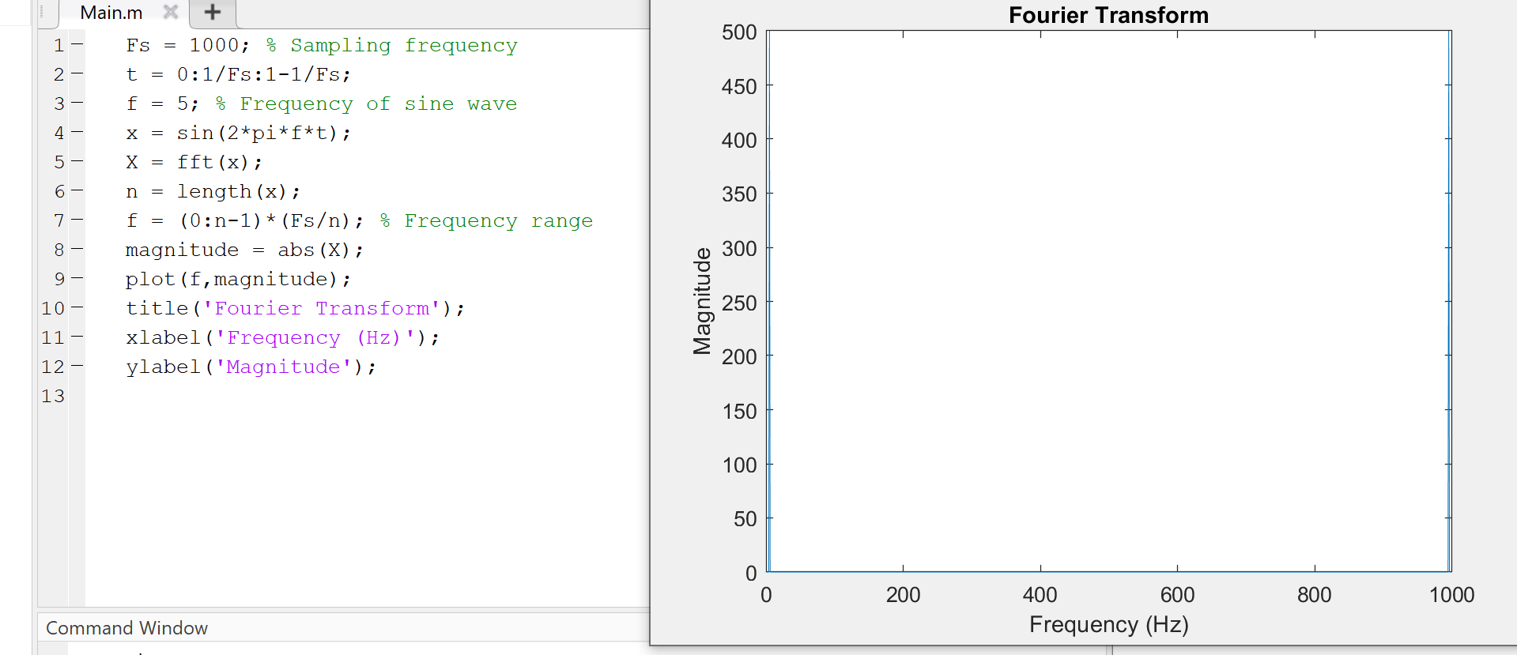

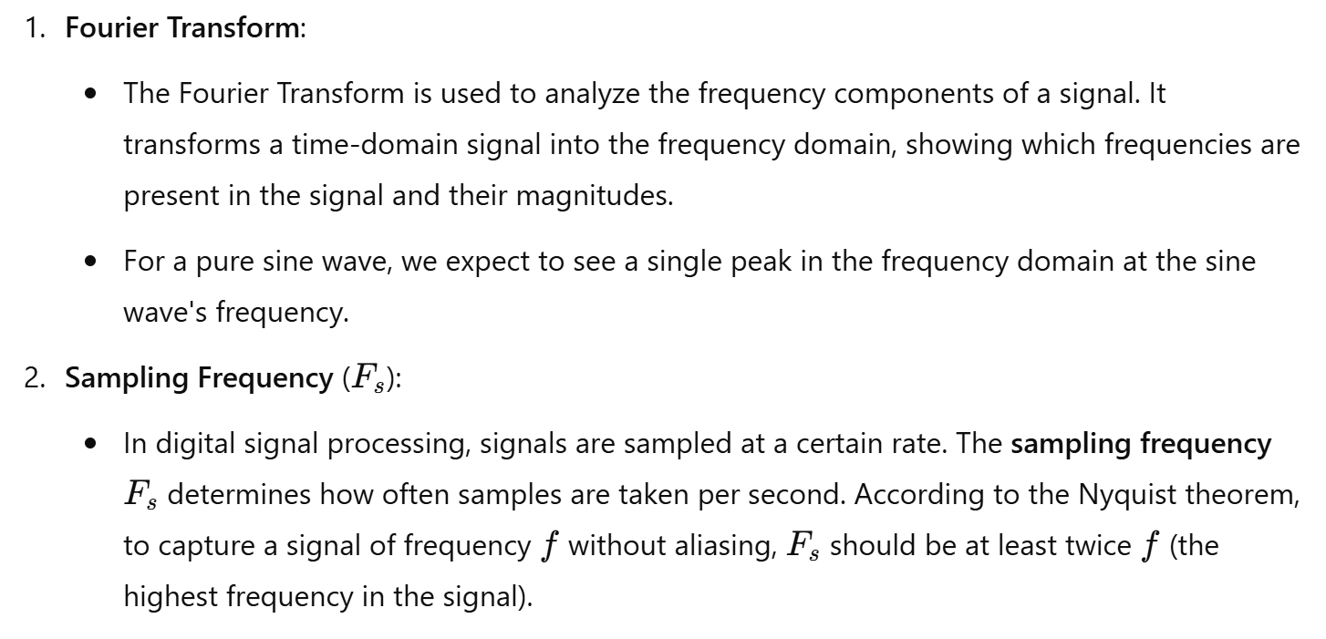

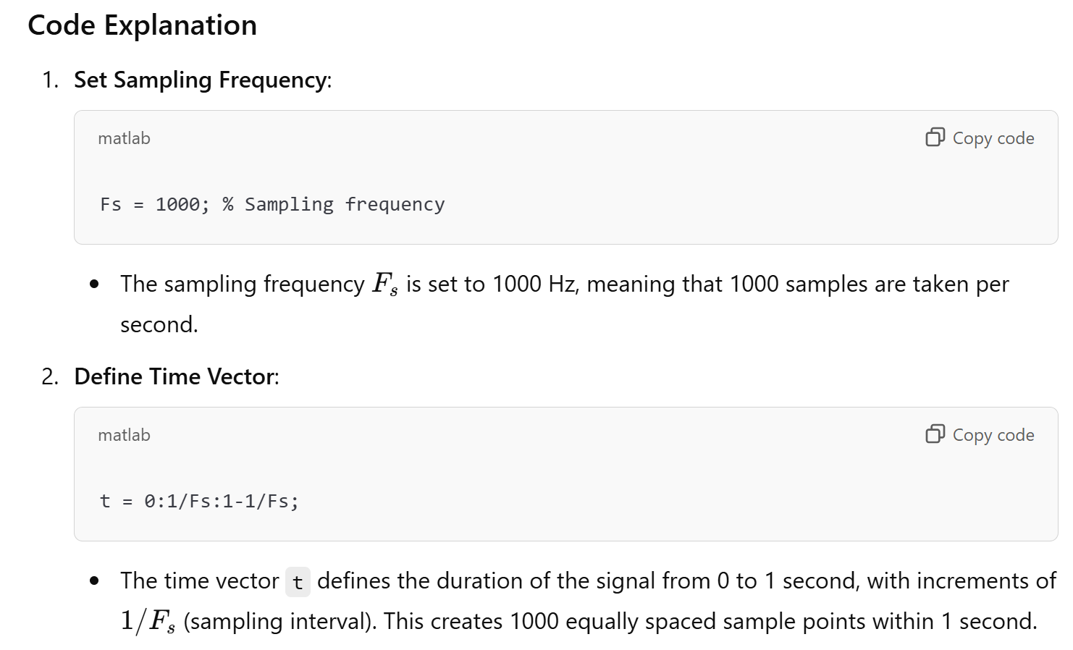

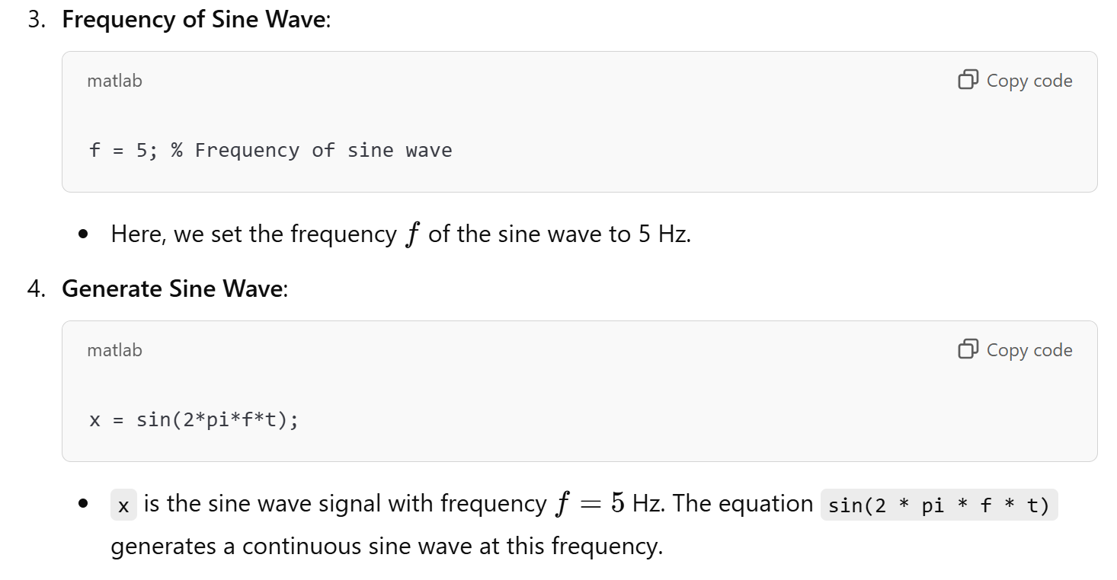

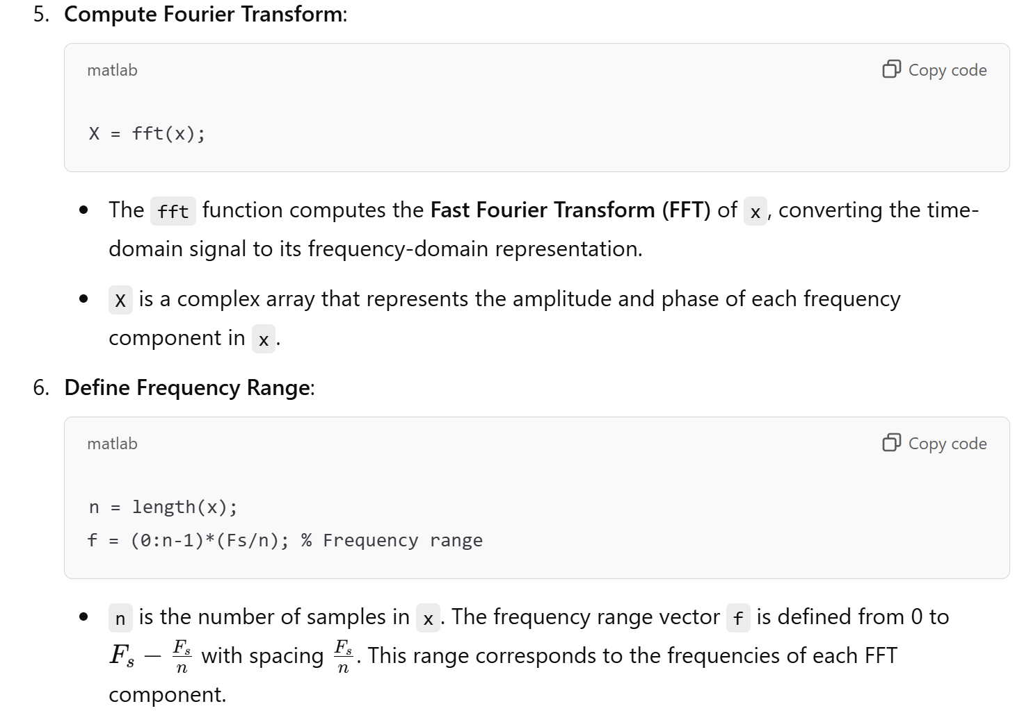

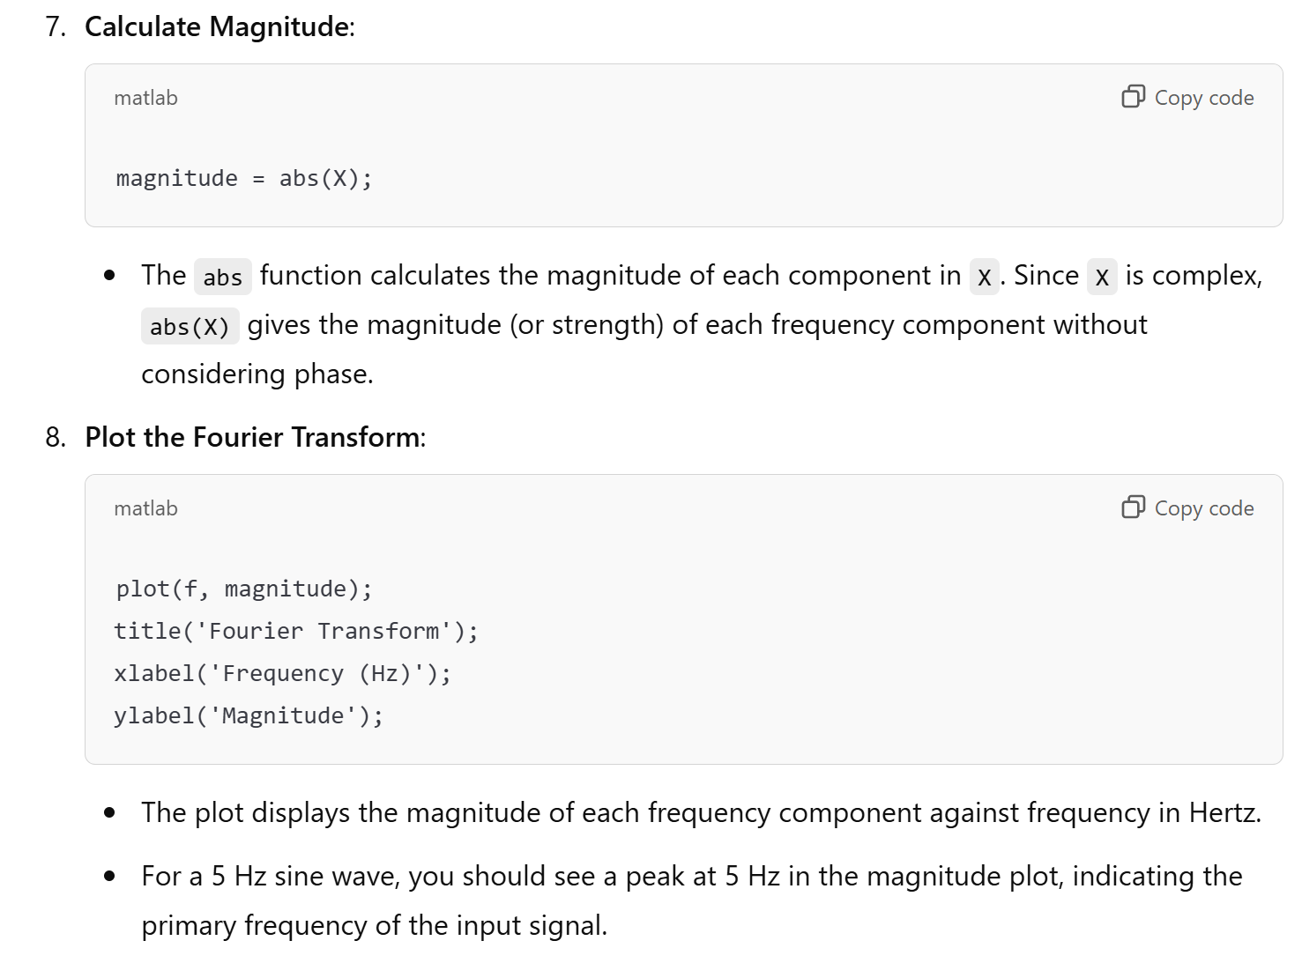

5. RC Low Pass Filter

Theory: An RC low-pass filter allows signals with a frequency lower than a certain cutoff frequency to pass through.



MATLAB Code:

% RC Low Pass Filter

R = 1e3; % Resistance in ohms

C = 1e-6; % Capacitance in farads

fc = 1/(2*pi*R*C); % Cutoff frequency

sys = tf([1], [R*C 1]);

bode(sys);

title('RC Low Pass Filter');

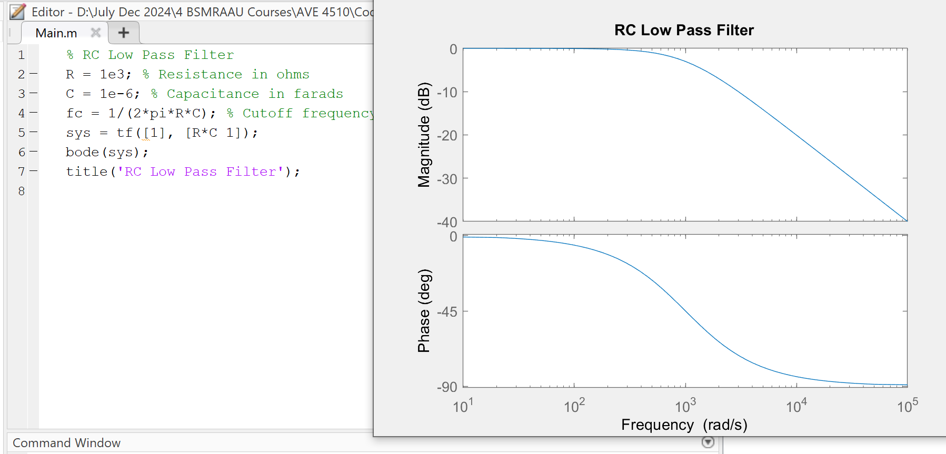

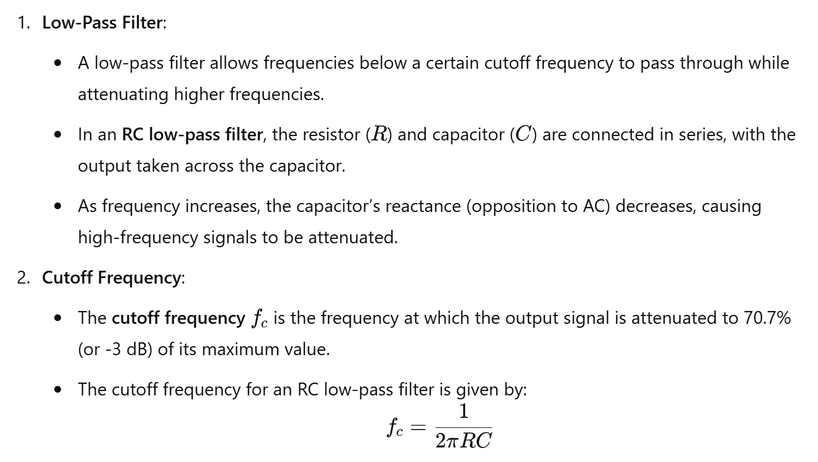

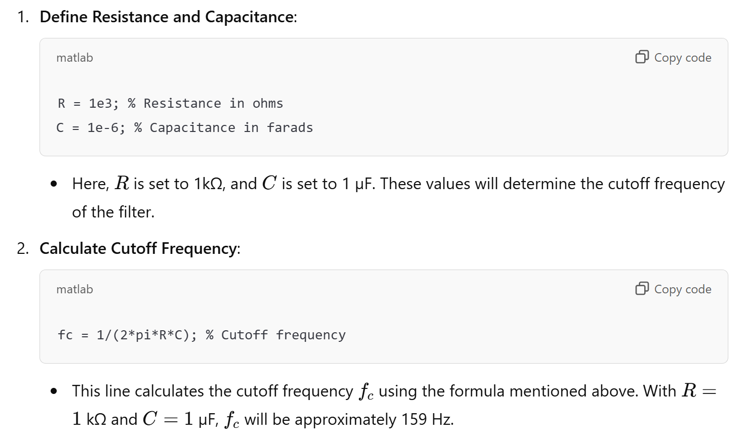

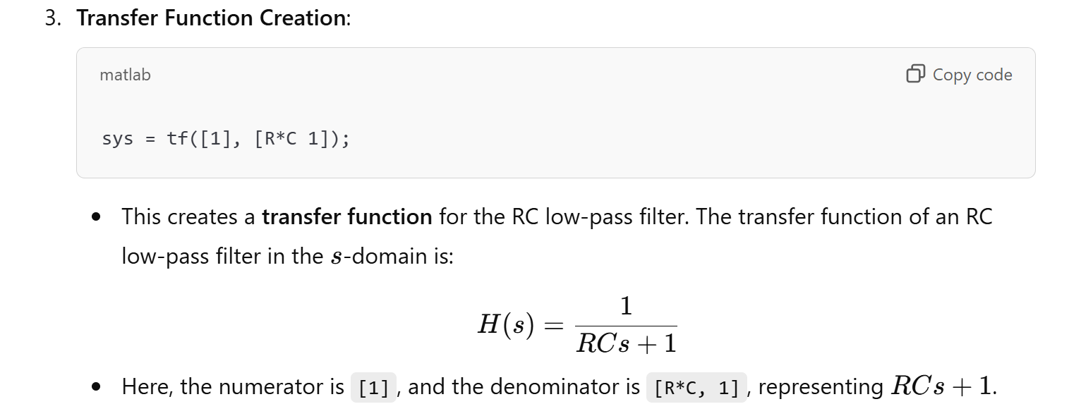

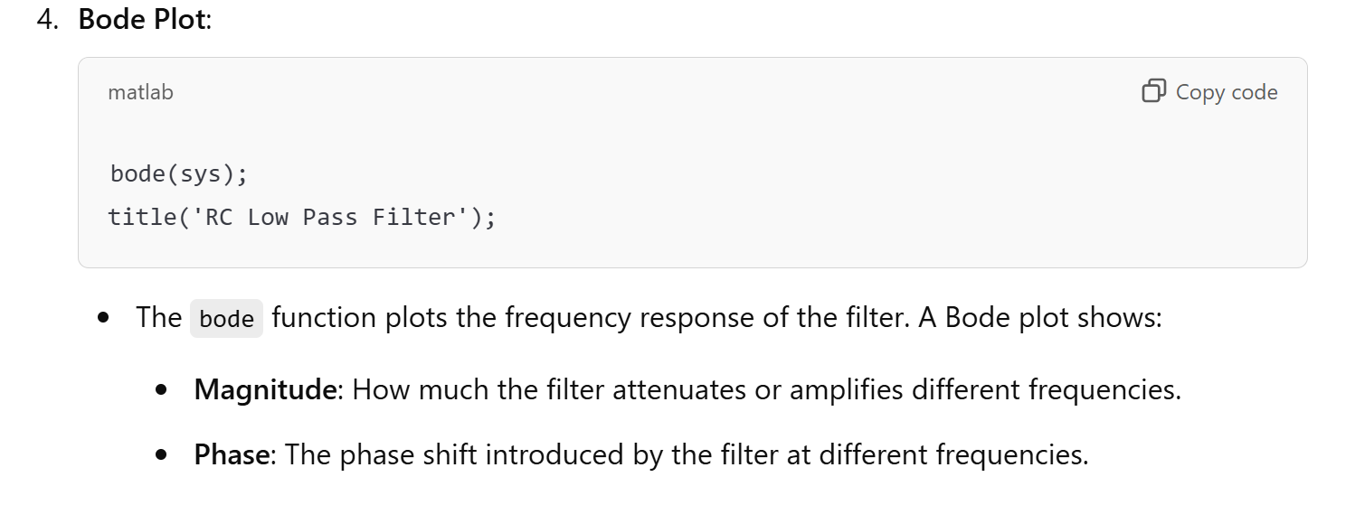

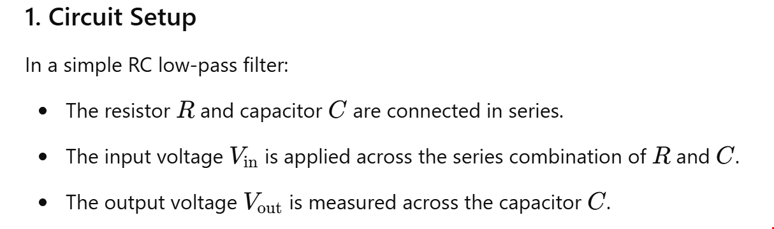

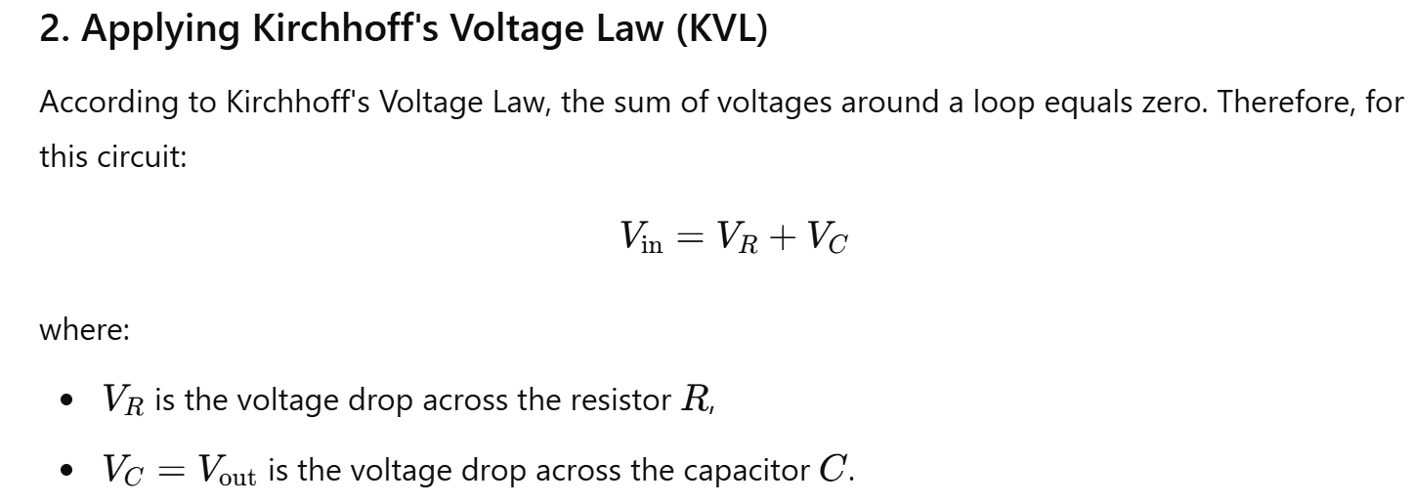

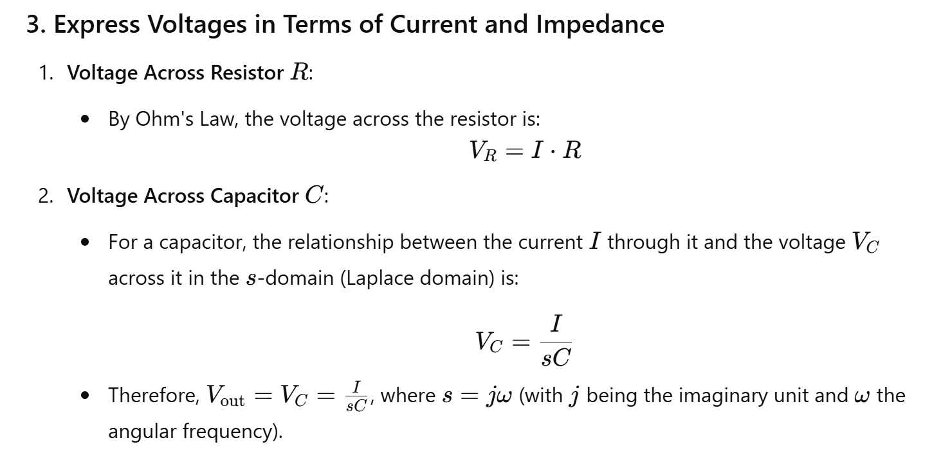

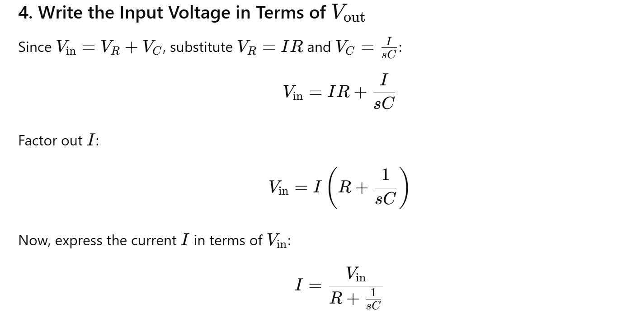

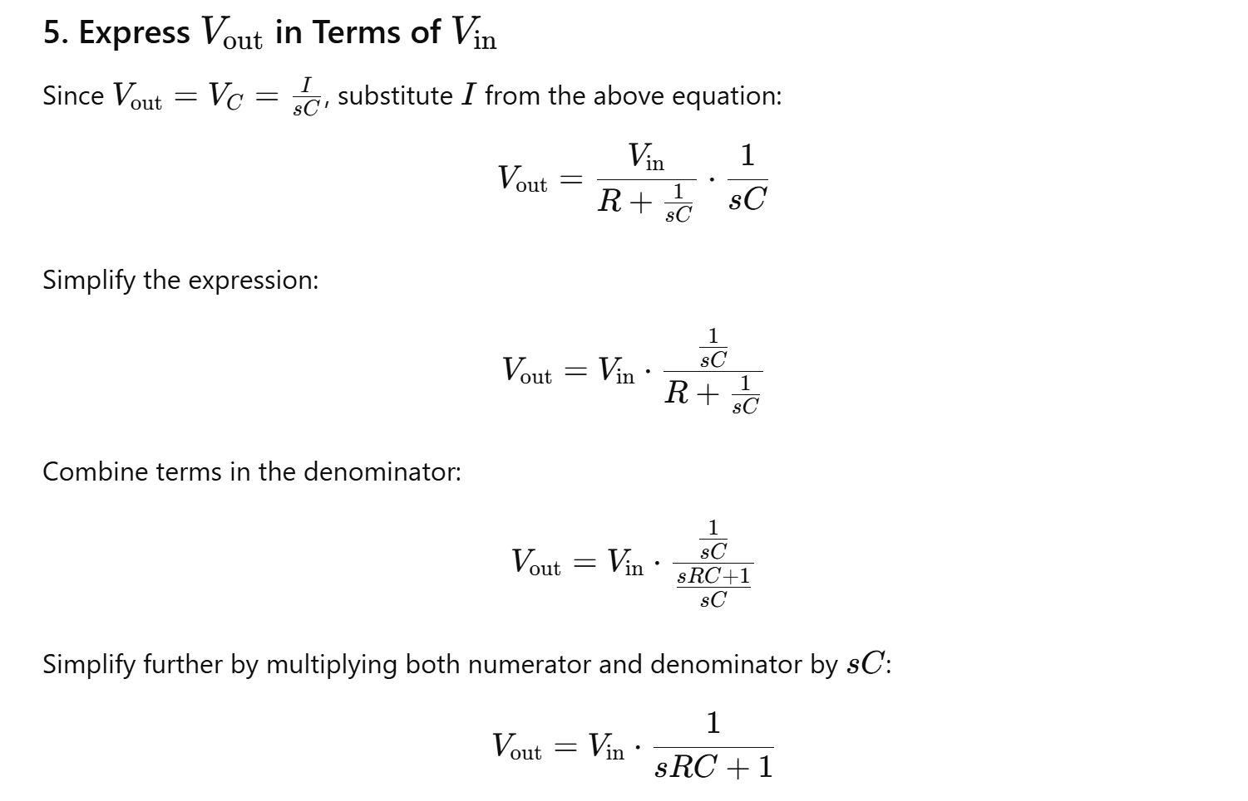

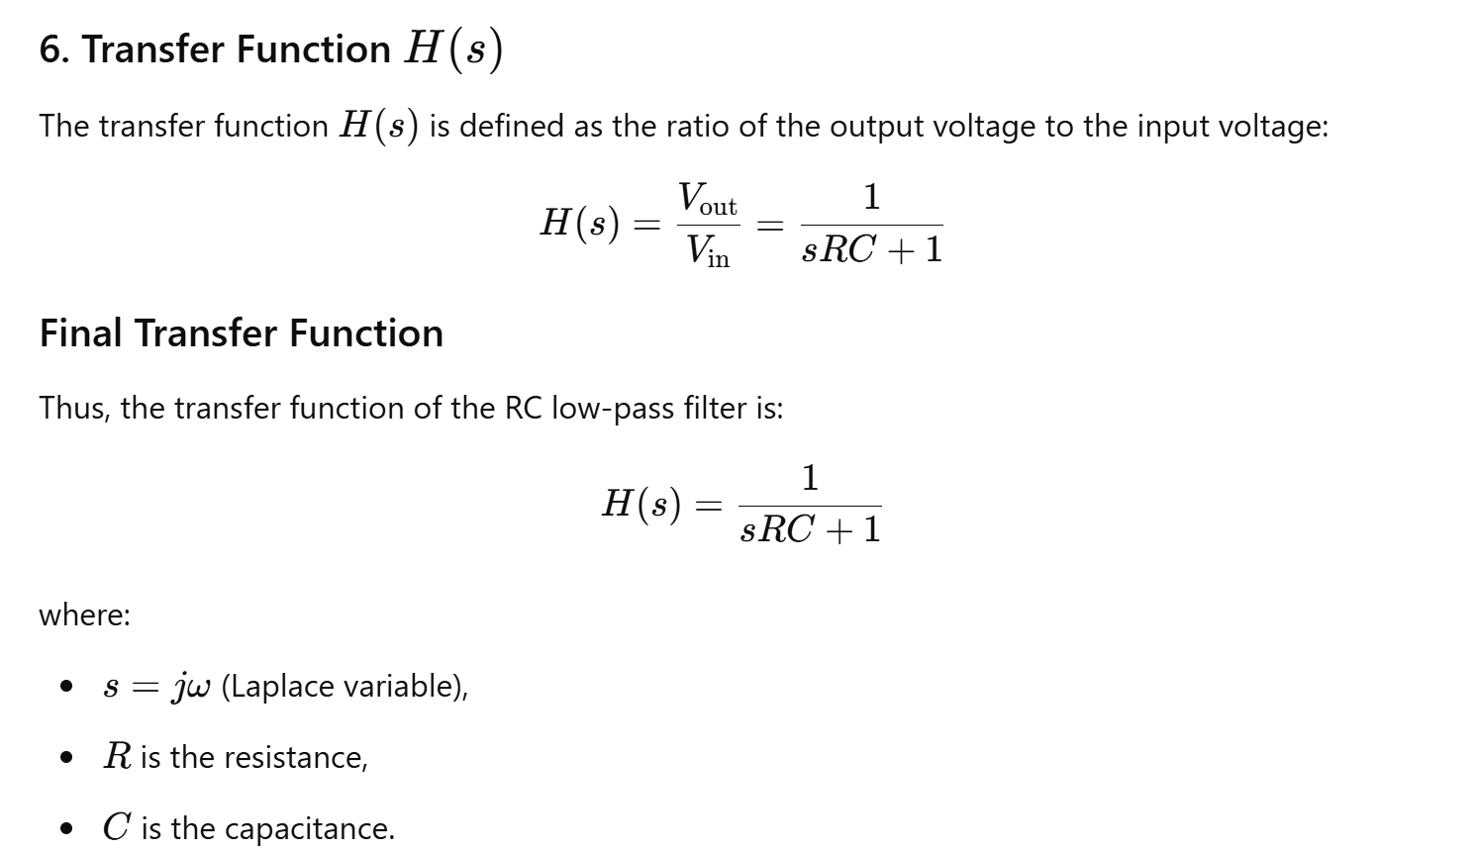

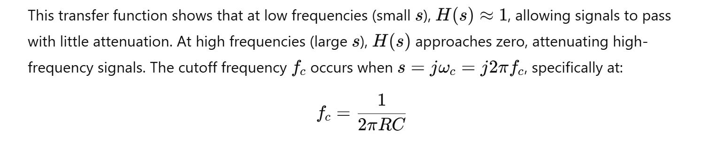

6. AC Voltage Analysis

In our tutorial about the AC Waveform we looked briefly at the **RMS Voltage** value of a sinusoidal waveform and said that this RMS value gives the same heating effect as an equivalent DC power and in this tutorial we will expand on this theory a little more by looking at RMS voltages and currents in more detail.

The term “RMS” stands for “Root-Mean-Squared”. Most books define this as the “amount of AC power that produces the same heating effect as an equivalent DC power”, or something similar along these lines, but an RMS value is more than just that.

The RMS value is the square root of the mean (average) value of the squared function of the instantaneous values. The symbols used for defining an RMS value are VRMS or IRMS.

The term RMS, ONLY refers to time-varying sinusoidal voltages, currents or complex waveforms where the magnitude of the waveform changes over time and is not used in DC circuit analysis or calculations where the magnitude is always constant.

When used to compare the equivalent RMS voltage value of an alternating sinusoidal waveform that supplies the same electrical power to a given load as an equivalent DC circuit, the RMS value is called the “effective value” and is generally presented as: Veff or Ieff.

In other words, the effective value is an equivalent DC value which tells you how many volts or amps of DC that a time-varying sinusoidal waveform is equal to in terms of its ability to produce the same power.

For example, the domestic mains supply in the United Kingdom is 240Vac. This value is assumed to indicate an effective value of “240 Volts rms”. This means then that the sinusoidal rms voltage from the wall sockets of a UK home is capable of producing the same average positive power as 240 volts of steady DC voltage as shown below.

**RMS Voltage Equivalent**

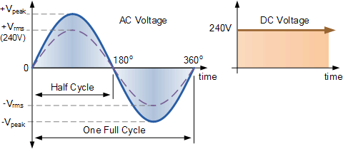

So how do we calculated the **RMS Voltage** of a sinusoidal waveform. The RMS voltage of a sinusoid or complex waveform can be determined by two basic methods.

* Graphical Method – which can be used to find the RMS value of any non-sinusoidal time-varying waveform by drawing a number of mid-ordinates onto the waveform.
* Analytical Method – is a mathematical procedure for finding the effective or RMS value of any periodic voltage or current using calculus.

**RMS Voltage Graphical Method**

Whilst the method of calculation is the same for both halves of an AC waveform, for this example we will consider only the positive half cycle. The effective or rms value of a waveform can be found with a reasonable amount of accuracy by taking equally spaced instantaneous values along the waveform.

The positive half of the waveform is divided up into any number of “n” equal portions or *mid-ordinates* and the more mid-ordinates that are drawn along the waveform, the more accurate will be the final result.

The width of each mid-ordinate will therefore be no degrees and the height of each mid-ordinate will be equal to the instantaneous value of the waveform at that time along the x-axis of the waveform.

**Graphical Method**

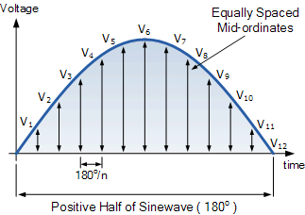

Each mid-ordinate value of a waveform (the voltage waveform in this case) is multiplied by itself (squared) and added to the next. This method gives us the “square” or **Squared** part of the RMS voltage expression.

Next this squared value is divided by the number of mid-ordinates used to give us the **Mean** part of the RMS voltage expression, and in our simple example above the number of mid-ordinates used was twelve (12). Finally, the square root of the previous result is found to give us the **Root** part of the RMS voltage.

Then we can define the term used to describe an rms voltage (VRMS) as being “the square root of the mean of the square of the mid-ordinates of the voltage waveform” and this is given as:

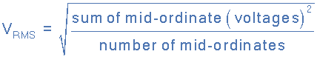

and for our simple example above, the RMS voltage will be calculated as:

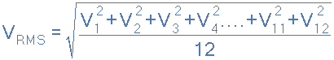

So let us assume that an alternating voltage has a peak voltage (Vpk) of 20 volts and by taking 10 mid-ordinate values is found to vary over one half cycle as follows:

|  |  |  |  |  |  |  |  |  |  |  |
| --- | --- | --- | --- | --- | --- | --- | --- | --- | --- | --- |
| Voltage | 6.2V | 11.8V | 16.2V | 19.0V | 20.0V | 19.0V | 16.2V | 11.8V | 6.2V | 0V |
| Angle | 18o | 36o | 54o | 72o | 90o | 108o | 126o | 144o | 162o | 180o |

The **RMS voltage** is therefore calculated as:

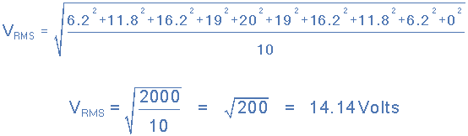

Then the RMS Voltage value using the graphical method is given as: 14.14 Volts.

**RMS Voltage Analytical Method**

The graphical method above is a very good way of finding the effective or RMS voltage, (or current) of an alternating waveform that is not symmetrical or sinusoidal in nature. In other words the waveform shape resembles that of a complex waveform.

However, when dealing with pure sinusoidal waveforms we can make life a little bit easier for ourselves by using an analytical or mathematical way of finding the RMS value.

A periodic sinusoidal voltage is constant and can be defined as V(t) = Vmax*cos(ωt) with a period of T. Then we can calculate the **root-mean-square** (rms) value of a sinusoidal voltage (V(t)) as:

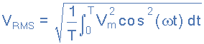

Integrating through with limits taken from 0 to 360o or “T”, the period gives:

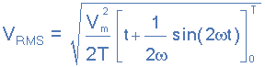

Where: Vm is the peak or maximum value of the waveform. Dividing through further as ω = 2π/T, the complex equation above eventually reduces down too:

**RMS Voltage Equation**

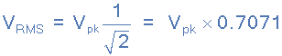

Then the RMS voltage (VRMS) of a sinusoidal waveform is determined by multiplying the peak voltage value by **0.7071**, which is the same as one divided by the square root of two ( 1/√2 ).

The RMS voltage, which can also be referred to as the effective value, depends on the magnitude of the waveform and is not a function of either the waveforms frequency nor its phase angle.

From the graphical example above, the peak voltage (Vpk) of the waveform was given as 20 Volts. By using the analytical method just defined we can calculate the RMS voltage as being:

VRMS = Vpk * 0.7071 = 20 x 0.7071 = 14.14V

Note that this value of 14.14 volts is the same value as for the previous graphical method. Then we can use either the graphical method of mid-ordinates, or the analytical method of calculation to find the RMS voltage or current values of a sinusoidal waveform.

Note that multiplying the peak or maximum value by the constant 0.7071, **ONLY** applies to sinusoidal waveforms. For non-sinusoidal waveforms the graphical method must be used.

But as well as using the peak or maximum value of the sinusoid, we can also use the peak-to-peak (VP-P) value or the average (VAVG) value to find the sinusoids equivalent root mean squared value as shown:

MATLAB Code:

% AC Voltage Analysis

Fs = 1000; % Sampling frequency

t = 0:1/Fs:1-1/Fs;

f = 50; % Frequency of AC voltage

V_peak = 10; % Peak voltage

V_ac = V_peak * sin(2*pi*f*t);

V_rms = rms(V_ac);

disp(['RMS Voltage: ', num2str(V_rms), ' V']);

7. DC Motor Simulation

Theory: Model and simulate the behavior of a DC motor.

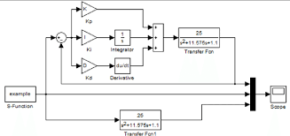

MATLAB Code:

% DC Motor Simulation

J = 0.01; % Moment of inertia of the rotor

b = 0.1; % Damping ratio of the mechanical system

K = 0.01; % Electromotive force constant

R = 1; % Electric resistance

L = 0.5; % Electric inductance

A = [0 1 0; 0 -b/J K/J; 0 -K/L -R/L];

B = [0; 0; 1/L];

C = [1 0 0];

D = 0;

sys = ss(A,B,C,D);

step(sys);

title('DC Motor Step Response');

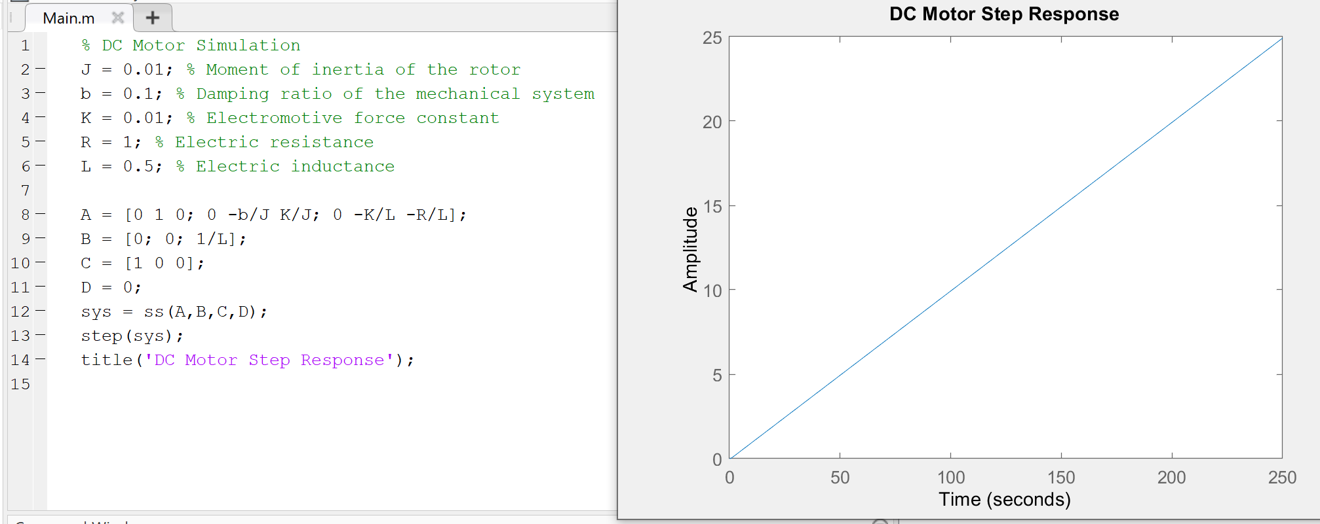

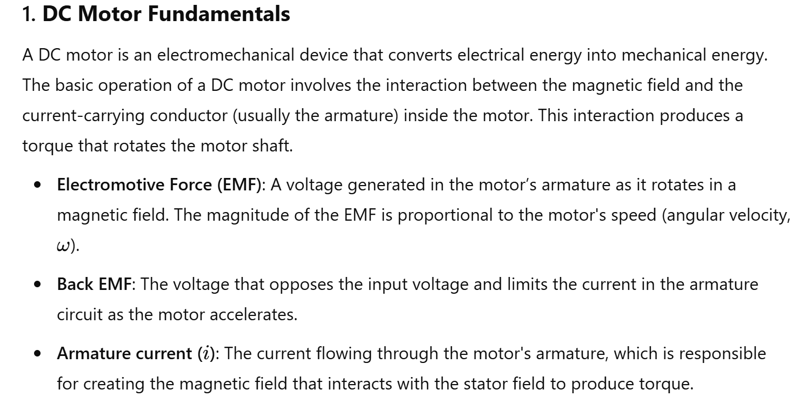

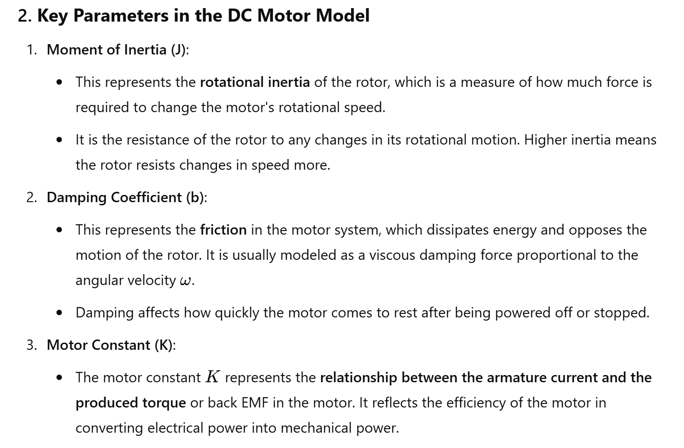

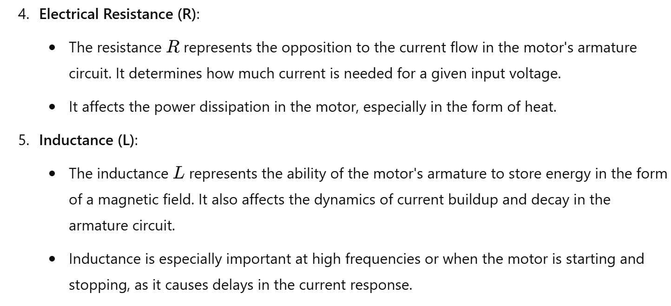

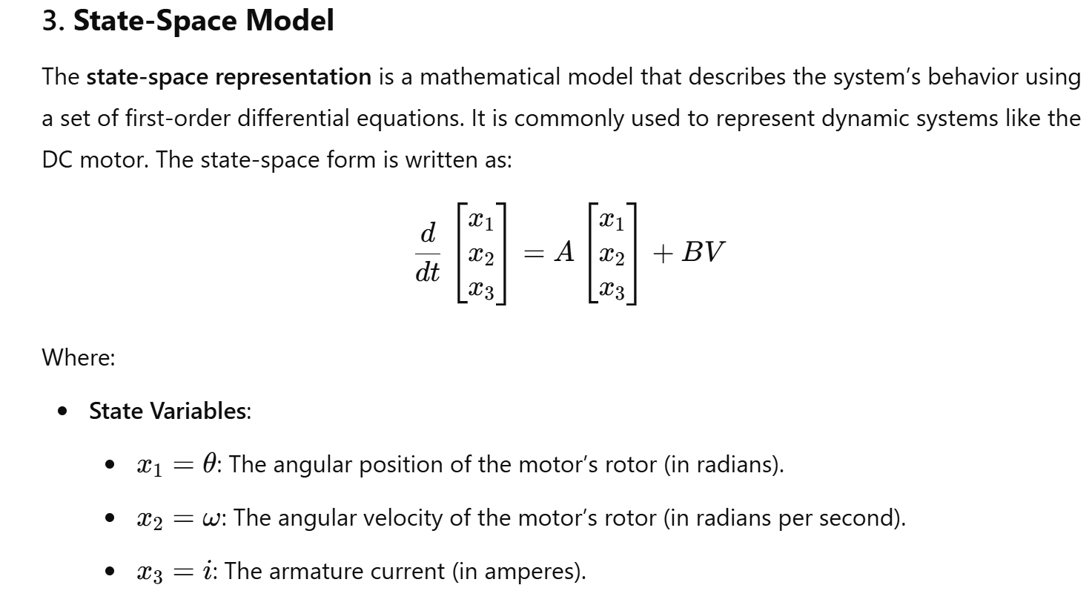

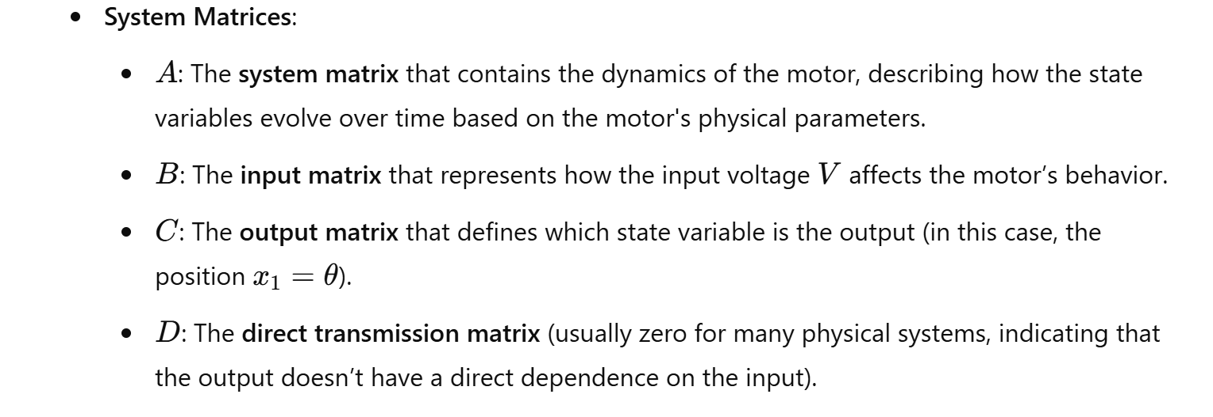

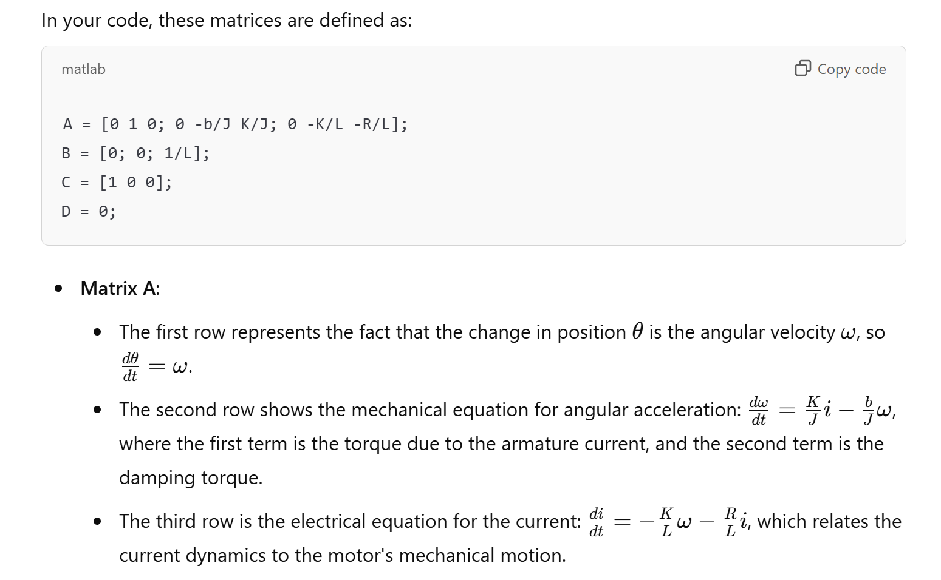

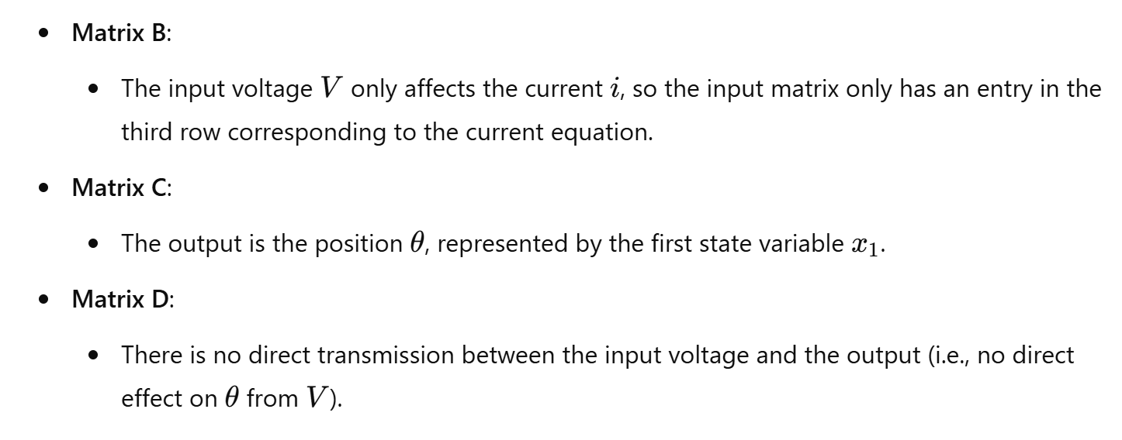

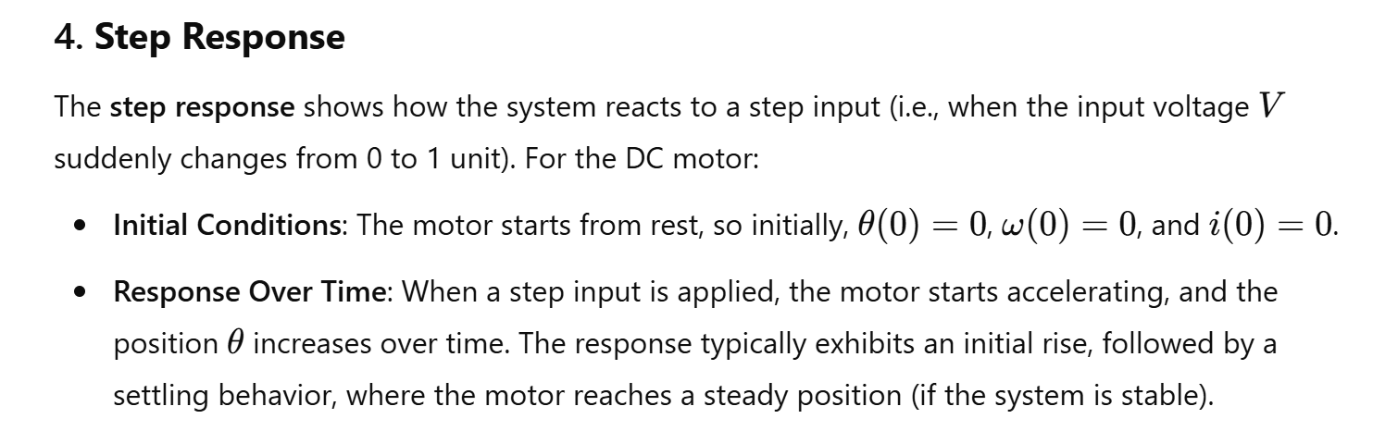

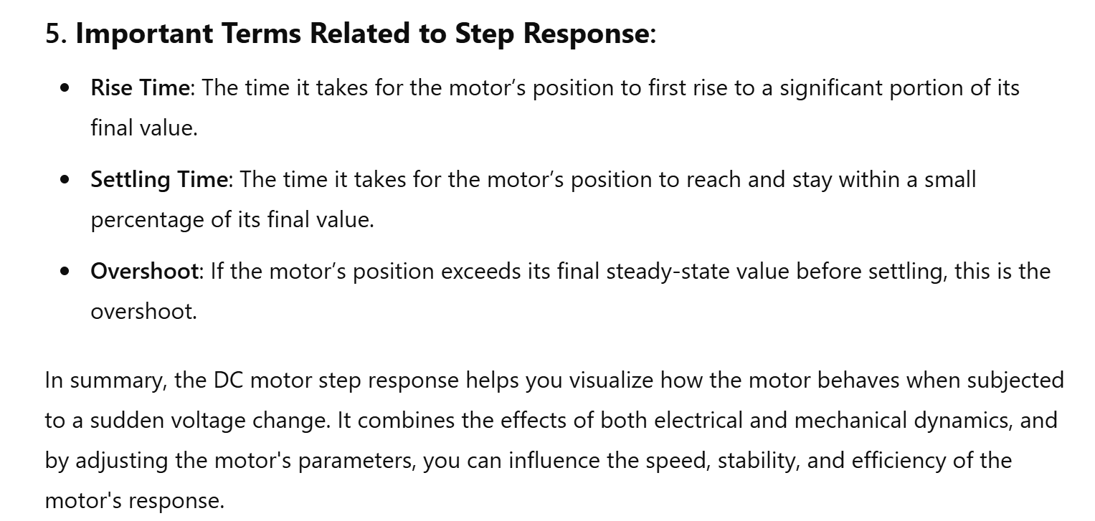

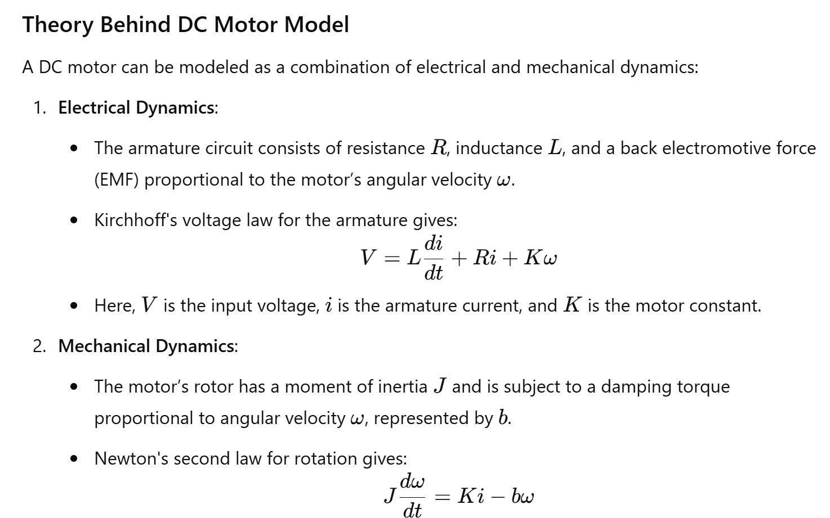

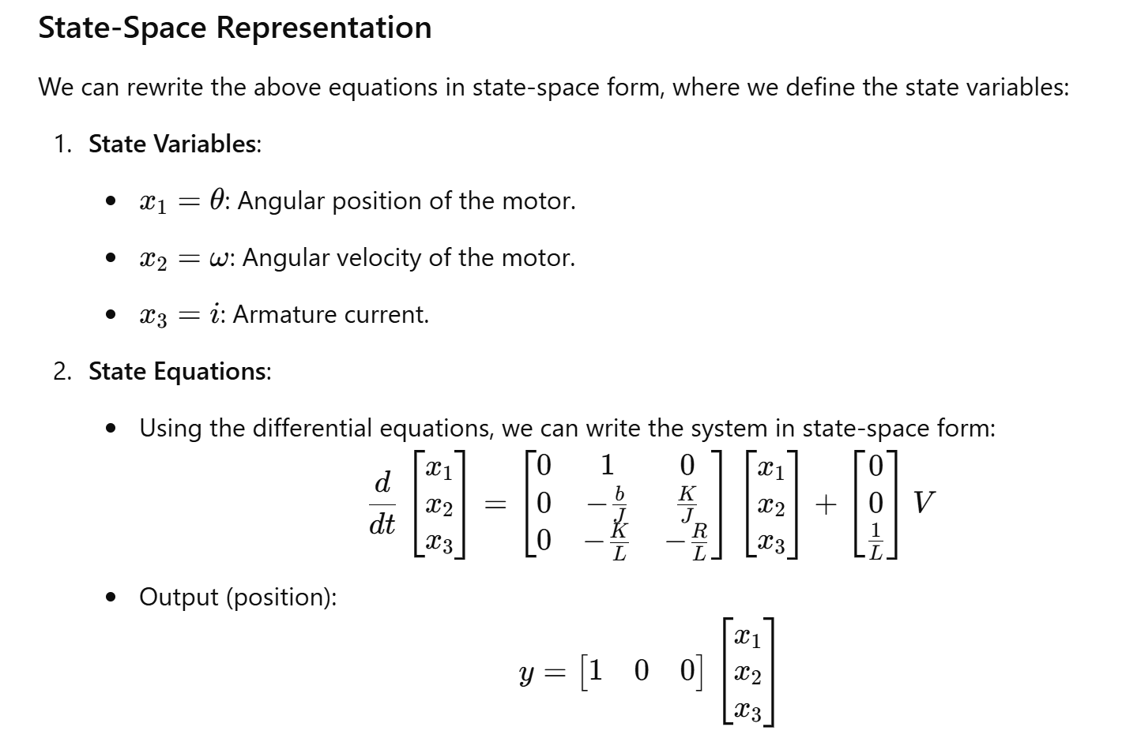

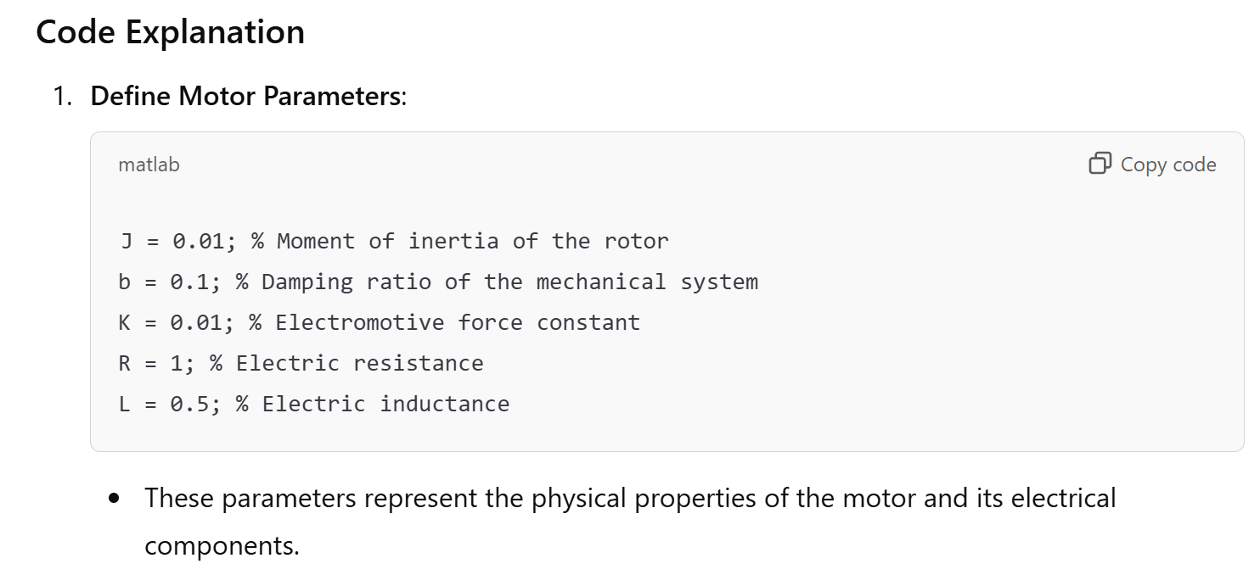

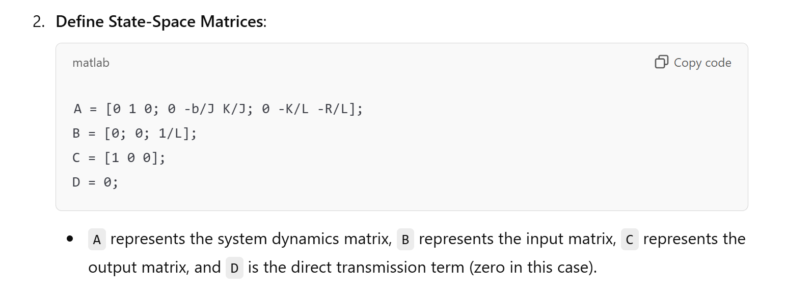

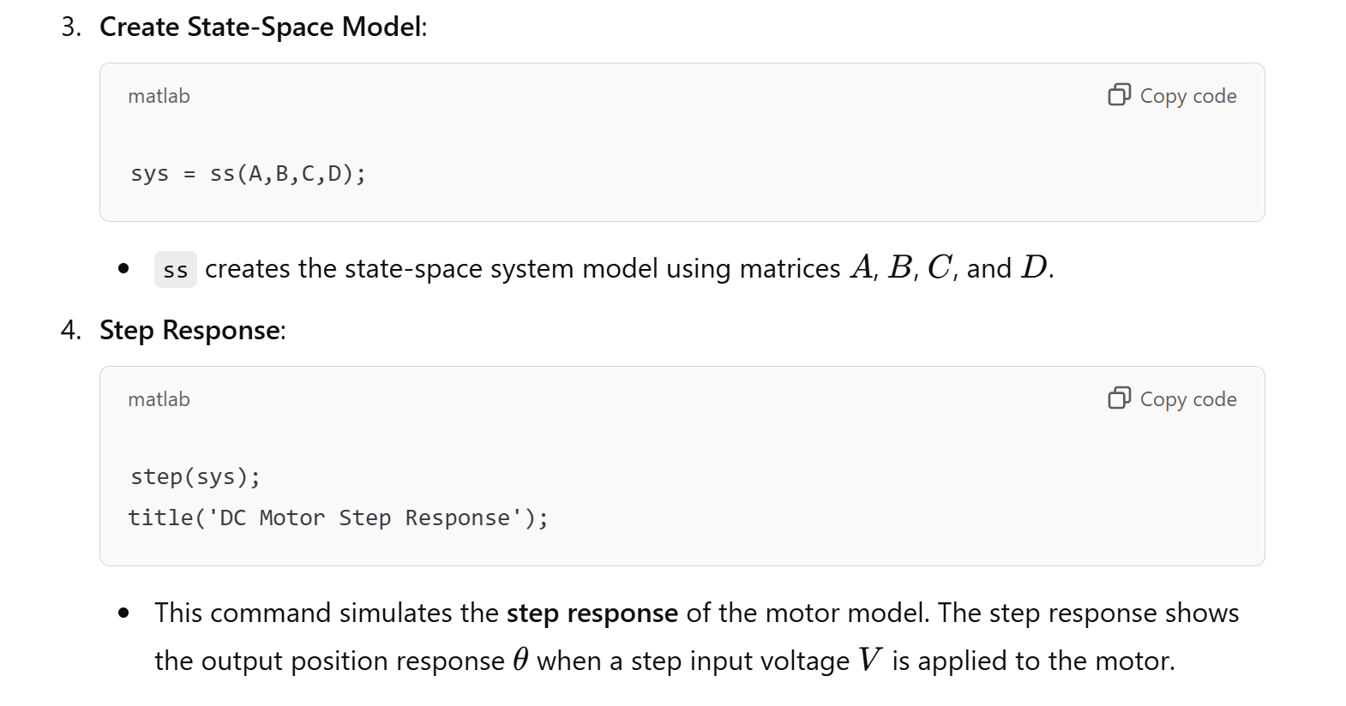

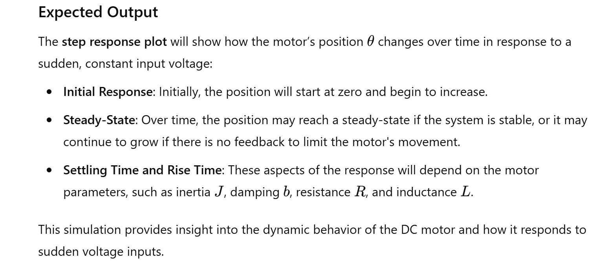

8. LED Characteristic Curve

Theory: Plot the I-V characteristic curve of an LED.

The characteristic curve of an LED is strongly non-linear. An LED is non-conductive if no external voltage is applied. The LED starts to conduct when the applied forward voltage UF is at least as high than the conducting voltage UD and the band gap is overcome by the electrons. The forward current is not proportional to the applied forward voltage. A small change in voltage can cause a large change in current. A small voltage change can lead to a strong change in light emission due to the proportionality of luminous flux and current intensity. This means that LEDs must generally be operated with a current limiter of some form or other, otherwise even slight fluctuations in the applied voltage can destroy the LED.

**The I-V characteristic curve of an LED is**

A

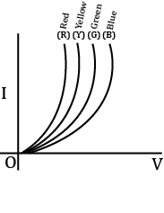

B

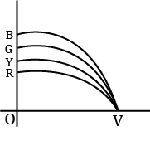

C

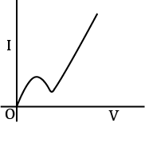

D

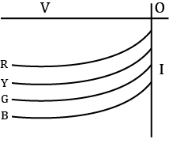

MATLAB Code:

% LED Characteristic Curve

V = 0:0.01:2; % Voltage range

I = exp(V); % Simplified exponential I-V relationship

plot(V, I);

title('LED I-V Characteristic Curve');

xlabel('Voltage (V)');

ylabel('Current (A)');

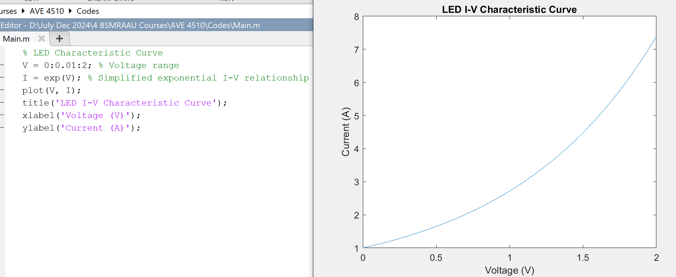

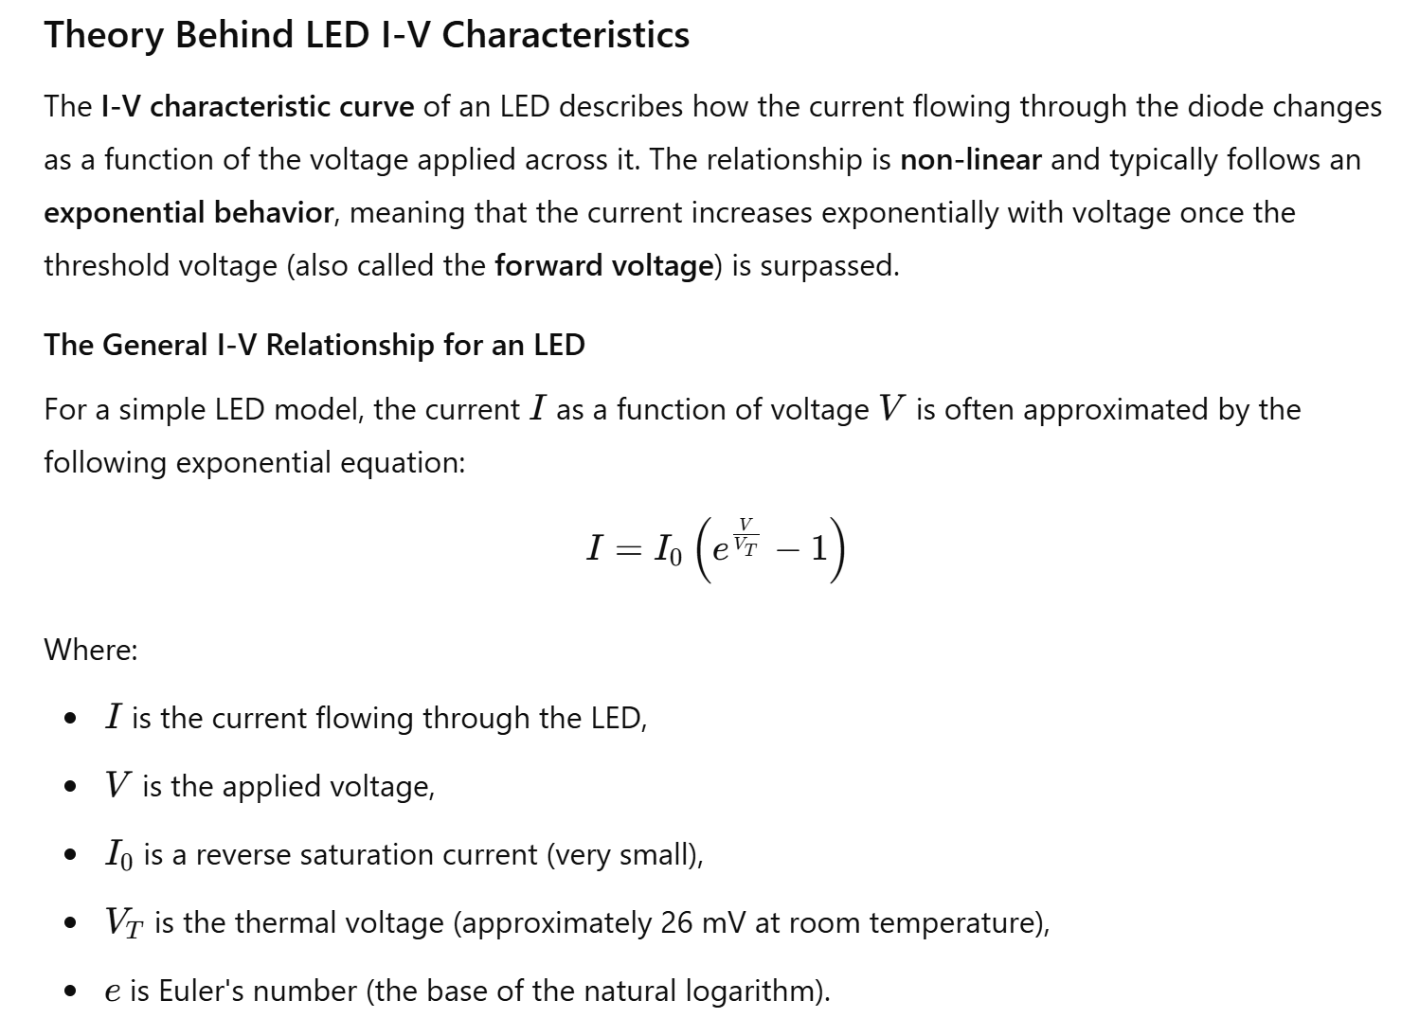

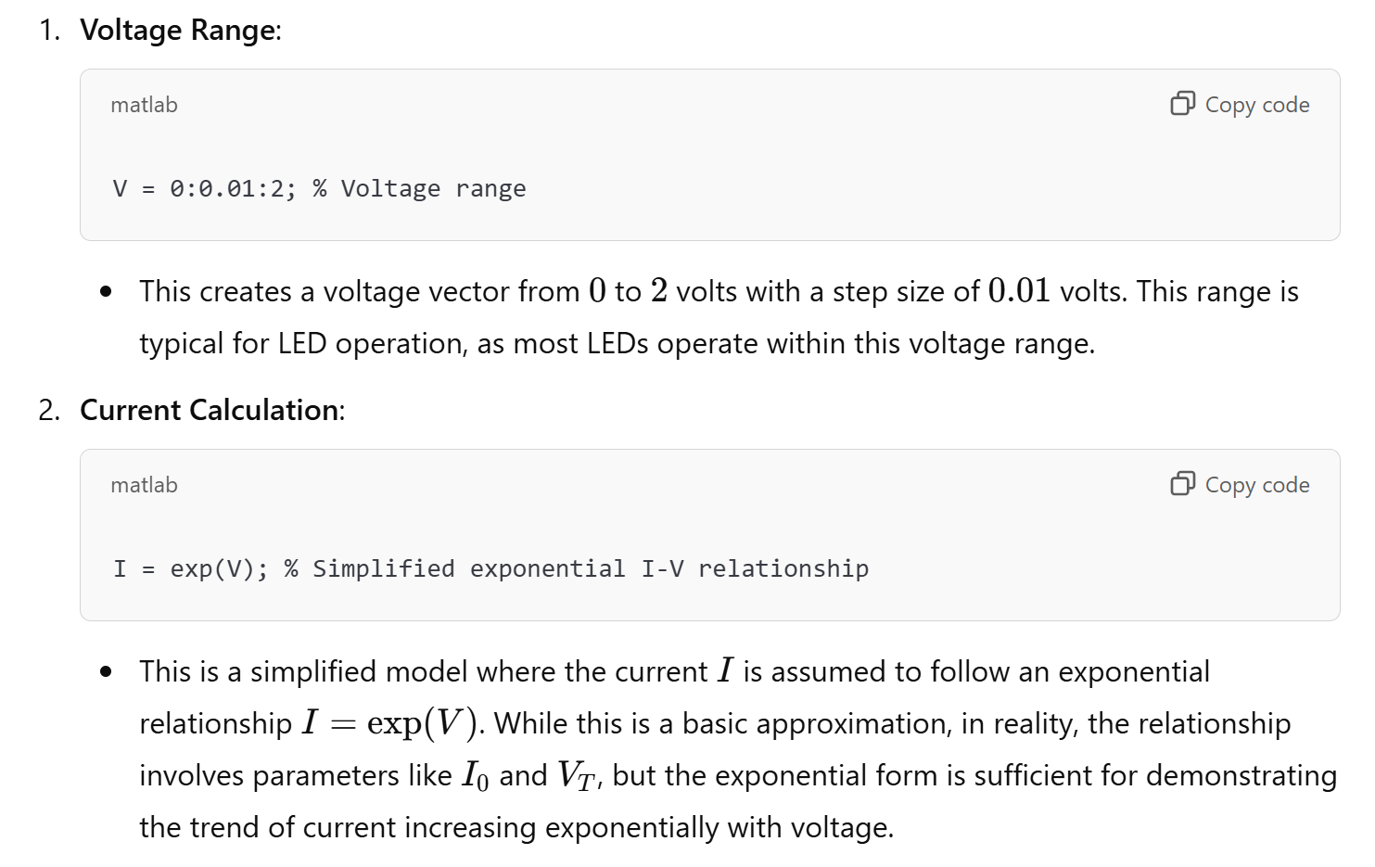

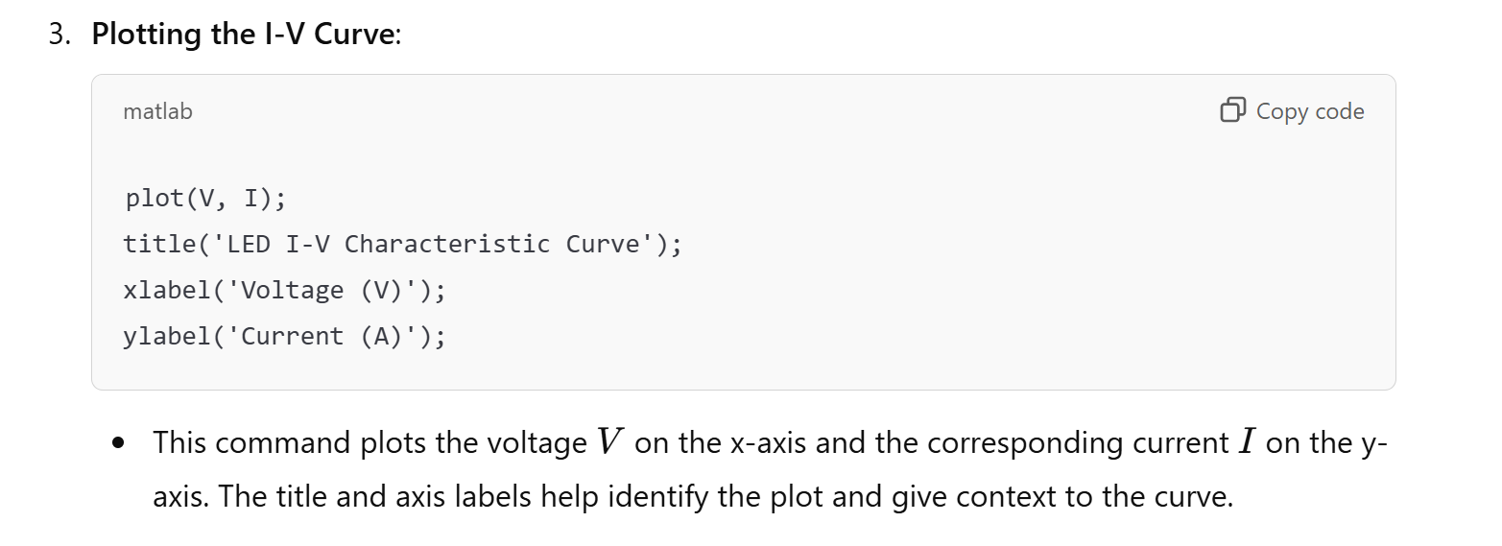

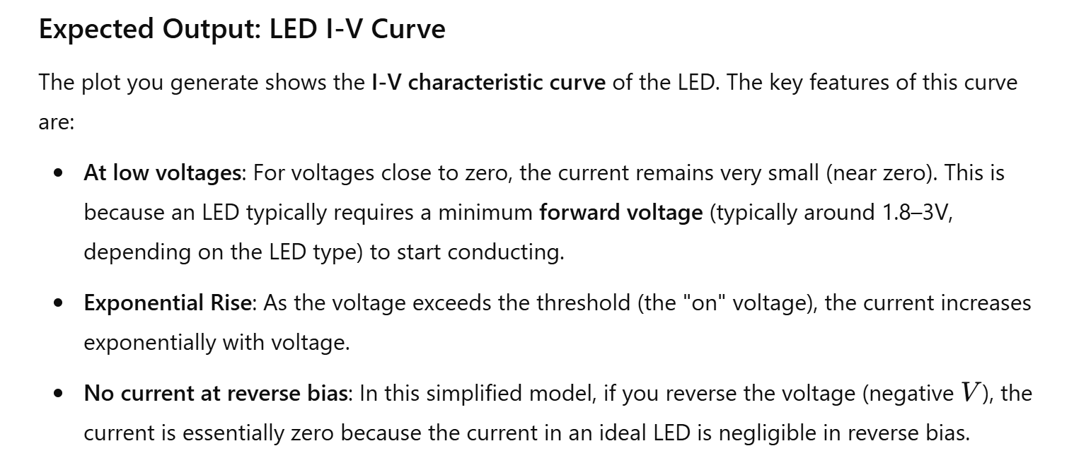

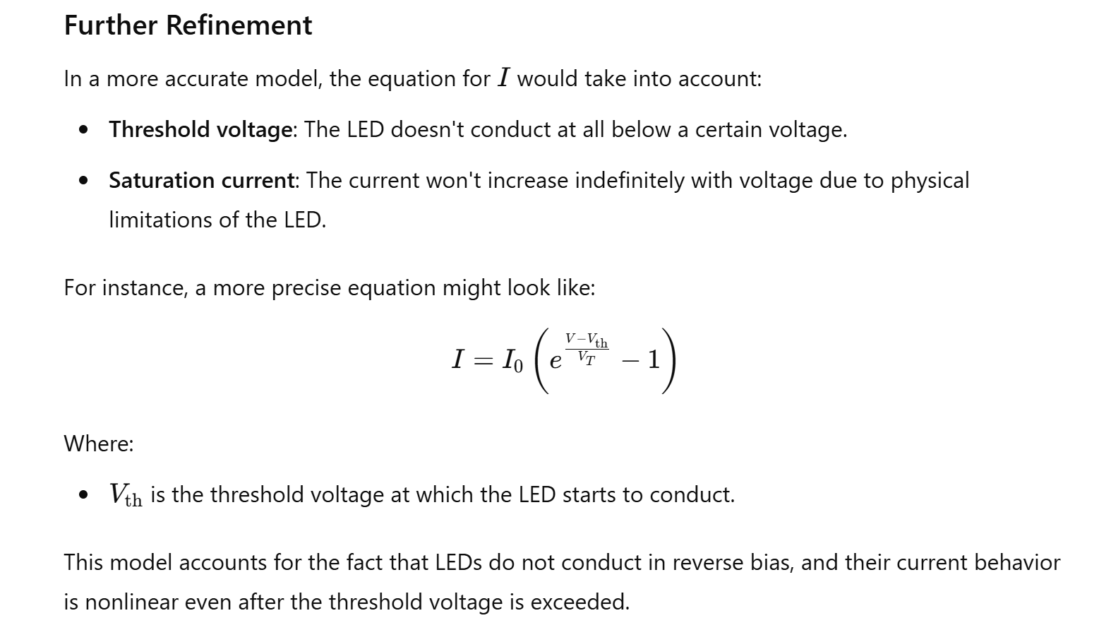

9. BJT Common Emitter Amplifier

Theory: Simulate the behavior of a BJT common emitter amplifier.

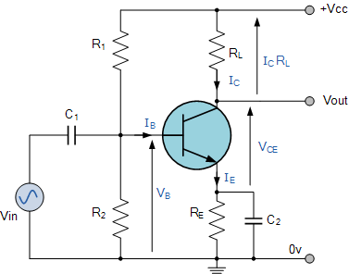

MATLAB Code:

% BJT Common Emitter Amplifier

beta = 100; % Current gain

R_C = 1e3; % Collector resistor in ohms

V_CC = 10; % Supply voltage in volts

I_B = 50e-6; % Base current in amperes

I_C = beta * I_B; % Collector current in amperes

V_CE = V_CC - I_C * R_C; % Collector-emitter voltage

disp(['Collector-Emitter Voltage: ', num2str(V_CE), ' V']);

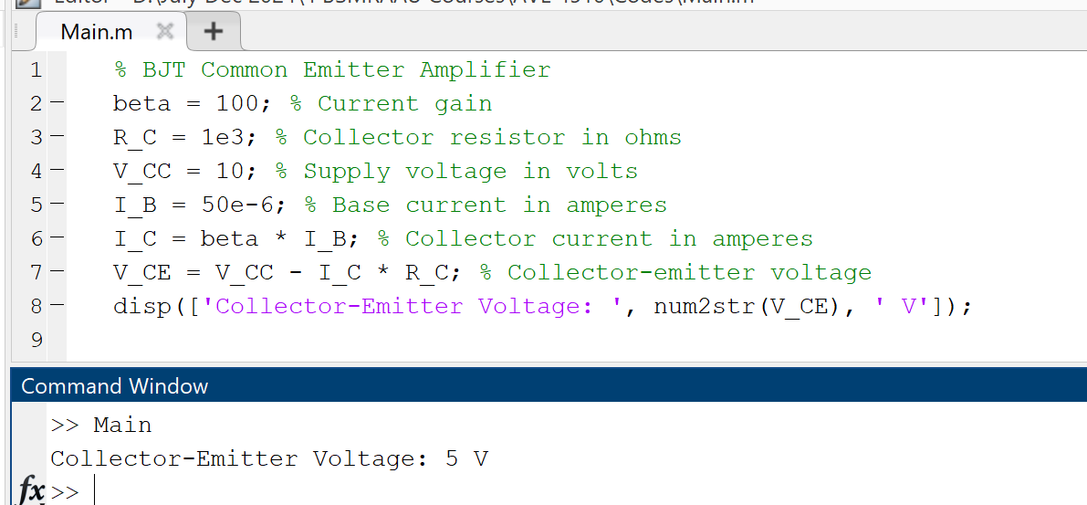

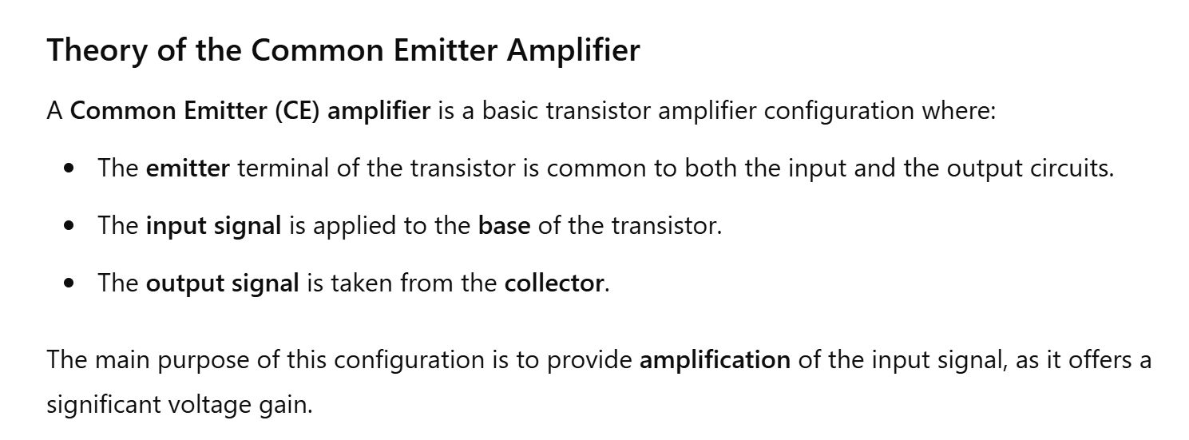

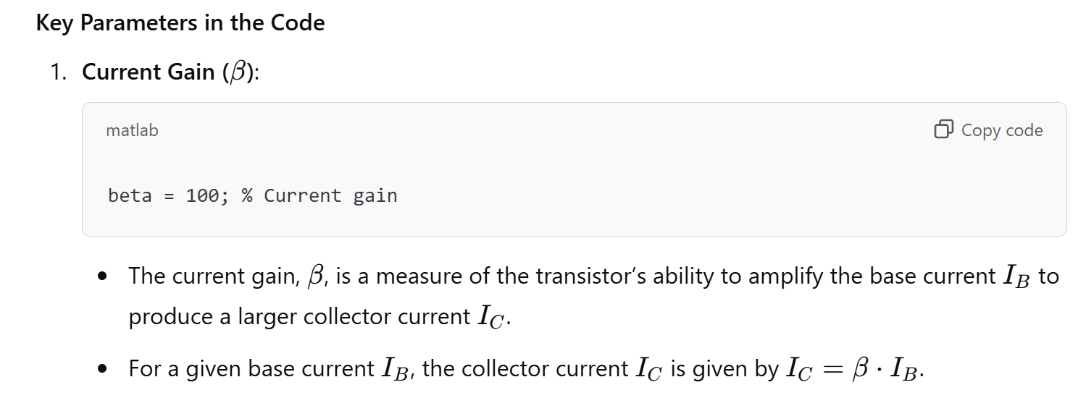

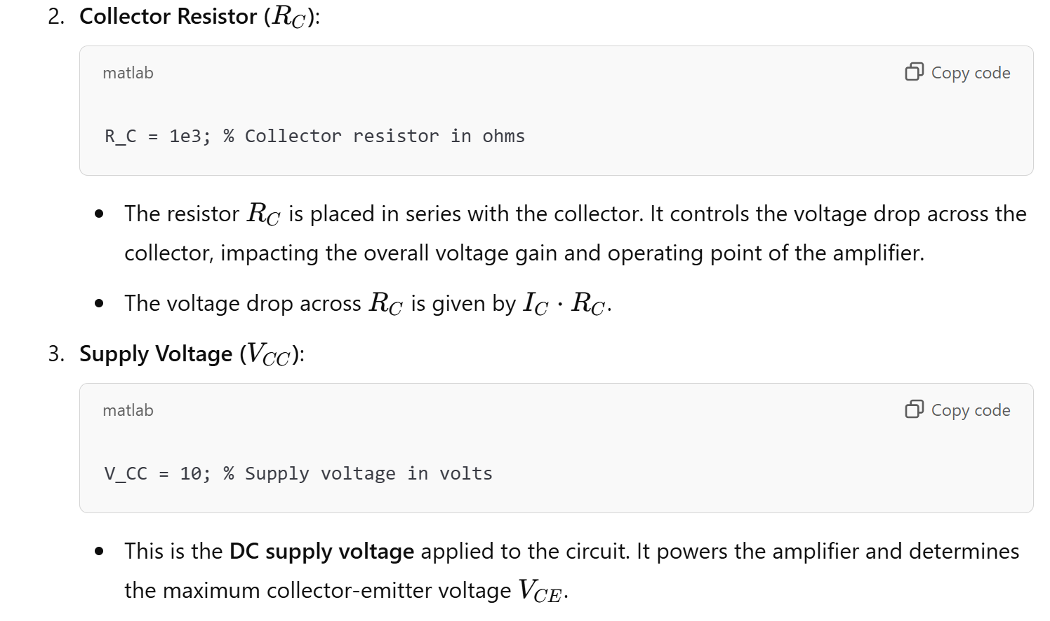

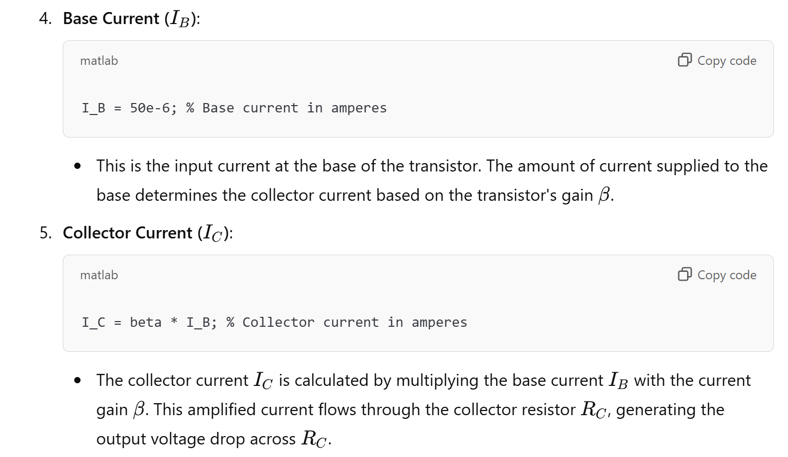

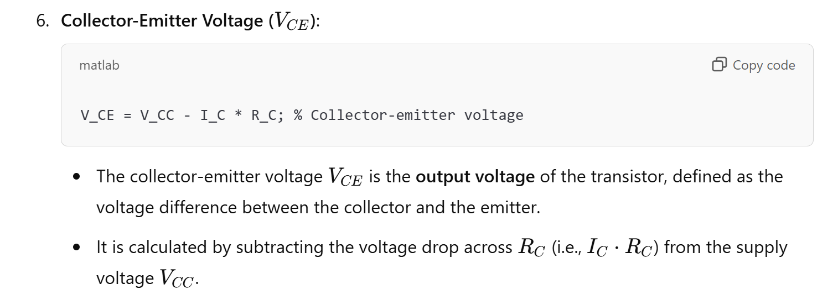

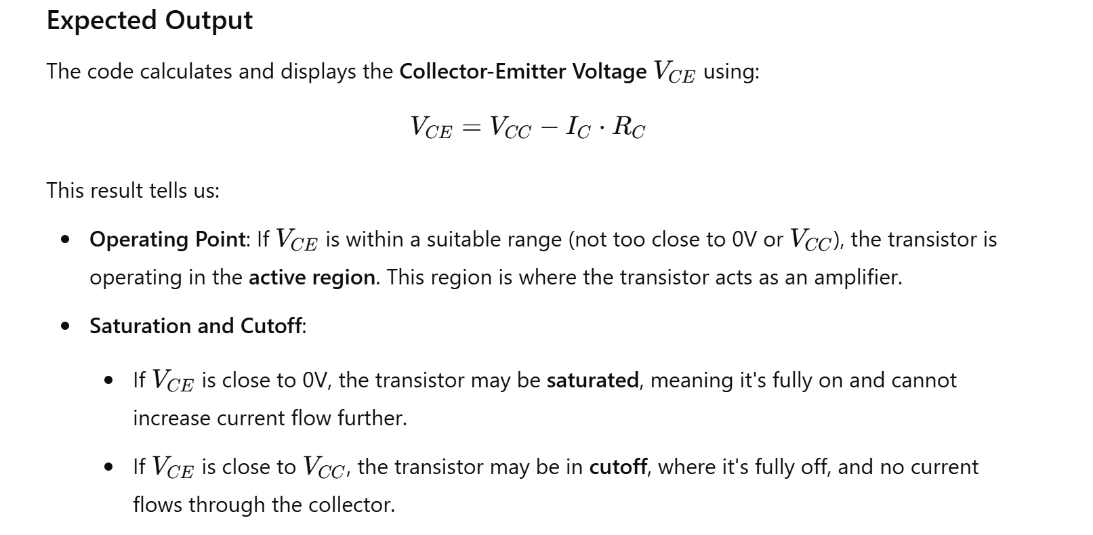

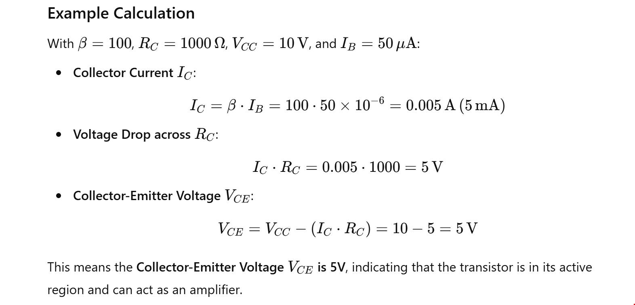

10. Diode Clipper Circuit

This diode clipping of the input signal produces an output waveform that resembles a flattened version of the input. For example, the half-wave rectifier is a clipper circuit, since all voltages below zero are eliminated.

But **Diode Clipping Circuits** can be used a variety of applications to modify an input waveform using signal and Schottky diodes or to provide over-voltage protection using zener diodes to ensure that the output voltage never exceeds a certain level protecting the circuit from high voltage spikes. Then diode clipping circuits can be used in voltage limiting applications.

We saw in the *Signal Diodes* tutorial that when a diode is forward biased it allows current to pass through itself clamping the voltage. When the diode is reverse biased, no current flows through it and the voltage across its terminals is unaffected, and this is the basic operation of the diode clipping circuit.

Although the input voltage to diode clipping circuits can have any waveform shape, we will assume here that the input voltage is sinusoidal. Consider the circuits below.

**Positive Diode Clipping Circuits**

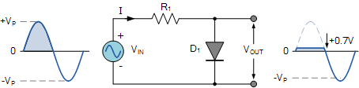

In this diode clipping circuit, the diode is forward biased (anode more positive than cathode) during the positive half cycle of the sinusoidal input waveform. For the diode to become forward biased, it must have the input voltage magnitude greater than +0.7 volts (0.3 volts for a germanium diode).

When this happens the diodes begins to conduct and holds the voltage across itself constant at 0.7V until the sinusoidal waveform falls below this value. Thus the output voltage which is taken across the diode can never exceed 0.7 volts during the positive half cycle.

During the negative half cycle, the diode is reverse biased (cathode more positive than anode) blocking current flow through itself and as a result has no effect on the negative half of the sinusoidal voltage which passes to the load unaltered. Thus the diode limits the positive half of the input waveform and is known as a positive clipper circuit.

**Negative Diode Clipping Circuit**

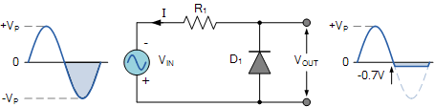

Here the reverse is true. The diode is forward biased during the negative half cycle of the sinusoidal waveform and limits or clips it to –0.7 volts while allowing the positive half cycle to pass unaltered when reverse biased. As the diode limits the negative half cycle of the input voltage it is therefore called a negative clipper circuit.

**Clipping of Both Half Cycles**

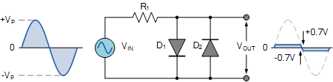

If we connected two diodes in inverse parallel as shown, then both the positive and negative half cycles would be clipped as diode D1 clips the positive half cycle of the sinusoidal input waveform while diode D2 clips the negative half cycle. Then diode clipping circuits can be used to clip the positive half cycle, the negative half cycle or both.

For ideal diodes the output waveform above would be zero. However, due to the forward bias voltage drop across the diodes the actual clipping point occurs at +0.7 volts and –0.7 volts respectively. But we can increase this ±0.7V threshold to any value we want up to the maximum value, (VPEAK) of the sinusoidal waveform either by connecting together more diodes in series creating multiples of 0.7 volts, or by adding a voltage bias to the diodes.

**Biased Diode Clipping Circuits**

To produce diode clipping circuits for voltage waveforms at different levels, a bias voltage, VBIAS is added in series with the diode to produce a combination clipper as shown. The voltage across the series combination must be greater than VBIAS + 0.7V before the diode becomes sufficiently forward biased to conduct. For example, if the VBIAS level is set at 4.0 volts, then the sinusoidal voltage at the diode’s anode terminal must be greater than **4.0 + 0.7 = 4.7 volts** for it to become forward biased. Any anode voltage levels above this bias point are clipped off.

**Positive Bias Diode**

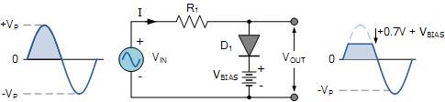

Likewise, by reversing the diode and the battery bias voltage, when a diode conducts the negative half cycle of the output waveform is held to a level –VBIAS – 0.7V as shown.

**Negative Bias Diode**

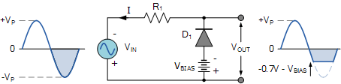

A variable diode clipping or diode limiting level can be achieved by varying the bias voltage of the diodes. If both the positive and the negative half cycles are to be clipped, then two biased clipping diodes are used. But for both positive and negative diode clipping, the bias voltage need not be the same. The positive bias voltage could be at one level, for example 4 volts, and the negative bias voltage at another, for example 6 volts as shown.

**Diode Clipping of Different Bias levels**

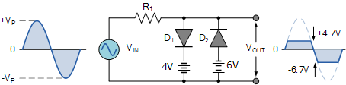

When the voltage of the positive half cycle reaches +4.7 V, diode D1 conducts and limits the waveform at +4.7 V. Diode D2 does not conduct until the voltage reaches –6.7 V. Therefore, all positive voltages above +4.7 V and negative voltages below –6.7 V are automatically clipped.

The advantage of biased diode clipping circuits is that it prevents the output signal from exceeding preset voltage limits for both half cycles of the input waveform, which could be an input from a noisy sensor or the positive and negative supply rails of a power supply.

If the diode clipping levels are set too low or the input waveform is too great then the elimination of both waveform peaks could end up with a square-wave shaped waveform.

**Zener Diode Clipping Circuits**

The use of a bias voltage means that the amount of the voltage waveform that is clipped off can be accurately controlled. But one of the main disadvantages of using voltage biased diode clipping circuits, is that they need an additional emf battery source which may or may not be a problem.

One easy way of creating biased diode clipping circuits without the need for an additional emf supply is to use [Zener Diodes](https://www.electronics-tutorials.ws/diode/diode_7.html).

As we know, the zener diode is a another type of diode that has been specially manufactured to operate in its reverse biased breakdown region and as such can be used for voltage regulation or zener diode clipping applications. In the forward region, the zener acts just like an ordinary silicon diode with a forward voltage drop of 0.7V (700mV) when conducting, the same as above.

However, in the reverse bias region, the voltage is blocked until the zener diodes breakdown voltage is reached. At this point, the reverse current through the zener increases sharply but the zener voltage, VZ across the device remains constant even if the zener current, IZ varies.

Then we can put this zener action to good effect by using them for clipping a waveform as shown.

**Zener Diode Clipping**

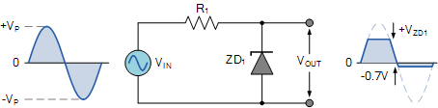

The zener diode is acting like a biased diode clipping circuit with the bias voltage being equal to the zener breakdown voltage. In this circuit during the positive half of the waveform the zener diode is reverse biased so the waveform is clipped at the zener voltage, VZD1. During the negative half cycle the zener acts like a normal diode with its usual 0.7V junction value.

We can develop this idea further by using the zener diodes reverse-voltage characteristics to clip both halves of a waveform using series connected back-to-back zener diodes as shown.

**Full-wave Zener Diode Clipping**

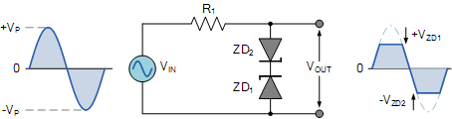

The output waveform from full wave zener diode clipping circuits resembles that of the previous voltage biased diode clipping circuit. The output waveform will be clipped at the zener voltage plus the 0.7V forward volt drop of the other diode. So for example, the positive half cycle will be clipped at the sum of zener diode, ZD1 plus 0.7V from ZD2 and vice versa for the negative half cycle.

Zener diodes are manufactured with a wide range of voltages and can be used to give different voltage references on each half cycle, the same as above. Zener diodes are available with zener breakdown voltages, VZ ranging from 2.4 to 33 volts, with a typical tolerance of 1 or 5%. Note that once conducting in the reverse breakdown region, full current will flow through the zener diode so a suitable current limiting resistor, R1 must be chosen.

Theory: Simulate a diode clipper circuit that limits the output voltage.

MATLAB Code:

% Diode Clipper Circuit

t = 0:0.001:1; % Time vector

Vi = 5*sin(2*pi*50*t); % Input sine wave

Vd = 0.7; % Diode forward voltage

Vo = Vi;

Vo(Vi > Vd) = Vd;

Vo(Vi < -Vd) = -Vd;

plot(t, Vi, t, Vo);

title('Diode Clipper Circuit');

xlabel('Time (s)');

ylabel('Voltage (V)');

legend('Input Voltage', 'Output Voltage');

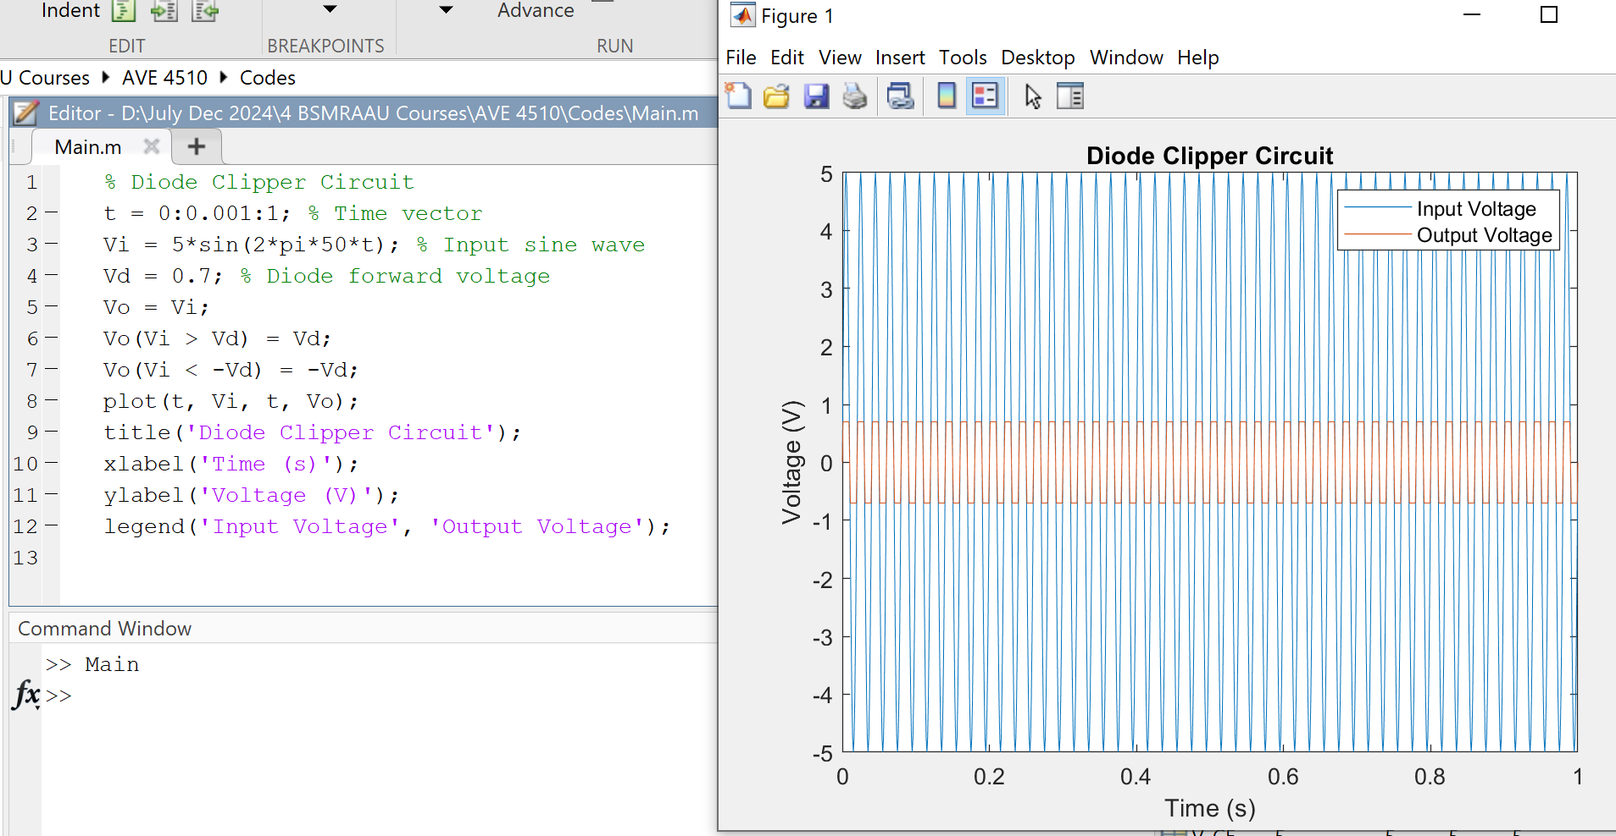

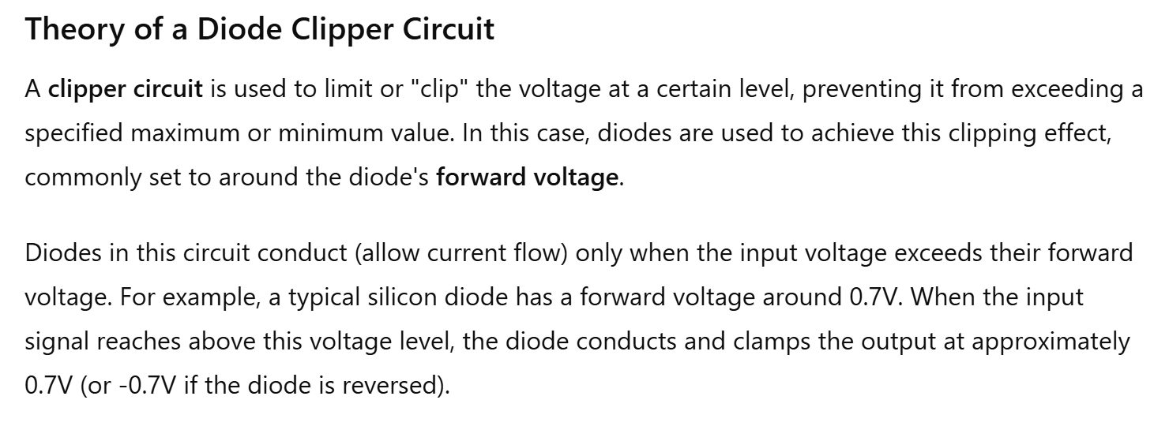

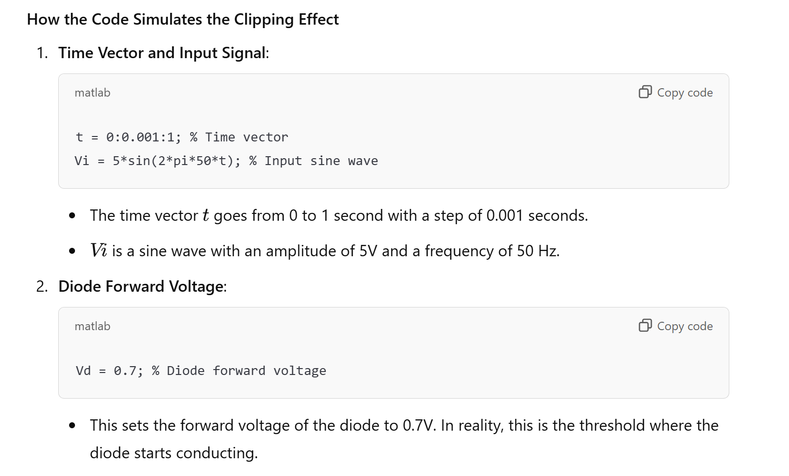

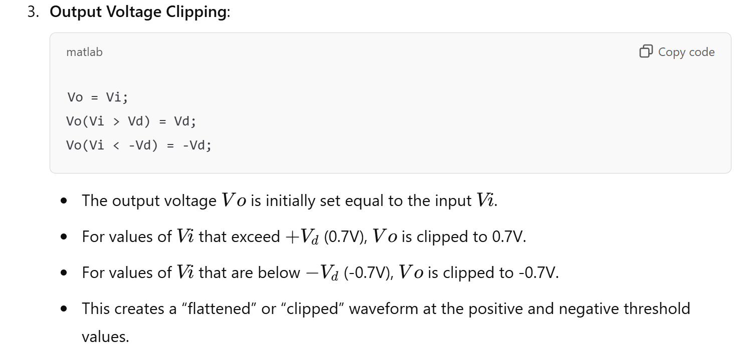

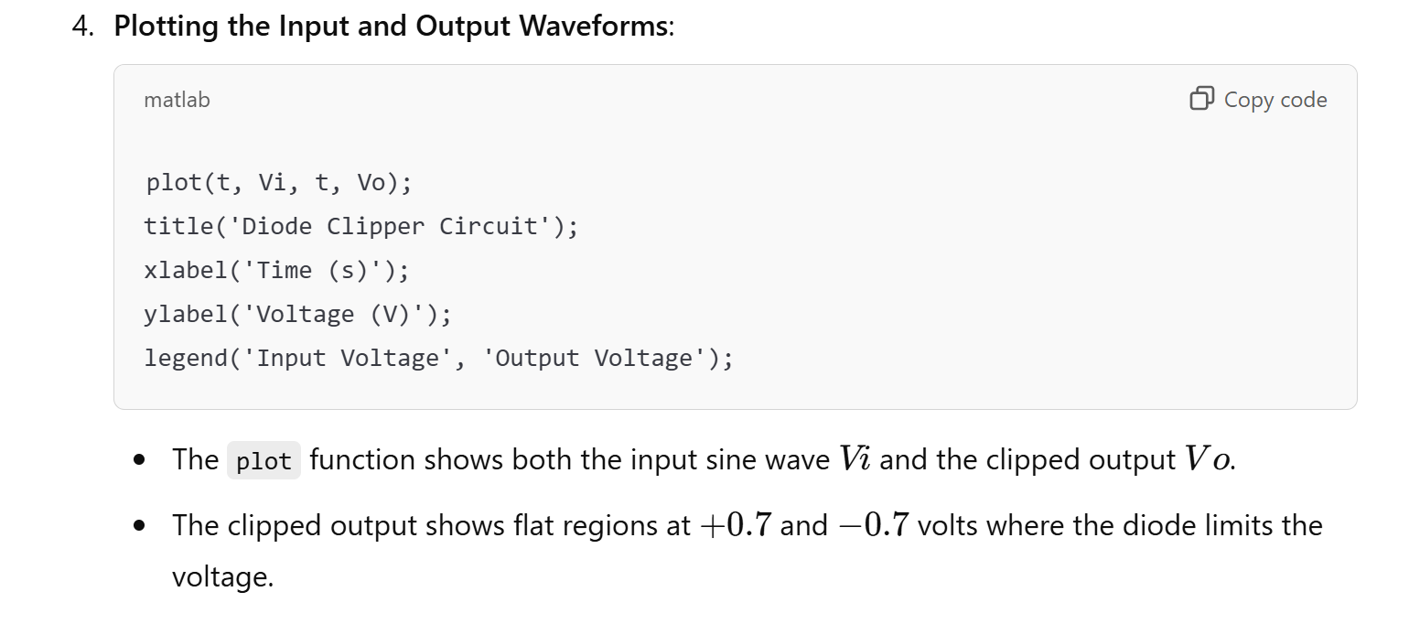

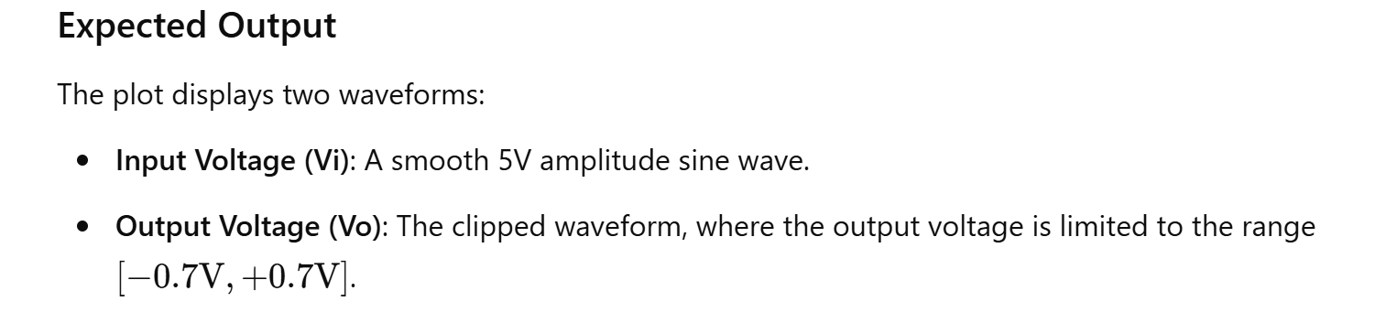

12. Phase Shift in RC Circuit

Theory: Calculate and plot the phase shift introduced by an RC circuit.

A single stage transistor amplifier can produce 180o of phase shift between its output and input signals when connected as a common-emitter type amplifier and we can use this configuration to produce an RC oscillator circuit.

But we can configure transistor stages to operate as oscillators by placing resistor-capacitor (RC) networks around the transistor to provide the required regenerative feedback without the need for a tank circuit. Frequency selective RC coupled amplifier circuits are easy to build and can be made to oscillate at any desired frequency by selecting the appropriate values of resistance and capacitance.

For an RC oscillator to sustain its oscillations indefinitely, sufficient feedback of the correct phase, that is positive (in-phase) Feedback must be provided along with the voltage gain of the single transistor amplifier being used to inject adequate loop gain into the closed-loop circuit in order to maintain oscillations allowing it to oscillates continuously at the selected frequency.

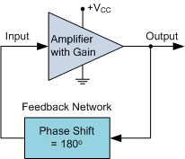

In an **RC Oscillator** circuit the input is shifted 180o through the feedback circuit returning the signal out-of-phase and 180o again through an inverting amplifier stage to produces the required positive feedback. This then gives us “180o + 180o = 360o” of phase shift which is effectively the same as 0o, thereby giving us the required positive feedback. In other words, the total phase shift of the feedback loop should be “0” or any multiple of 360o to obtain the same effect.

In a **Resistance-Capacitance Oscillator** or simply known as an **RC Oscillator**, we can make use of the fact that a phase shift occurs between the input to a RC network and the output from the same network by using interconnected RC elements in the feedback branch, for example.

**RC Phase-Shift Network**

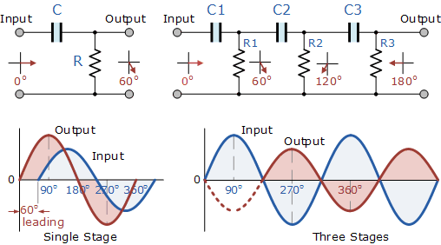

The circuit on the left shows a single resistor-capacitor network whose output voltage “leads” the input voltage by some angle less than 90o. In a pure or ideal single-pole RC network. it would produce a maximum phase shift of exactly 90o, and because 180o of phase shift is required for oscillation, at least two single-poles networks must be used within an *RC oscillator* design.

However in reality it is difficult to obtain exactly 90o of phase shift for each RC stage so we must therefore use more RC stages cascaded together to obtain the required value at the oscillation frequency. The amount of actual phase shift in the circuit depends upon the values of the resistor (R) and the capacitor (C), at the chosen frequency of oscillations with the phase angle ( φ ) being given as:

**RC Phase Angle**

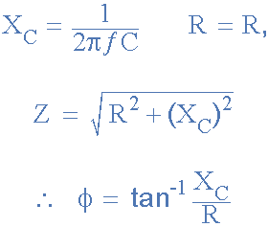

Where: XC is the Capacitive Reactance of the capacitor, R is the Resistance of the resistor, and ƒ is the Frequency.

In our simple example above, the values of R and C have been chosen so that at the required frequency the output voltage leads the input voltage by an angle of about 60o. Then the phase angle between each successive RC section increases by another 60o giving a phase difference between the input and output of 180o (3 x 60o) as shown by the following vector diagram.

**Vector Diagram**

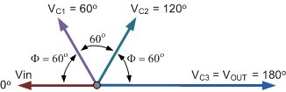

So by cascading together three such RC networks in series we can produce a total phase shift in the circuit of 180o at the chosen frequency and this forms the bases of a “RC Oscillator” otherwise known as a **Phase Shift Oscillator** as the phase angle is shifted by an amount through each stage of the circuit. Then the phase shift occurs in the phase difference between the individual RC stages. Conveniently op-amp circuits are available in quad IC packages. For example, the LM124, or the LM324, etc. so four RC stages could also be used to produce the required 180o of phase shift at the required oscillation frequency.

We know that in an amplifier circuit either using a Bipolar Transistor or an Inverting Operational Amplifier configuration, it will produce a phase-shift of 180o between its input and output. If a three-stage RC phase-shift network is connected as a feedback network between the output and input of an amplifier circuit, then the total phase shift created to produce the required regenerative feedback is: 3 x 60o + 180o = 360o = 0o as shown.

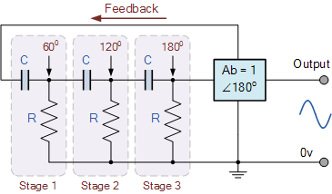

The three RC stages are cascaded together to obtain the required slope for a stable oscillation frequency. The feedback loop phase shift is -180o when the phase shift of each stage is -60o. This occurs when jω = 2piƒ = 1/1.732RC as (tan 60o = 1.732). Then to achieve the required phase shift in an RC oscillator circuit is to use multiple RC phase-shifting networks such as the circuit below.

**Basic RC Oscillator Circuit**

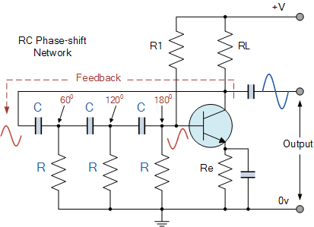

The basic **RC Oscillator** which is also known as a **Phase-shift Oscillator**, produces a sine wave output signal using regenerative feedback obtained from the resistor-capacitor (RC) ladder network. This regenerative feedback from the RC network is due to the ability of the capacitor to store an electric charge, (similar to the LC tank circuit).

This resistor-capacitor feedback network can be connected as shown above to produce a leading phase shift (phase advance network) or interchanged to produce a lagging phase shift (phase retard network) the outcome is still the same as the sine wave oscillations only occur at the frequency at which the overall phase-shift is 360o.

By varying one or more of the resistors or capacitors in the phase-shift network, the frequency can be varied and generally this is done by keeping the resistors the same and using a 3-ganged variable capacitor because capacitive reactance (XC) changes with a change in frequency as capacitors are frequency-sensitive components. However, it may be required to re-adjust the voltage gain of the amplifier for the new frequency.

If the three resistors, R are equal in value, that is R1 = R2 = R3, and the capacitors, C in the phase shift network are also equal in value, C1 = C2 = C3, then the frequency of oscillations produced by the RC oscillator is simply given as:

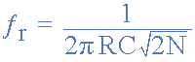

* Where:
* ƒr  is the oscillators output frequency in Hertz
* R   is the feedback resistance in Ohms
* C   is the feedback capacitance in Farads
* N   is the number of RC feedback stages.

This is the frequency at which the phase shift circuit oscillates. In our simple example above, the number of stages is given as three, so N = 3 (√2*3 = √6). For a four stage RC network, N = 4 (√2*4 = √8), etc.

Since the resistor-capacitor combination in the **RC Oscillator** ladder network also acts as an attenuator, that is the signal reduces by some amount as it passes through each passive stage.

It could be assumed that the three phase shift sections are independent of each other but this is not the case as the total accumulative feedback attenuation becomes -1/29th ( Vo/Vi = β = -1/29 ) across all three stages.

Thus the voltage gain of the amplifier must be sufficiently high enough to overcome these passive RC losses. Clearly then in order to produce a total loop gain of -1, in our three stage RC network above, the amplifier gain must be equal too, or greater than, 29 to compensate for the attenuation of the RC network.

The loading effect of the amplifier on the feedback network has an effect on the frequency of oscillations and can cause the oscillator frequency to be up to 25% higher than calculated. Then the feedback network should be driven from a high impedance output source and fed into a low impedance load such as a common emitter transistor amplifier but better still is to use an [Operational Amplifier](https://www.electronics-tutorials.ws/opamp/opamp_1.html)  as it satisfies these conditions perfectly.

**The Op-amp RC Oscillator**

When used as RC oscillators, **Operational Amplifier RC Oscillators** are more common than their bipolar transistors counterparts. The oscillator circuit consists of a negative-gain operational amplifier and a three section RC network that produces the 180o phase shift. The phase shift network is connected from the op-amps output back to its “inverting” input as shown below.

**Op-amp Phase-lead RC Oscillator Circuit**

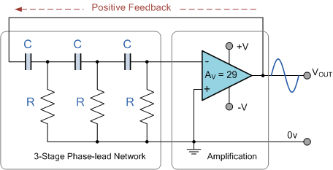

As the feedback is connected to the inverting input, the operational amplifier is therefore connected in its “inverting amplifier” configuration which produces the required 180o phase shift while the RC network produces the other 180o phase shift at the required frequency (180o + 180o). This type of feedback connection with the capacitors in series and the resistors connected to ground (0V) potential is known as a *phase-lead* configuration. In other words, the output voltage leads the input voltage producing a positive phase angle.

But we can also create a *phase-lag* configuration by simply changing the positions of the RC components so that the resistors are connected in series and the capacitors are connected to ground (0V) potential as shown. This means that the output voltage lags the input voltage producing a negative phase angle.

**Op-amp Phase-lag RC Oscillator Circuit**

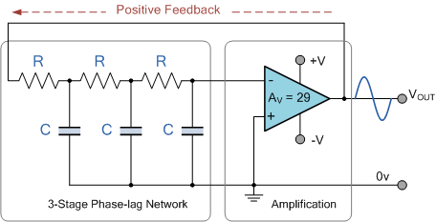

However, due to the reversal of the feedback components, the orginal equation for the frequency output of the phase-lead RC oscillator is modified to:

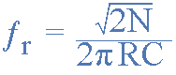

Although it is possible to cascade together only two single-pole RC stages to provide the required 180o of phase shift (90o + 90o), the stability of the oscillator at low frequencies is generally poor.

One of the most important features of an **RC Oscillator** is its frequency stability which is its ability to provide a constant frequency sine wave output under varying load conditions. By cascading three or even four RC stages together (4 x 45o), the stability of the oscillator can be greatly improved.

*RC Oscillators* with four stages are generally used because commonly available operational amplifiers come in quad IC packages so designing a 4-stage oscillator with 45o of phase shift relative to each other is relatively easy.

**RC Oscillators** are stable and provide a well-shaped sine wave output with the frequency being proportional to 1/RC and therefore, a wider frequency range is possible when using a variable capacitor. However, RC Oscillators are restricted to frequency applications because of their bandwidth limitations to produce the desired phase shift at high frequencies.

**RC Oscillator Example No1**

An operational amplifier based *3-stage RC Phase Shift Oscillator* is required to produce a sinusoidal output frequency of 4kHz. If 2.4nF capacitors are used in the feedback circuit, calculate the value of the frequency determining resistors and the value of the feedback resistor required to sustain oscillations. Also draw the circuit.

The standard equation given for the phase shift RC Oscillator is:



The circuit is to be a 3-stage RC oscillator which will therefore consist of equal resistors and three equal 2.4nF capacitors. As the frequency of oscillation is given as 4.0kHz, the value of the resistors are calculated as:

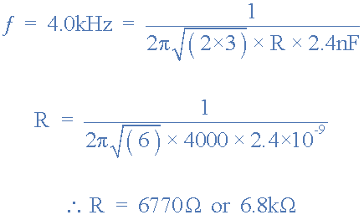

The operational amplifiers gain must be equal to 29 in order to sustain oscillations. The resistive value of the oscillation resistors are 6.8kΩ, therefore the value of the op-amps feedback resistor Rƒ is calculated as:

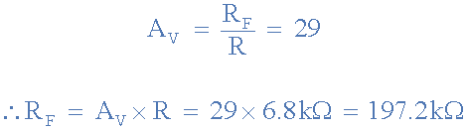

**RC Oscillator Op-amp Circuit**

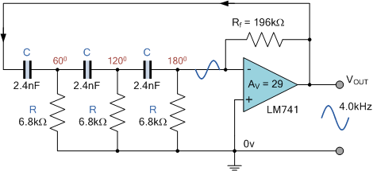

In the next tutorial about Oscillators, we will look at another type of **RC Oscillator** called a Wien Bridge Oscillators which uses resistors and capacitors as its tank circuit to produce a low frequency sinusoidal waveform.

MATLAB Code:

% Phase Shift in RC Circuit

R = 1e3; % Resistance in ohms

C = 1e-6; % Capacitance in farads

f = 1000; % Frequency in Hz

omega = 2*pi*f; % Angular frequency

phi = atan(1/(omega*R*C)); % Phase shift

disp(['Phase Shift: ', num2str(rad2deg(phi)), ' degrees']);

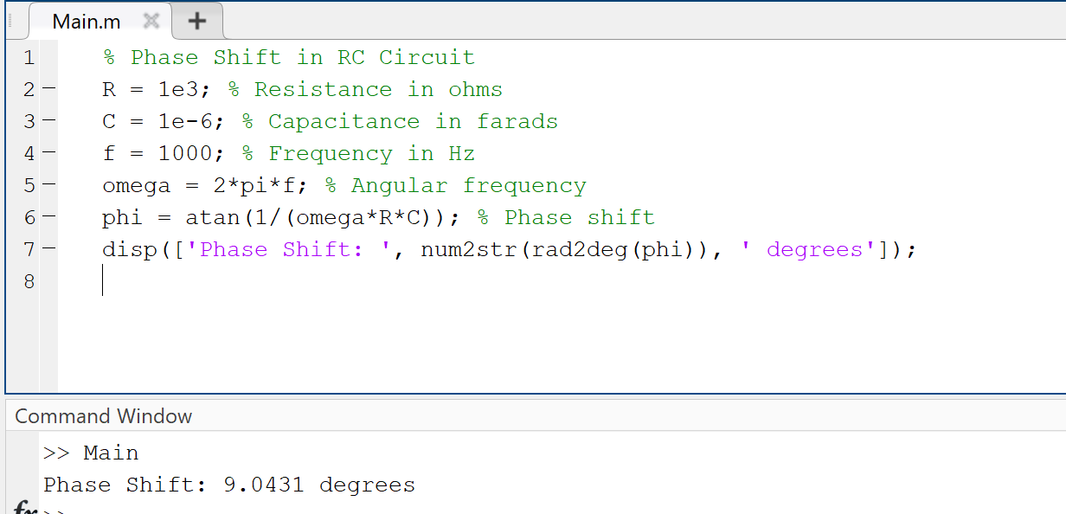

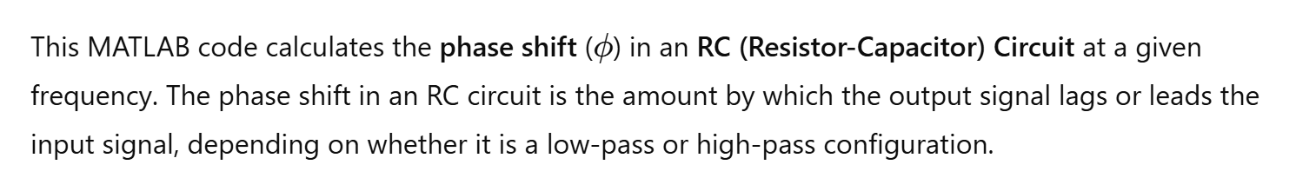

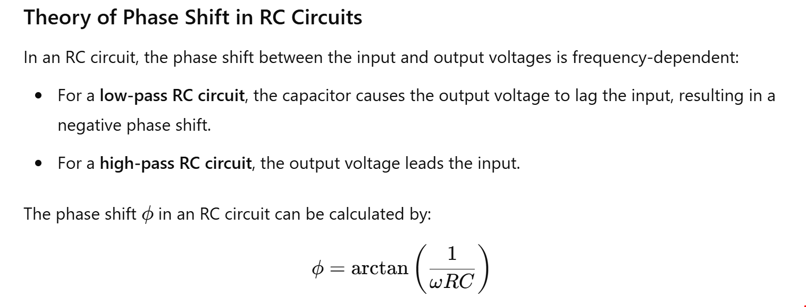

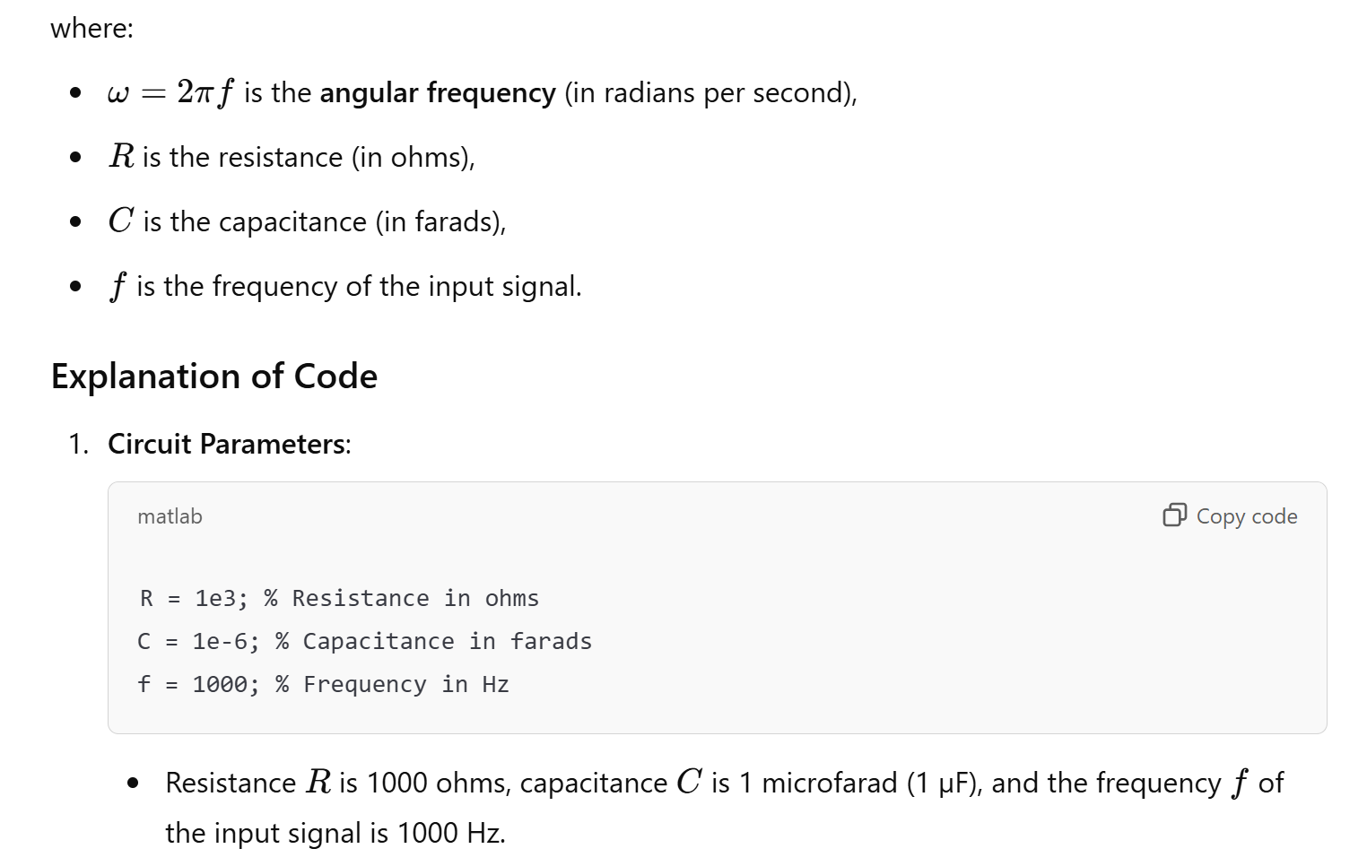

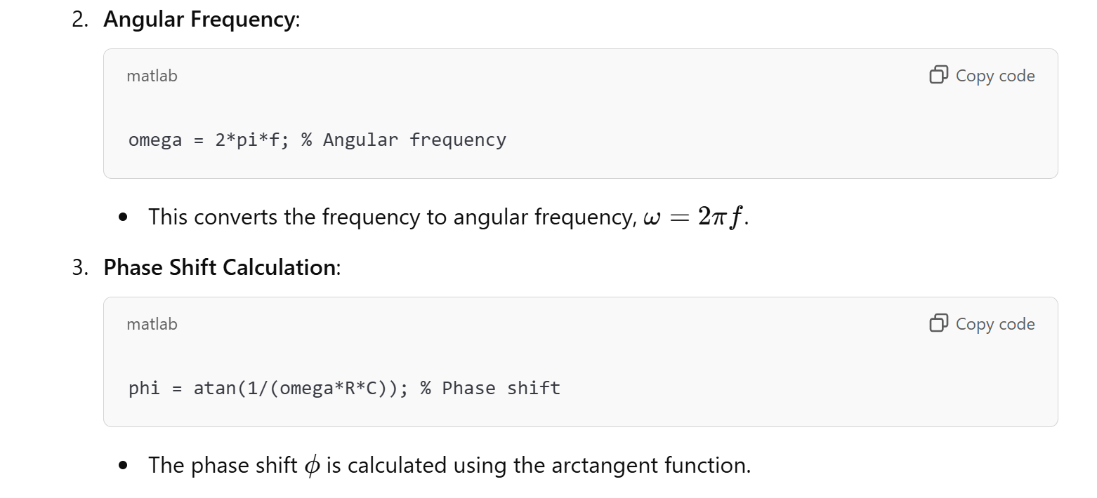

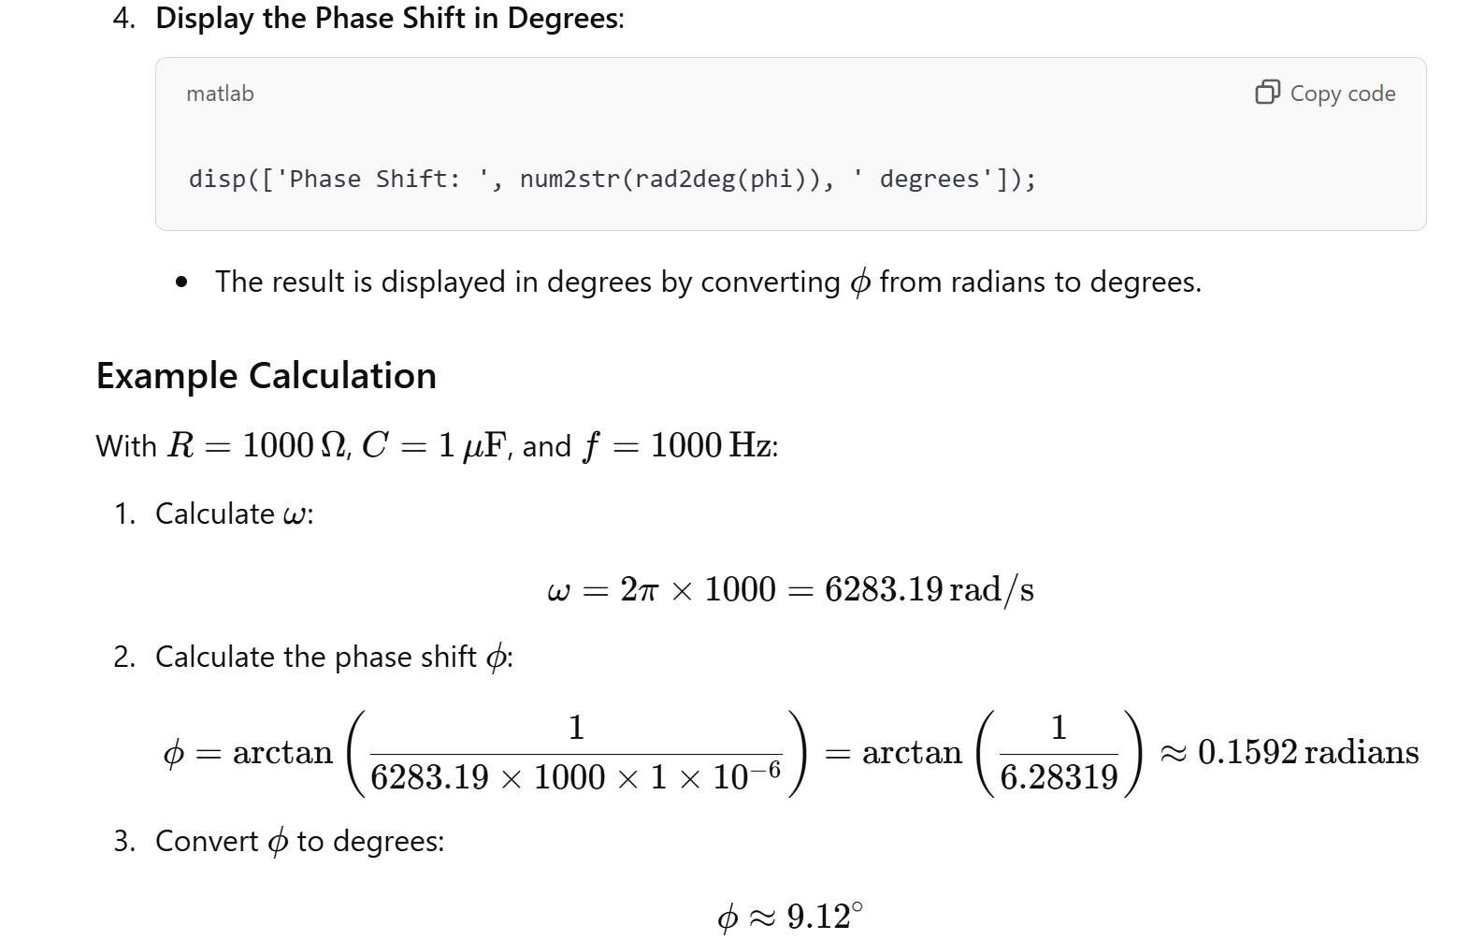

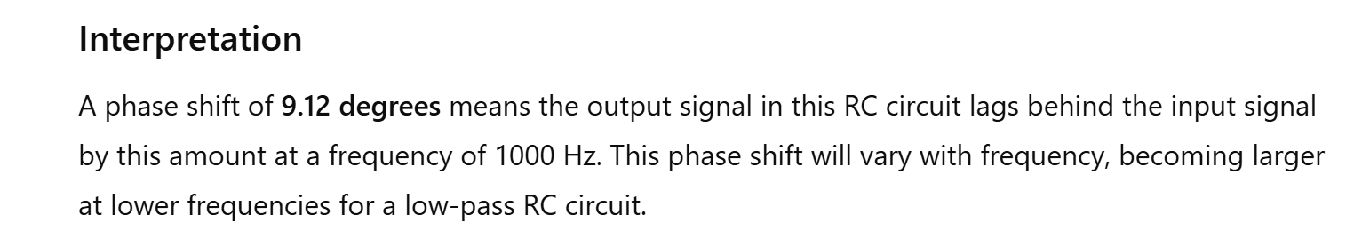

19. Bandpass Filter Design

# Passive Band Pass Filter

Passive Band Pass Filters can be made by connecting together a low pass filter with a high pass filter

The **Passive Band Pass Filter** can be used to isolate or filter out certain frequencies that lie within a particular band or range of frequencies. The cut-off frequency or ƒc point in a simple RC passive filter can be accurately controlled using just a single resistor in series with a non-polarized capacitor, and depending upon which way around they are connected, we have seen that either a Low Pass or a High Pass filter is obtained.

One simple use for these types of passive filters is in audio amplifier applications or circuits such as in loudspeaker crossover filters or pre-amplifier tone controls. Sometimes it is necessary to only pass a certain range of frequencies that do not begin at 0Hz, (DC) or end at some upper high frequency point but are within a certain range or band of frequencies, either narrow or wide.

By connecting or “cascading” together a single Low Pass Filter circuit with a High Pass Filter circuit, we can produce another type of passive RC filter that passes a selected range or “band” of frequencies that can be either narrow or wide while attenuating all those outside of this range.

This new type of passive filter arrangement produces a frequency selective filter known commonly as a **Band Pass Filter** or **BPF** for short.

### Typical Band Pass Filter Circuit

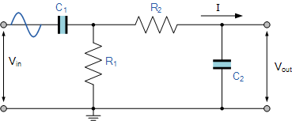

Unlike the low pass filter which only pass signals of a low frequency range or the high pass filter which pass signals of a higher frequency range, a **Band Pass Filters** passes signals within a certain “band” or “spread” of frequencies without distorting the input signal or introducing extra noise. This band of frequencies can be any width and is commonly known as the filters **Bandwidth**.

Bandwidth is commonly defined as the frequency range that exists between two specified frequency cut-off points ( ƒc ), that are 3dB below the maximum centre or resonant peak while attenuating or weakening the others outside of these two points.

Then for widely spread frequencies, we can simply define the term “bandwidth”, BW as being the difference between the lower cut-off frequency ( ƒcLOWER ) and the higher cut-off frequency ( ƒcHIGHER ) points. In other words, BW = ƒH – ƒL. Clearly for a pass band filter to function correctly, the cut-off frequency of the low pass filter must be higher than the cut-off frequency for the high pass filter.

The “ideal” **Band Pass Filter** can also be used to isolate or filter out certain frequencies that lie within a particular band of frequencies, for example, noise cancellation. Band pass filters are known generally as second-order filters, (two-pole) because they have “two” reactive component, the capacitors, within their circuit design. One capacitor in the low pass circuit and another capacitor in the high pass circuit.

### Frequency Response of a 2nd Order Band Pass Filter

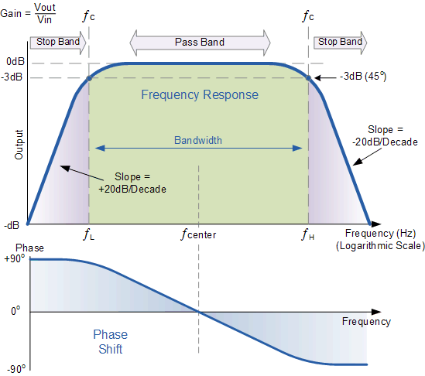

The **Bode Plot** or frequency response curve above shows the characteristics of the band pass filter. Here the signal is attenuated at low frequencies with the output increasing at a slope of +20dB/Decade (6dB/Octave) until the frequency reaches the “lower cut-off” point ƒL. At this frequency the output voltage is again 1/√2 = 70.7% of the input signal value or **-3dB** (20*log(VOUT/VIN)) of the input.

The output continues at maximum gain until it reaches the “upper cut-off” point ƒH where the output decreases at a rate of -20dB/Decade (6dB/Octave) attenuating any high frequency signals. The point of maximum output gain is generally the geometric mean of the two -3dB value between the lower and upper cut-off points and is called the “Centre Frequency” or “Resonant Peak” value ƒr. This geometric mean value is calculated as being ƒr2 = ƒ(UPPER) x ƒ(LOWER).

A band pass filter is regarded as a second-order (two-pole) type filter because it has “two” reactive components within its circuit structure, then the phase angle will be twice that of the previously seen first-order filters, ie, **180o**.

The phase angle of the output signal **LEADS** that of the input by **+90o** up to the centre or resonant frequency, ƒr point were it becomes “zero” degrees (0o) or “in-phase” and then changes to **LAG** the input by **-90o** as the output frequency increases.

The upper and lower cut-off frequency points for a band pass filter can be found using the same formula as that for both the low and high pass filters, For example.

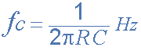

Then clearly, the width of the pass band of the filter can be controlled by the positioning of the two cut-off frequency points of the two filters.

## Band Pass Filter Example No1.

A second-order **band pass filter** is to be constructed using RC components that will only allow a range of frequencies to pass above 1kHz (1,000Hz) and below 30kHz (30,000Hz). Assuming that both the resistors have values of 10kΩ, calculate the values of the two capacitors required.

### The High Pass Filter Stage

The value of the capacitor C1 required to give a cut-off frequency ƒL of 1kHz with a resistor value of 10kΩ is calculated as:

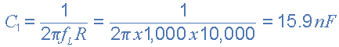

Then, the values of R1 and C1 required for the high pass stage to give a cut-off frequency of 1.0kHz are: R1 = 10kΩ and to the nearest preferred value, C1 = 15nF.

### The Low Pass Filter Stage

The value of the capacitor C2 required to give a cut-off frequency ƒH of 30kHz with a resistor value of 10kΩ is calculated as:

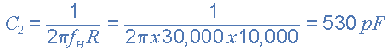

Then, the values of R2 and C2 required for the low pass stage to give a cut-off frequency of 30kHz are, R = 10kΩ and C = 530pF. However, the nearest preferred value of the calculated capacitor value of 530pF is 560pF, so this is used instead.

With the values of both the resistances R1 and R2 given as 10kΩ, and the two values of the capacitors C1 and C2 found for both the high pass and low pass filters as 15nF and 560pF respectively, then the circuit for our simple passive **Band Pass Filter** is given as.

### Completed Band Pass Filter Circuit

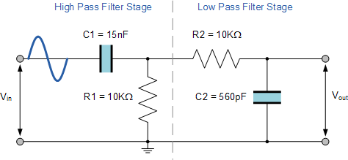

## The Filters Resonant Frequency

We can also calculate the “Resonant” or “Centre Frequency” (ƒr) point of the band pass filter were the output gain is at its maximum or peak value. This peak value is not the arithmetic average of the upper and lower -3dB cut-off points as you might expect but is in fact the “geometric” or mean value. This geometric mean value is calculated as being ƒr2 = ƒc(UPPER) x ƒc(LOWER) for example:

### Centre Frequency Equation

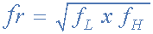

* Where, ƒr is the resonant or centre frequency
* ƒL is the lower -3dB cut-off frequency point
* ƒH is the upper -3db cut-off frequency point

and in our simple example above, the calculated cut-off frequencies were found to be ƒL = 1,060 Hz and ƒH = 28,420 Hz using the filter values.

Then by substituting these values into the above equation gives a central resonant frequency of:



## Band Pass Summary

A simple passive **Band Pass Filter** can be made by cascading together a single **Low Pass Filter** with a **High Pass Filter**. The frequency range, in Hertz, between the lower and upper -3dB cut-off points of the RC combination is know as the filters “Bandwidth”.

The width or frequency range of the filters bandwidth can be very small and selective, or very wide and non-selective depending upon the values of R and C used.

The centre or resonant frequency point is the geometric mean of the lower and upper cut-off points. At this centre frequency the output signal is at its maximum and the phase shift of the output signal is the same as the input signal.

The amplitude of the output signal from a band pass filter or any passive RC filter for that matter, will always be less than that of the input signal. In other words a passive filter is also an attenuator giving a voltage gain of less than 1 (Unity). To provide an output signal with a voltage gain greater than unity, some form of amplification is required within the design of the circuit.

A **Passive Band Pass Filter** is classed as a second-order type filter because it has two reactive components within its design, the capacitors. It is made up from two single RC filter circuits that are each first-order filters themselves.

If more filters are cascaded together the resulting circuit will be known as an “nth-order” filter where the “n” stands for the number of individual reactive components and therefore poles within the filter circuit. For example, filters can be a 2nd-order, 4th-order, 10th-order, etc.

The higher the filters order the steeper will be the slope at n times -20dB/decade. However, a single capacitor value made by combining together two or more individual capacitors is still one capacitor.

Our example above shows the output frequency response curve for an “ideal” band pass filter with constant gain in the pass band and zero gain in the stop bands. In practice the frequency response of this Band Pass Filter circuit would not be the same as the input reactance of the high pass circuit would affect the frequency response of the low pass circuit (components connected in series or parallel) and vice versa. One way of overcoming this would be to provide some form of electrical isolation between the two filter circuits as shown below.

### Buffering Individual Filter Stages

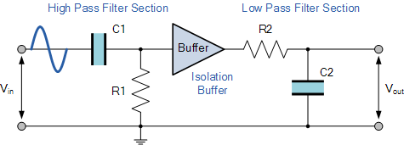

One way of combining amplification and filtering into the same circuit would be to use an Operational Amplifier or Op-amp, and examples of these are given in the Operational Amplifier section.

In the next tutorial we will look at filter circuits which use an operational amplifier within their design to not only to introduce gain but provide isolation between stages. These types of filter arrangements are generally known as **Active Filters**.

Theory: Design and simulate a bandpass filter.

MATLAB Code:

% Bandpass Filter Design

Fs = 1000; % Sampling frequency

Fpass1 = 100; % First passband frequency

Fpass2 = 200; % Second passband frequency

N = 50; % Filter order

bpFilt = designfilt('bandpassfir', 'FilterOrder', N, ...

'CutoffFrequency1', Fpass1, 'CutoffFrequency2', Fpass2, ...

'SampleRate', Fs);

fvtool(bpFilt);

title('Bandpass Filter Design');

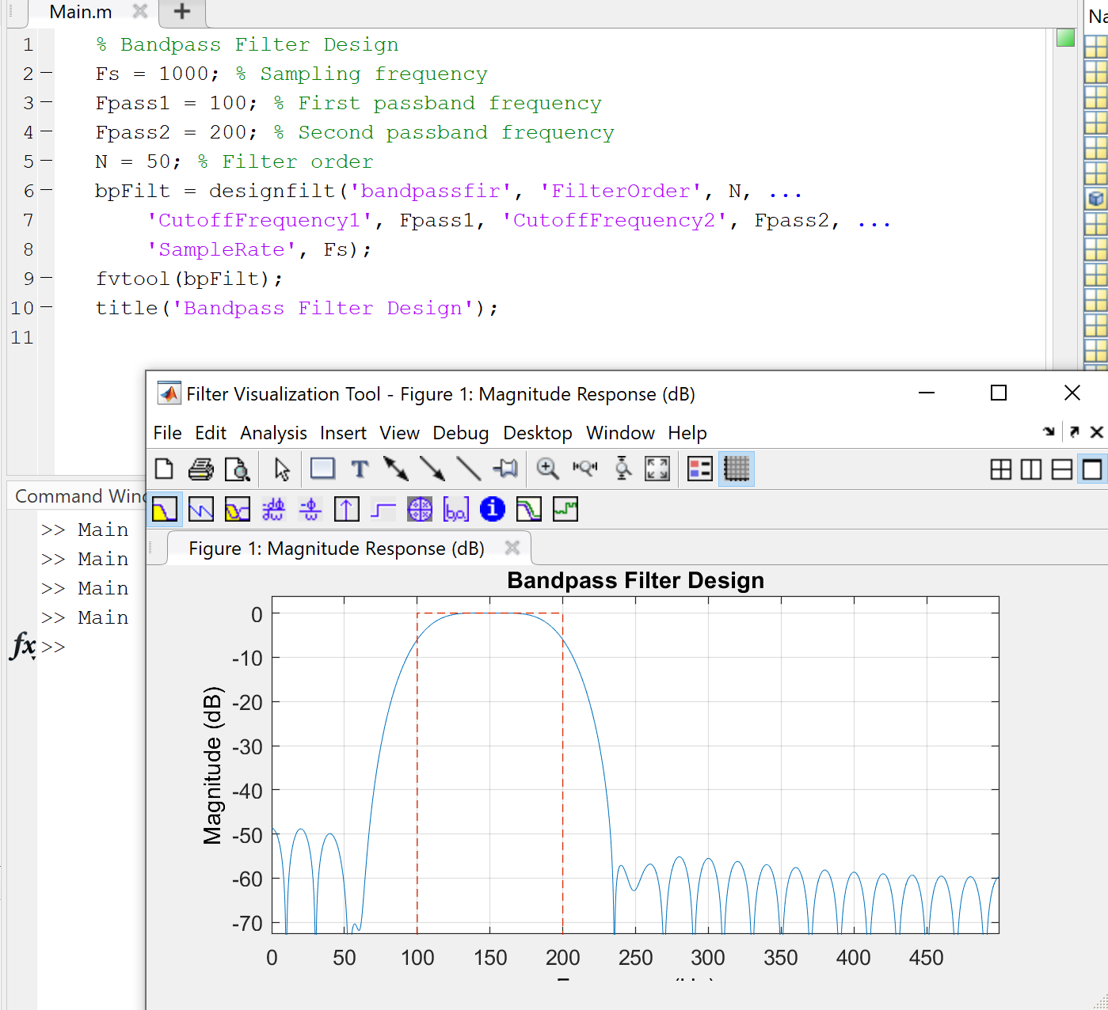

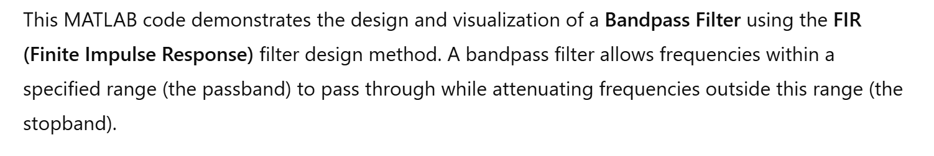

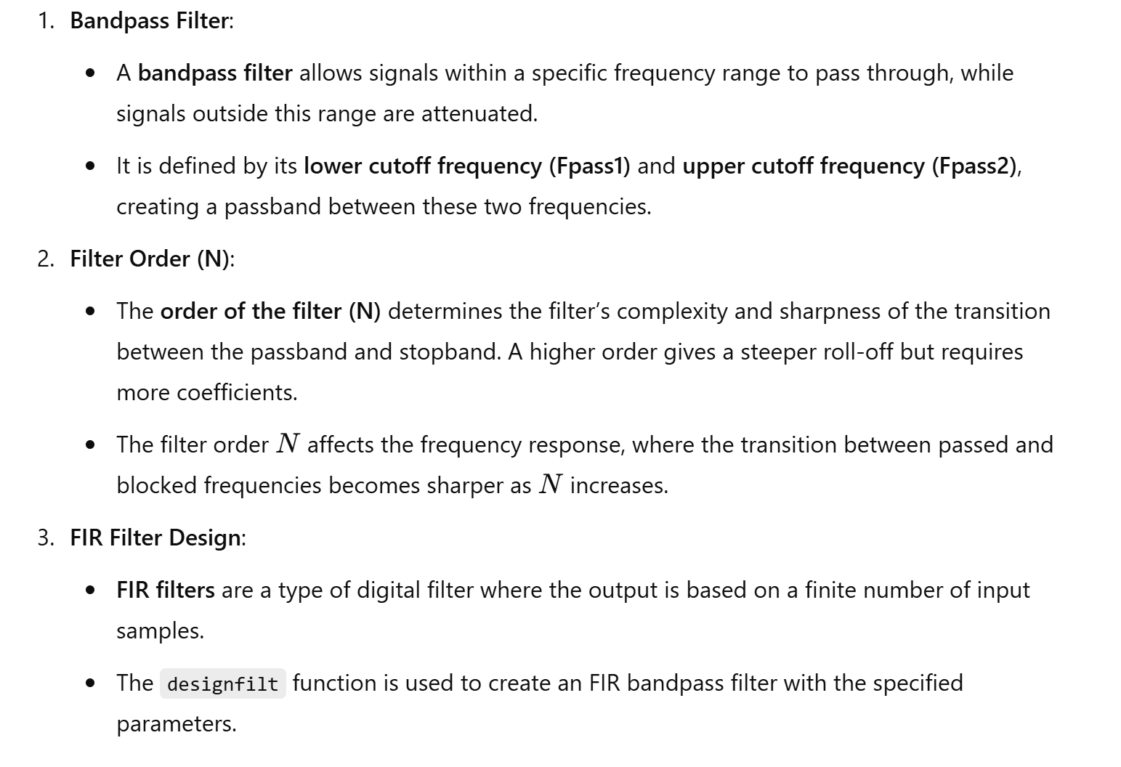

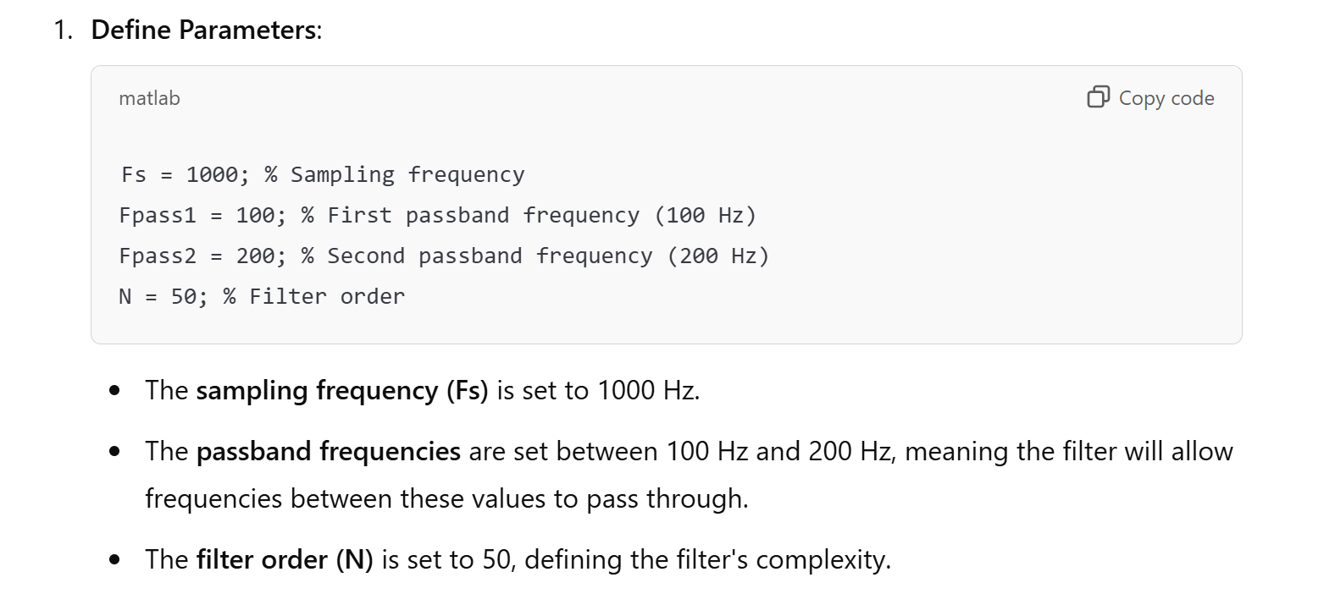

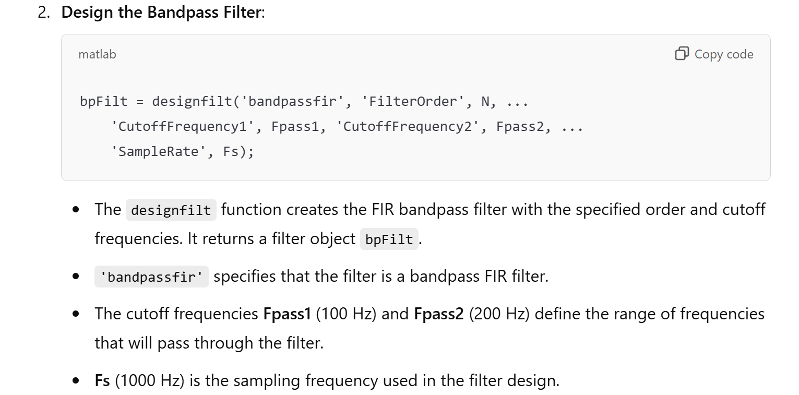

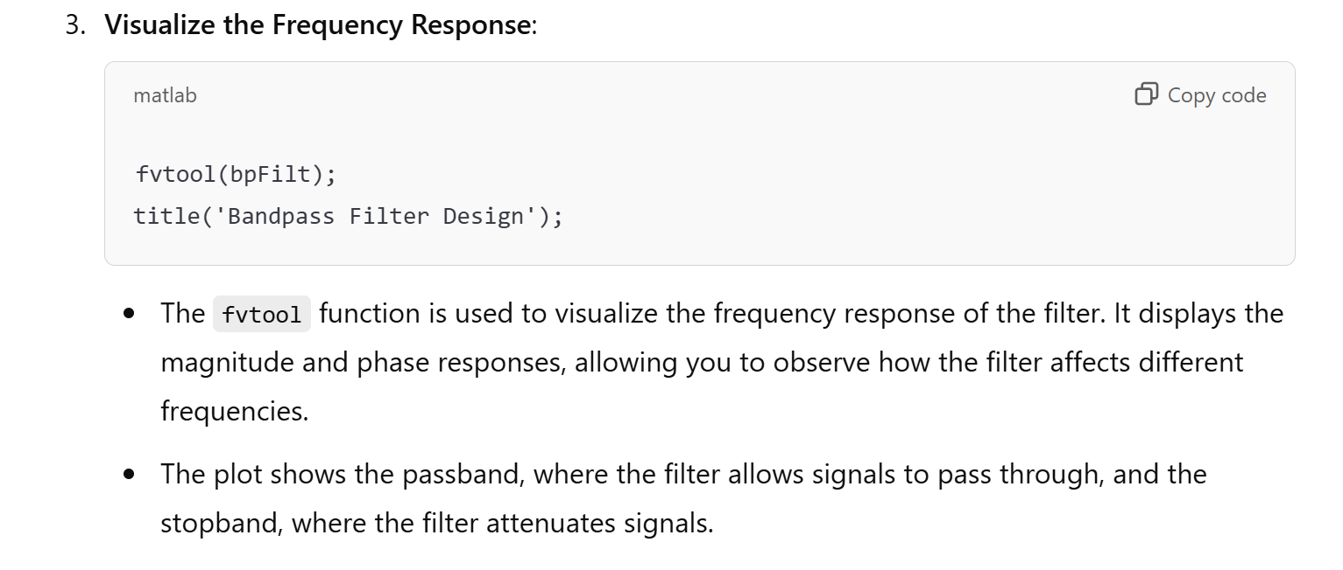

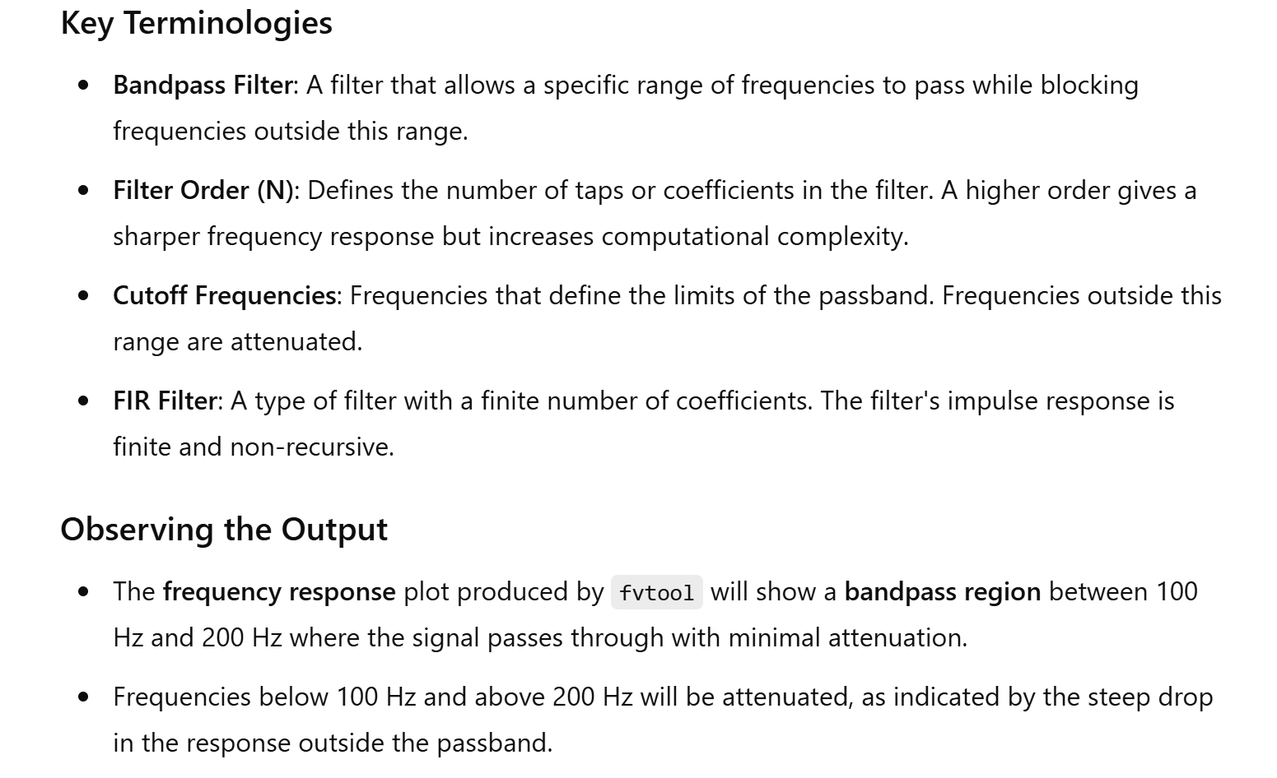

20. Operational Amplifier (Op-Amp) Inverting Amplifier

Theory: Analyze the behavior of an inverting amplifier using an operational amplifier.

# Inverting Operational Amplifier

The Inverting Operational Amplifier configuration is one of the simplest and most commonly used op-amp topologies

The inverting operational amplifier is basically a constant or fixed-gain amplifier producing a negative output voltage as its gain is always negative.

We saw in the last tutorial that the **Open Loop Gain**, ( AVO ) of an operational amplifier can be very high, as much as 1,000,000 (120dB) or more.

However, this very high gain is of no real use to us as it makes the amplifier both unstable and hard to control as the smallest of input signals, just a few micro-volts, (μV) would be enough to cause the output voltage to saturate and swing towards one or the other of the voltage supply rails losing complete control of the output.

As the open loop DC gain of an operational amplifier is extremely high we can therefore afford to lose some of this high gain by connecting a suitable resistor across the amplifier from the output terminal back to the inverting input terminal to both reduce and control the overall gain of the amplifier. This then produces and effect known commonly as Negative Feedback, and thus produces a very stable Operational Amplifier based system.

**Negative Feedback** is the process of “feeding back” a fraction of the output signal back to the input, but to make the feedback negative, we must feed it back to the negative or “inverting input” terminal of the op-amp using an external **Feedback Resistor** called Rƒ. This feedback connection between the output and the inverting input terminal forces the differential input voltage towards zero.

This effect produces a closed loop circuit to the amplifier resulting in the gain of the amplifier now being called its **Closed-loop Gain**. Then a closed-loop inverting amplifier uses negative feedback to accurately control the overall gain of the amplifier, but at a cost in the reduction of the amplifiers gain.

This negative feedback results in the inverting input terminal having a different signal on it than the actual input voltage as it will be the sum of the input voltage plus the negative feedback voltage giving it the label or term of a Summing Point. We must therefore separate the real input signal from the inverting input by using an **Input Resistor**, Rin.

As we are not using the positive non-inverting input this is connected to a common ground or zero voltage terminal as shown below, but the effect of this closed loop feedback circuit results in the voltage potential at the inverting input being equal to that at the non-inverting input producing a Virtual Earth summing point because it will be at the same potential as the grounded reference input. In other words, the op-amp becomes a “differential amplifier”.

### Inverting Operational Amplifier Configuration

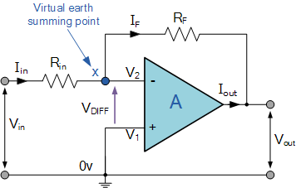

In this **Inverting Amplifier** circuit the operational amplifier is connected with feedback to produce a closed loop operation. When dealing with operational amplifiers there are two very important rules to remember about inverting amplifiers, these are: “No current flows into the input terminal” and that “V1 always equals V2”. However, in real world op-amp circuits both of these rules are slightly broken.

This is because the junction of the input and feedback signal ( X ) is at the same potential as the positive ( + ) input which is at zero volts or ground then, the junction is a **“Virtual Earth”**. Because of this virtual earth node the input resistance of the amplifier is equal to the value of the input resistor, Rin and the closed loop gain of the inverting amplifier can be set by the ratio of the two external resistors.

We said above that there are two very important rules to remember about **Inverting Amplifiers** or any operational amplifier for that matter and these are.

* No Current Flows into the Input Terminals
* The Differential Input Voltage is Zero as V1 = V2 = 0 (Virtual Earth)

Then by using these two rules we can derive the equation for calculating the closed-loop gain of an inverting amplifier, using first principles.

Current ( i ) flows through the resistor network as shown.

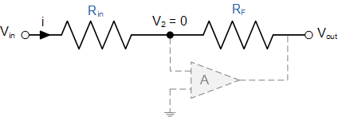

Then, the **Closed-Loop Voltage Gain** of an Inverting Amplifier is given as.

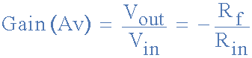

and this can be transposed to give Vout as:



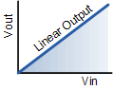

Linear Output

The negative sign in the equation indicates an inversion of the output signal with respect to the input as it is 180o out of phase. This is due to the feedback being negative in value.

The equation for the output voltage Vout also shows that the circuit is linear in nature for a fixed amplifier gain as Vout = Vin x Gain. This property can be very useful for converting a smaller sensor signal to a much larger voltage.

Another useful application of an inverting amplifier is that of a “transresistance amplifier” circuit. A **Transresistance Amplifier** also known as a “transimpedance amplifier”, is basically a current-to-voltage converter (Current “in” and Voltage “out”). They can be used in low-power applications to convert a very small current generated by a photo-diode or photo-detecting device etc, into a usable output voltage which is proportional to the input current as shown.

### Transresistance Amplifier Circuit

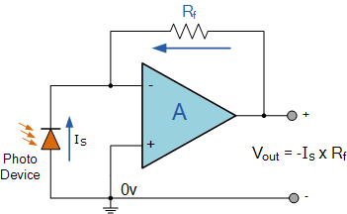

The simple light-activated circuit above, converts a current generated by the photo-diode into a voltage. The feedback resistor Rƒ sets the operating voltage point at the inverting input and controls the amount of output. The output voltage is given as Vout = Is x Rƒ. Therefore, the output voltage is proportional to the amount of input current generated by the photo-diode.

## Inverting Operational Amplifier Example No1

Find the closed loop gain of the following inverting amplifier circuit.

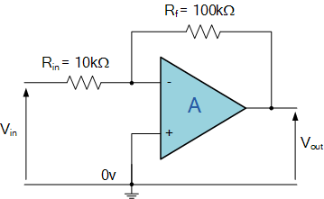

Using the previously found formula for the gain of the circuit



we can now substitute the values of the resistors in the circuit as follows,

Rin = 10kΩ  and  Rƒ = 100kΩ

and the gain of the circuit is calculated as: -Rƒ/Rin = 100k/10k = -10

Therefore, the closed loop gain of the inverting amplifier circuit above is given **-10** or **20dB** (20log(10)).

## Inverting Operational Amplifier Example No2

The gain of the original circuit is to be increased to **40** (32dB), find the new values of the resistors required.

Assuming that the input resistor is to remain at the same value of 10KΩ, then by re-arranging the closed loop voltage gain formula we can find the new value required for the feedback resistor Rƒ.

   Gain = Rƒ/Rin

therefore,   Rƒ = Gain x Rin

  Rƒ = 40 x 10,000

  Rƒ = 400,000 or 400KΩ

The new values of resistors required for the circuit to have a gain of **40** would be:

 Rin = 10KΩ  and  Rƒ = 400KΩ

The formula could also be rearranged to give a new value of Rin, keeping the same value of Rƒ.

One final point to note about the **Inverting Amplifier** configuration for an operational amplifier, if the two resistors are of equal value, Rin = Rƒ  then the gain of the amplifier will be **-1** producing a complementary form of the input voltage at its output as Vout = -Vin. This type of inverting amplifier configuration is generally called a **Unity Gain Inverter** of simply an Inverting Buffer.

In the next tutorial about Operational Amplifiers, we will analyse the complement of the **Inverting Amplifier** operational amplifier circuit called the Non-inverting Amplifier that produces an output signal which is “in-phase” with the input.

MATLAB Code:

% Op-Amp Inverting Amplifier

Rin = 10e3; % Input resistor in ohms

Rf = 100e3; % Feedback resistor in ohms

Av = -Rf/Rin; % Voltage gain

Vin = 1; % Input voltage in volts

Vout = Av * Vin; % Output voltage

disp(['Output Voltage: ', num2str(Vout), ' V']);

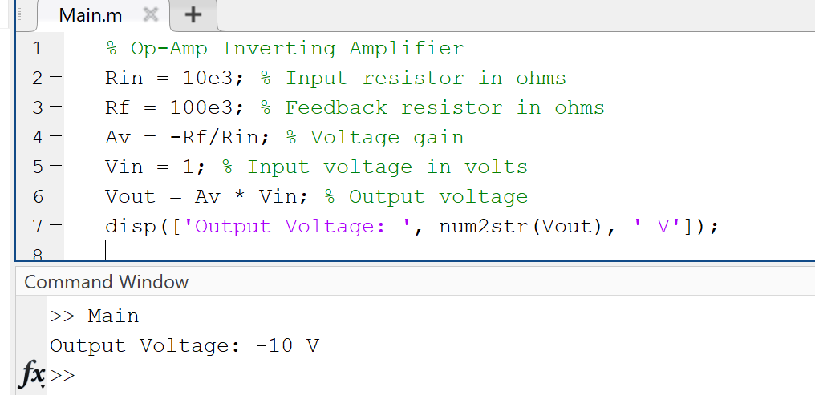

21. Butterworth Low Pass Filter Design

# Butterworth Filter Design

In the previous filter tutorials we looked at simple first-order type low and high pass filters that contain only one single resistor and a single reactive component (a capacitor) within their RC filter circuit design.

The Butterworth filter is an analogue filter design which produces the best output response with no ripple in the pass band or the stop band resulting in a maximally flat filter response but at the expense of a relatively wide transition band.

In applications that use filters to shape the frequency spectrum of a signal such as in communications or control systems, the shape or width of the roll-off also called the “transition band”. For simple first-order filters this transition band maybe too long or too wide, so active filters designed with more than one “order” are required. These types of filters are commonly known as “High-order” or “nth-order” filters.

The complexity or filter type is defined by the filters “order”, and which is dependant upon the number of reactive components such as capacitors or inductors within its design. We also know that the rate of roll-off and therefore the width of the transition band, depends upon the order number of the filter and that for a simple first-order filter it has a standard roll-off rate of 20dB/decade or 6dB/octave.

Then, for a filter that has an nth number order, it will have a subsequent roll-off rate of 20n dB/decade or 6n dB/octave. So a first-order filter has a roll-off rate of 20dB/decade (6dB/octave), a second-order filter has a roll-off rate of 40dB/decade (12dB/octave), and a fourth-order filter has a roll-off rate of 80dB/decade (24dB/octave), etc, etc.

High-order filters, such as third, fourth, and fifth-order are usually formed by cascading together single first-order and second-order filters.

For example, two second-order low pass filters can be cascaded together to produce a fourth-order low pass filter, and so on. Although there is no limit to the order of the filter that can be formed, as the order increases so does its size and cost, also its accuracy declines.

## Decades and Octaves

One final comment about Decades and Octaves. On the frequency scale, a **Decade** is a tenfold increase (multiply by 10) or tenfold decrease (divide by 10). For example, 2 to 20Hz represents one decade, whereas 50 to 5000Hz represents two decades (50 to 500Hz and then 500 to 5000Hz).

An **Octave** is a doubling (multiply by 2) or halving (divide by 2) of the frequency scale. For example, 10 to 20Hz represents one octave, while 2 to 16Hz is three octaves (2 to 4, 4 to 8 and finally 8 to 16Hz) doubling the frequency each time. Either way, Logarithmic scales are used extensively in the frequency domain to denote a frequency value when working with amplifiers and filters so it is important to understand them.

### Logarithmic Frequency Scale

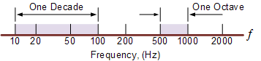

Since the frequency determining resistors are all equal, and as are the frequency determining capacitors, the cut-off or corner frequency ( ƒC ) for either a first, second, third or even a fourth-order filter must also be equal and is found by using our now old familiar equation:



As with the first and second-order filters, the third and fourth-order high pass filters are formed by simply interchanging the positions of the frequency determining components (resistors and capacitors) in the equivalent low pass filter. High-order filters can be designed by following the procedures we saw previously in the Low Pass filter and High Pass filter tutorials. However, the overall gain of high-order filters is **fixed** because all the frequency determining components are equal.

## Filter Approximations

So far we have looked at a low and high pass first-order filter circuits, their resultant frequency and phase responses. An ideal filter would give us specifications of maximum pass band gain and flatness, minimum stop band attenuation and also a very steep pass band to stop band roll-off (the transition band) and it is therefore apparent that a large number of network responses would satisfy these requirements.

Not surprisingly then that there are a number of “approximation functions” in linear analogue filter design that use a mathematical approach to best approximate the transfer function we require for the filters design.

Such designs are known as **Elliptical**, **Butterworth**, **Chebyshev**, **Bessel**, **Cauer** as well as many others. Of these five “classic” linear analogue filter approximation functions only the **Butterworth Filter** and especially the low pass Butterworth filter design will be considered here as its the most commonly used function.

## Low Pass Butterworth Filter Design

The frequency response of the **Butterworth Filter** approximation function is also often referred to as “maximally flat” (no ripples) response because the pass band is designed to have a frequency response which is as flat as mathematically possible from 0Hz (DC) until the cut-off frequency at -3dB with no ripples. Higher frequencies beyond the cut-off point rolls-off down to zero in the stop band at 20dB/decade or 6dB/octave. This is because it has a “quality factor”, “Q” of just 0.707.

However, one main disadvantage of the Butterworth filter is that it achieves this pass band flatness at the expense of a wide transition band as the filter changes from the pass band to the stop band. It also has poor phase characteristics as well. The ideal frequency response, referred to as a “brick wall” filter, and the standard Butterworth approximations, for different filter orders are given below.

### Ideal Frequency Response for a Butterworth Filter

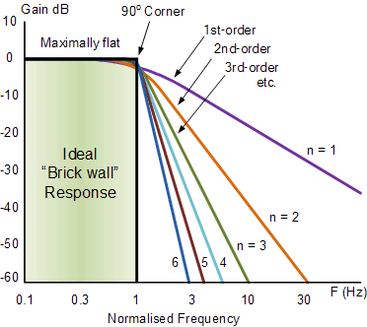

Note that the higher the Butterworth filter order, the higher the number of cascaded stages there are within the filter design, and the closer the filter becomes to the ideal “brick wall” response.

In practice however, Butterworth’s ideal frequency response is unattainable as it produces excessive passband ripple.

Where the generalised equation representing a “nth” Order Butterworth filter, the frequency response is given as:

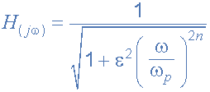

Where: n represents the filter order, Omega ω is equal to 2πƒ and Epsilon ε is the maximum pass band gain, (Amax). If Amax is defined at a frequency equal to the cut-off -3dB corner point (ƒc), ε will then be equal to one and therefore ε2 will also be one. However, if you now wish to define Amax at a different voltage gain value, for example 1dB, or 1.1220 (1dB = 20*logAmax) then the new value of epsilon, ε is found by:

|  |  |
| --- | --- |
| pass band gain formula | * Where: * H0 = the Maximum Pass band Gain, Amax. * H1 = the Minimum Pass band Gain. |

Transpose the equation to give:

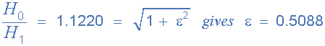

The **Frequency Response** of a filter can be defined mathematically by its **Transfer Function** with the standard Voltage Transfer Function H(jω) written as:

|  |  |
| --- | --- |
| voltage transfer function | * Where: * Vout = the output signal voltage. * Vin  = the input signal voltage. * j   = to the square root of -1 (√-1) * ω  = the radian frequency (2πƒ) |

Note: ( jω ) can also be written as ( s ) to denote the **S-domain.** and the resultant transfer function for a second-order low pass filter is given as:

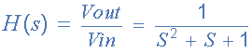

### Normalised Low Pass Butterworth Filter Polynomials

To help in the design of his low pass filters, Butterworth produced standard tables of normalised second-order low pass polynomials given the values of coefficient that correspond to a cut-off corner frequency of 1 radian/sec.

|  |  |
| --- | --- |
| **n** | **Normalised Denominator Polynomials in Factored Form** |
| 1 | (1+s) |
| 2 | (1+1.414s+s2) |
| 3 | (1+s)(1+s+s2) |
| 4 | (1+0.765s+s2)(1+1.848s+s2) |
| 5 | (1+s)(1+0.618s+s2)(1+1.618s+s2) |
| 6 | (1+0.518s+s2)(1+1.414s+s2)(1+1.932s+s2) |
| 7 | (1+s)(1+0.445s+s2)(1+1.247s+s2)(1+1.802s+s2) |
| 8 | (1+0.390s+s2)(1+1.111s+s2)(1+1.663s+s2)(1+1.962s+s2) |
| 9 | (1+s)(1+0.347s+s2)(1+s+s2)(1+1.532s+s2)(1+1.879s+s2) |
| 10 | (1+0.313s+s2)(1+0.908s+s2)(1+1.414s+s2)(1+1.782s+s2)(1+1.975s+s2) |

## Filter Design – Butterworth Low Pass

Find the order of an active low pass Butterworth filter whose specifications are given as: Amax = 0.5dB at a pass band frequency (ωp) of 200 radian/sec (31.8Hz), and Amin = -20dB at a stop band frequency (ωs) of 800 radian/sec. Also design a suitable Butterworth filter circuit to match these requirements.

Firstly, the maximum pass band gain Amax = 0.5dB which is equal to a gain of **1.0593**, remember that: 0.5dB = 20*log(A) at a frequency (ωp) of 200 rads/s, so the value of epsilon ε is found by:

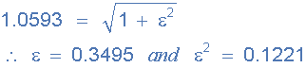

Secondly, the minimum stop band gain Amin = -20dB which is equal to a gain of **10** (-20dB = 20*log(A)) at a stop band frequency (ωs) of 800 rads/s or 127.3Hz.

Substituting the values into the general equation for a Butterworth filters frequency response gives us the following:

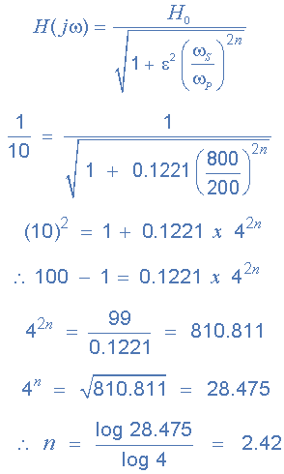

Since n must always be an integer ( whole number ) then the next highest value to 2.42 is n = 3, therefore a **“a third-order filter is required”** and to produce a third-order **Butterworth filter**, a second-order filter stage cascaded together with a first-order filter stage is required.

From the normalised low pass Butterworth Polynomials table above, the coefficient for a third-order filter is given as (1+s)(1+s+s2) and this gives us a gain of 3-A = 1, or A = 2. As A = 1 + (Rf/R1), choosing a value for both the feedback resistor Rf and resistor R1 gives us values of 1kΩ and 1kΩ respectively as: ( 1kΩ/1kΩ ) + 1 = 2.

We know that the cut-off corner frequency, the -3dB point (ωo) can be found using the formula 1/CR, but we need to find ωo from the pass band frequency ωp then,

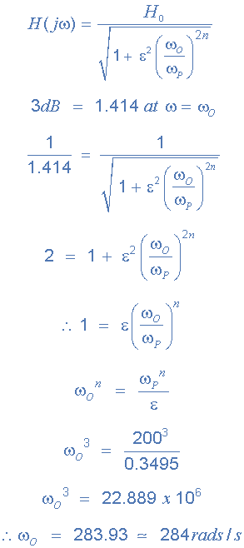

So, the cut-off corner frequency is given as 284 rads/s or 45.2Hz, (284/2π) and using the familiar formula 1/CR we can find the values of the resistors and capacitors for our third-order circuit.

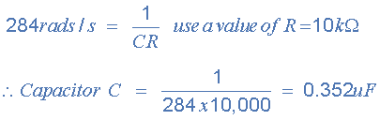

Note that the nearest preferred value to 0.352uF would be 0.36uF, or 360nF.

### Third-order Butterworth Low Pass Filter

and finally our circuit of the third-order low pass **Butterworth Filter** with a cut-off corner frequency of 284 rads/s or 45.2Hz, a maximum pass band gain of 0.5dB and a minimum stop band gain of 20dB is constructed as follows.

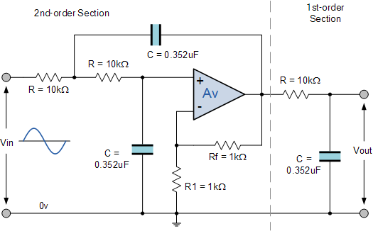

So for our 3rd-order Butterworth Low Pass Filter with a corner frequency of 45.2Hz, C = 360nF and R = 10kΩ

Theory: Design and simulate a Butterworth low pass filter.

MATLAB Code:

% Butterworth Low Pass Filter Design

Fs = 1000; % Sampling frequency

Fc = 200; % Cutoff frequency

[b, a] = butter(4, Fc/(Fs/2)); % 4th order Butterworth filter

freqz(b, a, [], Fs);

title('Butterworth Low Pass Filter');

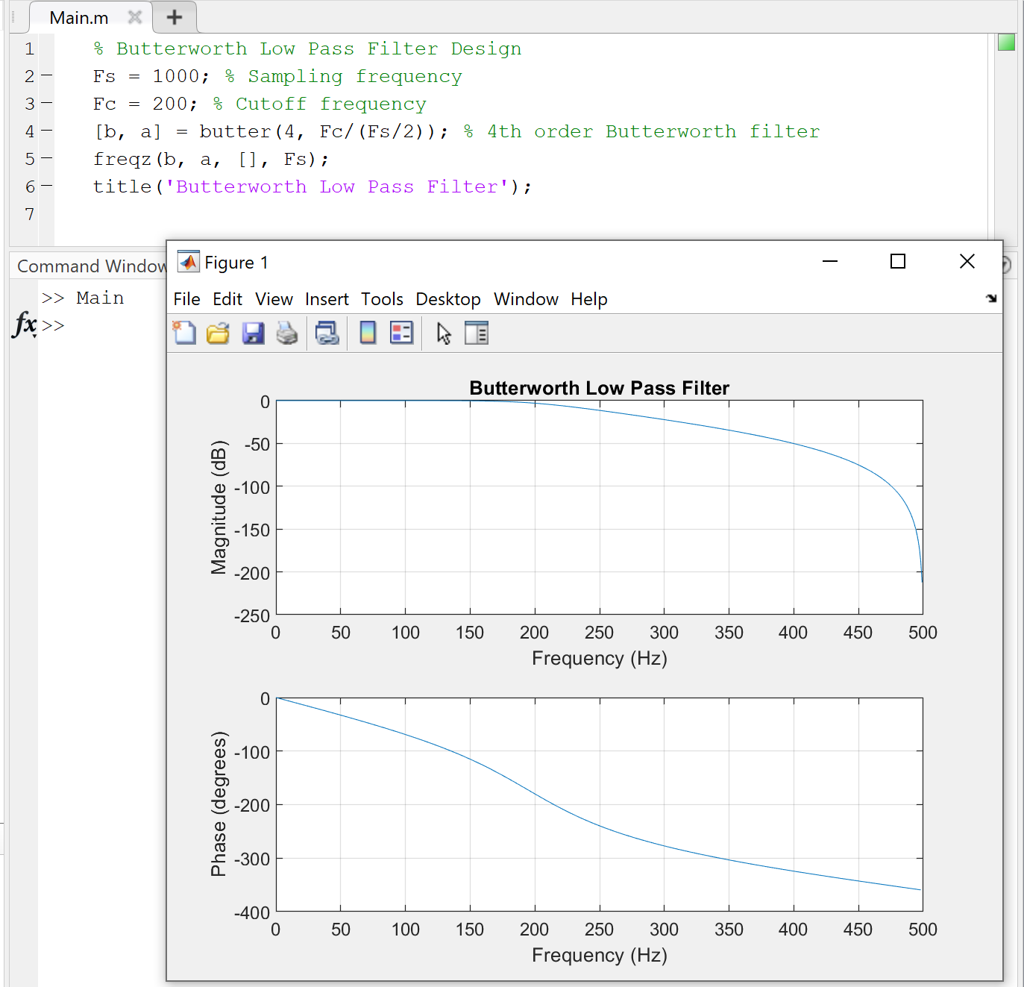

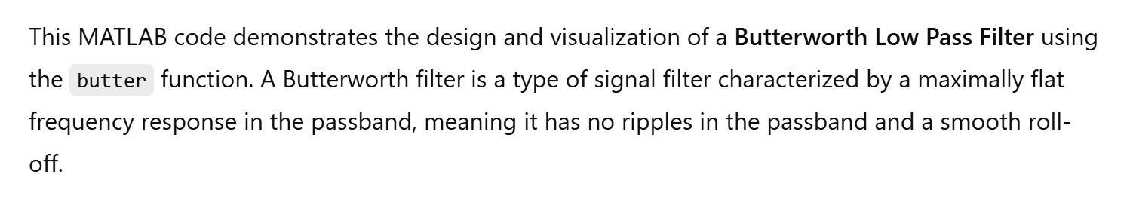

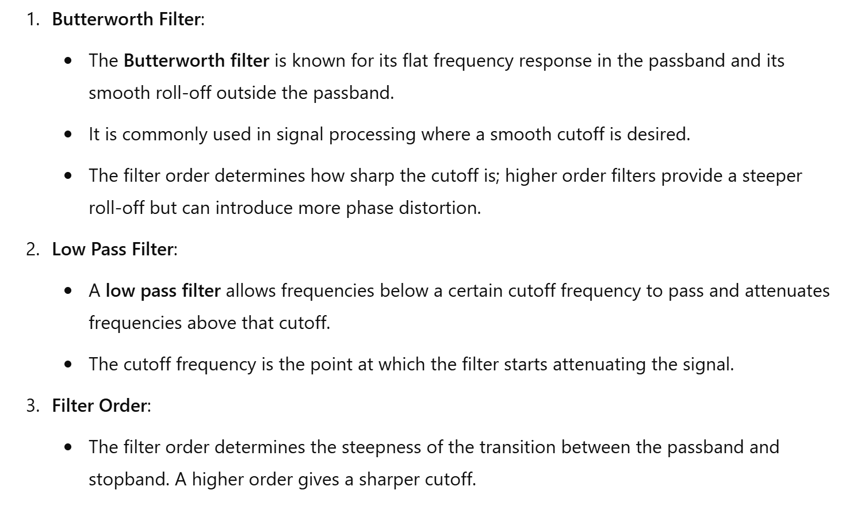

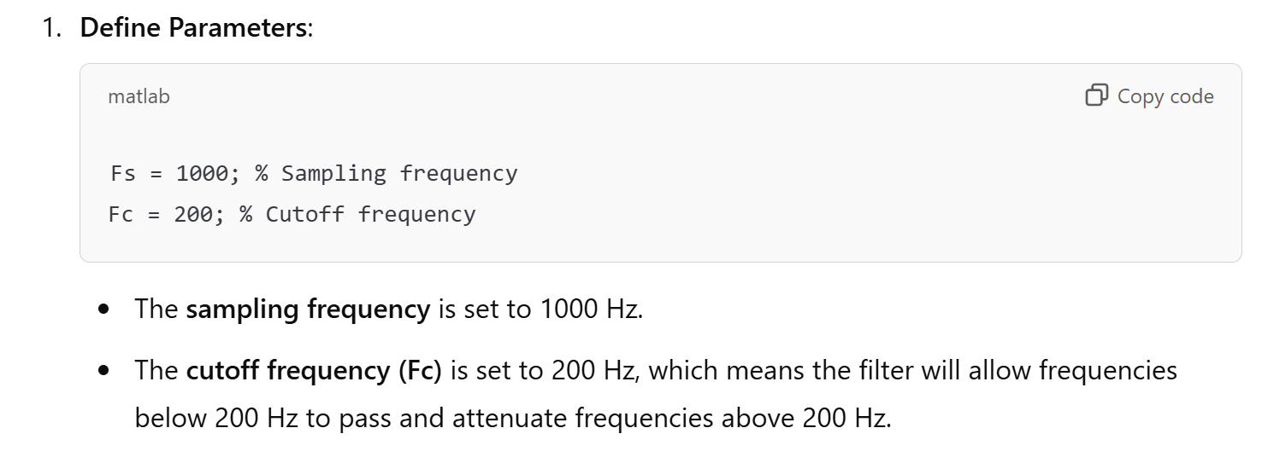

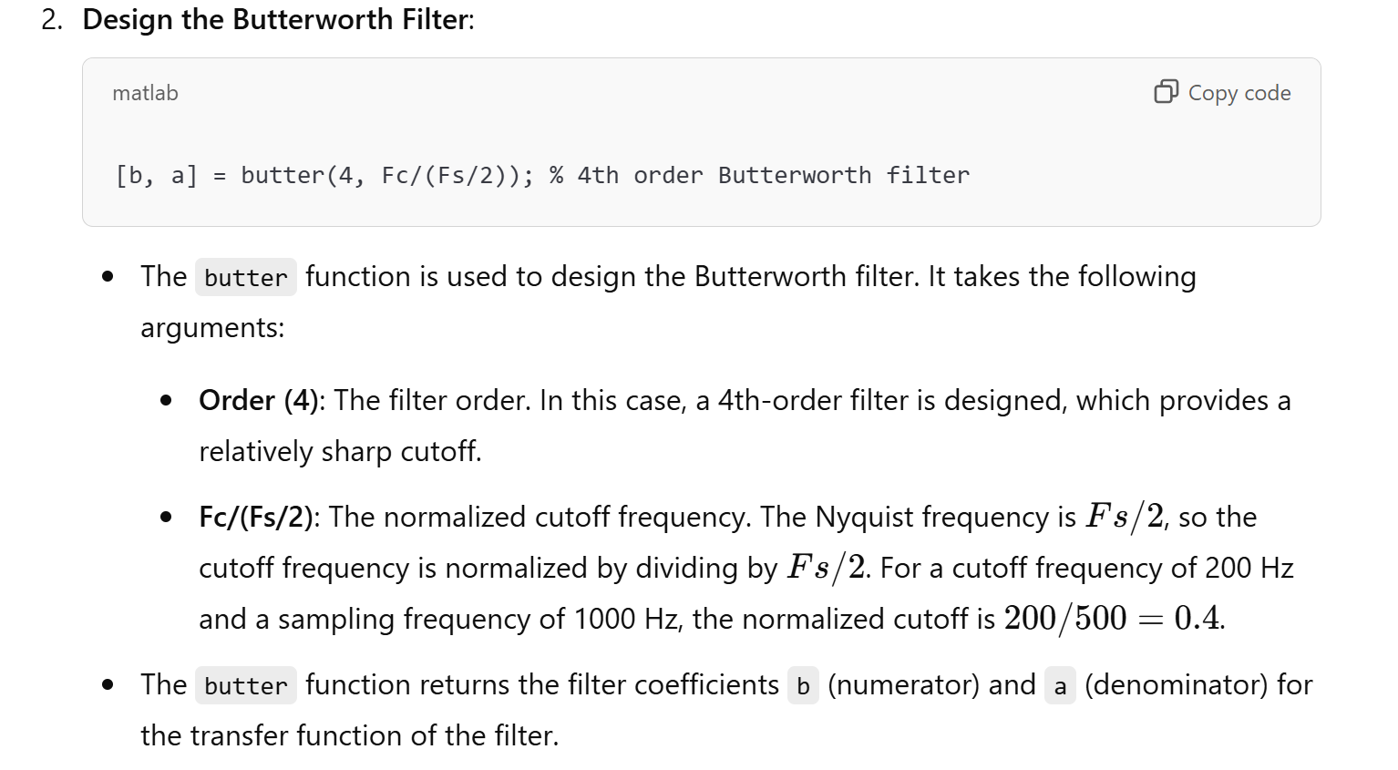

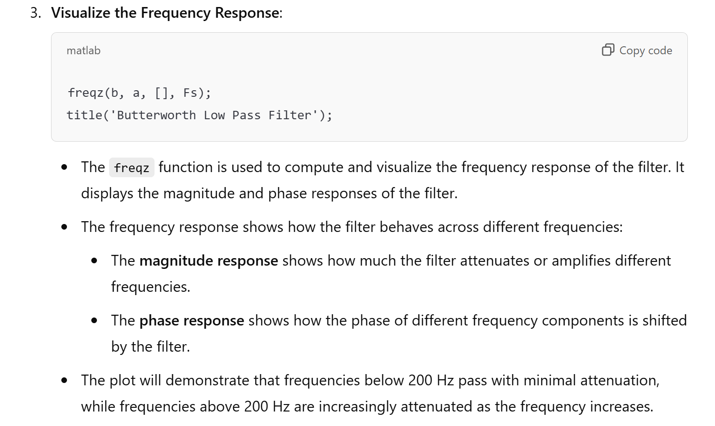

22. Transient Analysis of RC Circuit

Theory: Analyze the transient response of an RC circuit.

Considering the RC Circuit (also called RC network) shown in this figure

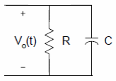

we can use the Kirchhoff’s current law (KCL) to write the following equation

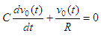

and we can rearrange into the equation

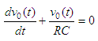

The solution to the equation above is

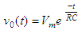

where  
*Vm* is the initial voltage across the capacitor  
*RC* is the time constant

This solution represents the voltage across a discharging capacitor.

Now, to obtain the voltage across a charging capacitor, let us consider this figure that includes a voltage source

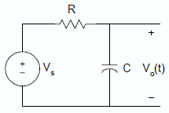

Again, using KCL, the equation describing the charging RC circuit is

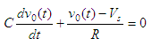

If the capacitor is not charged initially, that is v0(t) = 0 when t = 0, then the solution to the equation above is given by

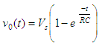

The following examples illustrate the use of Matlab for solving problems  
related to RC circuits.

MATLAB Code:

% Transient Analysis of RC Circuit

R = 1e3; % Resistance in ohms

C = 1e-6; % Capacitance in farads

sys = tf([1], [R*C 1]);

impulse(sys);

title('Transient Response of RC Circuit');

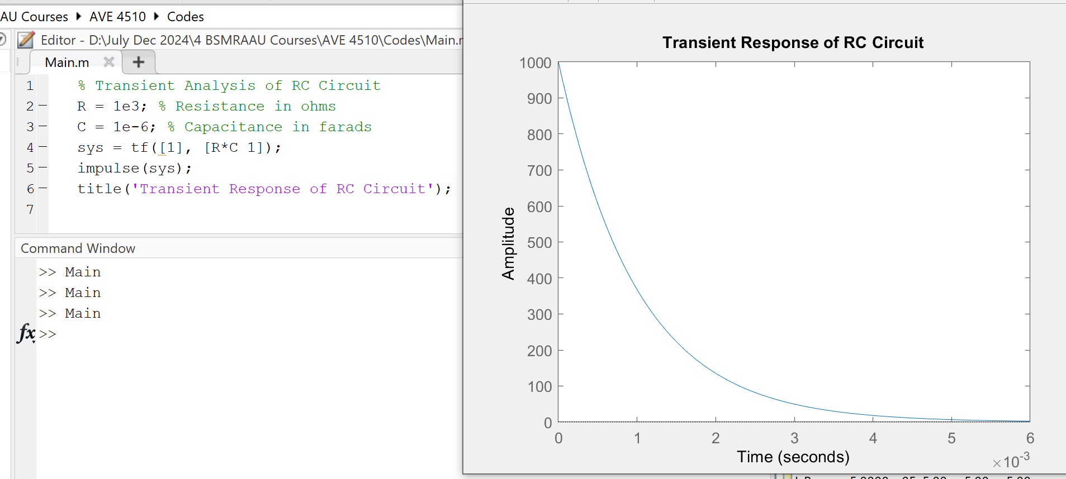



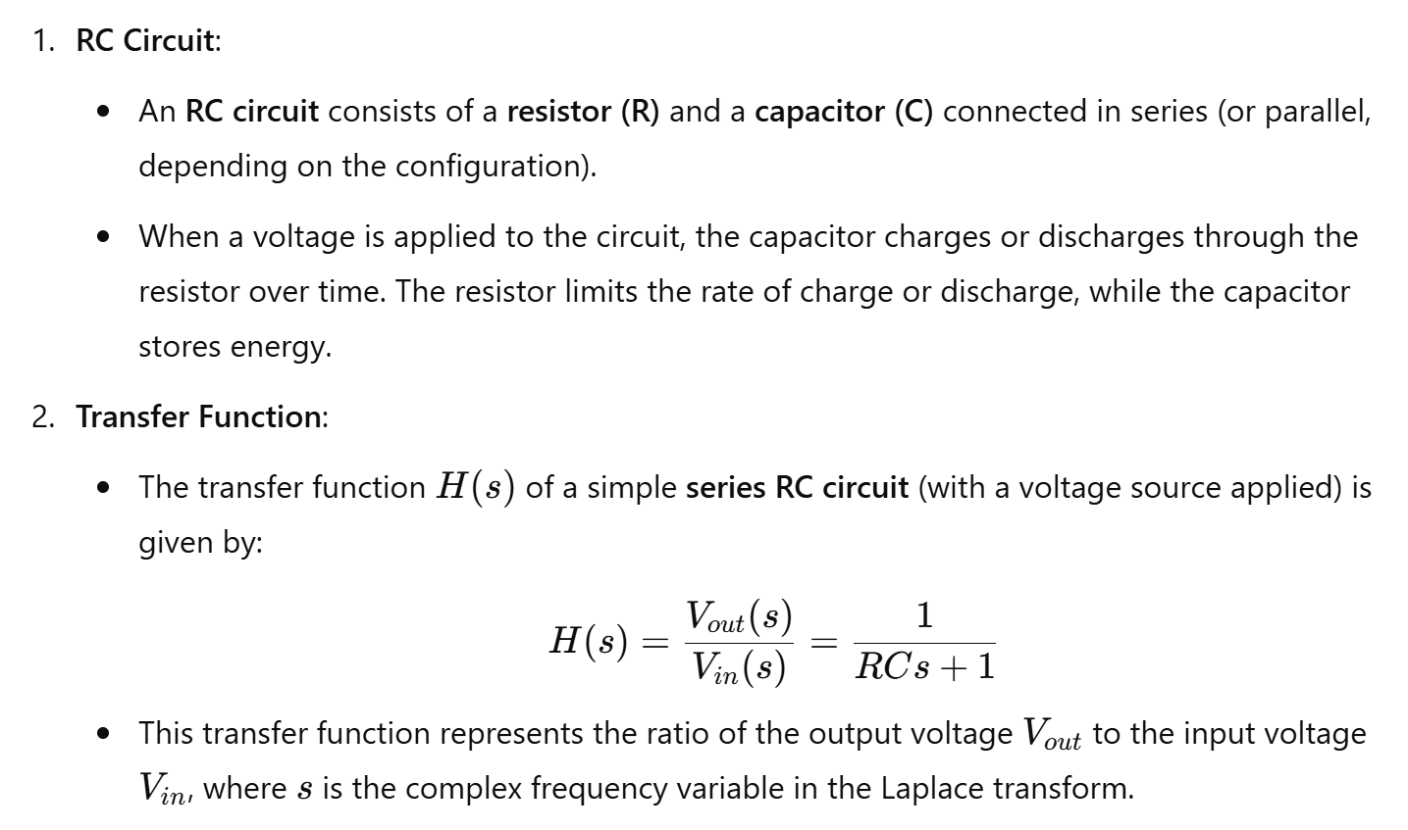

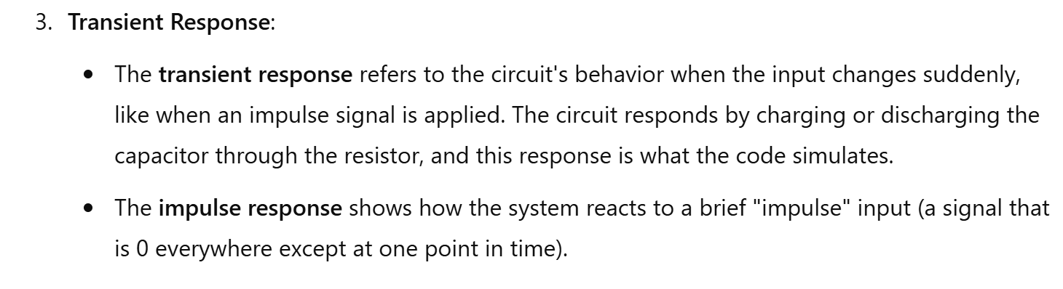

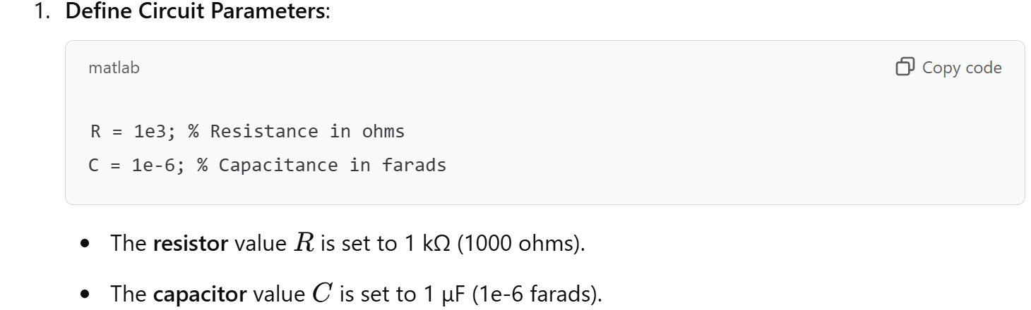

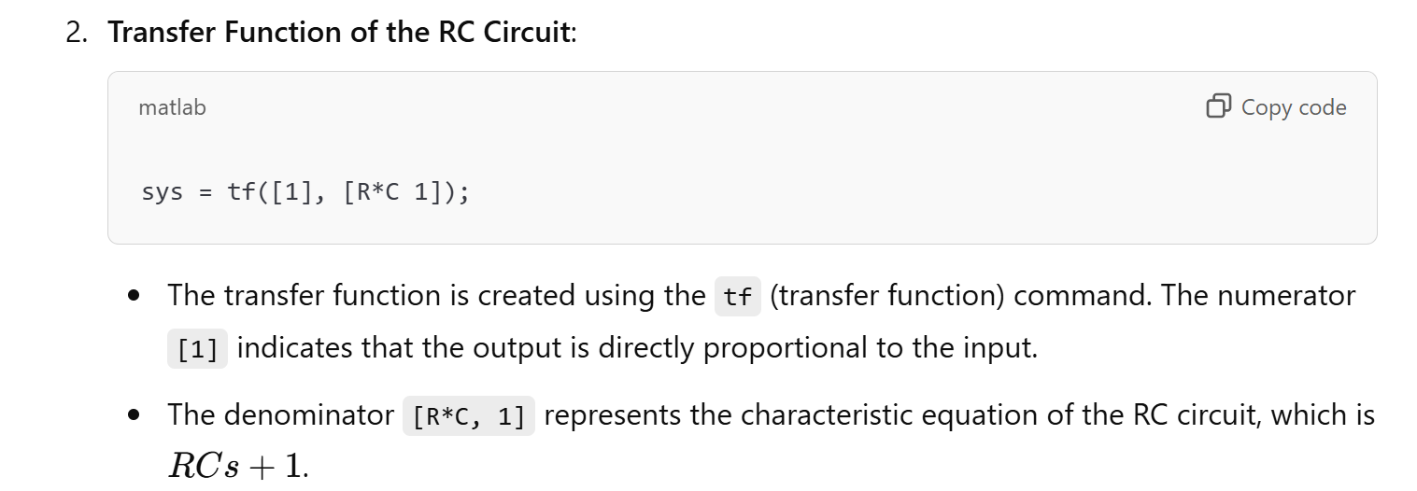

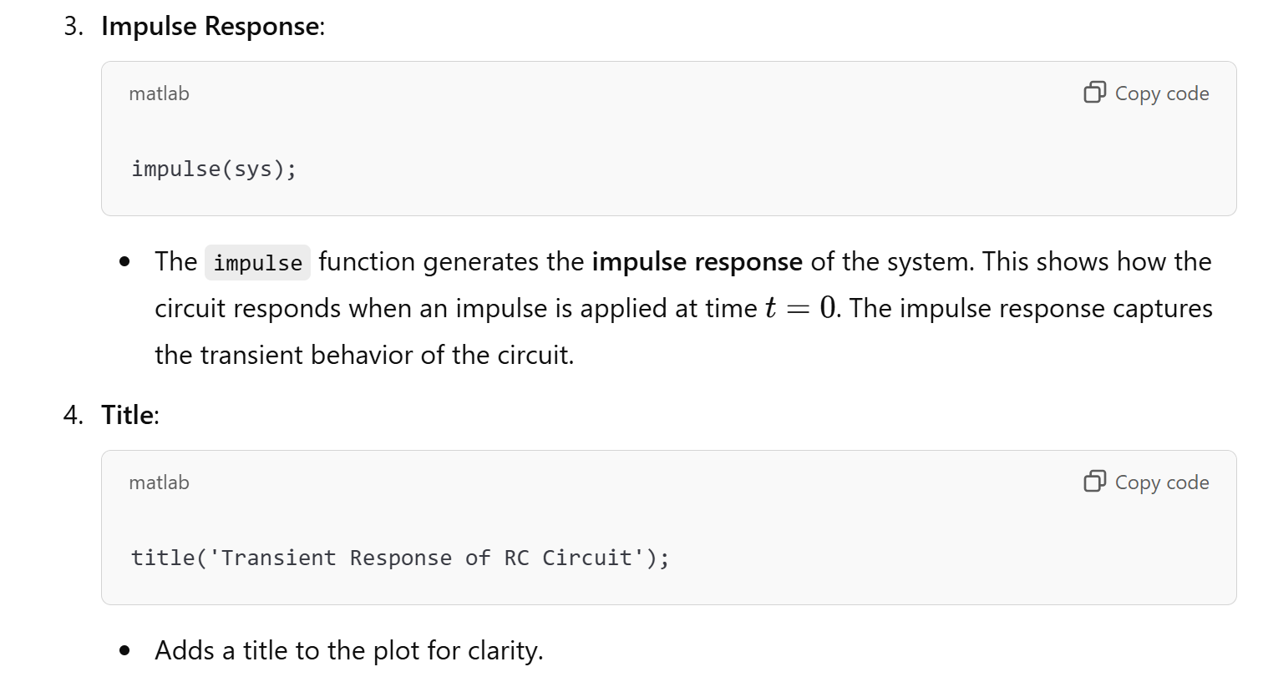

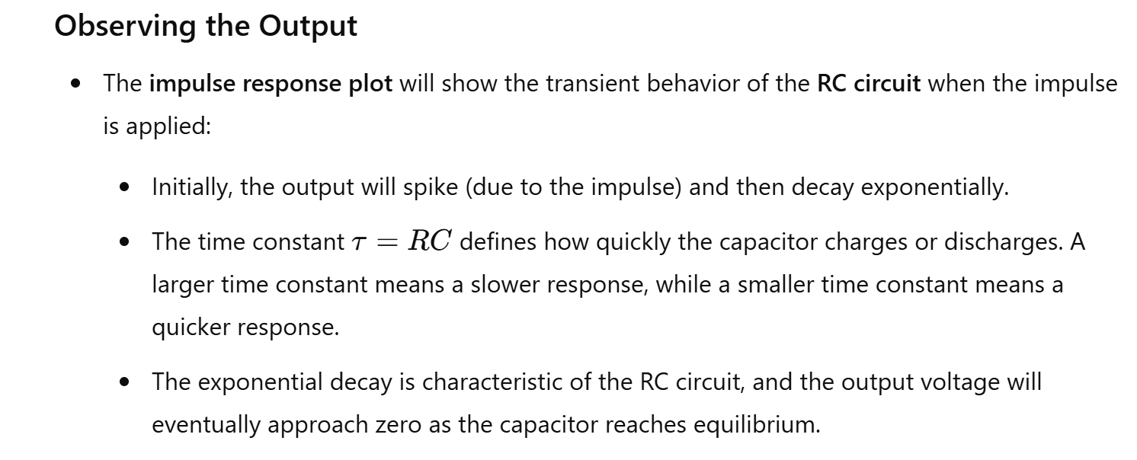

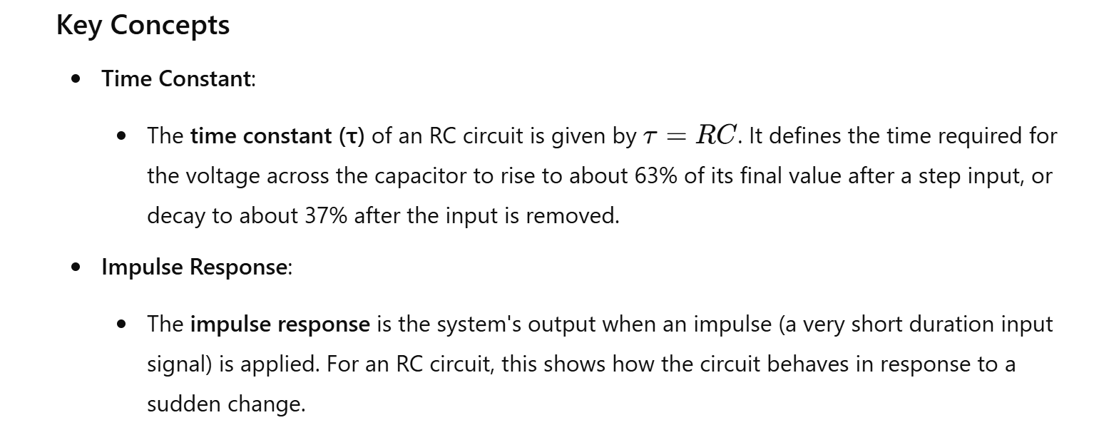

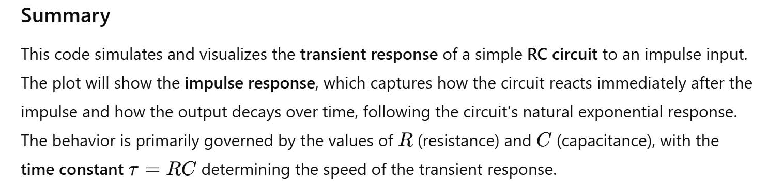

23. Voltage Divider Rule

Theory: Calculate the output voltage in a voltage divider circuit.

**Voltage Division Rule**

A series circuit acts as a **voltage divider** as it divides the total supply voltage into different voltages across the circuit elements. Figure2 shows a voltage divider circuit in which the total supply voltage *V* has been divided into voltages *V1* and *V2* across two resistances *R1* and *R2*. Although, the current through both resistances is same, i.e., *I*.

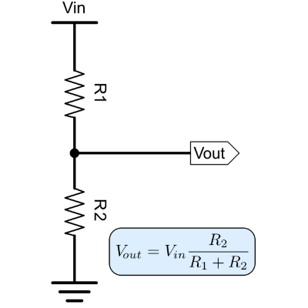

MATLAB Code:

% Voltage Divider Rule

R1 = 10e3; % Resistor 1 in ohms

R2 = 20e3; % Resistor 2 in ohms

Vin = 10; % Input voltage in volts

Vout = (R2 / (R1 + R2)) * Vin; % Output voltage

disp(['Output Voltage: ', num2str(Vout), ' V']);

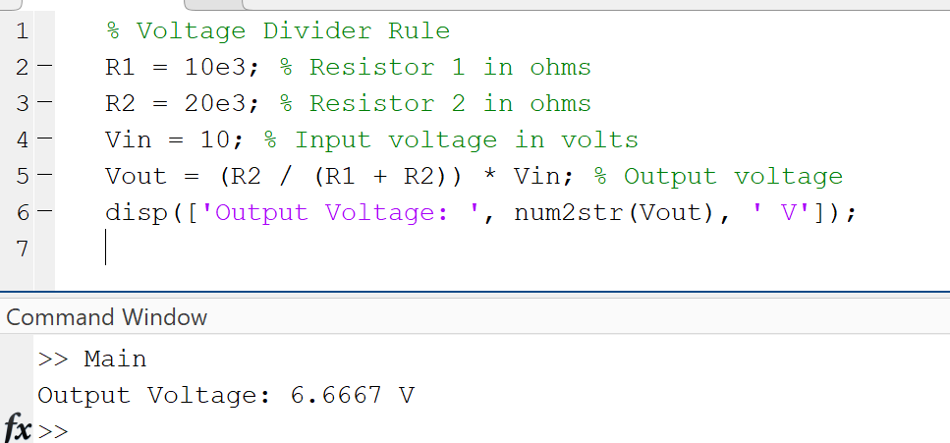

24. Digital to Analog Conversion (DAC)

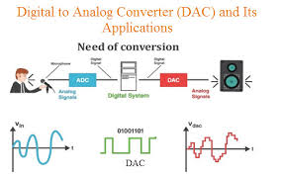

26. Impedance of RLC Circuit

Theory: Calculate the impedance of a series RLC circuit at a given frequency.

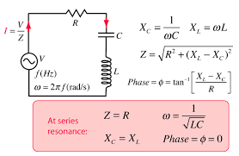

MATLAB Code:

% Impedance of RLC Circuit

R = 50; % Resistance in ohms

L = 100e-3; % Inductance in henrys

C = 10e-6; % Capacitance in farads

f = 60; % Frequency in Hz

omega = 2*pi*f; % Angular frequency

Z = R + 1i*(omega*L - 1/(omega*C)); % Impedance

disp(['Impedance: ', num2str(abs(Z)), ' Ohms']);

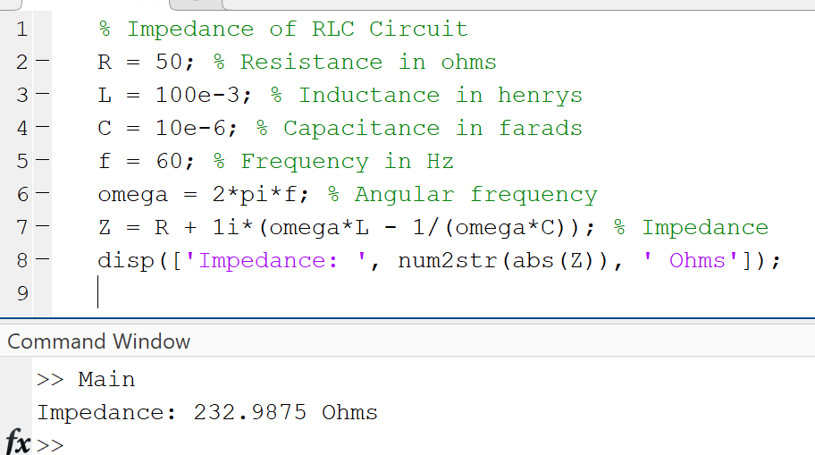

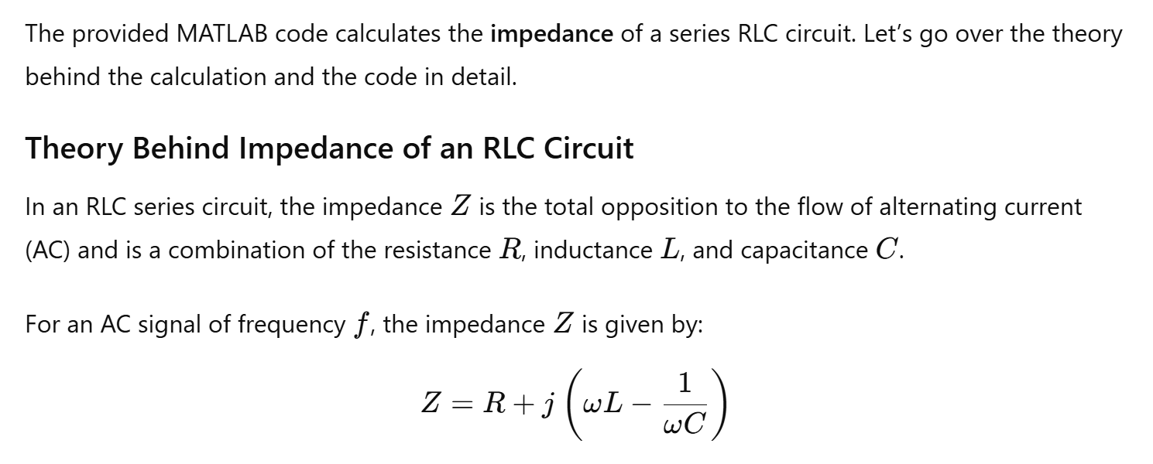

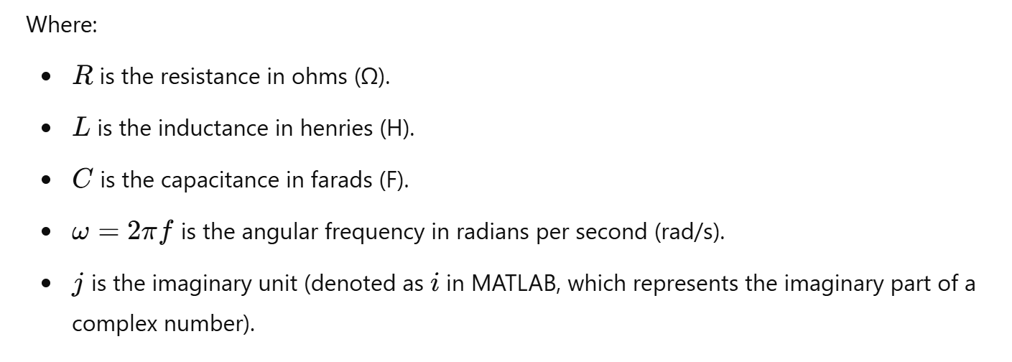

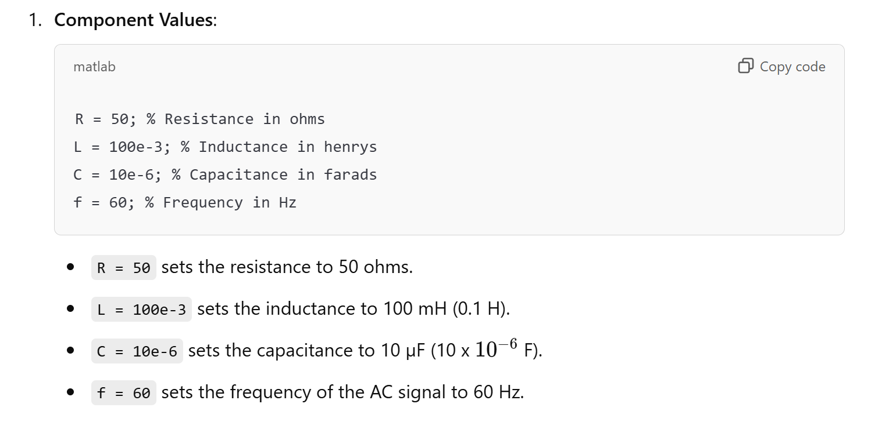

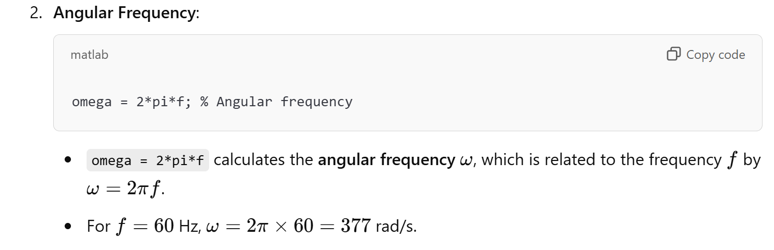

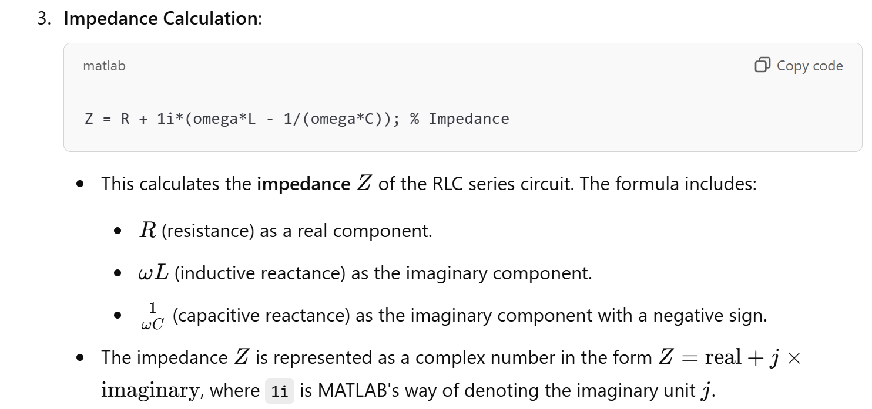

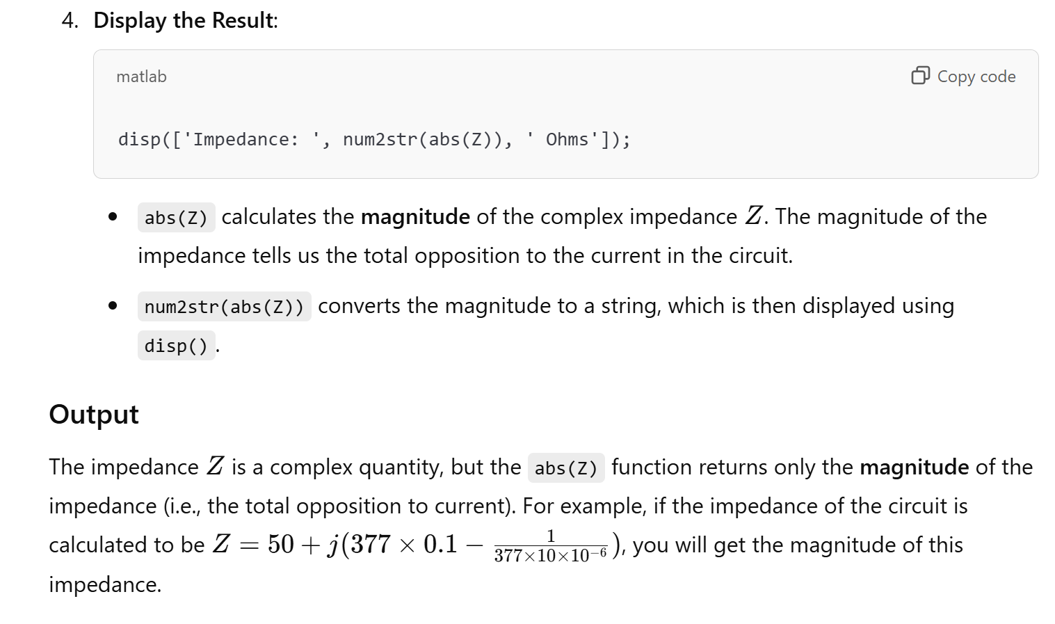

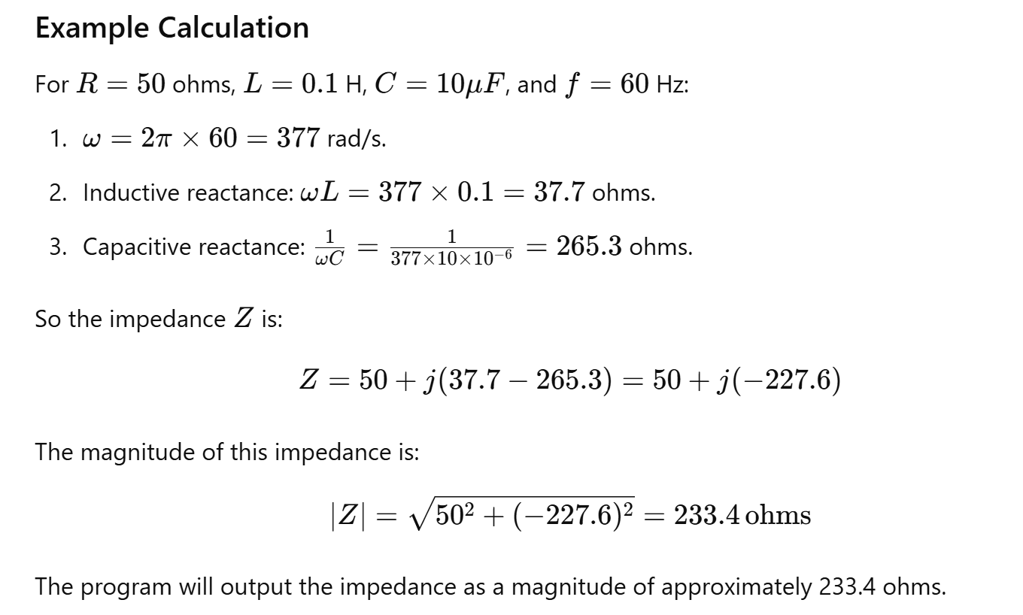

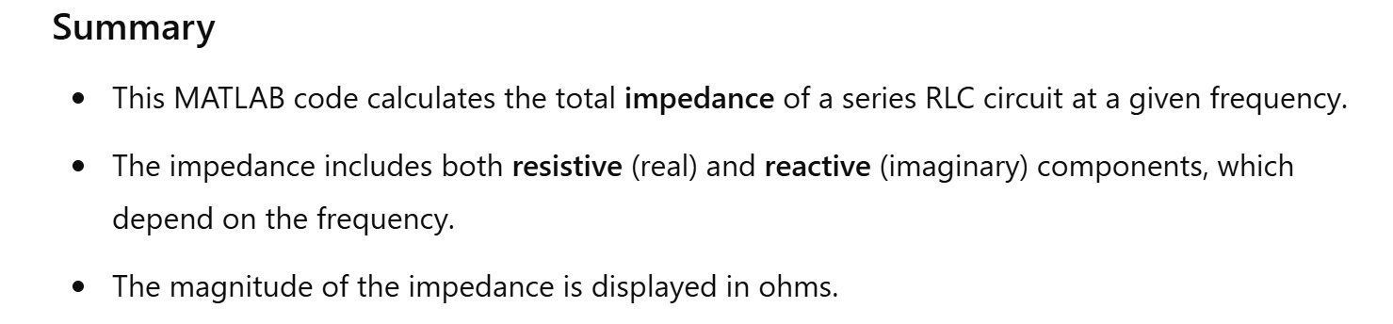

29. Resonance in RLC Circuit

Theory: Analyze the resonance frequency and behavior of a series RLC circuit.

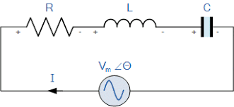

MATLAB Code:

% Resonance in RLC Circuit

L = 1e-3; % Inductance in henrys

C = 100e-9; % Capacitance in farads

f_resonance = 1/(2*pi*sqrt(L*C)); % Resonance frequency

disp(['Resonance Frequency: ', num2str(f_resonance), ' Hz']);

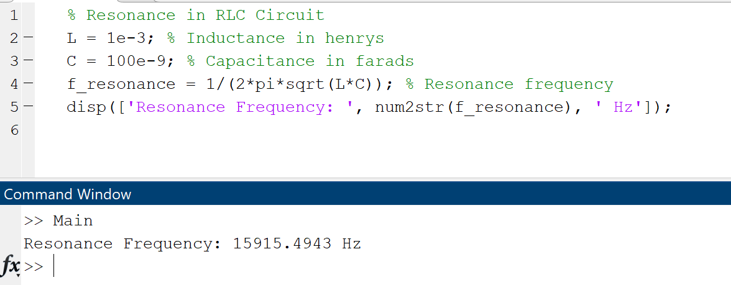

32. Step Response of a Transfer Function

Theory: Compute and plot the step response of a transfer function.

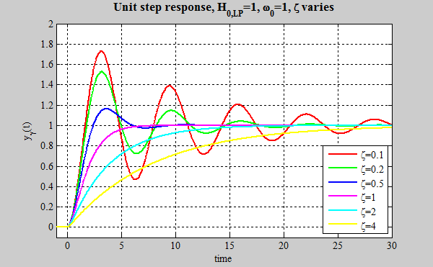

MATLAB Code:

% Step Response of a Transfer Function

sys = tf([1], [1 2 1]);

step(sys);

title('Step Response');

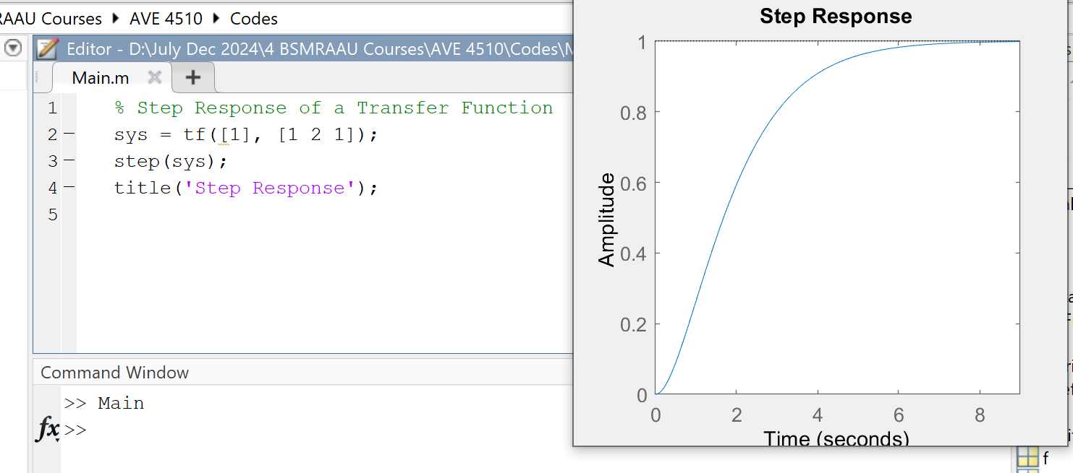

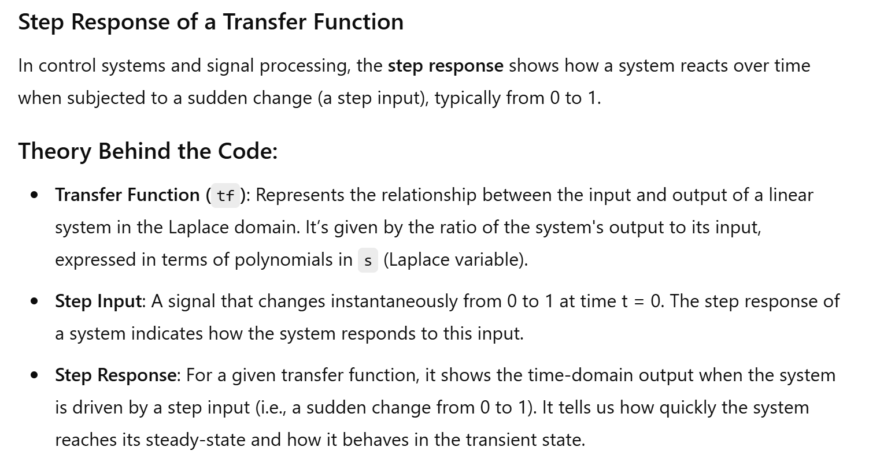

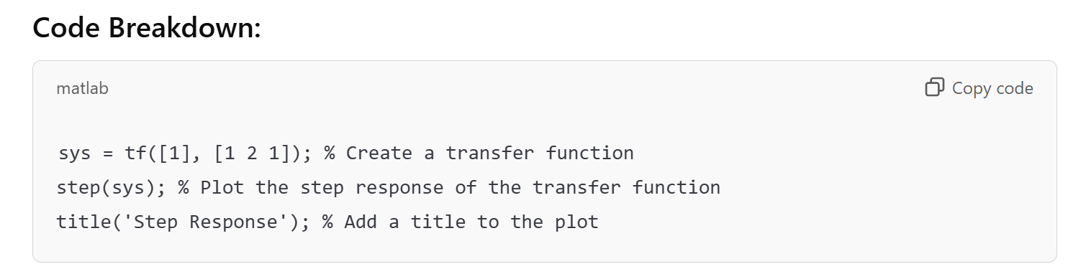

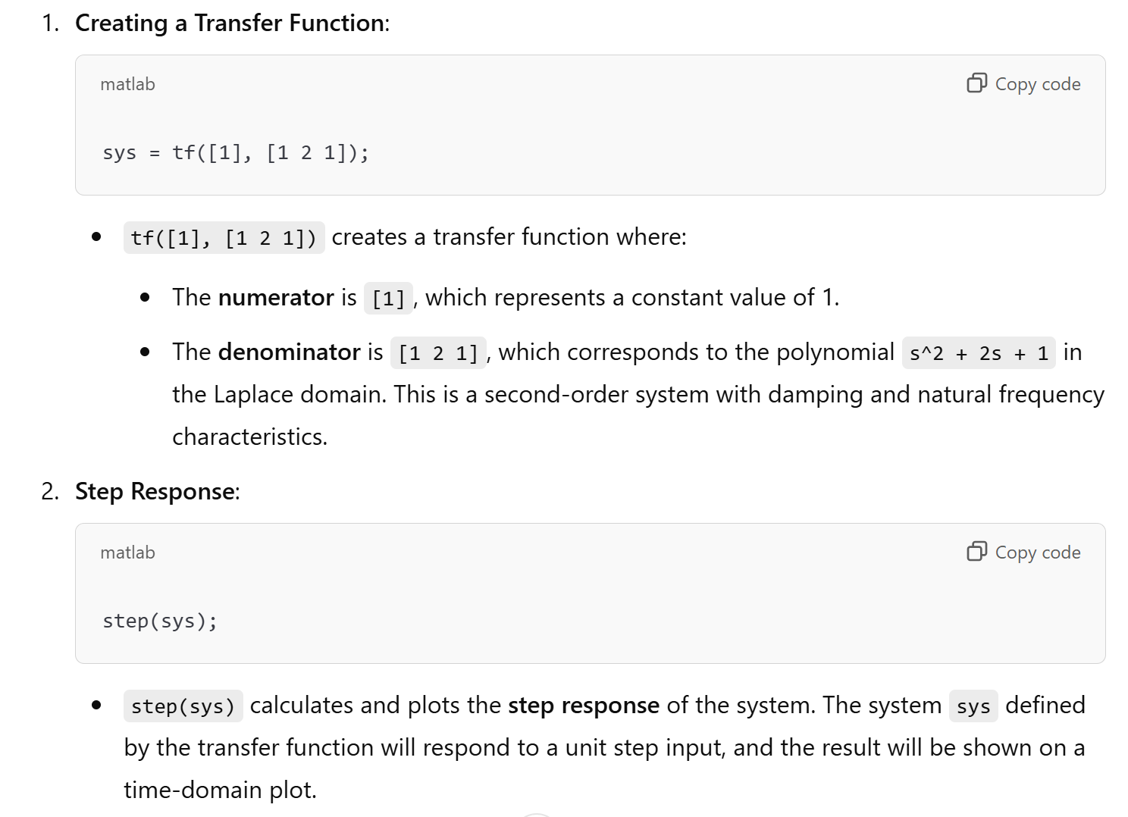

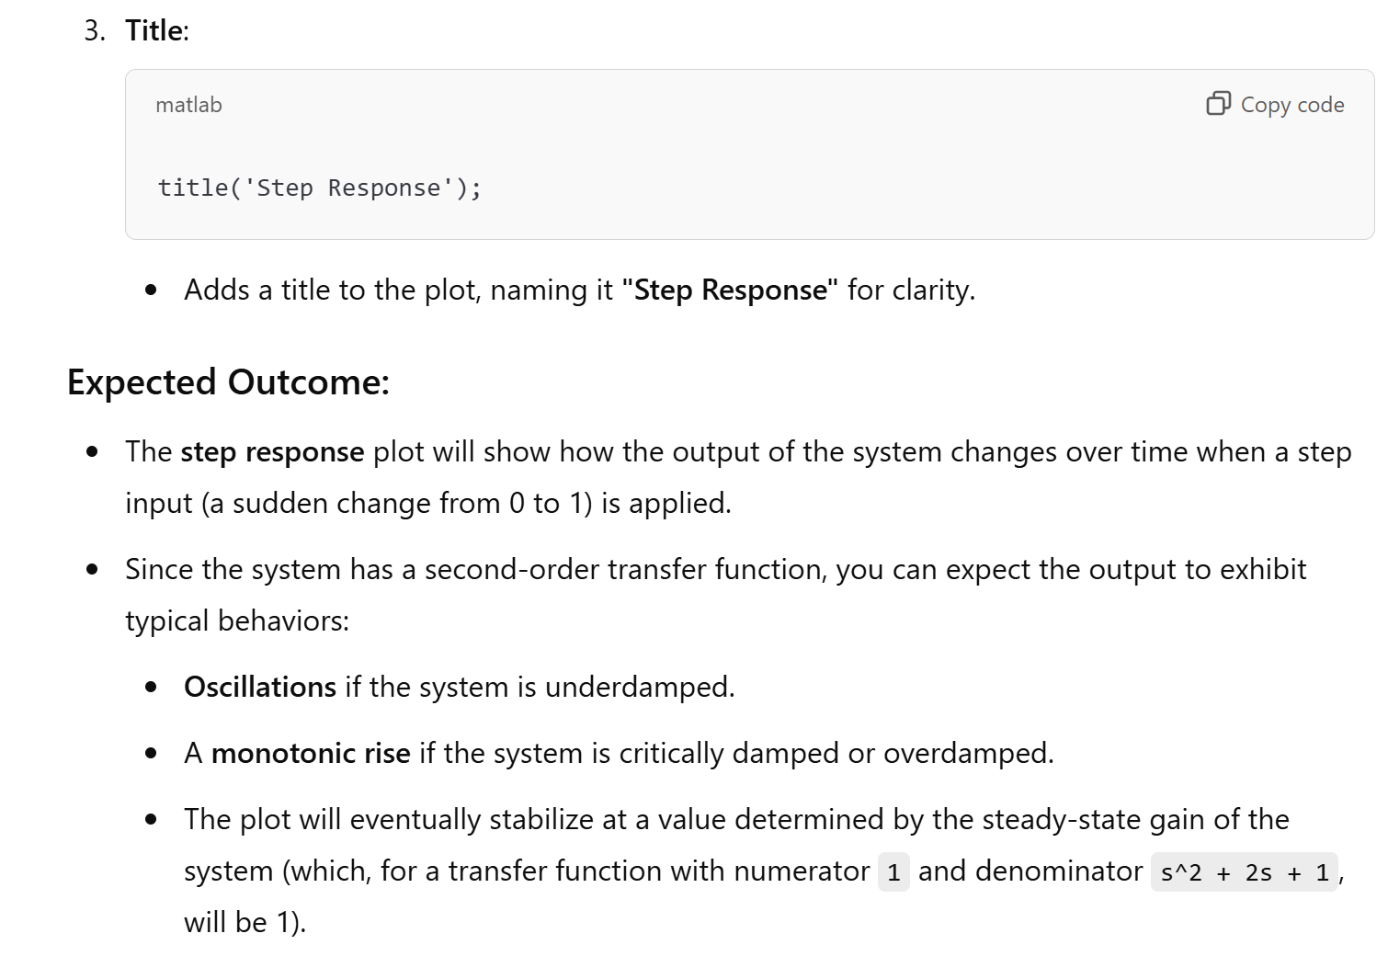

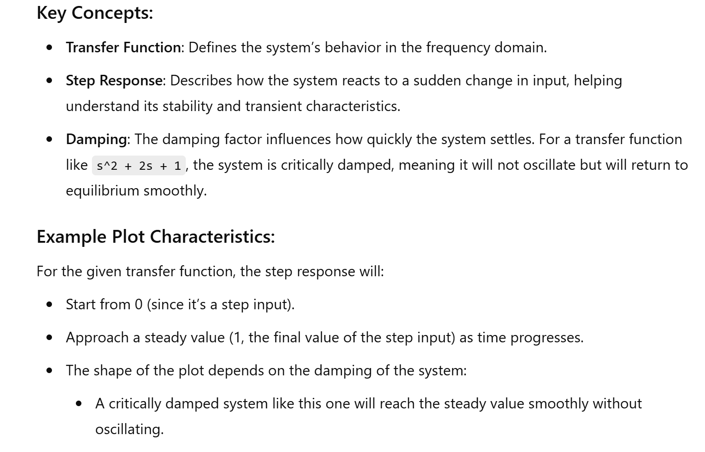

33. Impulse Response of a Transfer Function

Theory: Compute and plot the impulse response of a transfer function.

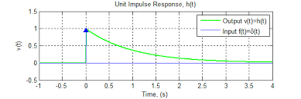

MATLAB Code:

% Impulse Response of a Transfer Function

sys = tf([1], [1 2 1]);

impulse(sys);

title('Impulse Response');

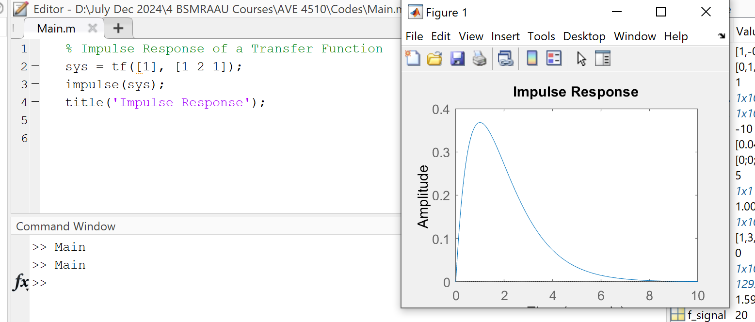

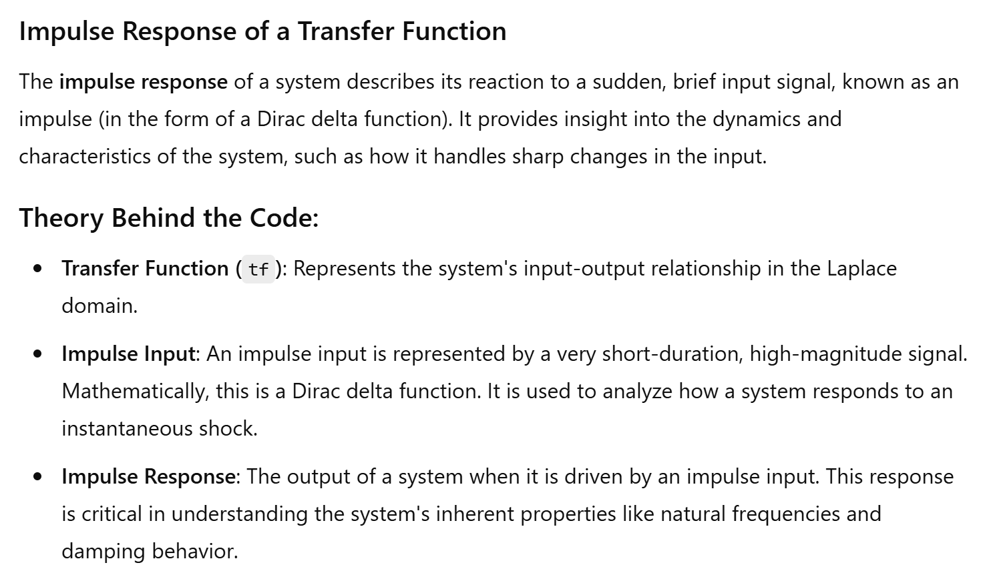

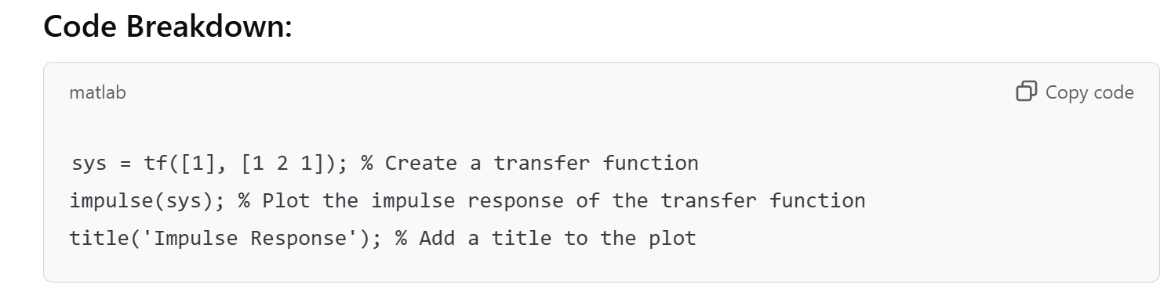

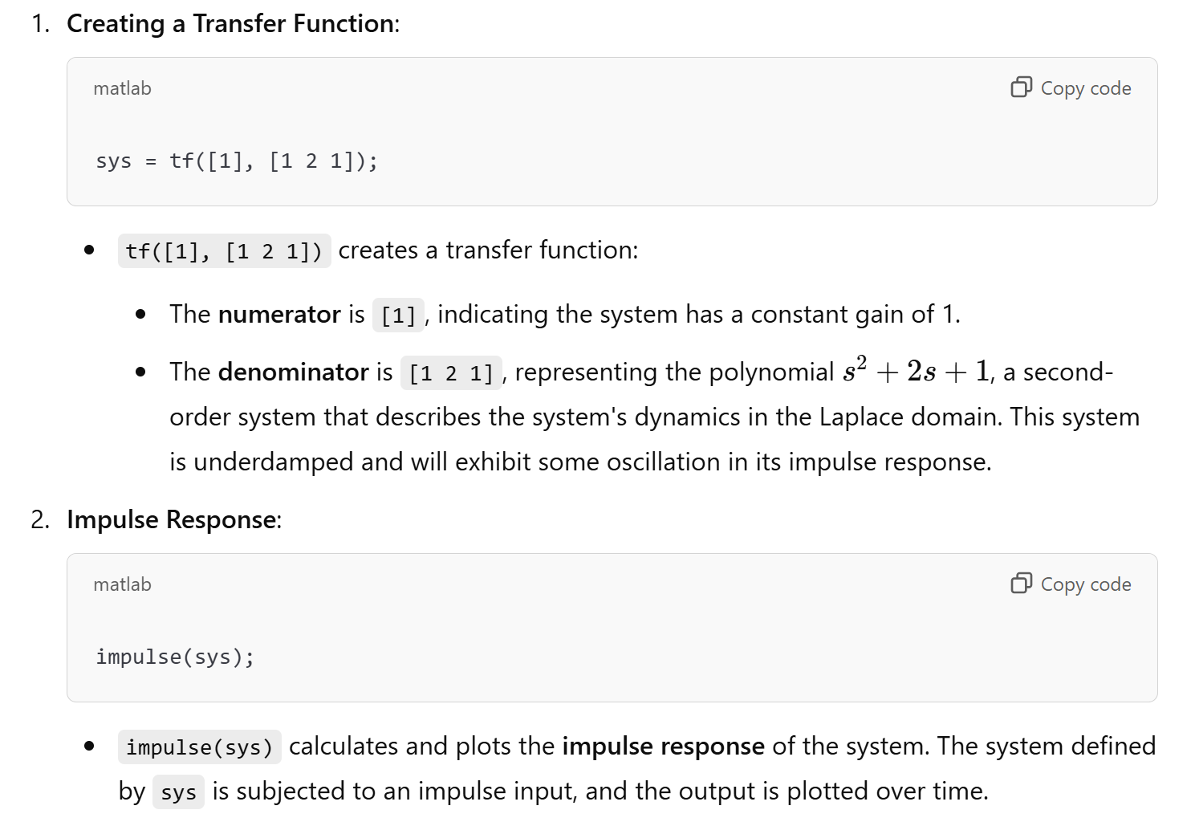

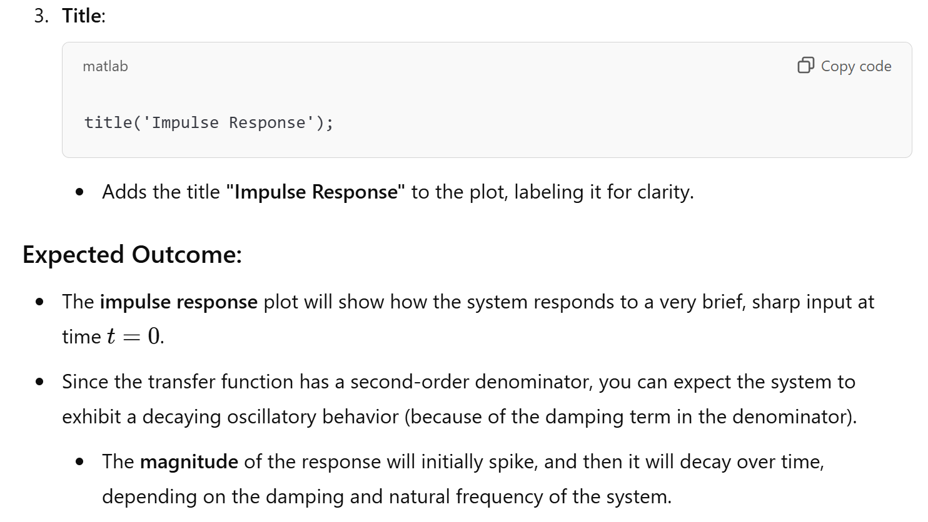

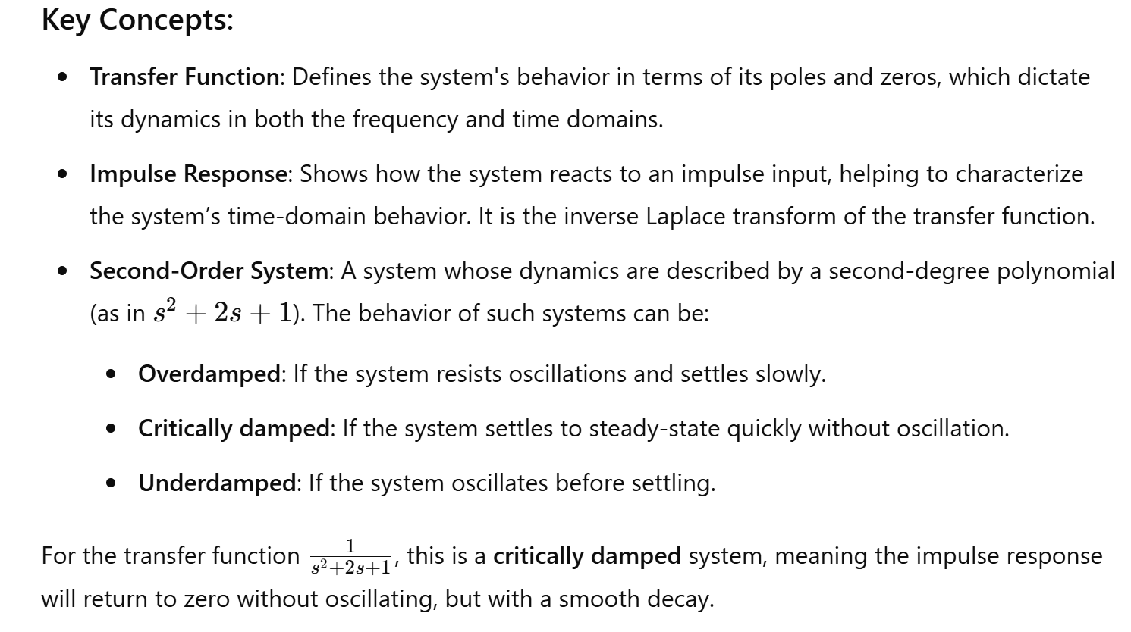

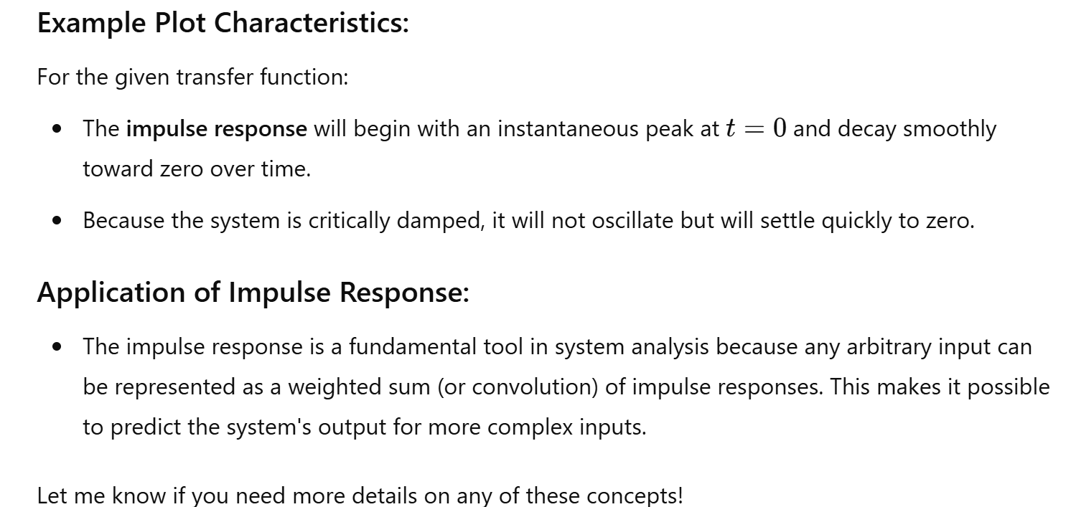

35. Active Low Pass Filter

Theory: Design and simulate an active low pass filter using an operational amplifier.

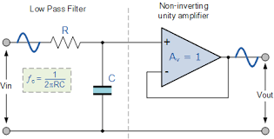

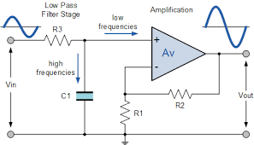

MATLAB Code:

% Active Low Pass Filter

R = 1e3; % Resistance in ohms

C = 1e-6; % Capacitance in farads

sys = tf([1], [R*C 1]);

bode(sys);

title('Active Low Pass Filter');

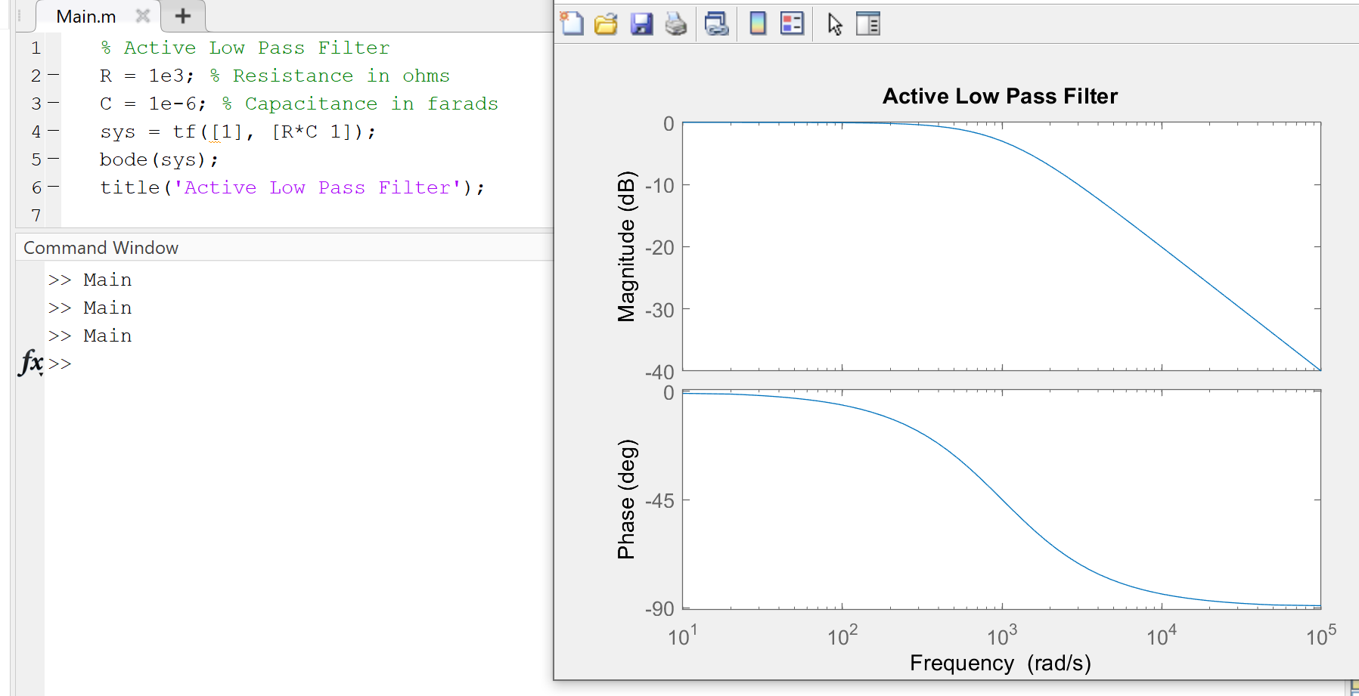

41. Power Factor Calculation

Theory: Calculate the power factor of an AC circuit.

Power factor is defined as the cosine of the angle between voltage and current. Ideally, in AC circuits, the phase difference between voltage and current is zero. But, practically there exists some phase difference between the two. The cosine of the phase difference between the two is defined as the power factor.

**Power Factor Calculation**

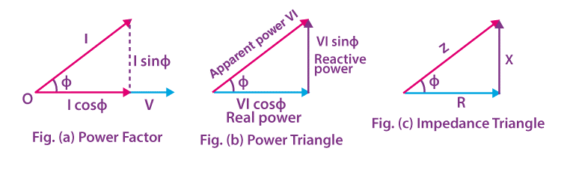

In the figure, angle ɸ is the phase difference between the voltage and current phasor. Therefore, the power factor is:

**Power Factor = cosɸ**

In the figure of the power triangle,

VI sinɸ = Reactive power (in VAR)

VI cosɸ = Active power (in Watts)

VI = Apparent power (in VA)

**PF = cosɸ = Active Power (W) / Apparent Power (VA)**

|  |
| --- |
| **Knowledge Review** |
| **Real Power –** The power supplied to the equipment that performs useful and productive work.  **Reactive Power –** The power required by equipment such as transformers and motors to produce magnetic fields enabling actual work to be done.  **Apparent Power –** The vector sum of real power and reactive power |

**Power Factor can be Lagging, Leading or Unity**

**Lagging Power Factor**

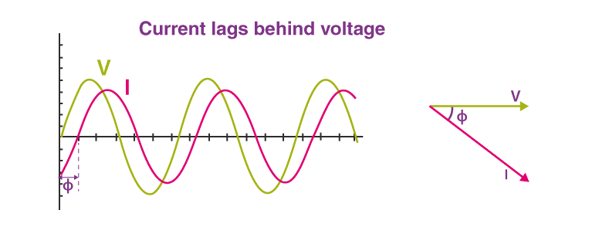

In a circuit, when the current lags behind the voltage, then the power factor of the circuit is known as a lagging power factor. The power factor lags when the circuit is inductive. Loads such as coils, motors and lamps are inductive and have lagging pf.

**Leading Power Factor**

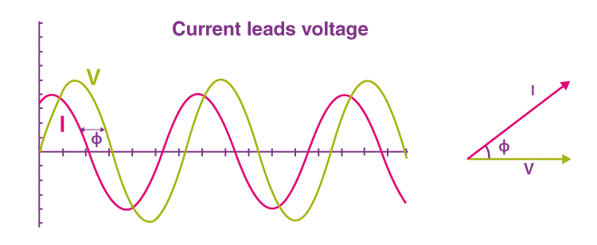

When the current in the circuit leads the voltage, then the power factor of the circuit is said to be leading. A capacitive circuit has a leading power factor. Capacitor banks and Synchronous condensers are capacitive loads that have a leading power factor.

**Unity Power Factor**

The power factor is unity for ideal circuits. The power factor is unity when the current and voltage are in phase.

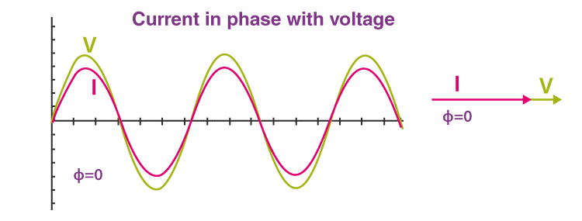

|  |
| --- |
| **Similar Reading:** |

MATLAB Code:

% Power Factor Calculation

P = 100; % Real power in watts

Q = 75; % Reactive power in VAR

S = sqrt(P^2 + Q^2); % Apparent power in VA

power_factor = P / S;

disp(['Power Factor: ', num2str(power_factor)]);

MATLAB Code:

44. Fourier Series Approximation

Theory: Approximate a periodic function using Fourier series.

A Fourier series is an expansion of a periodic function f(x) in terms of an infinite sum of sines and cosines. Fourier Series makes use of the orthogonality relationships of the sine and cosine functions.

**Laurent Series yield Fourier Series**

A difficult thing to understand and/or motivate is the fact that arbitrary periodic functions have Fourier series representations. In this section, we prove that periodic analytic functions have such a representation using Laurent expansions.

**Fourier Analysis for Periodic Functions**

The Fourier series representation of analytic functions is derived from Laurent expansions. The elementary complex analysis is used to derive additional fundamental results in the harmonic analysis including the representation of C∞ periodic functions by Fourier series, the representation of rapidly decreasing functions by Fourier integrals, and Shannon’s sampling theorem. The ideas are classical and of transcendent beauty.

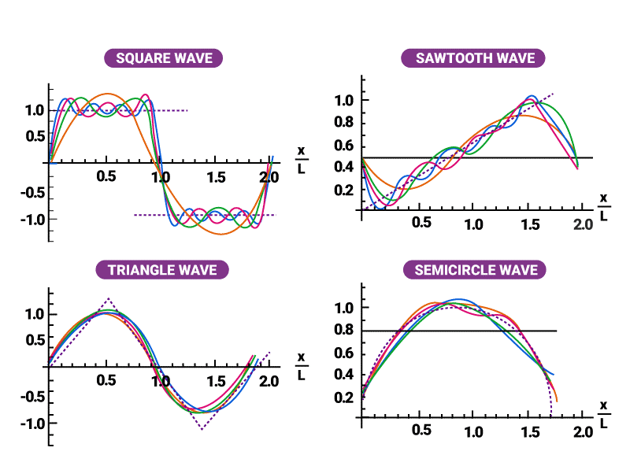

A function is periodic of period L if f(x+L) = f(x) for all x in the domain of f. The smallest positive value of L is called the fundamental period.

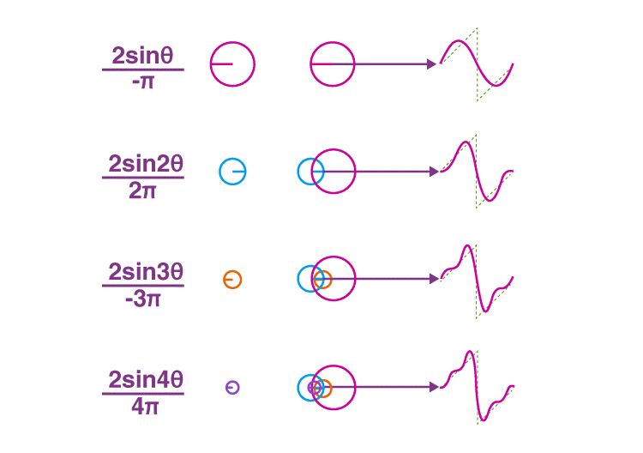

The trigonometric functions sin x and cos x are examples of periodic functions with fundamental period 2π and tan x is periodic with fundamental period π. A constant function is a periodic function with arbitrary period L.

It is easy to verify that if the functions f1, . . . , fn are periodic of period L, then any linear combination

is also periodic. Furthermore, if the infinite series

consisting of 2L-periodic functions converges for all x, then the function to which it converges will be periodic of period 2L. There are two symmetry properties of functions that will be useful in the study of Fourier series.

**Even and Odd Function**

A function f(x) is said to be even if f(−x) = f(x).

The function f(x) is said to be odd if f(−x) = −f(x).

Graphically, even functions have symmetry about the y-axis, whereas odd functions have symmetry around the origin.

47. Electrostatic Force Calculation

Theory: Calculate the electrostatic force between two charges.

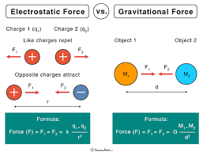

MATLAB Code:

% Electrostatic Force Calculation

q1 = 1e-6; % Charge 1 in coulombs

q2 = 2e-6; % Charge 2 in coulombs

r = 0.01; % Distance between charges in meters

epsilon_0 = 8.854e-12; % Permittivity of free space

F = (q1 * q2) / (4 * pi * epsilon_0 * r^2); % Force in newtons

disp(['Electrostatic Force: ', num2str(F), ' N']);

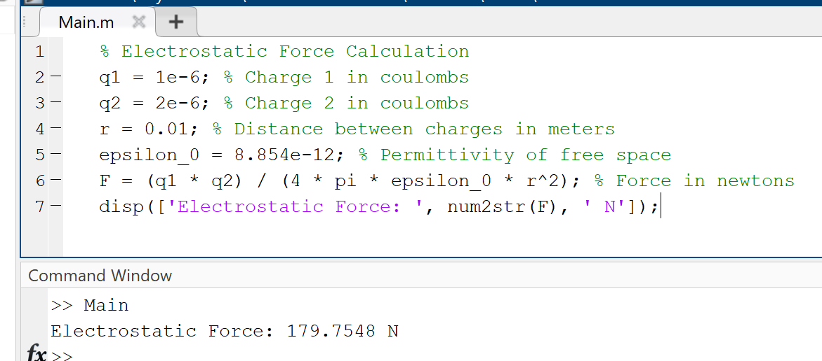

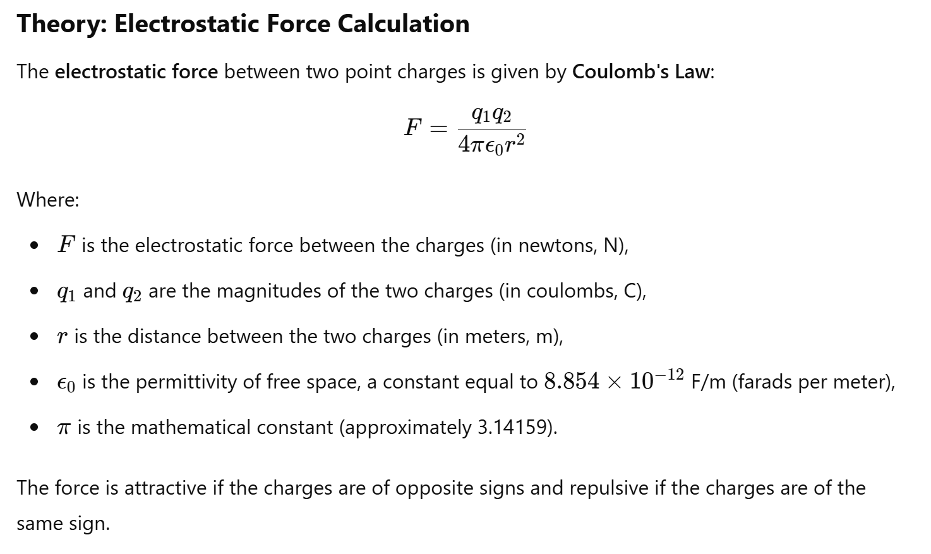

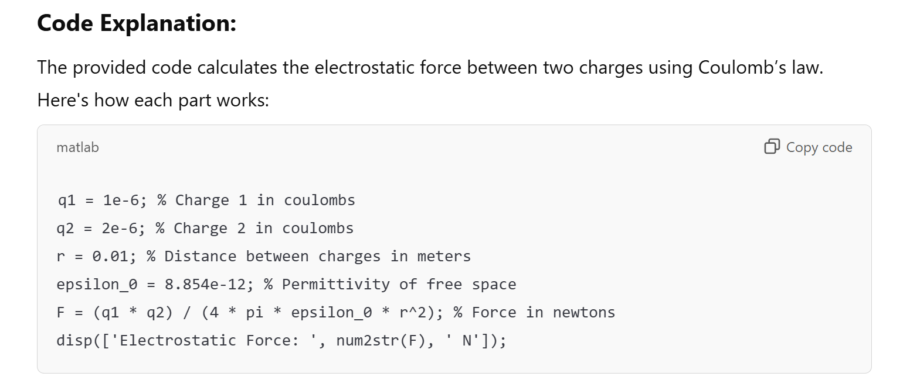

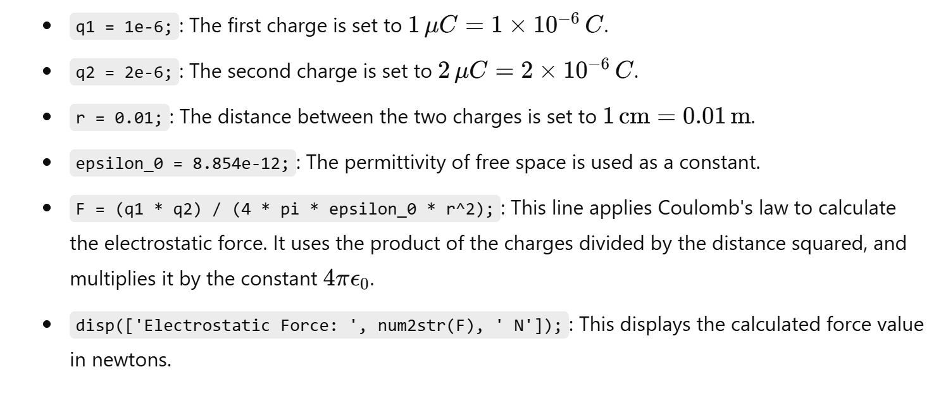

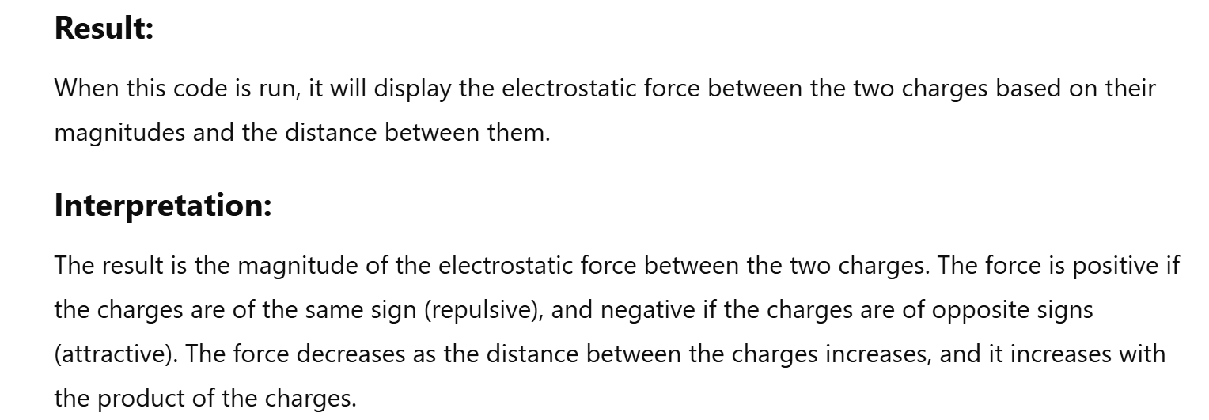

61. Maximum Power Transfer Theorem

Theory: Verify the maximum power transfer theorem in an electrical circuit.

Maximum Power Transfer Theorem explains that to generate maximum external power through a finite internal resistance (DC network), the resistance of the given load must be equal to the resistance of the available source.

In other words, the resistance of the load must be the same as Thevenin’s equivalent resistance.

In the case of AC voltage sources, maximum power is produced only if the load impedance’s value is equivalent to the complex conjugate of the source impedance.

**Maximum Power Transfer Formula**

As shown in the figure, a dc source network is connected with variable resistance RL.

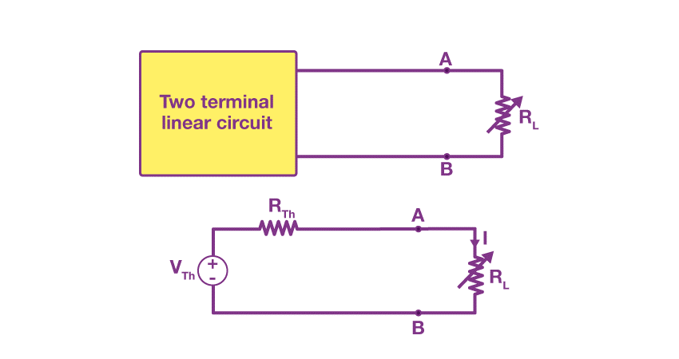

The fundamental Maximum Power Transfer Formula is

MATLAB Code:

% Maximum Power Transfer Theorem

R_source = 50; % Source resistance in ohms

R_load = linspace(1, 100, 100); % Load resistance in ohms

V_source = 10; % Source voltage in volts

P_load = (V_source^2) * (R_load ./ (R_source + R_load).^2); % Power delivered to the load

plot(R_load, P_load);

title('Maximum Power Transfer Theorem');

xlabel('Load Resistance (Ohms)');

ylabel('Power Delivered (Watts)');

62. Mutual Inductance Calculation

Theory: Calculate the mutual inductance between two inductors.

**Mutual inductance** is the main operating principle of generators, motors and transformers. Any electrical device having components that tend to interact with another magnetic field also follows the same principle. The interaction is usually brought about by a mutual induction where the current flowing in one coil generates a voltage in a secondary coil.

**Download Complete Chapter Notes of Electromagnetic Induction**

**What Is Mutual Inductance?**

When two coils are brought in proximity to each other, the magnetic field in one of the coils tends to link with the other. This further leads to the generation of voltage in the second coil. This property of a coil which affects or changes the current and voltage in a secondary coil is called mutual inductance.

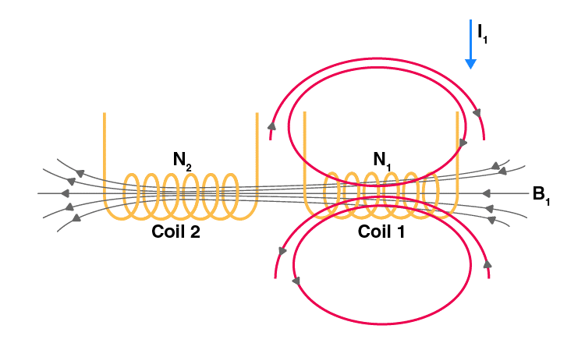

Changing I1 produces changing magnetic flux in coil 2.

In the first coil of N1 turns, when a current I1 passes through it, magnetic field B is produced. As the two coils are closer to each other, a few magnetic field lines will also pass through coil 2.

If we vary the current with respect to time, then there will be an induced emf in coil 2.

[According to Faraday’s law]

The induced emf in coil 2 is directly proportional to the current that passes through coil 1.

The constant of proportionality is called mutual inductance. It can be written as

The SI unit of inductance is henry (H)

In a similar manner, the current in coil 2, I2, can produce an induced emf in coil 1 when I2 varies with respect to time. Then,

This constant of proportionality is another mutual inductance.

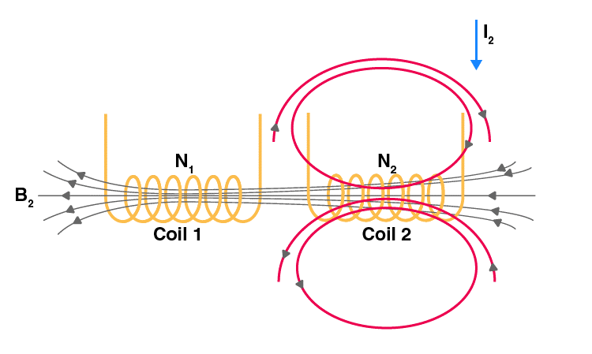

Changing I2 produces changing magnetic flux in coil 1.

MATLAB Code:

% Mutual Inductance Calculation

L1 = 10e-3; % Inductance of coil 1 in henrys

L2 = 20e-3; % Inductance of coil 2 in henrys

k = 0.5; % Coupling coefficient

M = k * sqrt(L1 * L2); % Mutual inductance

disp(['Mutual Inductance: ', num2str(M), ' H']);

66. Phase Shifter Circuit

Theory: Design and simulate a phase shifter circuit.

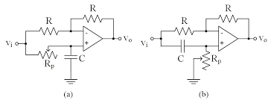

MATLAB Code:

% Phase Shifter Circuit

f = 1000; % Frequency in Hz

R = 1e3; % Resistance in ohms

C = 1e-6; % Capacitance in farads

omega = 2 * pi * f;

phi = atan(1 / (omega * R * C)); % Phase shift in radians

disp(['Phase Shift: ', num2str(phi * (180/pi)), ' degrees']);

67. Schmitt Trigger Circuit

Theory: Design and simulate a Schmitt trigger circuit using an operational amplifier.

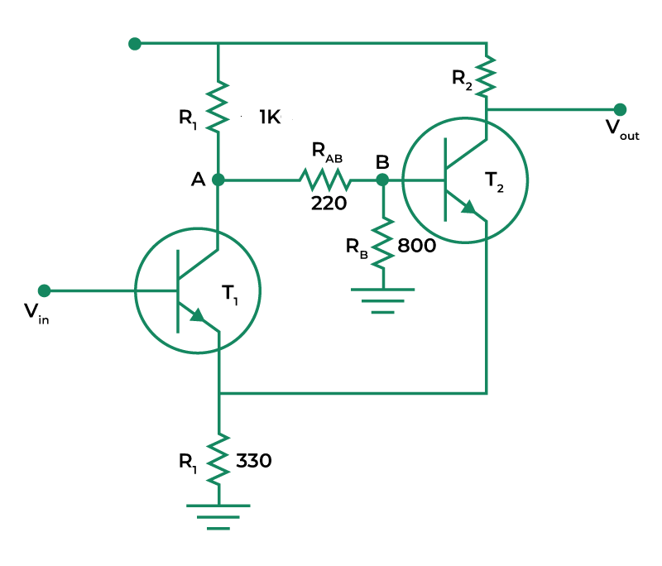

MATLAB Code:

% Schmitt Trigger Circuit

Vcc = 5; % Supply voltage in volts

R1 = 1e3; % Resistance R1 in ohms

R2 = 10e3; % Resistance R2 in ohms

Vin = linspace(-Vcc, Vcc, 1000); % Input voltage sweep

Vout = zeros(size(Vin));

Vh = Vcc * (R2 / (R1 + R2)); % High threshold voltage

Vl = -Vcc * (R2 / (R1 + R2)); % Low threshold voltage

for i = 2:length(Vin)

if Vin(i) > Vh

Vout(i) = Vcc;

elseif Vin(i) < Vl

Vout(i) = -Vcc;

else

Vout(i) = Vout(i-1);

end

end

plot(Vin, Vout);

title('Schmitt Trigger Circuit');

xlabel('Input Voltage (V)');

ylabel('Output Voltage (V)');

68. Band Pass Filter Design

Theory: Design and simulate a band pass filter using RLC components.

**Passive Band Pass Filter**

Passive Band Pass Filters can be made by connecting together a low pass filter with a high pass filter

The **Passive Band Pass Filter** can be used to isolate or filter out certain frequencies that lie within a particular band or range of frequencies. The cut-off frequency or ƒc point in a simple RC passive filter can be accurately controlled using just a single resistor in series with a non-polarized capacitor, and depending upon which way around they are connected, we have seen that either a Low Pass or a High Pass filter is obtained.

One simple use for these types of passive filters is in audio amplifier applications or circuits such as in loudspeaker crossover filters or pre-amplifier tone controls. Sometimes it is necessary to only pass a certain range of frequencies that do not begin at 0Hz, (DC) or end at some upper high frequency point but are within a certain range or band of frequencies, either narrow or wide.

By connecting or “cascading” together a single *Low Pass Filter* circuit with a *High Pass Filter* circuit, we can produce another type of passive RC filter that passes a selected range or “band” of frequencies that can be either narrow or wide while attenuating all those outside of this range.

This new type of passive filter arrangement produces a frequency selective filter known commonly as a **Band Pass Filter** or **BPF** for short.

**Typical Band Pass Filter Circuit**



Unlike the low pass filter which only pass signals of a low frequency range or the high pass filter which pass signals of a higher frequency range, a **Band Pass Filters** passes signals within a certain “band” or “spread” of frequencies without distorting the input signal or introducing extra noise. This band of frequencies can be any width and is commonly known as the filters **Bandwidth**.

MATLAB Code:

% Band Pass Filter Design

R = 1e3; % Resistance in ohms

L = 1e-3; % Inductance in henrys

C = 1e-6; % Capacitance in farads

sys = tf([R*C 0], [L*C R*C 1]);

bode(sys);

title('Band Pass Filter Design');

69. Transient Response Analysis

Theory: Analyze the transient response of a second-order system.

**Transient Response in Control System**

**Transient Response** is an important concept in the analysis of dynamic systems. In engineering and physics, dynamic systems are systems that change over time, often in response to an external stimulus or disturbance. Understanding how a system responds to such stimuli is critical in many fields, including control systems, signal processing, and electronics.

**Transient Response** refers to the behavior of a system during the time it takes to reach a stable state after a disturbance. In other words, it’s the system’s initial response to a sudden change in its inputs. On the other hand, steady-state response refers to the behavior of a system when it has reached a stable state and is no longer changing in response to the original disturbance. In this article, we will explore these concepts in more detail, including the factors that affect the transient and steady-state response, and how they are used in practice.

MATLAB Code:

% Transient Response Analysis

wn = 5; % Natural frequency

zeta = 0.5; % Damping ratio

sys = tf([wn^2], [1 2*zeta*wn wn^2]);

step(sys);

title('Transient Response Analysis');

70. Delta-Wye Transformation

Theory: Perform Delta-Wye transformation for a three-phase network.

**Delta–Wye Transformation Formula**

Depending upon the conversion of the network different delta-wye transformation formula is produced. Let us see the formula for finding the resistance for various cases of conversion.

**Conversion of Delta–Wye or Conversion of Delta – Star**

If the resistors are connected in the form of a Delta or triangle (∆), then it is known as the Delta network. If we invert this delta symbol, then we will get the symbol of the del operator (). This del form, we can modify and represent in the form of the pi symbol (П). Then it is known as pi-network or П-network. Hence, these three networks (∆, ∇, П) are the same.

If the resistors are connected in the form of the letter Y, then it is known as the Wye network. If we invert the letter Y, then it is known as an inverted Y or star (⅄) network. The letter Y, can be modified into the letter T, then it is known as T-network. Hence, these three networks (Y, ⅄, T) are the same.

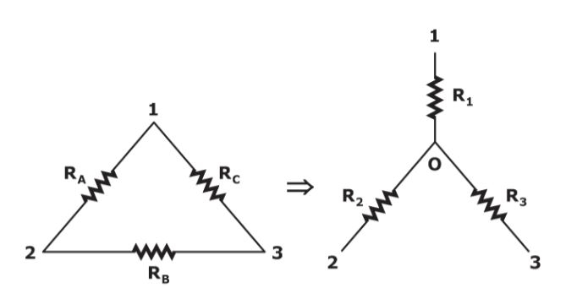

The above figure represents the conversion of the Delta network into a star network. Here, Delta networks consist of three resistors RA, RB, and RC. The resistors in the corresponding Wye network are R1, R2,and R3. We can calculate the values of R1, R2,and R3by using the following formulae.

* R1=(RARC)/(RA+RB+RC).
* R2=(RARB)/(RA+RB+RC)
* R3=(RBRC)//(RA+RB+RC)

**Conversion of Wye-Delta or Conversion of Star-Delta**

Previously, we converted the Delta network into the Star network. Now, let’s see the conversion of Wye-Delta or Star–Delta. The following figure represents the conversion of the Star network into the Delta network.

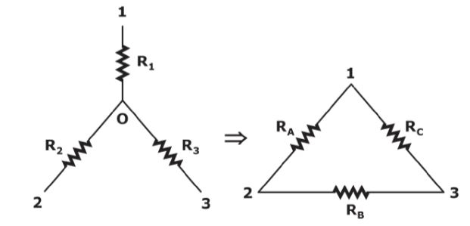

Here, Star networks consist of three resistors R1, R2,and R3. The resistors in the corresponding Delta network are RA, RB,and RC. We can calculate the values of RA, RB,and RC by using the following formulae.

* RA=R1+R2+(R1R2)/R3.
* RB=R2+R3+(R2R3)/R1.
* RC=R1+R3+(R1R3)R2.

MATLAB Code:

% Delta-Wye Transformation

Zab = 50; % Impedance between points A and B

Zbc = 50; % Impedance between points B and C

Zca = 50; % Impedance between points C and A

Z1 = Zab * Zbc / (Zab + Zbc + Zca);

Z2 = Zbc * Zca / (Zab + Zbc + Zca);

Z3 = Zca * Zab / (Zab + Zbc + Zca);

disp(['Z1: ', num2str(Z1), ' Ohms']);

disp(['Z2: ', num2str(Z2), ' Ohms']);

disp(['Z3: ', num2str(Z3), ' Ohms']);

71. RC Integrator Circuit

Theory: Design and simulate an RC integrator circuit.

For a passive RC integrator circuit, the input is connected to a resistance while the output voltage is taken from across a capacitor being the exact opposite to the *RC Differentiator Circuit*. The capacitor charges up when the input is high and discharges when the input is low.

In Electronics, the basic series connected resistor-capacitor (RC) circuit has many uses and applications from basic charging/discharging circuits to high-order filter circuits. This two component passive RC circuit may look simple enough, but depending on the type and frequency of the applied input signal, the behaviour and response of this basic RC circuit can be very different.

A passive RC network is nothing more than a resistor in series with a capacitor, that is a fixed resistance in series with a capacitor that has a frequency dependant reactance which decreases as the frequency across its plates increases. Thus at low frequencies the reactance, Xc of the capacitor is high while at high frequencies its reactance is low due to the standard capacitive reactance formula of Xc = 1/(2πƒC), and we saw this effect in our tutorial about *Passive Low Pass Filters*.

If the input signal is a sine wave, an **rc integrator** will simply act as a simple low pass filter (LPF) above its cut-off point with the cut-off or corner frequency corresponding to the RC time constant (tau, τ) of the series network. Thus when fed with a pure sine wave, an RC integrator acts as a passive low pass filter reducing its output above the cut-off frequency point.

As we have seen previously, the RC time constant reflects the relationship between the resistance and the capacitance with respect to time with the amount of time, given in seconds, being directly proportional to resistance, **R** and capacitance, **C**.

Thus the rate of charging or discharging depends on the RC time constant, τ = RC. Consider the circuit below.

**RC Integrator**

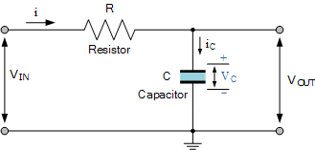

For an RC integrator circuit, the input signal is applied to the resistance with the output taken across the capacitor, then VOUT equals VC. As the capacitor is a frequency dependant element, the amount of charge that is established across the plates is equal to the time domain integral of the current. That is it takes a certain amount of time for the capacitor to fully charge as the capacitor can not charge instantaneously only charge exponentially.

Therefore the capacitor charging current can be written as:

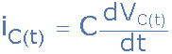

This basic equation above of iC = C(dVc/dt) can also be expressed as the instantaneous rate of change of charge, Q with respect to time giving us the following standard equation of: iC = dQ/dt where the charge Q = C x VC, that is capacitance times voltage.

The rate at which the capacitor charges (or discharges) is directly proportional to the amount of the resistance and capacitance giving the time constant of the circuit. Thus the time constant of a RC integrator circuit is the time interval that equals the product of R and C.

Since capacitance is equal to Q/Vc where electrical charge, Q is the flow of a current (i) over time (t), that is the product of i x t in coulombs, and from Ohms law we know that voltage (V) is equal to i x R, substituting these into the equation for the RC time constant gives:

**RC Time Constant**

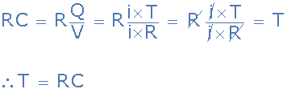

Then we can see that as both i and R cancel out, only T remains indicating that the time constant of an RC integrator circuit has the dimension of time in seconds, being given the Greek letter tau, τ.

Note that this time constant reflects the time (in seconds) required for the capacitor to charge up to 63.2% of the maximum voltage or discharge down to 36.8% of maximum voltage.

**Capacitor Voltage**

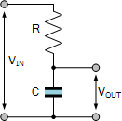

We said previously that for the RC integrator, the output is equal to the voltage across the capacitor, that is: VOUT equals VC. This voltage is proportional to the charge, Q being stored on the capacitor given by: Q = V x C.

The result is that the output voltage is the integral of the input voltage with the amount of integration dependent upon the values of R and C and therefore the time constant of the network.

We saw above that the capacitors current can be expressed as the rate of change of charge, Q with respect to time. Therefore, from a basic rule of differential calculus, the derivative of Q with respect to time is dQ/dt and as i = dQ/dt we get the following relationship of:

Q = ∫idt (the charge Q on the capacitor at any instant in time)

Since the input is connected to the resistor, the same current, i must pass through both the resistor and the capacitor (iR = iC) producing a VR voltage drop across the resistor so the current, (i) flowing through this series RC network is given as:

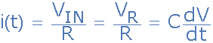

therefore:



As i = VIN/R, substituting and rearranging to solve for VOUT as a function of time gives:



So in other words, the output from an RC integrator circuit, which is the voltage across the capacitor is equal to the time Integral of the input voltage, VIN weighted by a constant of 1/RC. Where RC represents the time constant, τ.

Then assuming the initial charge on the capacitor is zero, that is VOUT = 0, and the input voltage VIN is constant, the output voltage, VOUT is expressed in the time domain as:

**RC Integrator Formula**



Thus an RC integrator circuit is one in which the output voltage, VOUT is proportional to the integral of the input voltage, and with this in mind, lets see what happens when we apply a single positive pulse in the form of a step voltage to the RC integrator circuit.

**Single Pulse RC Integrator**

When a single step voltage pulse is applied to the input of an RC integrator, the capacitor charges up via the resistor in response to the pulse. However, the output is not instant as the voltage across the capacitor cannot change instantaneously but increases exponentially as the capacitor charges at a rate determined by the RC time constant, τ = RC.

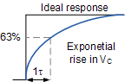

We now know that the rate at which the capacitor either charges or discharges is determined by the RC time constant of the circuit. If an ideal step voltage pulse is applied, that is with the leading edge and trailing edge considered as being instantaneous, the voltage across the capacitor will increase for charging and decrease for discharging, exponentially over time at a rate determined by:

Capacitor Charging:

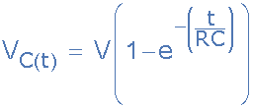

Capacitor Discharging:

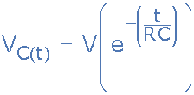

So if we assume a capacitor voltage of one volt (1V), we can plot the percentage of charge or discharge of the capacitor for each individual R time constant as shown in the following table.

|  |  |  |
| --- | --- | --- |
| Time Constant | Capacitor Charging | Capacitor Discharging |
| τ | % Charged | % Discharged |
| 0.5 | 39.4% | 60.6% |
| 0.7 | 50% | 50% |
| 1 | 63.2% | 36.7% |
| 2 | 86.4% | 13.5% |
| 3 | 95.0% | 4.9% |
| 4 | 98.1% | 1.8% |
| 5 | 99.3% | 0.67% |

Note that at 5 time constants or above, the capacitor is considered to be 100 percent fully charged or fully discharged.

Now lets assume we have an RC integrator circuit consisting of a 100kΩ resistor and a 1uF capacitor as shown.

**RC Integrator Circuit Example**

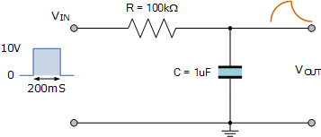

The time constant, τ of the RC integrator circuit is therefore given as:

RC = 100kΩ x 1uF = 100ms.

If we apply a step voltage pulse to the input with a duration of say, two time constants (200mS), then from the table above we can see that the capacitor will charge to 86.4% of its fully charged value.

If this pulse has an amplitude of 10 volts, then this equates to 8.64 volts before the capacitor discharges again back through the resistor to the source as the input pulse returns to zero.

Assuming that the capacitor is allowed to fully discharge in a time of 5 time constants, or 500mS before the arrival of the next input pulse, then the graph of the charging and discharging curves would look something like this:

**RC Integrator Charging/Discharging Curves**

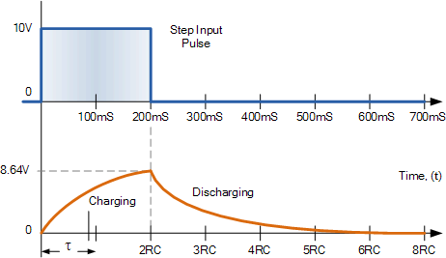

Note that the capacitor is discharging from an initial value of 8.64 volts (2 time constants) and not from the 10 volts input.

Then we can see that as the RC time constant is fixed, any variation to the input pulse width will affect the output of the RC integrator circuit. If the pulse width is increased and is equal too or greater than 5RC, then the shape of the output pulse will be similar to that of the input as the output voltage reaches the same value as the input.

If however the pulse width is decreased below 5RC, the capacitor will only partially charge and not reach the maximum input voltage resulting in a smaller output voltage because the capacitor cannot charge as much resulting in an output voltage that is proportional to the integral of the input voltage.

So if we assume an input pulse equal to one time constant, that is 1RC, the capacitor will charge and discharge not between 0 volts and 10 volts but between 63.2% and 38.7% of the voltage across the capacitor at the time of change. Note that these values are determined by the RC time constant.

**Fixed RC Integrator Time Constant**

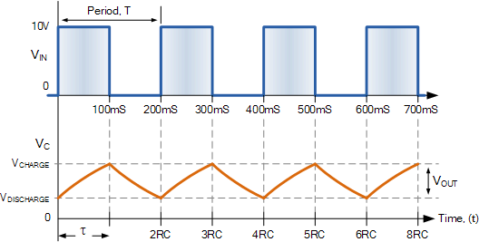

So for a continuous pulse input, the correct relationship between the periodic time of the input and the RC time constant of the circuit, integration of the input will take place producing a sort of ramp up, and then a ramp down output.

But for the circuit to function correctly as an integrator, the value of the RC time constant has to be large compared to the inputs periodic time. That is RC ≫ T, usually 10 times greater.

This means that the magnitude of the output voltage (which was proportional to 1/RC) will be very small between its high and low voltages severely attenuating the output voltage. This is because the capacitor has much less time to charge and discharge between pulses but the average output DC voltage will increase towards one half magnitude of the input and in our pulse example above, this will be 5 volts (10/2).

**RC Integrator as a Sine Wave Generator**

We have seen above that an *RC integrator* circuit can perform the operation of integration by applying a pulse input resulting in a ramp-up and ramp-down triangular wave output due to the charging and discharging characteristics of the capacitor. But what would happen if we reversed the process and applied a triangular waveform to the input, would we get a pulse or square wave output?

When the input signal to an RC integrator circuit is a pulse shaped input, the output is a triangular wave. But when we apply a triangular wave, the output becomes a sine wave due to the integration over time of the ramp signal.

There are many ways to produce a sinusoidal waveform, but one simple and cheap way to electronically produce a sine waves type waveform is to use a pair of passive RC integrator circuits connected together in series as shown.

**Sine Wave RC Integrator**

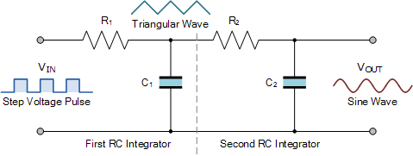

Here the first RC integrator converts the original pulse shaped input into a ramp-up and ramp-down triangular waveform which becomes the input of the second RC integrator. This second RC integrator circuit rounds off the points of the triangular waveform converting it into a sine wave as it is effectively performing a double integration on the original input signal with the RC time constant affecting the degree of integration.

As the integration of a ramp produces a sine function, (basically a round-off triangular waveform) its periodic frequency in Hertz will be equal to the period T of the original pulse. Note also that if we reverse this signal and the input signal is a sine wave, the circuit does not act as an integrator, but as a simple low pass filter (LPF) with the sine wave, being a pure waveform does not change shape, only its amplitude is affected.

MATLAB Code:

% RC Integrator Circuit

R = 1e3; % Resistance in ohms

C = 1e-6; % Capacitance in farads

sys = tf([1], [R*C 1]);

bode(sys);

title('RC Integrator Circuit');

74. Root Mean Square (RMS) Calculation

Theory: Calculate the RMS value of a periodic signal.

**What is Root Mean Square (RMS)?**

Statistically, the **root mean square (RMS)** is the square root of the mean square, which is the arithmetic mean of the squares of a group of values. RMS is also called a quadratic mean and is a special case of the generalized mean whose exponent is 2. Root mean square is also defined as a varying function based on an integral of the squares of the values which are instantaneous in a cycle.

In other words, the RMS of a group of numbers is the square of the arithmetic mean or the function’s square which defines the continuous waveform.

**Root Mean Square Formula**

The **formula for Root Mean Square** is given below to get the RMS value of a set of data values.

For a group of n values involving {x1, x2, x3,…. Xn}, the RMS is given by:

The formula for a continuous function f(t), defined for the interval **T1 ≤ t ≤ T2** is given by:

The RMS of a periodic function is always equivalent to the RMS of a function’s single period. The continuous function’s RMS value can be considered approximately by taking the RMS of a sequence of evenly spaced entities. Also, the RMS value of different waveforms can also be calculated without calculus.

How to Calculate the Root Mean Square

Steps to Find the Root mean square for a given set of values are given below:

**Step 1:** Get the squares of all the values

**Step 2:** Calculate the average of the obtained squares

**Step 3:** Finally, take the square root of the average

Solved Example

**Question:**

Calculate the root mean square (RMS) of the data set: 1, 3, 5, 7, 9

**Solution:**

Given set of data values:

1, 3, 5, 7, 9

Step 1: Squares of these values

12, 32, 52, 72, 92

Or

1, 9, 25, 49, 81

Step 2: Average of the squares

(1 + 9 + 25 + 49 + 81)/5

= 165/5

= 33

Step 3: Take the square root of the average.

RMS = √33 = 5.745 (approx)

MATLAB Code:

% Root Mean Square (RMS) Calculation

t = linspace(0, 2*pi, 1000);

x = sin(t);

RMS = sqrt(mean(x.^2));

disp(['RMS Value: ', num2str(RMS)]);

75. AC Voltage Regulation

Theory: Calculate the voltage regulation of a transformer.

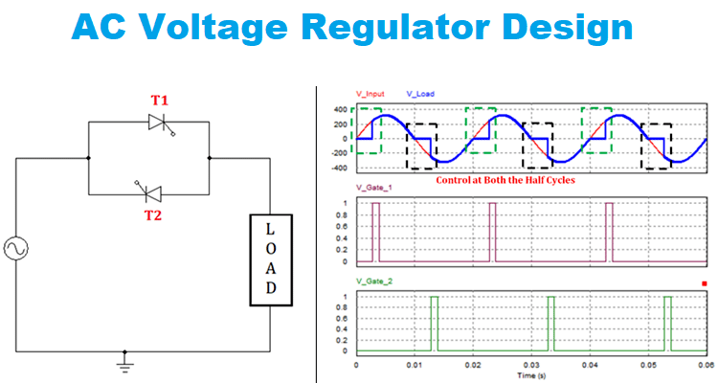

MATLAB Code:

% AC Voltage Regulation

V_no_load = 230; % No-load voltage in volts

V_full_load = 220; % Full-load voltage in volts

regulation = ((V_no_load - V_full_load) / V_full_load) * 100;

disp(['Voltage Regulation: ', num2str(regulation), '%']);

77. Resonance in RLC Circuit

Theory: Analyze the resonance behavior in an RLC circuit.

In the series RLC circuit at resonance, we will connect the AC voltage source, Resistor (R), Inductor (L), and Capacitor (C), all in series. This circuit diagram is shown in the figure below.

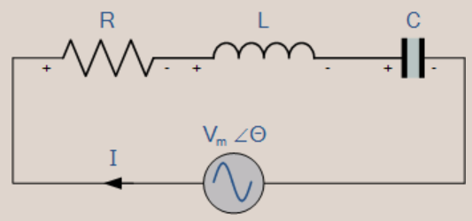

The current is the same in series, but the supply voltage (AC) gets divided among the passive elements.

* Since R, L, and C are connected in series, the equivalent impedance will be Z=R+j(ωL-1/ωC).
* The impedance, Z, will be real, equal to R when the imaginary part of impedance becomes zero at ω=0.
* At ω=ω0, the inductor and capacitor reactance is the same.

ω0L=1/ω0C

=>ω02=1/LC

=>ω0=1/√LC

=>f0=1/2π√LC

* f0 is the series resonant frequency, equal to 1/2π√LC.
* At ω=ω0, V=IZ=IR. That is, voltage and current are in phase at a resonant frequency. i.e., ∅=0.
* At the series resonant frequency, the power factor cos ∅ will equal 1. Hence, it is called a unity power factor.

**Resonance in Parallel RLC Circuit**

In a parallel RLC circuit, we will connect the AC source, Resistor (R), Inductor (L), and Capacitor (C) all in parallel. This circuit diagram is shown in the figure below.

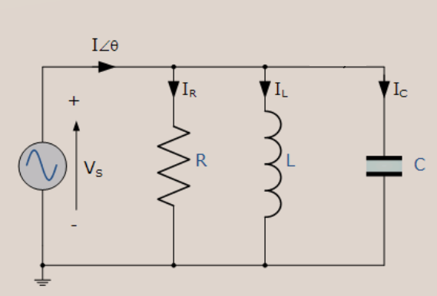

Voltage is the same, but the supply current (AC) gets divided among the passive elements.

* Since R, L and C are connected in parallel, and the equivalent admittance will be Y=1/R+j(ωC-1/ωL).
* The admittance, Y will be real, and it is equal to 1R when the imaginary part of admittance becomes zero at ω=ω0.
* At ω=ω0, the inductor and capacitor susceptance are the same.

ω0C=1/ω0L

=>ω02=1/LC

=>ω0=1/√LC

=>f0=1/2π√LC

* f0 is the parallel resonant frequency, equal to 1/2π√LC.
* At ω=ω0, I=VY=V/R. That is, current and voltage are in phase at a resonant frequency. i.e., ∅=0.
* The power factor at resonance in RLC parallel circuit is cos ∅ , which will equal 1. Hence, it is called a unity power factor.

MATLAB Code:

% Resonance in RLC Circuit

R = 10; % Resistance in ohms

L = 1e-3; % Inductance in henrys

C = 1e-6; % Capacitance in farads

f_resonance = 1 / (2*pi*sqrt(L*C)); % Resonant frequency

disp(['Resonant Frequency: ', num2str(f_resonance), ' Hz']);

f = linspace(0, 2*f_resonance, 1000);

Z = sqrt(R^2 + (2*pi*f*L - 1./(2*pi*f*C)).^2); % Impedance

plot(f, Z);

title('Resonance in RLC Circuit');

xlabel('Frequency (Hz)');

ylabel('Impedance (Ohms)');

78. Synchronous Motor Simulation

Theory: Simulate the operation of a synchronous motor.

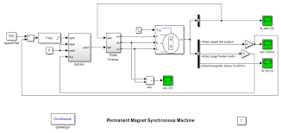

MATLAB Code:

% Synchronous Motor Simulation

V = 230; % Supply voltage in volts

f = 50; % Supply frequency in Hz

P = 4; % Number of poles

N_sync = 120*f/P; % Synchronous speed in RPM

t = linspace(0, 1, 1000);

theta = 2*pi*N_sync/60 * t; % Rotor angle in radians

I = V * sin(theta); % Induced current

plot(t, I);

title('Synchronous Motor Simulation');

xlabel('Time (s)');

ylabel('Current (A)');

80. Diode Clipper Circuit

Theory: Design and simulate a diode clipper circuit.

**Positive Diode Clipping Circuits**



In this diode clipping circuit, the diode is forward biased (anode more positive than cathode) during the positive half cycle of the sinusoidal input waveform. For the diode to become forward biased, it must have the input voltage magnitude greater than +0.7 volts (0.3 volts for a germanium diode).

When this happens the diodes begins to conduct and holds the voltage across itself constant at 0.7V until the sinusoidal waveform falls below this value. Thus the output voltage which is taken across the diode can never exceed 0.7 volts during the positive half cycle.

During the negative half cycle, the diode is reverse biased (cathode more positive than anode) blocking current flow through itself and as a result has no effect on the negative half of the sinusoidal voltage which passes to the load unaltered. Thus the diode limits the positive half of the input waveform and is known as a positive clipper circuit.

**Negative Diode Clipping Circuit**



Here the reverse is true. The diode is forward biased during the negative half cycle of the sinusoidal waveform and limits or clips it to –0.7 volts while allowing the positive half cycle to pass unaltered when reverse biased. As the diode limits the negative half cycle of the input voltage it is therefore called a negative clipper circuit.

**Clipping of Both Half Cycles**



If we connected two diodes in inverse parallel as shown, then both the positive and negative half cycles would be clipped as diode D1 clips the positive half cycle of the sinusoidal input waveform while diode D2 clips the negative half cycle. Then diode clipping circuits can be used to clip the positive half cycle, the negative half cycle or both.

For ideal diodes the output waveform above would be zero. However, due to the forward bias voltage drop across the diodes the actual clipping point occurs at +0.7 volts and –0.7 volts respectively. But we can increase this ±0.7V threshold to any value we want up to the maximum value, (VPEAK) of the sinusoidal waveform either by connecting together more diodes in series creating multiples of 0.7 volts, or by adding a voltage bias to the diodes.

**Biased Diode Clipping Circuits**

To produce diode clipping circuits for voltage waveforms at different levels, a bias voltage, VBIAS is added in series with the diode to produce a combination clipper as shown. The voltage across the series combination must be greater than VBIAS + 0.7V before the diode becomes sufficiently forward biased to conduct. For example, if the VBIAS level is set at 4.0 volts, then the sinusoidal voltage at the diode’s anode terminal must be greater than **4.0 + 0.7 = 4.7 volts** for it to become forward biased. Any anode voltage levels above this bias point are clipped off.

**Positive Bias Diode**



Likewise, by reversing the diode and the battery bias voltage, when a diode conducts the negative half cycle of the output waveform is held to a level –VBIAS – 0.7V as shown.

**Negative Bias Diode**



A variable diode clipping or diode limiting level can be achieved by varying the bias voltage of the diodes. If both the positive and the negative half cycles are to be clipped, then two biased clipping diodes are used. But for both positive and negative diode clipping, the bias voltage need not be the same. The positive bias voltage could be at one level, for example 4 volts, and the negative bias voltage at another, for example 6 volts as shown.

**Diode Clipping of Different Bias levels**



When the voltage of the positive half cycle reaches +4.7 V, diode D1 conducts and limits the waveform at +4.7 V. Diode D2 does not conduct until the voltage reaches –6.7 V. Therefore, all positive voltages above +4.7 V and negative voltages below –6.7 V are automatically clipped.

The advantage of biased diode clipping circuits is that it prevents the output signal from exceeding preset voltage limits for both half cycles of the input waveform, which could be an input from a noisy sensor or the positive and negative supply rails of a power supply.

If the diode clipping levels are set too low or the input waveform is too great then the elimination of both waveform peaks could end up with a square-wave shaped waveform.

**Zener Diode Clipping Circuits**

The use of a bias voltage means that the amount of the voltage waveform that is clipped off can be accurately controlled. But one of the main disadvantages of using voltage biased diode clipping circuits, is that they need an additional emf battery source which may or may not be a problem.

One easy way of creating biased diode clipping circuits without the need for an additional emf supply is to use Zener Diodes.

As we know, the zener diode is a another type of diode that has been specially manufactured to operate in its reverse biased breakdown region and as such can be used for voltage regulation or zener diode clipping applications. In the forward region, the zener acts just like an ordinary silicon diode with a forward voltage drop of 0.7V (700mV) when conducting, the same as above.

However, in the reverse bias region, the voltage is blocked until the zener diodes breakdown voltage is reached. At this point, the reverse current through the zener increases sharply but the zener voltage, VZ across the device remains constant even if the zener current, IZ varies.

Then we can put this zener action to good effect by using them for clipping a waveform as shown.

**Zener Diode Clipping**



The zener diode is acting like a biased diode clipping circuit with the bias voltage being equal to the zener breakdown voltage. In this circuit during the positive half of the waveform the zener diode is reverse biased so the waveform is clipped at the zener voltage, VZD1. During the negative half cycle the zener acts like a normal diode with its usual 0.7V junction value.

We can develop this idea further by using the zener diodes reverse-voltage characteristics to clip both halves of a waveform using series connected back-to-back zener diodes as shown.

**Full-wave Zener Diode Clipping**



The output waveform from full wave zener diode clipping circuits resembles that of the previous voltage biased diode clipping circuit. The output waveform will be clipped at the zener voltage plus the 0.7V forward volt drop of the other diode. So for example, the positive half cycle will be clipped at the sum of zener diode, ZD1 plus 0.7V from ZD2 and vice versa for the negative half cycle.

Zener diodes are manufactured with a wide range of voltages and can be used to give different voltage references on each half cycle, the same as above. Zener diodes are available with zener breakdown voltages, VZ ranging from 2.4 to 33 volts, with a typical tolerance of 1 or 5%. Note that once conducting in the reverse breakdown region, full current will flow through the zener diode so a suitable current limiting resistor, R1 must be chosen.

MATLAB Code:

% Diode Clipper Circuit

V_in = linspace(-10, 10, 1000); % Input voltage range

V_clip = 3; % Clipping voltage

V_out = zeros(size(V_in));

for i = 1:length(V_in)

if V_in(i) > V_clip

V_out(i) = V_clip;

elseif V_in(i) < -V_clip

V_out(i) = -V_clip;

else

V_out(i) = V_in(i);

end

end

plot(V_in, V_out);

title('Diode Clipper Circuit');

xlabel('Input Voltage (V)');

ylabel('Output Voltage (V)');

81. Voltage Doubler Circuit

Theory: Design and simulate a voltage doubler circuit.

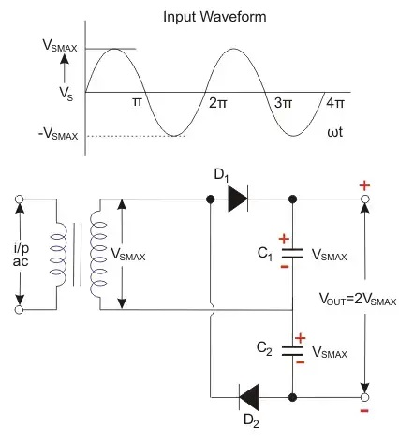

MATLAB Code:

% Voltage Doubler Circuit

V_in = 5; % Input AC voltage peak

f = 60; % Frequency in Hz

t = linspace(0, 1/f, 1000); % Time vector

V_out = 2 * V_in * abs(sin(2*pi*f*t)); % Output voltage waveform

plot(t, V_out);

title('Voltage Doubler Circuit');

xlabel('Time (s)');

ylabel('Voltage (V)');

82. Three-Phase Power Calculation

Theory: Calculate the power in a balanced three-phase system.

**Three Phase Power and Current**

The power was taken by a circuit (single or three-phase) is measured in watts W (or kW).  The product of the voltage and current is the apparent power and measured in VA (or kVA).   The relationship between kVA and kW is the power factor (Pf):

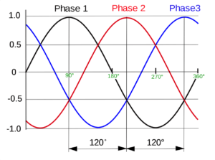

kW = kVA x pf

which can also be expressed as:

kVA = kW/pf

*Single phase system*

this is the easiest to deal with.  Given the kW and power factor, the kVA can be easily worked out.  The current is simply the kVA divided by the voltage.  As an example, consider a load consuming 23 kW of power at 230 V and a power factor of 0.86:

kVA = kW / power factor = 23/0.86 = 26.7 kVA (26700VA)

Current = VA / voltage = 26700 / 230 = 116 A

Note: you can do these equations in either VA, V, and A or kVA, kV, and KA depending on the parameters you are dealing with. To convert from VA to kVA just divide by 1000.

Three phase system

The main difference between a three-phase system and a single-phase system is the voltage.  In a three-phase system, we have the line to line voltage (VLL)  and the phase voltage (VLN), related by:

VLL =√3  x VLN

or alternatively as:

VLN= VLL/ √3

the easiest way to solve three-phase problems is to convert them to a single-phase problem.  Take a three-phase motor (with three windings, each identical) consuming a given kW.  The kW per winding (single-phase) has to be the total divided by 3.  Similarly, a transformer (with three windings, each identical) supplying a given kVA will have each winding supplying a third of the total power.  To convert a three-phase problem to a single phase problem take the total kW (or kVA) and divide it by three.

As an example, consider a balanced three phase  load consuming 36 kW at a power factor of 0.86 and line to line voltage of 400 V (VLL) :

note: the line to neutral (phase) voltage **VLN = 400/ √3  = 230 V**three phase power is 36 kW, single phase power = 36/3 = 12 kW  
now simply follow the above single phase method

**kVA = kW / power factor = 12 / 0.86 = 13.9 kVA (13900 VA)**

**Current = VA / voltage = 13900 / 230 = 60 A**

MATLAB Code:

% Three-Phase Power Calculation

V_phase = 230; % Phase voltage in volts

I_phase = 10; % Phase current in amperes

pf = 0.8; % Power factor

P = 3 * V_phase * I_phase * pf; % Total real power

Q = 3 * V_phase * I_phase * sqrt(1 - pf^2); % Total reactive power

disp(['Total Real Power: ', num2str(P), ' W']);

disp(['Total Reactive Power: ', num2str(Q), ' VAR']);

83. MOSFET Characteristics Plot

Theory: Plot the I-V characteristics of a MOSFET.

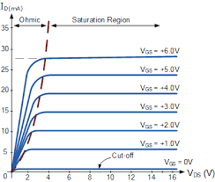

MATLAB Code:

% MOSFET Characteristics Plot

Vds = linspace(0, 10, 100); % Drain-source voltage range

Vgs = [2, 4, 6]; % Gate-source voltages

for Vg = Vgs

Id = (Vg > 1) .* ((Vg - 1) .* (Vds < Vg - 1) + (Vg - 1)^2/2 .* (Vds >= Vg - 1));

plot(Vds, Id);

hold on;

end

hold off;

title('MOSFET I-V Characteristics');

xlabel('V_{DS} (V)');

ylabel('I_{D} (A)');

legend('V_{GS} = 2V', 'V_{GS} = 4V', 'V_{GS} = 6V');

84. Stepper Motor Control

Theory: Simulate the control of a stepper motor using pulse signals.

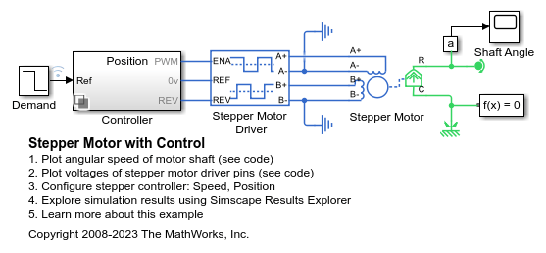

MATLAB Code:

% Stepper Motor Control

steps = 100; % Number of steps

step_angle = 1.8; % Step angle in degrees

angle = 0; % Initial angle

angles = zeros(1, steps);

for i = 1:steps

angle = angle + step_angle;

angles(i) = angle;

end

plot(1:steps, angles);

title('Stepper Motor Control');

xlabel('Step');

ylabel('Angle (degrees)');

85. Photodiode IV Characteristics

Theory: Plot the I-V characteristics of a photodiode.

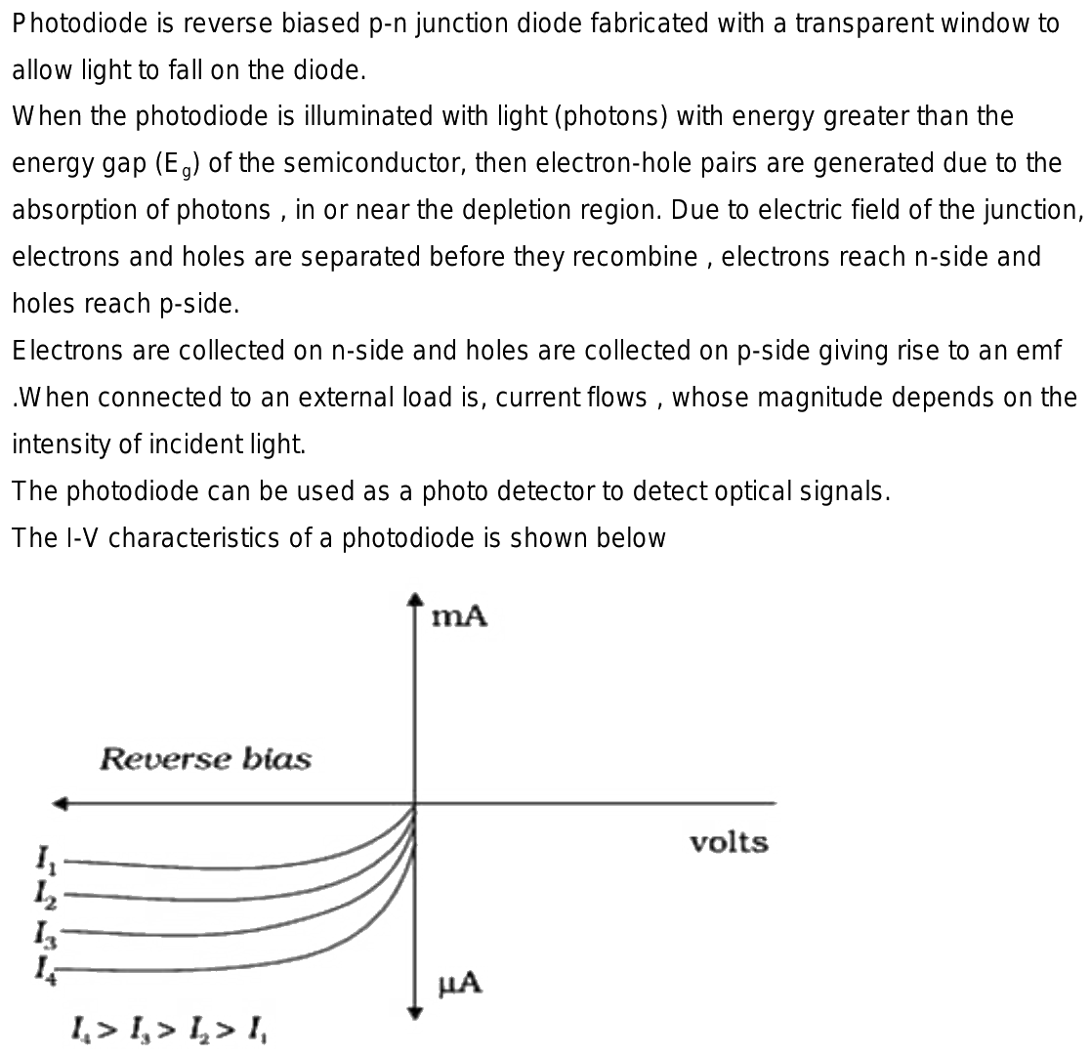

MATLAB Code:

% Photodiode IV Characteristics

V = linspace(-2, 2, 100); % Voltage range

I_dark = 1e-9; % Dark current in amperes

n = 1; % Ideality factor

Is = 1e-12; % Saturation current in amperes

k = 1.38e-23; % Boltzmann constant

T = 300; % Temperature in Kelvin

q = 1.6e-19; % Electron charge

I = Is * (exp((q*V)/(n*k*T)) - 1) + I_dark; % Current

plot(V, I);

title('Photodiode IV Characteristics');

xlabel('Voltage (V)');

ylabel('Current (A)');

86. Battery Charging Simulation

Theory: Simulate the charging process of a battery.

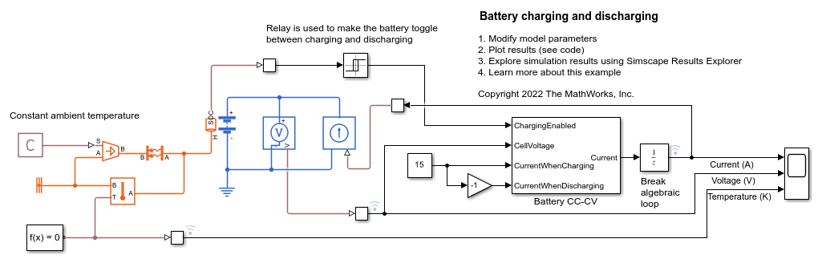

MATLAB Code:

% Battery Charging Simulation

V_batt = 12; % Battery voltage in volts

I_charge = 2; % Charging current in amperes

C = 60; % Battery capacity in Ah

t = linspace(0, C/I_charge, 1000); % Time vector

V = V_batt * (1 - exp(-t / (C/I_charge))); % Voltage during charging

plot(t, V);

title('Battery Charging Simulation');

xlabel('Time (hours)');

ylabel('Voltage (V)');

87. 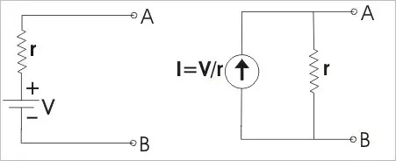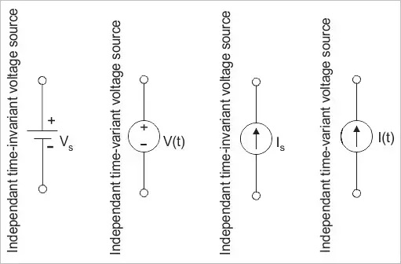

Theory: Plot the characteristics of an ideal current source.

MATLAB Code:

% Current Source Characteristics

I_source = 10; % Current source value in amperes

V = linspace(-10, 10, 1000); % Voltage range

I = I_source * ones(size(V)); % Current is constant

plot(V, I);

title('Current Source Characteristics');

xlabel('Voltage (V)');

ylabel('Current (A)');

88. Series RLC Circuit Analysis

Theory: Analyze a series RLC circuit in the time domain.

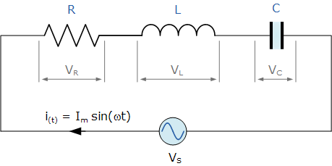

MATLAB Code:

% Series RLC Circuit Analysis

R = 10; % Resistance in ohms

L = 1e-3; % Inductance in henrys

C = 1e-6; % Capacitance in farads

V = 1; % Voltage step input in volts

sys = tf([1], [L*C R*C 1]);

t = linspace(0, 0.01, 1000);

step_response = step(V*sys, t);

plot(t, step_response);

title('Series RLC Circuit Analysis');

xlabel('Time (s)');

ylabel('Voltage (V)');

89. Light Emitting Diode (LED) Characteristics

Theory: Plot the I-V characteristics of an LED.

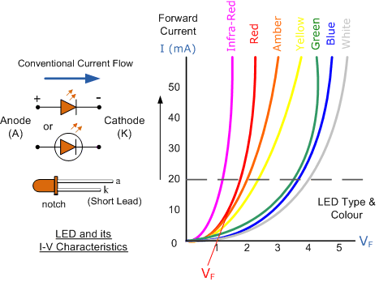

MATLAB Code:

% LED Characteristics

V = linspace(0, 3, 100); % Voltage range

I = 1e-9 * (exp(V / 0.026) - 1); % Current

plot(V, I);

title('LED I-V Characteristics');

xlabel('Voltage (V)');

ylabel('Current (A)');

90. Full-Wave Rectifier Simulation

Theory: Simulate the operation of a full-wave rectifier circuit.

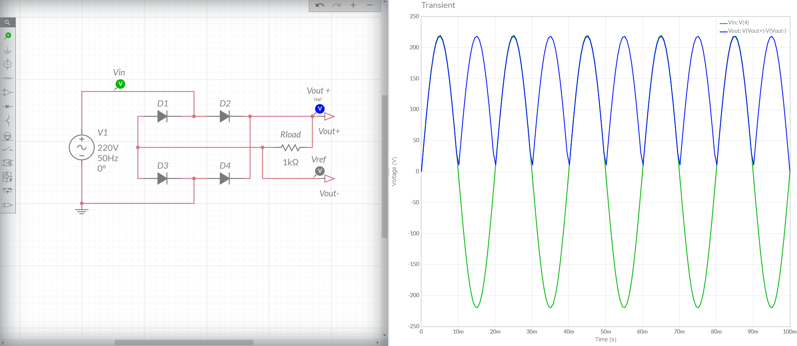

MATLAB Code:

% Full-Wave Rectifier Simulation

t = linspace(0, 0.1, 1000); % Time vector

V_in = sin(2 * pi * 50 * t); % Input AC voltage

V_out = abs(V_in); % Full-wave rectified voltage

plot(t, V_in, t, V_out);

title('Full-Wave Rectifier Simulation');

xlabel('Time (s)');

ylabel('Voltage (V)');

legend('Input Voltage', 'Output Voltage');

)]);